How to register for the Parent Portal

Go to the Edison Board of Education website at:
www.edison.k12.nj.us

You will need to register with the Edison Board of Education website in order to register for the parent portal.

On the top right hand side click on register and follow the steps to register for the website.
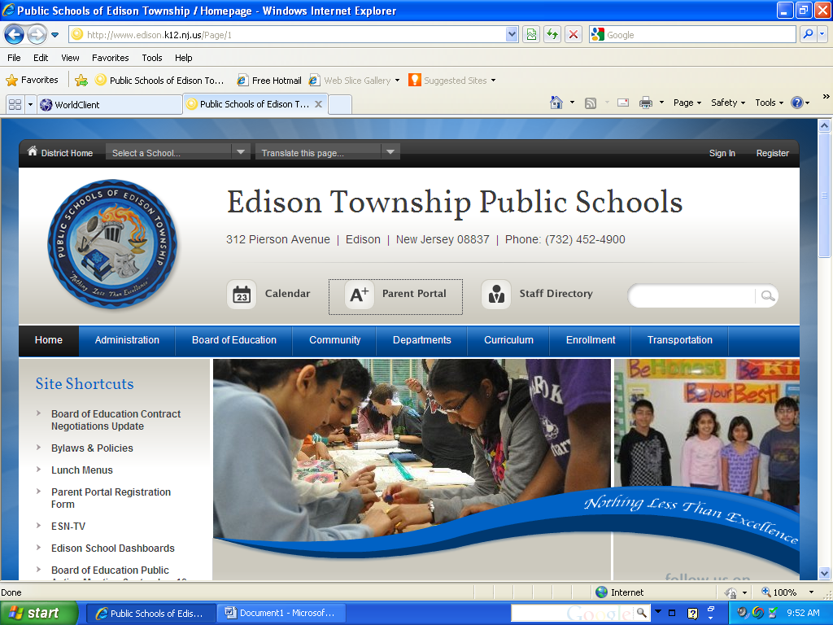
Register

Once you are registered you will need to sign in. On the top right hand side click on sign in and follow the steps.
Sign in

Once signed in, you can register for parent portal.

On the left hand side click on the tab for the parent portal registration form.

Parent Portal Registration
Follow the steps to register your child. You will need your child’s student ID # to complete the registration. You will need to complete a separate form for each of your children in 6th through 12th grades.

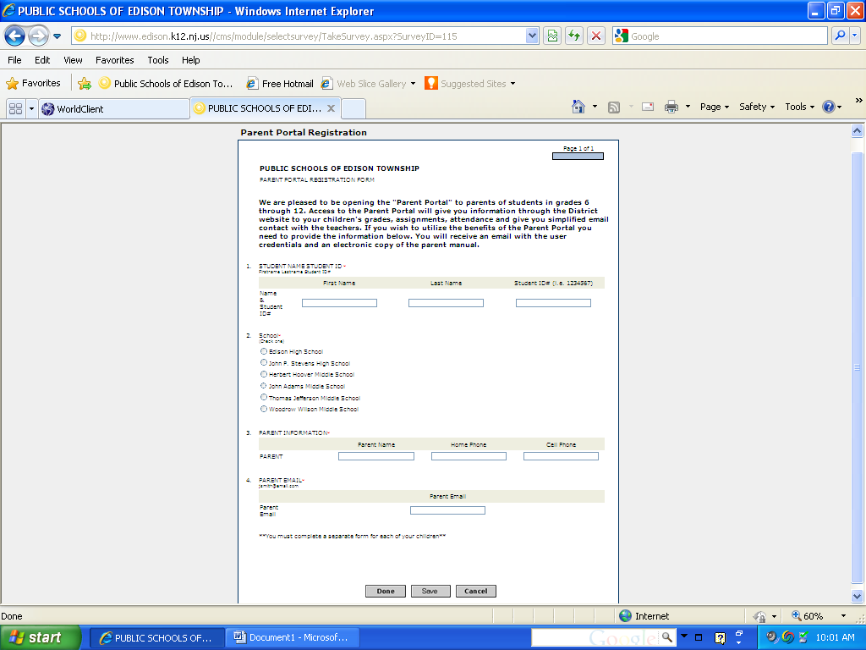

Once all these steps are completed all you will need to do is the following:

On the top of the Edison Board of Education website find the link for the “A+ Parent Portal”. Click on the link and enter your log in information.

A+ Parent Portal

User Name:

Password:

