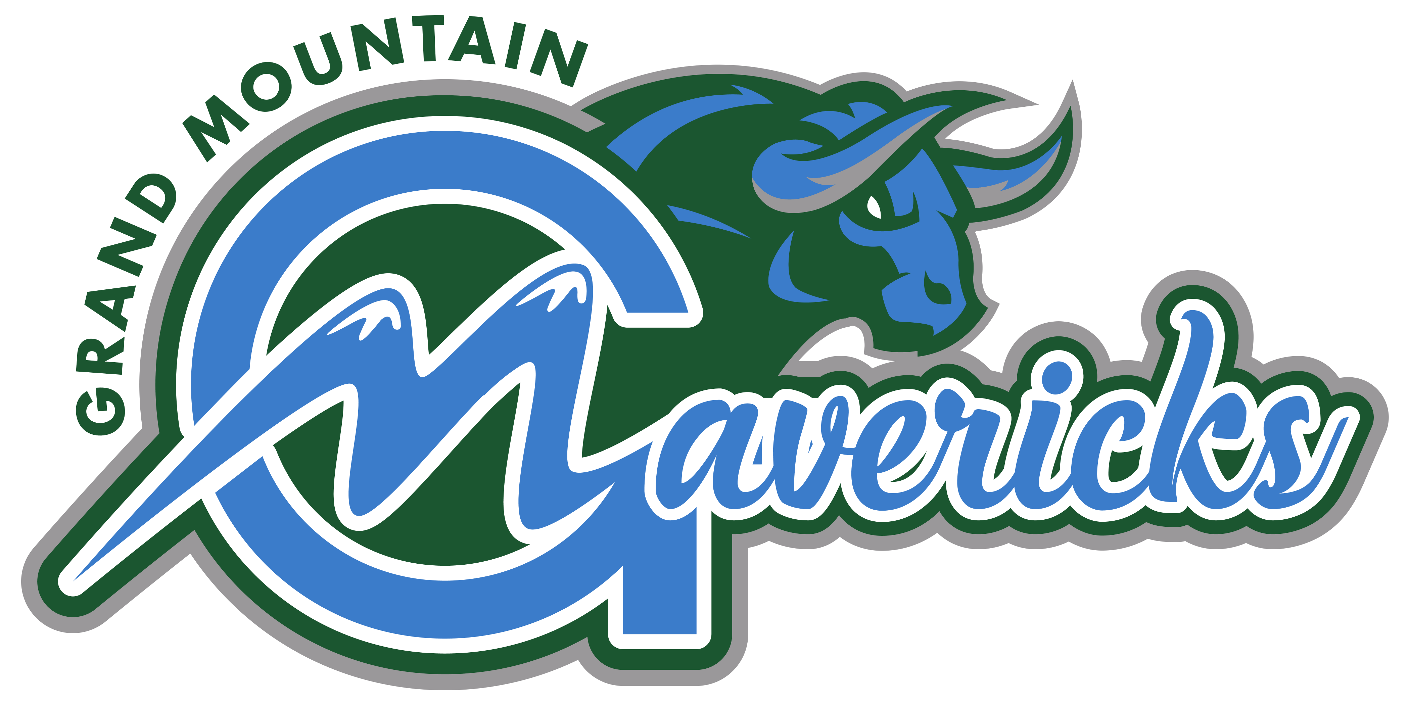
Maverick - (noun) /mav-rik/ - an unorthodox or independent-minded person,
an unbranded range animal. Synonyms: individualist, free spirit, original, trendsetter.

Volume #2, September 30, 2019, School Year 2019-20

Welcome to Grand Mountain School! We continue to grow, learn, and get better daily. When opening a new school there are many systems that evolve and develop and we continue to work on those and build better relationships as our continued focus.
Some areas to highlight (future newsletters will highlight other groups and grade levels)-
- We will have Parent Teacher Conferences on October 17 & 18 for grades K-5. Grades 6-8 will still have school as regularly scheduled on those days. No school October 7.
- We have started a Green Team of staff and students to complete our recycling here at school. Comprised of 4-8 grade students, the green team helps Grand Mountain move towards a more environmentally friendly school via recycling. Twice a week the Green Team comes in early and empties all recycling bins from classrooms and offices. Not only does this reduce the amount of trash Grand Mountain is sending to the landfill but it also helps teach our Mavericks responsibility and respect for our environment, two core principles of our school creed. Way to go Mavericks!
- Kindergarten is underway! Learners have begun learning about and using the 6 Learner Characteristics in class. Kindergarteners have started to learn about how to be safe online through our Code.org curriculum. Centers are fully going and students are now in decodable readers in class and learning about the beginning stages of phonemic awareness. They have 2 math assessments under their belt, and their brains are growing every day! Looking ahead to the coming weeks, IPAD centers will be introduced. These Mighty Mavericks are ready to learn!
- First grade is learning! Setting, asking & answering questions, text organization, synthesizing and sight words: about, eat, how, make, out, put, takes & who. Writing sentences that possess correct letter formation, capitalization, punctuation, verb agreement and pronouns. Using first-person perspective, complete sentences, specific noun modifiers, and spelling consonant digraphs are this week’s focus. EnVisions math curriculum, focusing on continuing counting on to add, using an open number line, doubles, doubles plus one and two. Develop programming and debugging skills on a computer platform. The block-based format of these puzzles will help students learn about sequence and concepts, without having to worry about perfecting syntax. Using characters from the game Angry Birds, students will develop sequential algorithms to move a bird from one side of a maze to the pig at the other side. To do this they will stack code blocks together in a linear sequence, making them move straight, turn left, or turn right. Discovering the answers to the following questions: What is technology? What are objects made of? What is the design process? This is not your traditional first grade!
- Innovation focus on computer science/coding integration, some staff have begun implementing this in their classrooms all ready, we are planning a school wide launch for this in October to build enthusiasm around this. The students I have seen doing lessons in this area have been very highly engaged!
- Staff focused on human growth & character development of students utilizing Responsive Classroom techniques. RC has a language component staff continue to implement; as well as, focused meetings to build relationships among students in their classrooms and with the adult in the room.
Our Lost & Found area is full. We will keep current items until October 18th, then we will donate or dispose of items as they are currently overflowing in our front office/town square. Please put your child’s name on all personal items.
Please remind your child to wear a helmet if riding their bike to school and to walk their bike once on school property.
Thank you for all your help and support.

