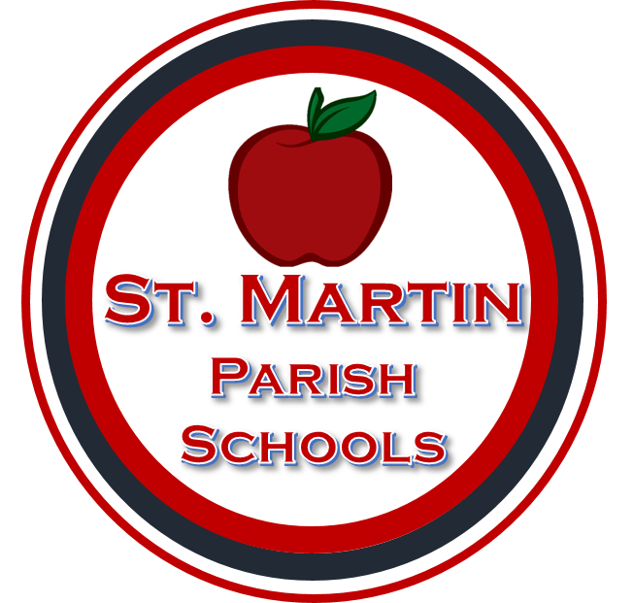
St. Martin Parish School Board
Special Services Department

625 Corporate Blvd. Breaux Bridge, Louisiana 70517
(337) 332-3388 (phone) (337) 332-6628 (fax)

Student: ______________________________ D.O.B:_________________
Documentation of Effort
Date | Name | Position | Reason  (include phone number if contact made by phone)

