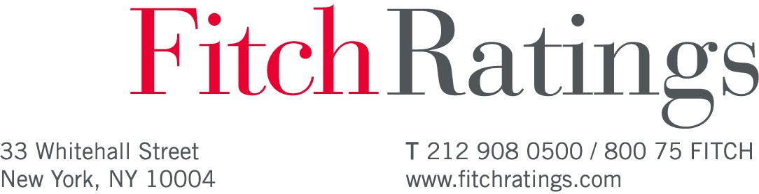

June 28, 2018

Mr. Kathryn Bohling
Assistant Superintendent Business Services Mesquite Independent School District
405 East Davis Street Mesquite, TX 75149

Dear Mr. Bohling:

Fitch Ratings has assigned one or more ratings and/or otherwise taken rating action(s), as detailed in the attached Notice of Rating Action.

In issuing and maintaining its ratings, Fitch relies on factual information it receives from issuers and underwriters and from other sources Fitch believes to be credible. Fitch conducts a reasonable investigation of the factual information relied upon by it in accordance with its ratings methodology, and obtains reasonable verification of that information from independent sources, to the extent such sources are available for a given security or in a given jurisdiction.

The manner of Fitch's factual investigation and the scope of the third-party verification it obtains will vary depending on the nature of the rated security and its issuer, the requirements and practices in the jurisdiction in which the rated security is offered and sold and/or the issuer is located, the availability and nature of relevant public information, access to the management of the issuer and its advisers, the availability of pre-existing third-party verifications such as audit reports, agreed-upon procedures letters,
appraisals, actuarial reports, engineering reports, legal opinions and other reports provided by third parties, the availability of independent and competent third-party verification sources with respect to the particular security or in the particular jurisdiction of the issuer, and a variety of other factors.

Users of Fitch's ratings should understand that neither an enhanced factual investigation nor any third-party verification can ensure that all of the information Fitch relies on in connection with a rating will be accurate and complete. Ultimately, the issuer and its advisers are responsible for the accuracy of the information they provide to Fitch and to the market in offering documents and other reports. In issuing its ratings Fitch must rely on the work of experts, including independent auditors with respect to financial statements and attorneys with respect to legal and tax matters. Further, ratings are inherently forward-looking and embody assumptions and predictions about future events that by their nature cannot be verified as facts. As a result, despite any verification of current facts, ratings can be affected by future events or conditions that were not anticipated at the time a rating was issued or affirmed.

Fitch seeks to continuously improve its ratings criteria and methodologies, and periodically updates the descriptions on its website of its criteria and methodologies for securities of a given type. The criteria and methodology used to determine a rating action are those in effect at the time the rating action is taken, which for public ratings is the date of the related rating action commentary. Each rating action commentary provides information about the criteria and methodology used to arrive at the stated rating, which may differ from the general criteria and methodology for the applicable security type posted on the website at a
given time. For this reason, you should always consult the applicable rating action commentary for the most accurate information on the basis of any given public rating.

Ratings are based on established criteria and methodologies that Fitch is continuously evaluating and updating. Therefore, ratings are the collective work product of Fitch and no individual, or group of
individuals, is solely responsible for a rating. All Fitch reports have shared authorship. Individuals identified in a Fitch report were involved in, but are not solely responsible for, the opinions stated therein. The individuals are named for contact purposes only.

Ratings are not a recommendation or suggestion, directly or indirectly, to you or any other person, to buy, sell, make or hold any investment, loan or security or to undertake any investment strategy with respect to any investment, loan or security or any issuer. Ratings do not comment on the adequacy of market price, the suitability of any investment, loan or security for a particular investor (including without limitation, any accounting and/or regulatory treatment), or the tax-exempt nature or taxability of payments made in respect of any investment, loan or security. Fitch is not your advisor, nor is Fitch providing to you or any other party any financial advice, or any legal, auditing, accounting, appraisal, valuation or actuarial services. A rating should not be viewed as a replacement for such advice or services.

The assignment of a rating by Fitch does not constitute consent by Fitch to the use of its name as an expert in connection with any registration statement or other filings under US, UK or any other relevant securities laws. Fitch does not consent to the inclusion of its ratings in any offering document in any instance in which US, UK or any other relevant securities laws requires such consent. Fitch does not consent to the inclusion of any written letter communicating its rating action in any offering document. You understand that Fitch has not consented to, and will not consent to, being named as an "expert" in connection with any registration statement or other filings under US, UK or any other relevant securities laws, including but not limited to Section 7 of the U.S. Securities Act of 1933. Fitch is not an "underwriter" or "seller" as those terms are defined under applicable securities laws or other regulatory guidance, rules or recommendations, including without limitation Sections 11 and 12(a)(2) of the U.S. Securities Act of 1933, nor has Fitch performed the roles or tasks associated with an "underwriter" or "seller" under this engagement.

Fitch will continue to monitor the credit quality of and maintain ratings on the Issuer/Securities. It is important that you promptly provide us with all information that may be material to the ratings so that our ratings continue to be appropriate. Ratings may be raised, lowered, withdrawn, or placed on Rating Watch due to changes in, additions to, accuracy of or the inadequacy of information or for any other reason Fitch deems sufficient.

Nothing in this letter is intended to or should be construed as creating a fiduciary relationship between Fitch and you or between us and any user of the ratings.

In this letter, "Fitch" means Fitch Ratings, Inc. and any successor in interest.

Public ratings will be valid and effective only upon publication of the ratings on Fitch’s website.

We are pleased to have had the opportunity to be of service to you. If we can be of further assistance, please feel free to contact us at any time.

Jeff Schaub Managing Director
U.S. Public Finance

JS/em

Enc: Notice of Rating Action (Doc ID:211182 Rev 0)

Notice of Rating Action

Bond Description Rating Type
Mesquite Independent School District

Rating
Action Rating
Outlook/
Watch Eff Date Notes

(TX) unltd tax sch bldg bonds ser 2018 (gtd: Texas Permanent School Fund)
Long Term Rating New Rating AAA RO:Sta 27-Jun-2018

27-Jun-2018
RO:Sta
New Rating AAA
Enhanced Long Term Rating
Mesquite Independent School District (TX) unltd tax sch bldg bonds ser 2018 (gtd: Texas Permanent School Fund)

Mesquite Independent School District (TX) unltd tax sch bldg bonds ser 2018 (gtd: Texas Permanent School Fund)

Unenhanced Long New Rating AA+ RO:Sta 27-Jun-2018 Term Rating

Key: RO: Rating Outlook, RW: Rating Watch, Pos: Positive, Neg: Negative, Sta: Stable, Evo: Evolving

Page 1 of 1

