Mesquite United
Henrie House Lesson
Grit #7
For our lesson this week, we are going to continue to focus on grit!
Feel free to use resources that you have or find, but below are some options.
A few video links you could show and discuss:
https://www.youtube.com/watch?v=LUtcigWSBsw – John Legend: Success through effort
https://www.youtube.com/watch?v=g7FdMi03CzI – Brain Jump with Ned the Neuron: Challenges grow your brain
https://www.youtube.com/watch?reload=9&v=pN34FNbOKXc TED Talk The power of belief
These are some activity options you could have students do.
Option 1: would be to have students conduct interviews with a parent, grandparent or some other adult they know and trust who have worked hard toward a long-term goal. Have them come back and share who they interviewed and what thoughts they had about grit from that interview.
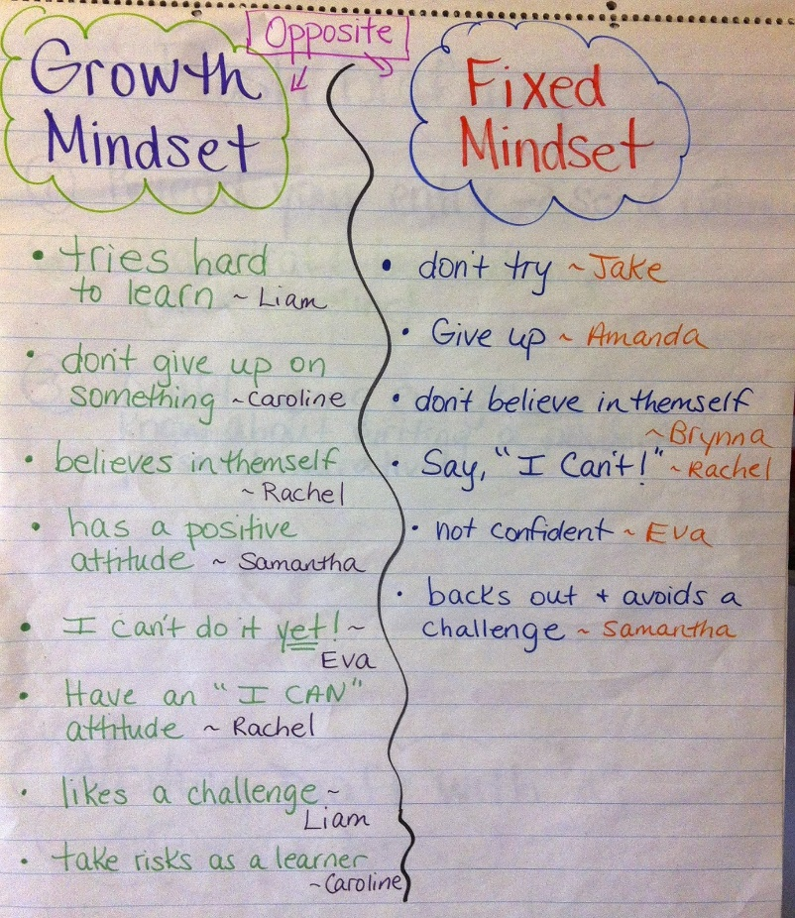
Option 2: Have students create a Fixed vs. Growth mindset poster. Talk about the difference between a fixed mindset and a growth mindset and make an anchor chart of the difference. It could include some of the thinking such as the things listed below. From the information you collect as a class, have students make a poster.

