Mesquite United
Embracing Diversity
Lesson #8
This week, focus on diversity, just as a general topic of being different. I am giving you a resource that talks about crayons, but you don’t have to tie it back to being different by color. It should just really be about diversity in general and how we all bring something different to the world.
A resource you could use could be “The crayon box that talked” by Shane Derolf. He is a link to a read aloud if you need it. It is used a lot in lower grades, but the older kids love these kinds of books too! https://www.youtube.com/watch?v=9OowIpz-lqs
You could also do a partnered discussion piece with this.
“IF I could be any crayon, I would be __________ because…”
“What would the world be like if it were just one color?’
Just give time to share out whole group
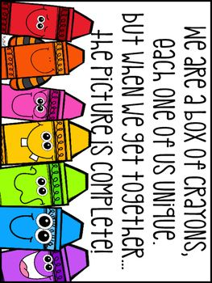
Or have a discussion about what we all contribute to the world with our differences. Try to suggest topics to take conversation to a place you haven’t had so far with our embracing diversity piece. Next week will be our last week for diversity with these lessons before we move on.

