Mesquite United
Embrace Diversity
Henrie House Lesson #4
Focus: Review with students we are talking about diversity and ways we can all be different. Explain that we can also all be different in our skin. Ask students, what colors of skin can different people have? Below is also a great video from Sesame Street that you could also use for this for the younger students that talks about our skin. https://www.youtube.com/watch?feature=youtu.be&v=xIC2hHECZ6Y&app=desktop –Lupita Nyong’o Loves Her Skin
For upper grades, as students list colors, you may also talk about the word “shades”, and that even with the colors they have named that people’s skin can be, we can also all be different shades of those colors. This is also another thing that makes us unique in who we are. You may give an example like the color red and can use a larger box of crayons as an example to demonstrate to students the variety of shades in one color like red or blue. It is important to love the skin you are in and embrace that!
Teach: You can share the story “The Judgmental Flower” by Julia Cook attached in the email.
Share the picture of the flower below with them and explain to them that we would like to make this flower to be up in our hallway up at the front of the building to show those who enter our school that we embrace being different and unique. This may be in the color of our skin, but it could also be in something else that we have already discussed in one of our previous lessons that makes them different, or it could be something that they think of on their own that we haven’t talked about yet. To create this, we are asking for them to trace their own hand, write something on it that makes them special, unique, and makes you, you! Have them cut out the traced hand. They can color it any color that they wish. Please turn these in to my box once your class is finished.
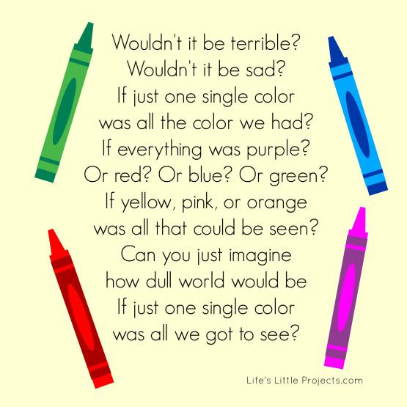
Close: You could also use the picture below with the crayons as a conversation piece or to print and put up in your room.
