- • a,., _

.: 1str t Effectiveness Report
W(S QUITl'.IMDDD,00, -r
'
!CMOOl CtSTaCT

Executive Summary
FacilitiesManagement

2018-2019

The Mesquite ISO Facilities Management Department supports the vision of Mesquite ISO - Success for All Students with Excellence AJways.Because a good physical learning environmentis important for student success, our mission is to provide and maintain a cost­ effecitve, safe, secure and healthy learning environment for the students and staff of MISD.

Each facilities management employee is a critical part of this mission; 135employees make up the Facilities Management Department and maintain 60+ buildings and facilities throughout the district.

The Goals for the Facilities Management Department are:

Handleeach request and project with 5-Star customer service, from the office staff to the field personnle.
Complete projects in a way that makes our customers feel valued and satisfied no matter how small or large the project. Maintainand restore each physical property to its original (optimal) operationalstate in a timely manner.
Use personnel and supplies in a cost-efef ctiveway. Meet100% completiondates for scheduledprojects.

Facilities Management 2018/2019

.
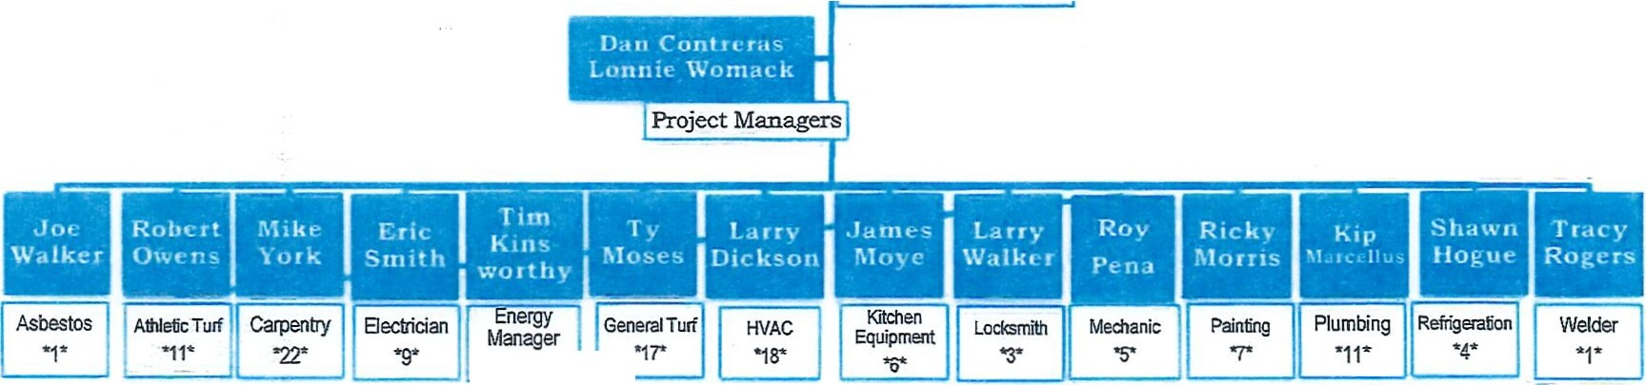.t. ive Director
·1·

-"li\. r.1"
...;ll.)I
'
JCSQUITI
SCIOC.l COS'BlrT

1strict Effectiveness Report

Descripiton

General Function:
Facilities Management
2018-2019

The purpose of the Facilities Management Department is to support the missionand goals of MISD. Keeping all facilities, campuses, machinery and grounds functioning at peak performance is critical to providing a safe and healthy learningand working atmosphere for students andteachersthat allows themto learn and work at the highest levels possible.

To accomplish this, the department employees approach each work order request with a "can-do" mindset. We use efficient systems including the work order process to ensure that requests are prioritized and completed in a timely manner. An emergency procedure is utilized to ensureefficient serviceis provided even during off-hours.

-Al­
-.ni­
SCMDOl Dl5nacf

District Effectiveness Report

Effectiveness Indicators

WORK ORDER COMPARISON

I
i
27,000 -----------------------------==-=
jw I
I 99/day I
26,000 - - - - - - - - - - - - - - - -
.
25500 -I!- _
I
_ _ _ _ _ _ _ _ _ _ _ _

25,000

1
Work Orders per Day
2018/2019: | 96
2017/2018: | 102
2016/2017: | 99

24,500
I
24,000
2018/2019 - 24,985
2017/2018- 26,442
2016/20172-5,933

-SOIO­OC.IIISTIQCT
- -
v
-

istrict Effectiveness Report

Effectiveness Indicators

WORK ORDER DAYS AGED

45 I
' I 1
4 • 13 27
45
days I

days

3.5 ! d ys I rDP
3 lam I
2.5 ..c' .. _J

11 ------ -
1
1 I
05 - - - - - - -

0 - - - - - - --,-

Days Required for
Work Order Completion
2018/2019:
3.27
- 2017/201:8 4.5
2016/2017:
4.52

2018/2019 - 24,985 2017/2018- 26,442 2016/2017-25,933

v
';_
MlS(II.ITl­
SOIOC4. MTIIICT

istrict Effectiveness Report

Eff ectiveness In dicators

The following items contribute tothe efficiencyand operationof Facilities Management: Project Managers
Staggered Work Schedule
North and South Division of Responsibilities Night and Weekend Emergency Call Service PrioritizedWork Orders and Call-in Requests Monltored Monthly Fuel Consumptino

The following items illustratethe effectiveness of the Job Performance of Facilities Management:

District Wide SatisfactionSurvey: 93% satisfaction rate Completion of Work Orders
Special Projects Completed:
Poteet - New SRO office and room swap
AC New - Coach's office and restroom renovation
Moss- installed 7 new humidity controls; connected 14 on line; library renovaotin

tAf
- 1strict Effectiveness Report
.,- \

-1 SC>IOOlDGT1IICT

Effectiveness Indicat ors

Communication office renovation
North Mesquite - security fence installed; ticket booth remodel; Gym concession remodel; C5 Grant project; New SRO Office in I wing
Mesquite High - security fence installed
Installednew security entrance doors at: Cannaday; Austin; Moss; Kimball; Shaw & Pirrung Henrie - remodeled room for Food Pantry
New roof/roof work at: North Mesquite; McDonald; McKenzie; Price; Tosch
Food Service Office - remodeled for new refrigerator Agnew room 33 - add sink and cabinet for new Art room
Wilkinson- Teacher's lounge and vending machine room remodels Vanston - C1 Darkroom remodel
TV projects for - Black;Floyd
Parent Engagement Center - renovation BEES Center - renovation
Ruge! - renovation

.tAJ­
MOCMTt­ istrict Effectiveness Report
SO<OCl OIST, C.

EffectivenessIndicatosr

District Wide Satisfaction Survey
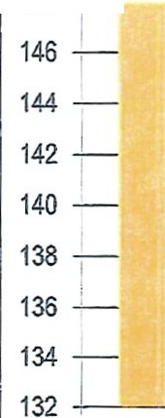
150 ===-----:--------------
155 points possible
148 -, - ,
2017/2018
Timely Response
Timely Accurate Work Resolution
Timely Completion
Communication
SatisfactionRate
2017/2018:
93%

. ,,. 1str1c Effectiveness Report
MiSClUl'T( N>El'OlD9<T
, •,
MiSClUl'T( N>El'OlD9<T
MiSClUl'T( N>El'OlD9<T
SCNOCLOISTRlcr

Cost of Program

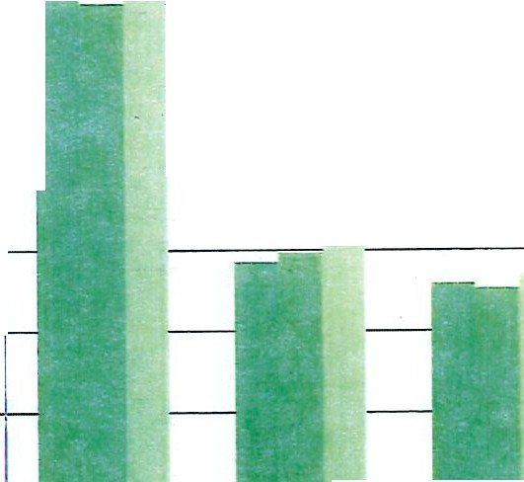l
r 7000000
0000
h
000

5000000 I
[
2016/2017
. 4000000 i
-20000001-
1000000
• 2017/2018
- - - - - - - - - - - - - - - - - - - - - - 2018/2019
0 I U 1·: :
Payroll
I 1'1F1:. en::-··
Contracted Services Supplies &
Maintenance
I :ai-·,---
Other Operation Fixed Assets Costs
Facilities Management Annual Budgets
2016/2017
$14,345,500
2017/2018
$14,047,700
2018/2019
$17,215,000

r.r_\
v_
_-
., .... 

S CHOOi.o,nw.f..

1st ct Effectiveness Report

Vision for the Future
Facilities Management
2018-2019

The vision for the future forthe Facilities Management Department of Mesquite ISD is a department that works seamlessly with campuses and facilities to·ensureoptimal work and.learning environments for MISD employees and students.

As MISD buildings age and new facilities are added it will be critical for work processes to be even more efficient. This will be accomplished through the continuous training and:learningof our team that will lead to innovation and improvement of our processes. To achieve this vision, we must:

Continually work toimprove response times:and customer satisfaction Inspireboth experienced and new employees to be top performers
Strive for all facilities management employees to motivate each other to continuoulsy improve their abilitiesand skills
Provide training and guidance for bothnew·andtenured employees that will ensure their success and continued growth with our department
Continually strive for effective communication with campuses and facilities
Ensure that all facilitei s·management- employees know and commit fully to the FacilitiesManagement Mission

