General Description

The goal of Mesquite Independent School District’s Bilingual and English as a Second Language (ESL) Programs is to provide a consistent and high quality education for culturally and linguistically diverse students. Our focal point is to align the district’s mission and belief statements with the rules of TAC Chapter 89 and the Commissioner’s Rules as follows:

- The goal of the bilingual education programs shall be to enable limited English proficient students to become competent in the comprehension, speaking, reading, and composition of the English language through the development of literacy and academic skills in both, their primary language and English. Such programs shall emphasize the mastery of English language skills, as well as mathematics, science, and social studies, as integral parts of the academic goals for all students to enable limited English proficient students to participate equitably in school.
- The goal of English as a Second Language program shall be to enable limited English proficient students to become competent in the comprehension, speaking, reading, and composition of the English language using sheltered instruction methods. The English as a Second Language program shall emphasize the mastery of English language skills, as well as mathematics, science, and social studies, as integral parts of the academic goals for all students to enable limited English proficient students to participate equitably in schools.

Mesquite ISD offers language support services through ESL and Bilingual Programs in grades Pre-K through 12th. All students entering Mesquite ISD who indicate that a language other than English is spoken at home, on his/her Home Language Survey, are sent to the BEES Center (Bilingual ESL Enrollment Services) to be tested in order to ensure proper placement.

Bilingual placement is available to eligible English Learners (ELs) in Pre-K through 5th grade at 24 different MISD schools. ESL support is available to eligible LEP students at every campus. Students in grades 6-12 are served only through the ESL program. The programs have grown over the years from 20 bilingual teachers and 34 ESL teachers, in the late 90’s, to approximately 266 bilingual teachers and 47 ESL teachers. Our bilingual campuses are: Achziger, Black, Cannaday, Florence, Floyd, Galloway, Gentry, Gray, Hanby, Henrie, Hodges, Lawrence, Mackey, McKenzie, McWhorter, Motley, Porter, Range, Rutherford, Seabourn, Shands, Shaw, Tisinger, and Tosch Elementary Schools.

Organizational Structure

The employee structure of our Bilingual/ESL Program by job title is listed below.

CENTRAL OFFICE
Director - Bilingual/ESL Department – Carolina Portillo Administrative Assistant – Christina Dominguez Bilingual/ESL Data Entry – Rosa Ortiz
Administrative Assistant/Translator – Michelle Valenzuela

BEES CENTER – BILINGUAL ESL ENROLLMENT SERVICES
LEP – Language Testing Facilitator – Daniel Ruvalcaba BEES Secretary – Abixag Ortega
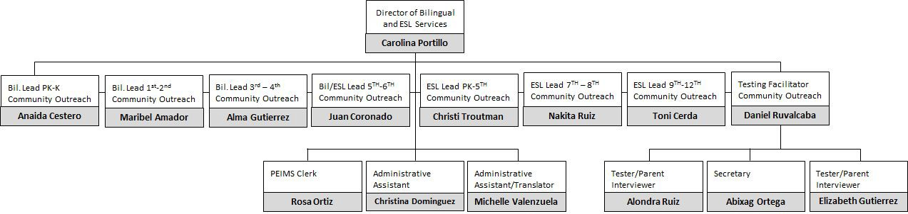
Parent Interview/Tester – Elizabeth Gutierrez Parent Interview/Tester – Alondra Ruiz

INSTRUCTIONAL SUPPORT
Bilingual Lead Teacher – PK and K – Anaida Cestero Bilingual Lead Teacher – 1st and 2nd – Maribel Amador Bilingual Lead Teacher –3rd and 4th – Alma Vazquez Bil/ESL Lead Teacher – 5th and 6th – Juan Coronado ESL Lead Teacher – Elementary – Christi Troutman ESL Lead Teacher –7th and 8th – Nakita Ruiz
ESL Lead Teacher – High School – Toni Cerda

PARENT, FAMILY, AND COMMUNITY OUTREACH
Anaida Cestero

Placement Process

When a parent or guardian starts the enrollment process, one of the documents completed is a Home Language Survey. If the parent indicates anything other than English is spoken by the student, or at home, the student is tested at the BEES Center (Bilingual ESL Enrollment Services). The student is given a battery of tests to determine if Bilingual/ESL services are warranted. All students are given an oral language proficiency test called the IPT (Idea Proficiency Test) and students in grades 2-12 are given the ITBS (Iowa Test of Basic Skills.) If the language testing reveals that the student qualifies for Bilingual/ESL services, the BEES personnel will direct the parent to a specific campus for registration.

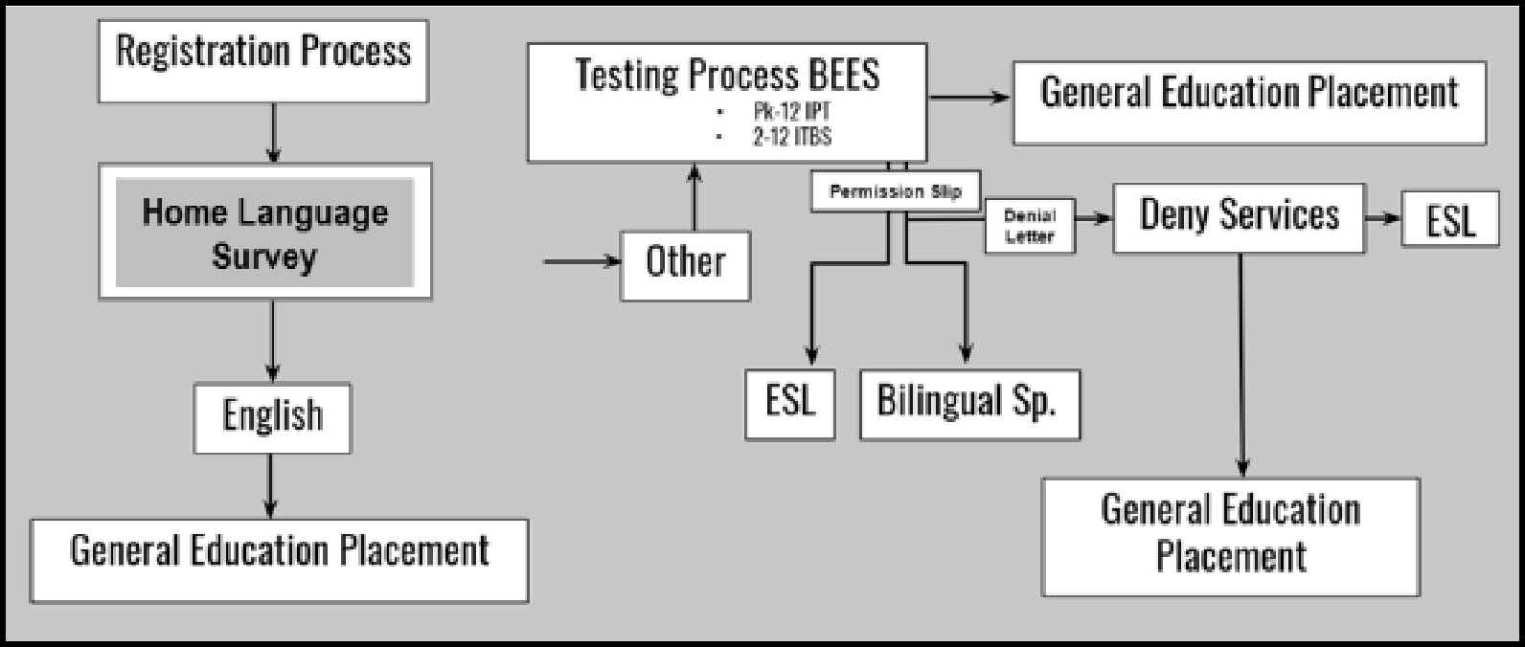

The chart below demonstrates the testing history at the BEES for the last 5 years. Notice that the bar graph for 2018-2019 does not represent a complete year; Pre-K and Kindergarten enrollment for next year have yet to be completed. Once completed, we would have tested over 2,000 students for the current 2018-2019 school year. Demonstrative graph as FIG 1.

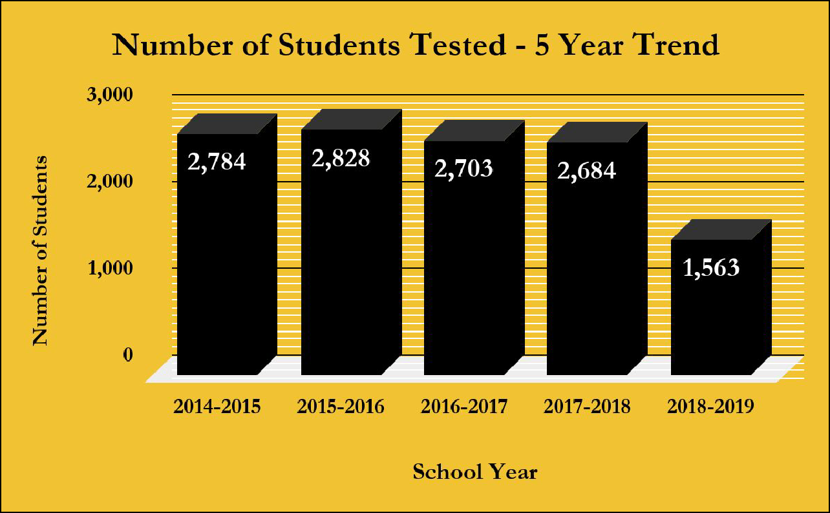
FIG 1

The following charts demonstrate the information collected upon registration from the Home Language Surveys (FIG 2A-B). They reflect the diversity of the population in Mesquite, where more than 16,000 students speak a language other than English. Approximately 50 different languages are spoken in MISD students’ homes. FIG 2A is a pie chart that shows the number of students that speak each language.

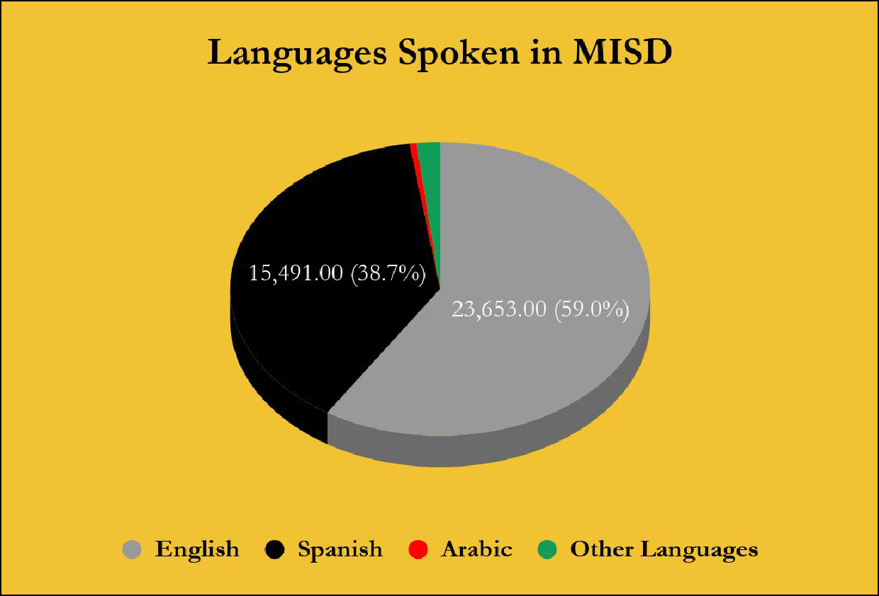
FIG 2A

FIG 2B is an additional chart that shows all the other minority groups that speak languages other than English, Spanish, or Arabic. In total, we have 47+ other languages spoken within the community of Mesquite.

FIG 2B
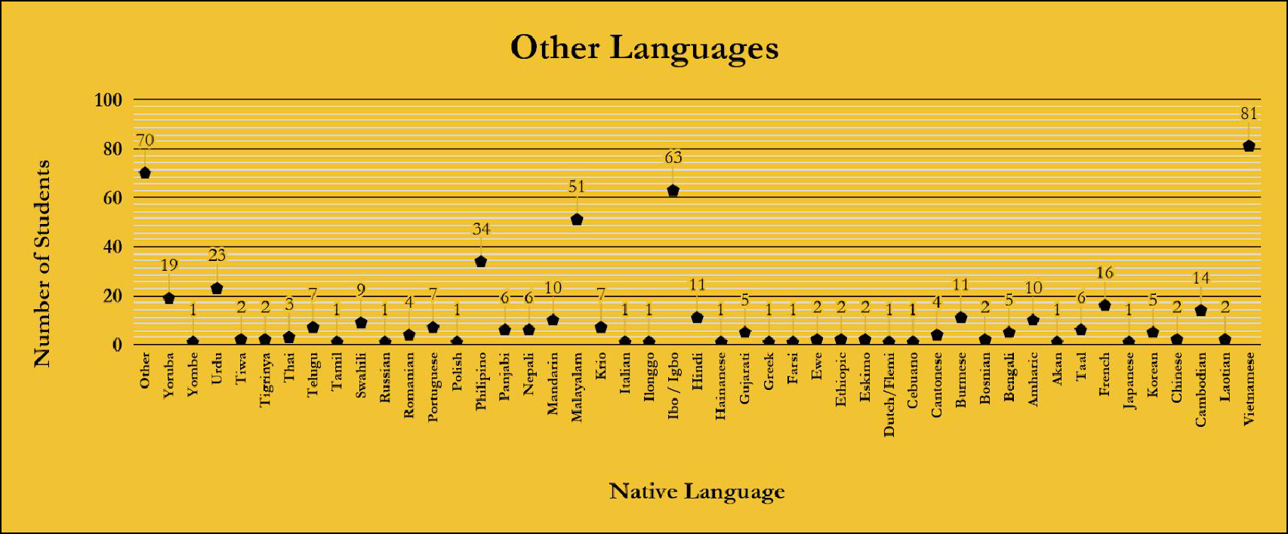

The rapidly increasing population of ELs over the past years is represented in the table below. In less than a decade, our EL population doubled from approximately 5,000 students in 2007 to approximately 10,000 in 2019. In other words, from 2007 to 2019 we have increased the number of ELs, registered in our programs, enough to fill approximately 227 classrooms. FIG 3 represents the number of EL students registered in MISD Bilingual/ESL programs since 1990.

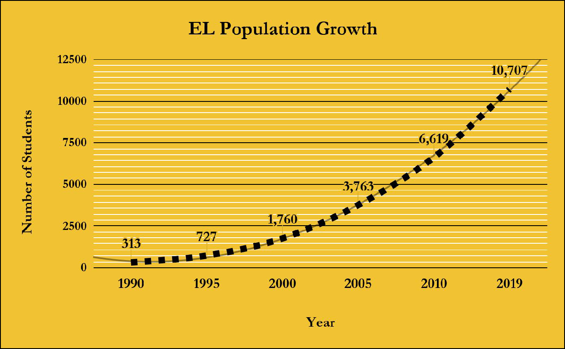
FIG 3

The fastest growing language program we offer is bilingual education. Once a student has been placed in a bilingual class, the method of delivery for instruction is through a Fifty-Fifty Dual Language Program. In this program we focus on five specific goals:

  - Provide high quality of instruction to the students in order for them to successfully meet state academic standards
  - Increase student’s proficiency in, both, language and academic levels in Spanish in order to develop biliteracy
  - Deliver instruction and provide support in order for the students to acquire listening, speaking, reading, and writing skills in English
  - Promote and guarantee an adequate environment for the students to develop high self-esteem
  - Appreciate cultural diversity by integrating students and community to the learning process

The following pages list the procedures for program implementation by grade levels. MISD bilingual program includes two different designs; K- 4th and 5th grade models. The delivery method and the language of instruction varies depending on the grade level to correspond with the demands of each developmental stage. Specific information about each program is included below.

Grades PK-4th: Fifty-Fifty Dual Language Program
This model implies the delivery of instruction in equal proportions. We teach in a way that students learn the content in both English and Spanish. This model utilizes the students’ native language for academic instruction fifty percent of the time (two and a half days) and English for the other fifty percent of the time. Students in this program are native Spanish speakers and receive the same curriculum in all content areas as the general education program through enrichment methods and strategies. To achieve this, teachers work with students at two different levels, personal/social communication and academic learning. Personal/social communication revolves around the student’s daily face-to-face communication, while academic learning embraces the skills needed to master learning standards. It takes two years of English exposure in order to develop a relatively high degree of English communication skills. On the other hand, it takes from five to seven years to develop the academic language needed to reach state academic standards.
Fifty-Fifty Dual Language Program

Grade | Spanish | English
K-4th | 50% (2.5 days) | 50% (2.5 days)

Grade 5th: Dual Language Program - Sheltered Instruction

Language Arts and Mathematics are delivered following the same Fifty-Fifty dual language model that PK-4th grade uses, two and a half days in Spanish and two and a half days in English per week. Science and Social Studies are delivered primarily in English, using sheltered instruction. For these last two subjects, native language support is front-loaded at the beginning of each lesson and used in groups during differentiated instruction, according to TELPAS levels.

Dual Language Program: Sheltered Instruction

ELA and Mathematics | Social Studies and Science
Fifty-Fifty  Purpose ensure access to content instruction in L1 (native language) and L2 (second language) while increasing English language proficiency | Sheltered Instruction
 | Front-Loading
 | Purpose ensure access to content instruction that will be taught in English by pre-teaching for upcoming language demands*
*Language demands encompass vocabulary for key concepts, vocabulary for terms that may cause confusion (BICS –conversational language/CALPS
– academic language), and sign words that determine function.
Content is taught in both languages,  Spanish and English, using the fifty-fifty Model  (two and a half days in Spanish and two and a half days in English) | Whole Group Instruction is delivered in English using Sheltered Instruction methods.
Small Group Instruction – to help students access depth of content
•Organized by level of English proficiency and level of content mastery

Mesquite ISD offers an ESL program to students who meet the LEP criteria, but are not eligible for or denied bilingual services. An ESL Pull-Out program is used in the district to appropriately meet the students’ needs. The ESL Pull-Out program serves the students with sheltered instruction during the Language Arts block by an ESL certified teacher on a daily basis. Instructors are trained and constantly monitored to assure that sheltered instruction is taking place in the classrooms. See distribution of LEP students served within the district on Fig 4.

FIG 4
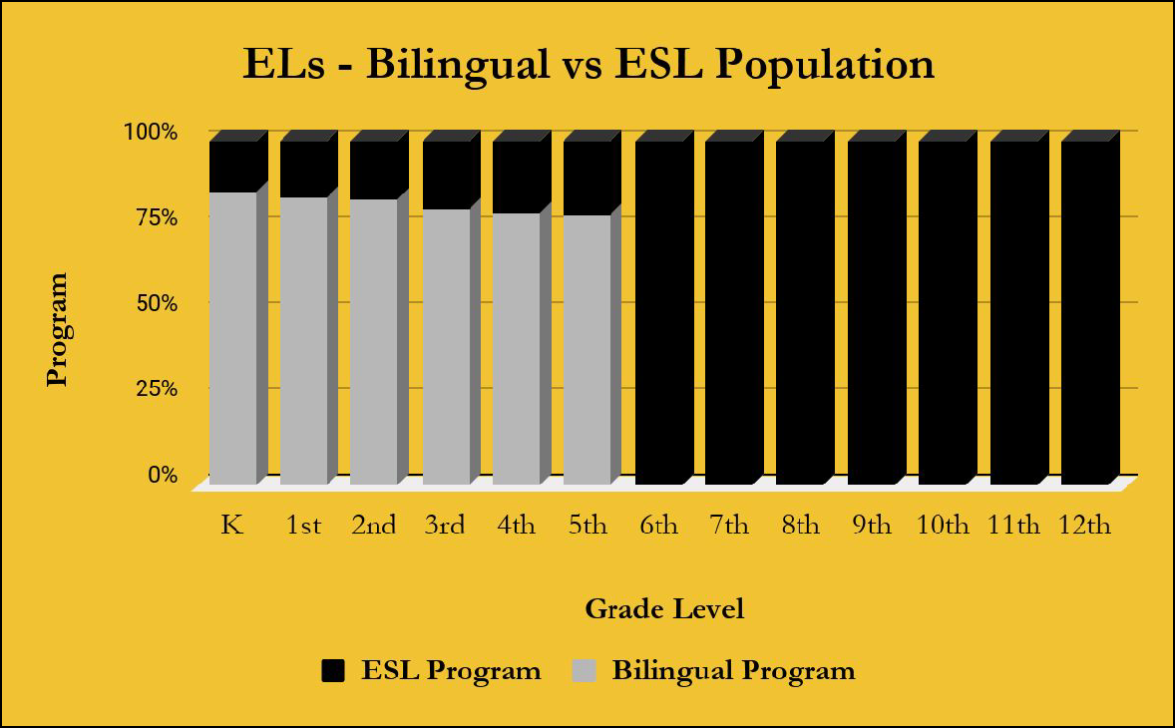

As a department, we provide several ongoing services to teachers and staff to build and support teaching capacity. Below is a list with a brief description of the opportunities offered:

  - Design and revise bilingual and ESL pieces to supplement the district’s adopted curriculum that perfectly align with designated standards. This duty constitutes the most important and extensive assignment for the department.

  - Create Spanish district assessments every six weeks to evaluate bilingual students’ performance. Results are posted on the district’s data system in order for the instructors to have access to them. The department analyzes the collected data and uses it to base the decision making process and conduct support action plans.

  - Purchase and distribute supplemental materials and resources to campuses and/or classrooms, including a large selection of Spanish books for individual classrooms’ and campus’ libraries.

  - Develop and present a variety of trainings focused on individual campus needs and data. Lead teachers from, both, bilingual and ESL areas collaboratively prepare and execute training pieces.

  - Provide stakeholders with information, updates, and trainings related with federal and state compliance and procedures.

  - Monitor implementation of content imparted during trainings and most effective practices in all bilingual and ESL settings.

  - Model lessons and activities to teachers of all grade-levels.

  - Support teachers and administrators during PLCs and individual meetings at all campuses.

  - Perform individual visits to all PK-12 bilingual and ESL teachers. Sheltered Instructional Strategies that have been effective in addressing the academic needs of ELs constitute one of the main topics of the visits. The components discussed include lesson preparation, building

background, comprehensive input, effective strategies, effective interaction, application process, lesson delivery, and review data/assessments. When teachers use the instructional strategies connected to each of these components, they are able to design and deliver lessons that address the academic and linguistic needs of their EL students.

  - Create and maintain different forms of communication to keep the school community informed about all pertinent topics.

  - Collaboratively work with all core content area departments to not only align instruction, but also discuss areas to improve as a district and explore new opportunities.

  - Support and monitor targeted campuses that have been identified in need. The department closely works with bilingual and ESL teachers at the campuses that are performing below desired standards. An identification process is developed using data collected from District Check-Points, STAAR, classroom observations, and campus administrators. Each lead teacher is in charge of mentoring and coaching the teachers at their designated grade levels, and work in conjunction with the rest of the department to guarantee appropriate vertical alignment. The process gives consistent support to the campuses as lead teachers provide resources, model lessons, and plan with the mentees building teacher capacity in, both, curriculum and instruction.

  - Team up with outsourcing organizations to provide professional learning opportunities to train teachers on knowledge and strategies to teach ELs as well as prepare them to take the ESL Certification Exam.

  - Assist campuses on the monitoring and improvement planning pieces for identified long term ELs. The application of an acceleration and testing instrument is monitored and analyzed by the department.

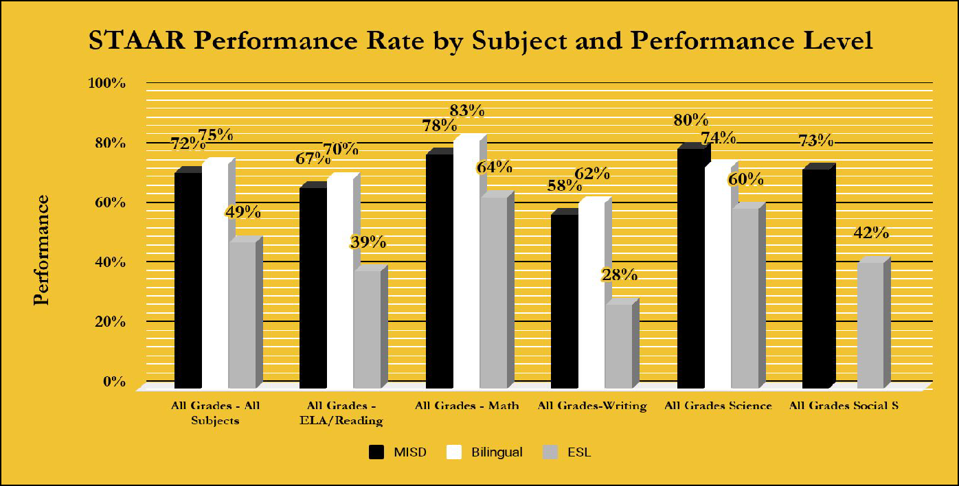
The following charts (FIG 5 A-D) show the 2018 STAAR Performance Rate by Subject and Performance Level of students enrolled in MISD Dual Language One Way and ESL Pull Out programs compared to all students in MISD. FIG 5 A indicates that bilingual students are performing more than three percentage points above the district in reading, writing, mathematics, and even in all grades and subject areas combined. 5th grade science is the only area where bilingual students performed below the district by six points. On the other hand, ESL students are achieving significantly lower levels compared to the district in all subject areas. The school district is moving forward to design a more robust ESL program where all ELA instructors are to provide ESL services in their own classrooms, instead of the current ESL pull out practice which is evidently not working effectively for this group of students.

FIG 5 A

FIG 5 B represents EL students in grades 3-8 who take a set of state assessments to evaluate their performance. The results include both Spanish and English test takers, when available. Mathematics and reading show performance of all grade levels (3-8) which differ from Science and writing that only represent 5th/7th grade, and 4th/7th grade performances respectively. The MISD bilingual group registered an increment of two or more percentage points in performance from 2016-17 to 2017-18 school year results in all subjects except for writing.

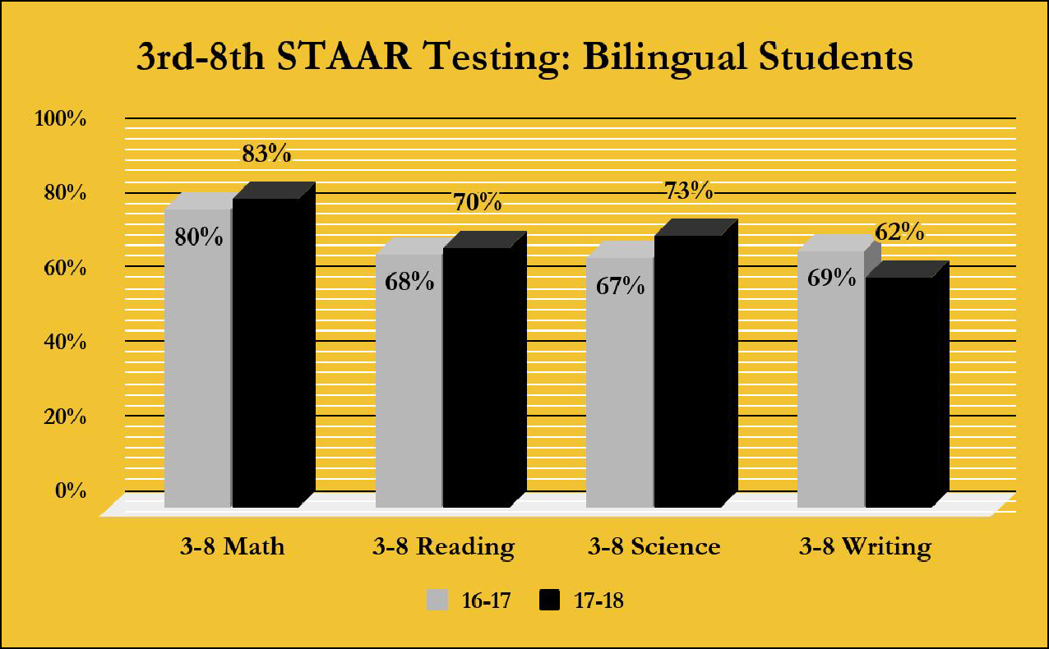
FIG 5 B

FIG 5 C represents ELs who took STAAR EOC assessments. As shown, MISD’s students improved their performance in Mathematics, Science, and ELA from 2016-17 to 2017-18 school year. Social Studies experienced a decrease of approximately four percent from the 2016-17 to 2017-18 school year.

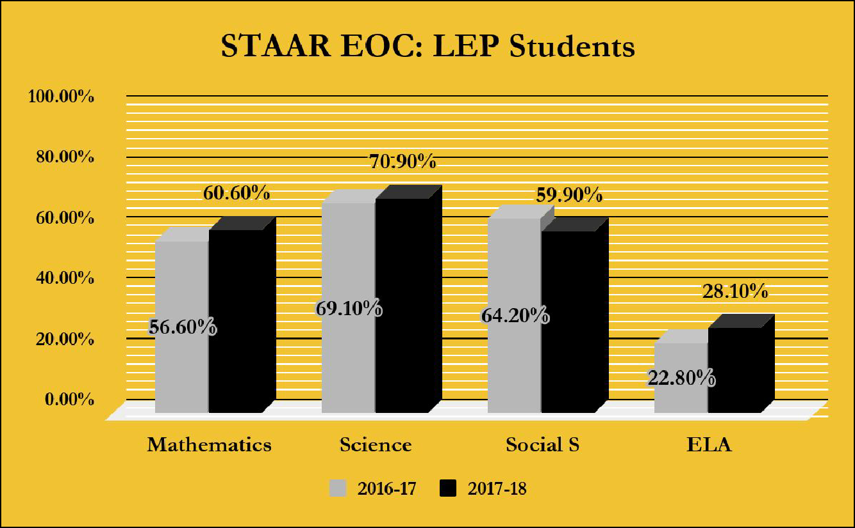
FIG 5 C

FIG 5 D represents collected data of the performance of all ESL students, in all subject areas, in all grade levels from 3rd-8th grade during the 2016-17 and 2017-18 school years. Mathematics, Science, and Social Studies presented a positive move from year 1 to year 2. On the contrary, ELA suffered a regression in the writing domain.

FIG 5 D
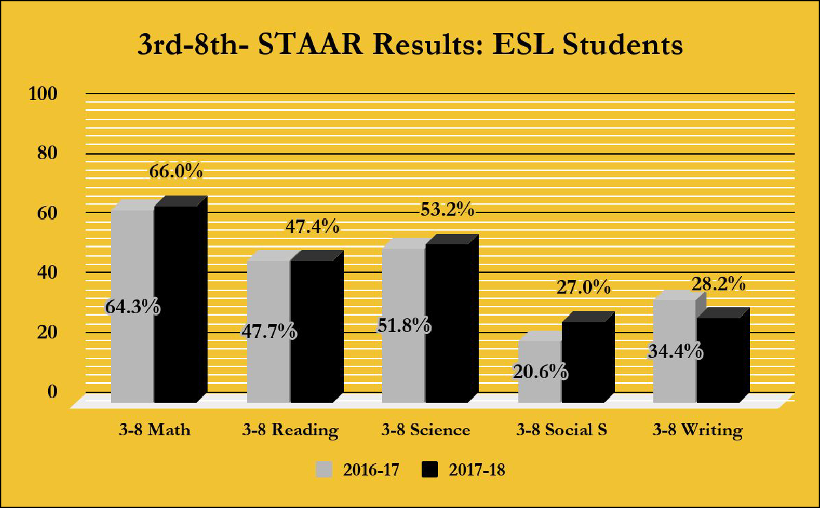

FIG 6 A-D represent the results from the TELPAS 2017 and 2018 assessments. The instrument measures students’ linguistic abilities and reports a district summary by levels. The data includes all ELs at all grade levels.

Listening and Speaking domains were measured differently in the 2017 and 2018 school years (FIG 6 A and 6 B). TEA designed a computer-based assessment for the 2018 administration, while in 2017 the students were holistically rated. A state-wide declining trend was demonstrated at the majority of the school districts in Texas due to the new component in the test.

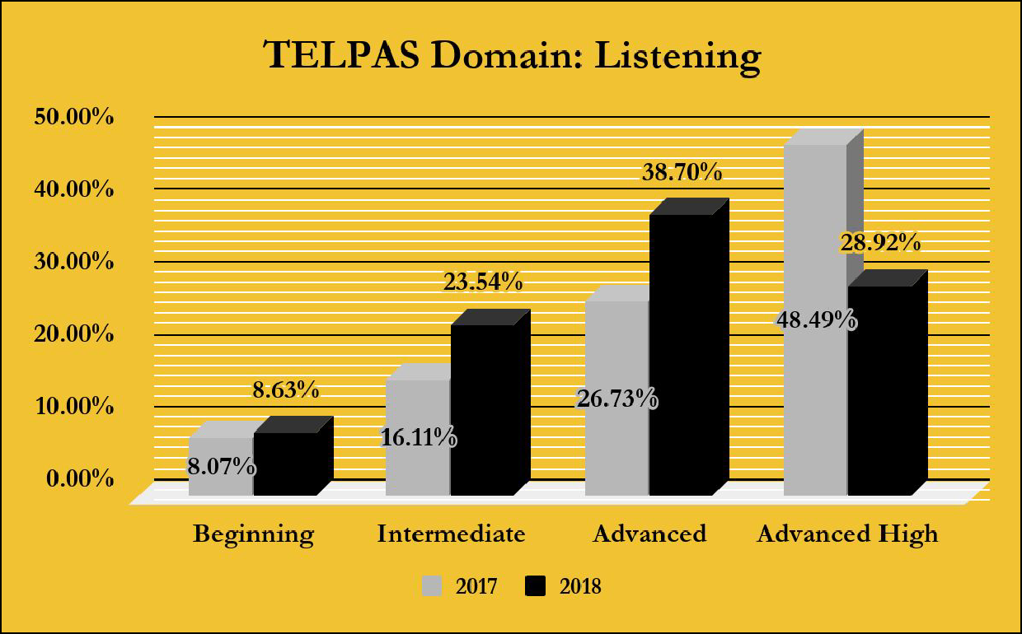
FIG 6 A

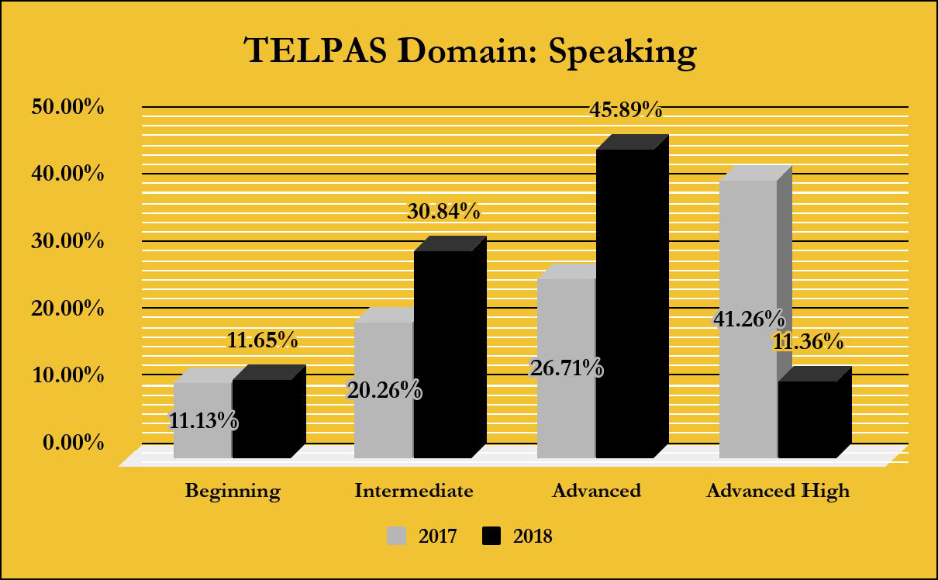
FIG 6 B

The results of the writing component of TELPAS 2017 and 2018 are displayed below in FIG 6 C. The assessments used in both years were holistically rated . Overall, the distribution of the number of students among the levels Beginning, Intermediate, Advanced, and Advanced High were distributed practically at the same proportions for the last two administrations.

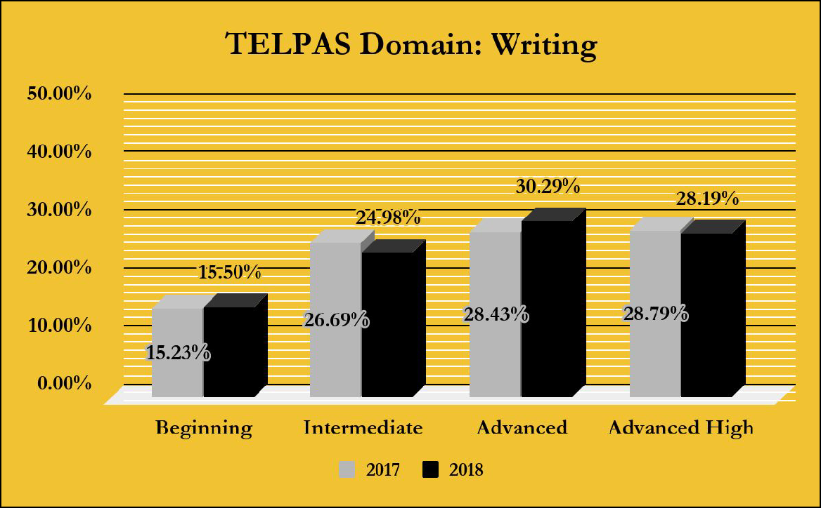
FIG 6 C

The following chart (FIG 6 D) compares 2017 vs 2018 MISD TELPAS reading scores. The district registered an increase in the number of students rated intermediate and advanced high in reading skills, and a decrease in the number of students rated beginning and advanced in the same skill.

FIG 6 D
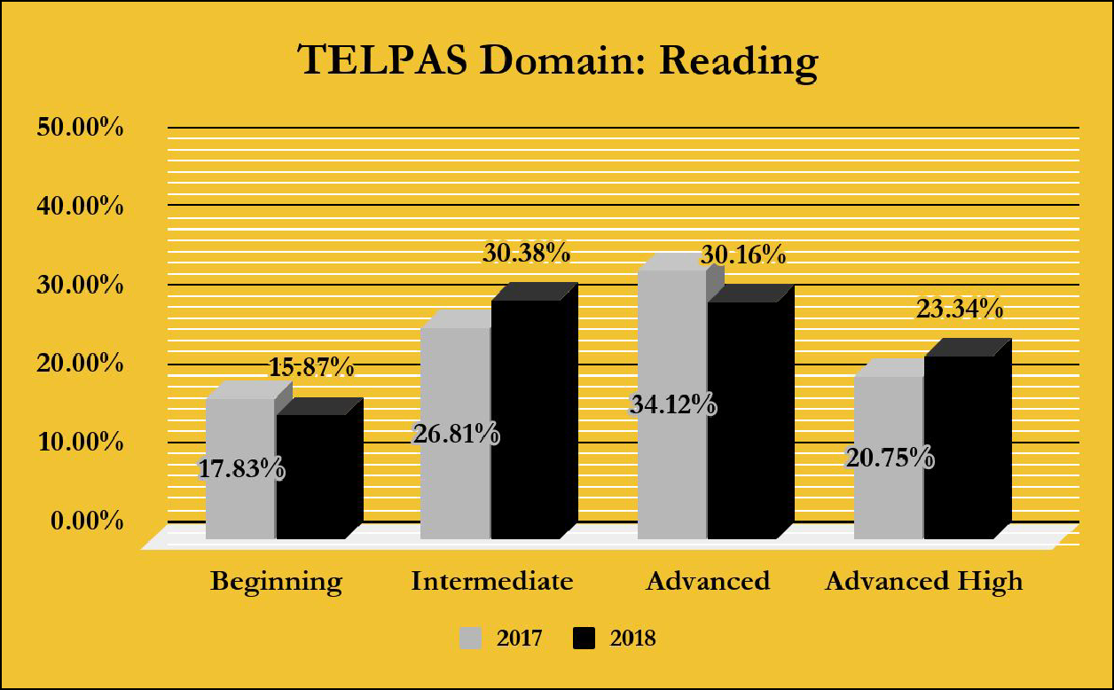

FIG 7 represents exit trends over a four-year period. For the 2017-2018 school year, the state of Texas redesigned the reclassification process, going away from holistic rating for the speaking and listening domains and implementing a new computerized component to measure the areas. Due to the difference in nature, lack of familiarity with the source, and the big shift it represented, a general decrease trend was registered all across the state. The number of students subject to reclassification this year significantly decreased from previous years.

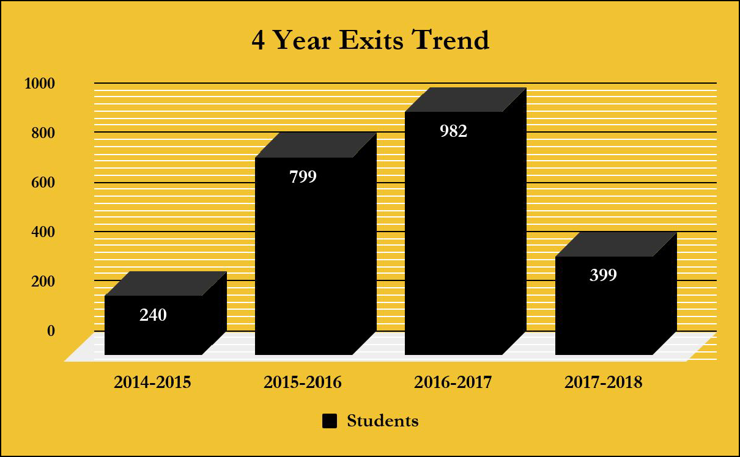
FIG 7

In addition to school year services, we provide a Summer School Program for English Learners who will be eligible for admission to kindergarten or 1st grade at the beginning of the next school year. Instruction focuses on language development, essential knowledge, and skills acquisition in accordance to the level of the student. Once the parent agrees to Summer school services, the student is able to attend classes with a student teacher ratio that does not exceed 18 to one. Summer school is approximately 4 weeks with 120 hours of instructional time. The chart below shows the breakdown of student participation over the last 5 years. FIG 8 shows history of a 5 year trend of program participation.

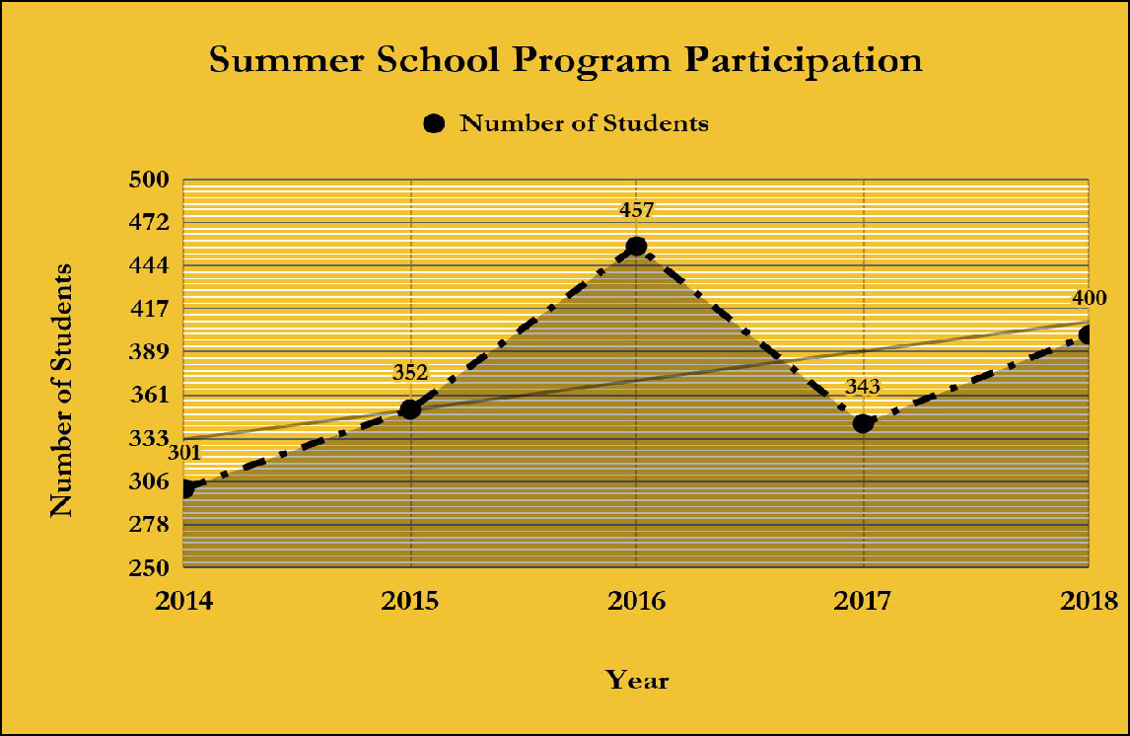
FIG 8

The students that participated in the 2018 Summer School Program were assessed in the areas of print conventions, and phonemic and phonological awareness at the beginning and end of the Program. Fig 9 reports the level of effectiveness reached after approximately one hundred and twenty minutes of instruction. All pre kindergarten, bilingual and ESL students increased their performance in more than twenty percentage points. A similar trend was registered by kindergarteners who attended the ESL classes advancing approximately fourteen percentage points as well. The kindergarteners who participated in the bilingual program also improved in one percentage point.

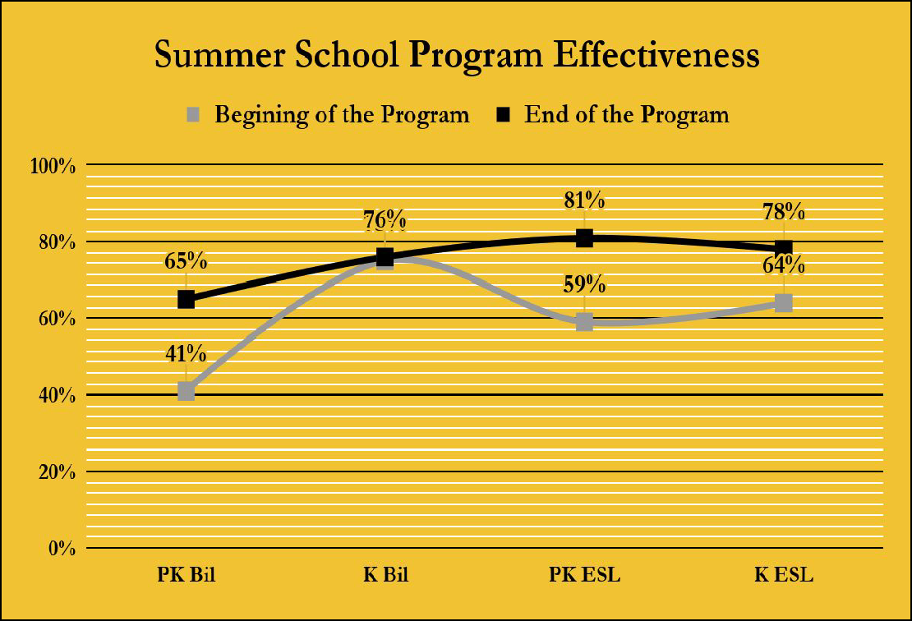
Fig 9

The MISD Bilingual and ESL Department designs and develops a variety of activities to promote parental, family, and community participation in language instruction educational programs of English Learners. The Parent ESL Program was implemented in 2006-2007 and has been in place for the last twelve academic years. We currently have three middle schools that sponsor the program: Berry Middle School, Vanston Middle School, and Wilkinson Middle School. The classes are offered weekly for beginner and intermediate English speakers and last one semester. Along with the classes and materials, we also provide a children’s program for parents to bring their youths while they are in class.

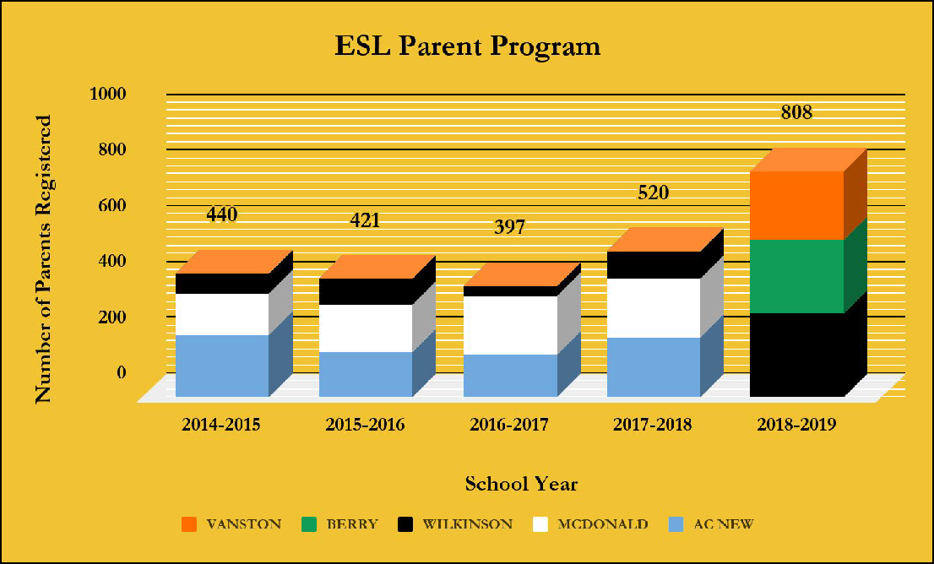
The program has impacted a total of 2,586 families over the course of 5 years. FIG 10 shows the participating campuses and the number of parents that participated in the program at each school.

FIG 10
YEAR | AC NEW | MCDONALD | WILKINSON | TOTAL
14-15 | 223 | 148 | 69 | 440
15-16 | 161 | 167 | 93 | 421
16-17 | 149 | 211 | 37 | 397
17-18 | 213 | 211 | 96 | 520
YEAR | BERRY | VANSTON | WILKINSON | TOTAL
18-19 | 261 | 248 | 299 | 808

The Latino Family Literacy Program is currently housed at three different campuses: Gray Elementary, Hanby Elementary, and Tosch Elementary. A total of thirty two families have been impacted by the program this year. The project focuses on grade levels PK, K, 1st and 2nd. The classes meet for a period of ten weeks per semester. Each family takes a different library book home, in English and Spanish, every week to encourage literacy/reading after school hours. The teachers guide the parents on reading skills and provide suggestions on how to navigate the book with their child. The goal is to provide parents with resources and skills to create new learning experiences and develop daily reading routines. The specific number of families trained at each participating campus is shown on chart FIG 11.

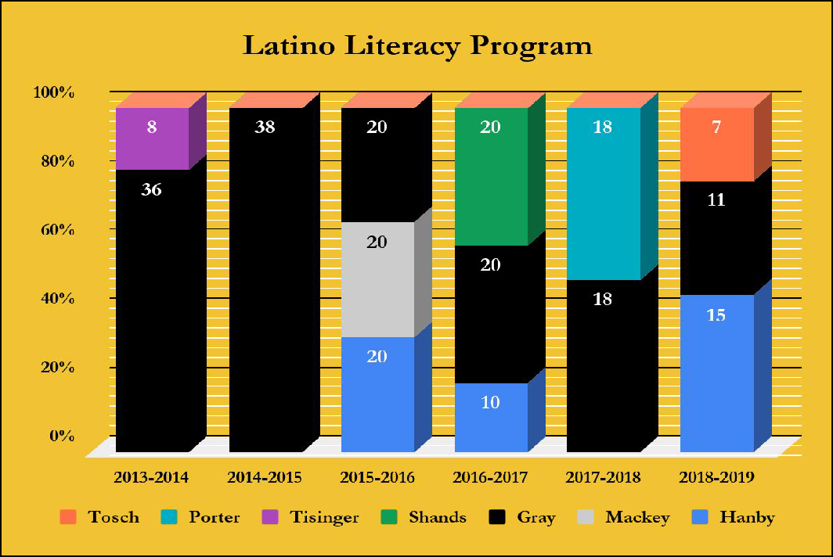
FIG 11

The Concilio Program constitutes one of the district efforts to enhance relations with the community and at the same time contribute to students’ academic and social well being. The program was hosted this year at Hanby Elementary, Floyd Elementary, and Henrie Elementary. The following graph (FIG 12) represents the 156 families that participated in the program divided by campus.

FIG 12
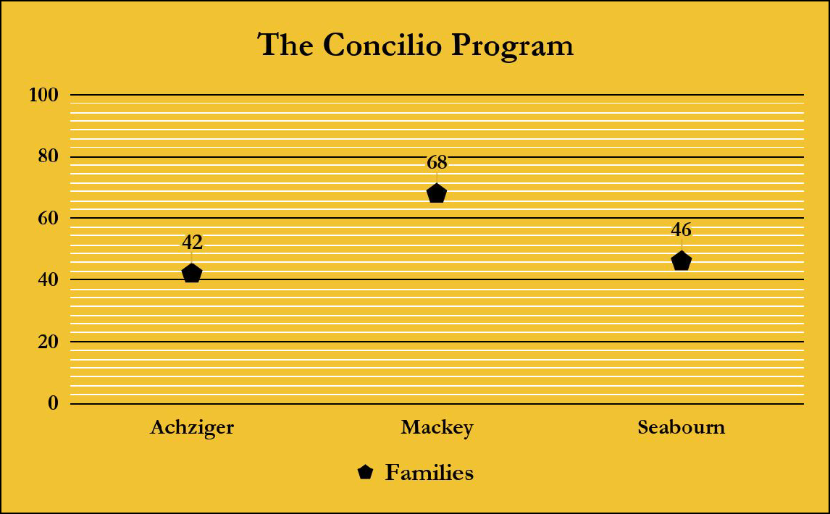

Another initiative that we have developed to support the EL population is the Newcomer Program. The main purpose of the program is to meet the variety of socio-emotional and academic needs of ELs who recently arrived to the country. Newcomer students go through a transition period not only to adjust to the education system, but also to the new country’s social environment. These students face many challenges in vast areas; their language limitations, gaps in age-appropriate education, lack of experience with United States schools and community systems, their own personal or family matter, and the development of low self-esteem make it very hard for the students to adapt to their new setting. The Newcomer program offers the students individual attention and support. As shown on FIG 13 more than a hundred and fifty students are currently being served through this program.

FIG 13
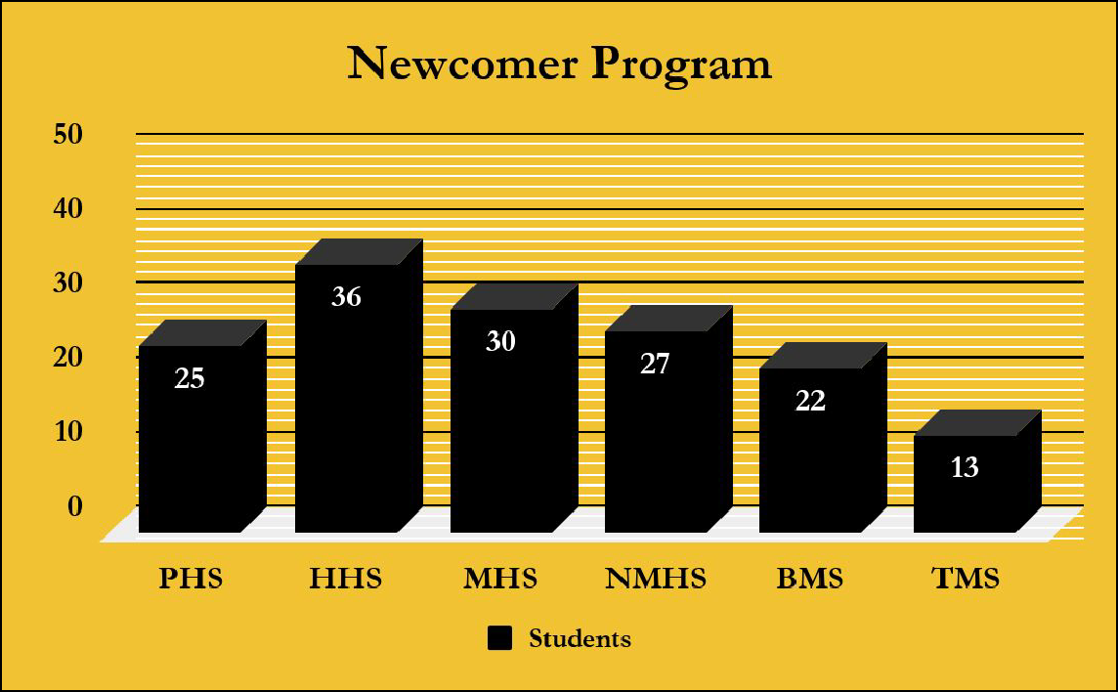

Bilingual and ESL programs help ELs develop language proficiency and succeed academically. The chart below shows the number of ELs in Pre-K through grade 12. The number is significantly lower in the upper grades which indicates that a large number of ELs meet the exit criteria. The chart presented on FIG 14 constitutes a very good visual representation of the programs’ effectiveness.

FIG 14
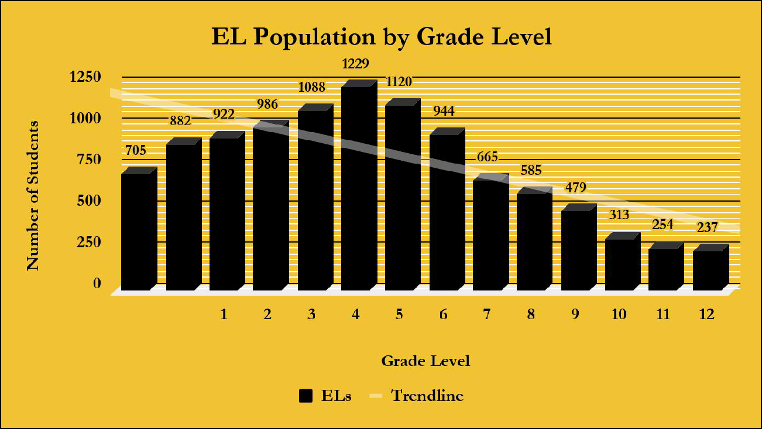

Resources

Mesquite ISD receives federal funding based on the number of LEP (Limited English Proficient) students enrolled in the district. The money is managed through a Shared Service agreement with Region 10 Service Center. The district received $904,565.00 in this year’s allotment. About 60% of the total amount is spent on salaries, extra duty pay for bilingual and ESL lead teachers who give support to bilingual/ESL classroom teachers and campuses, and all parent, family, and community outreach payroll costs. $262,565.00 or approximately 29% of the allocated money, is used to disburse any additional needs in the area of supplemental materials. Another $50,000.00 is for contracts with outside consultants who provide professional development that adds value to the instructional process. Capital outlay represents approximately 4% of the total amount of the Title III – LEP funds. Visual representation on FIG 15.

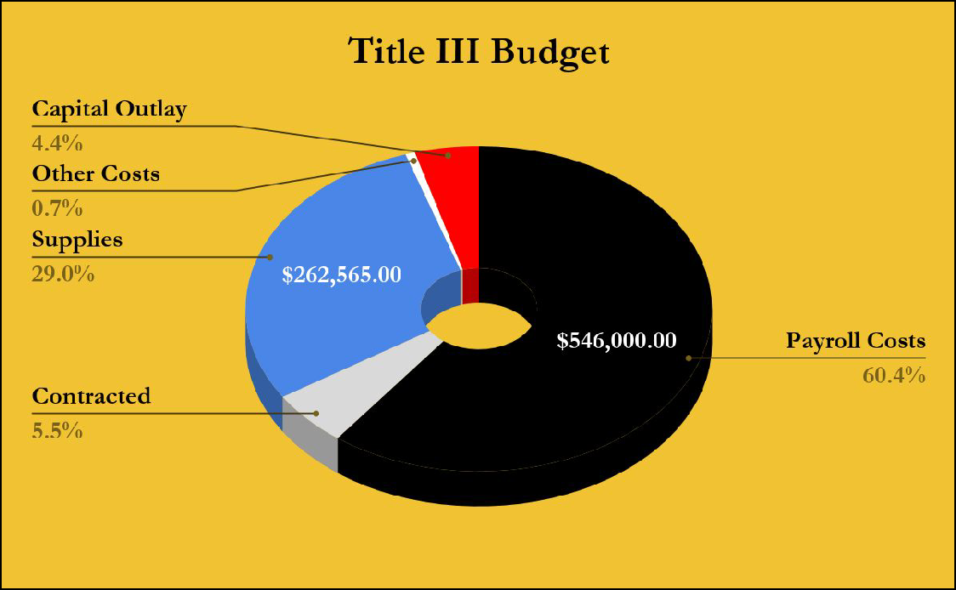
FIG 15

Resources

Part of the local budget assigned to MISD Bilingual/ESL Department is from the state in the form of ADA (Average Daily Attendance) and it is equivalent to $134,400.00. As shown on FIG 16, more than 90% of the total amount is assigned to cover extra duty pay for both, professional and support staff during the Summer School Program. $6,500.00 are assigned to cover general and computer supplies for the testing center (BEES). An amount of $1,400.00 is assigned to cover miscellaneous operating expenses, and another $500.00 to cover the cost of professional subs.

FIG 16
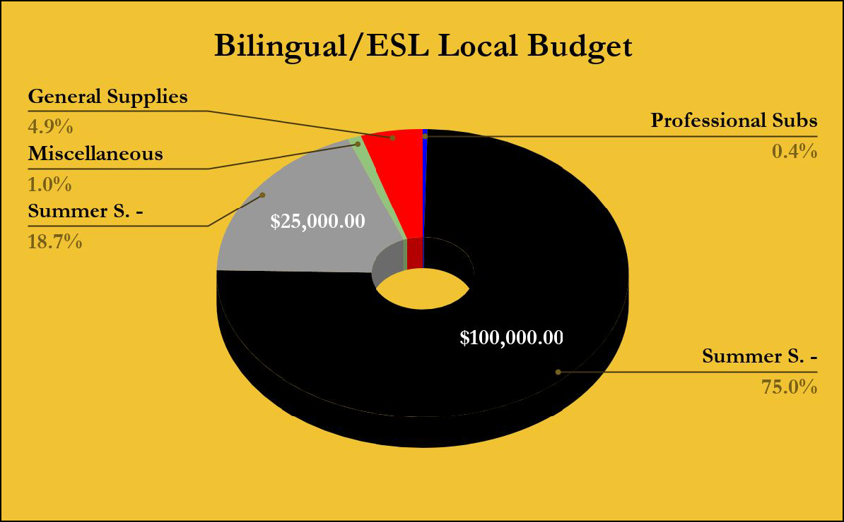

Celebrations:

  - Registered an increase of approximately two percentage points on the performance of all bilingual students from STAAR 2017 to STAAR 2018 in mathematics, reading and science.

  - Improved performance on STAAR EOC from 2017 to 2018 administration in the areas of mathematics, science, and ELA.

  - Enhanced monitor and support of students’ linguistic abilities at all campuses. As a result, the percentage of students reported as beginners in the TELPAS reading domain based on the PBMAS report decreased from 6.88% to 5.5%.

  - Enhanced the level of participation of parents in the ESL Parent Program in 55% from 2017-18 to 2018-19 school year.

  - Increased in 17% the number of PK-K students who participated in the Summer School Program compared with the previous year.

  - Developed and presented a variety of training sessions focussed on the planning and delivery of lessons that address the academic and linguistic needs of EL students. Monitored the implementation piece and provided coaching sessions for the teachers during PLCs and/or individual meetings at every campus.

  - Developed individual growth plans for specific schools. Target plans and performance progress reports are some of the tools that the department uses to provide support to all bilingual and ESL teachers that are performing below desired standards. Some specific campuses/teachers were identified at the end of the 2017-2018 school year by reviewing data collected from District Check-Points, state mandated assessments, classroom observations, and campus administrators. Each lead teacher is in charge of mentoring and coaching the teachers at their designated grade level, and work in conjunction with the rest of the department to guarantee appropriate vertical alignment. The process gives consistent support to the campuses as lead teachers provide resources, model lessons, and plan with the mentees building teacher capacity in, both, curriculum and instruction.

  - Provided training to teachers and administrators on compliance pieces stipulated by federal and state regulations.

  - Developed, translated, and recorded all bilingual district summative assessments in the areas of reading, writing, and social studies. Science and Mathematics assessments were only subject of translation.

  - Teamed with Texas A&M University to provide staff with opportunities to get prepared for the ESL Certification Exam, transition to a sheltered instruction environment, and improve the instructional process by learning new strategies.

  - Organized, inventoried, and distributed new supplemental materials from the district’s warehouse to the campuses.

  - Created a Bilingual/ESL Department Newsletter to communicate with campuses and administration important events, updates, and general information on a monthly basis.
  - Created a Bilingual/ESL Parent Newsletter to provide families with literacy strategies to support students at home.
  - Provided HS students and EL families with an informative session to inform about college readiness and programs available in the district and provided parents of ELs with extra support throughout the process .
  - Provided MISD’s parents of ELs with training on computer skills and basic Microsoft use, personal finances management, and workforce preparation.
  - Provided MISD’s parents of ELs with training on literacy skills to support students at home.
  - Equipped all new bilingual units with supplemental classroom libraries in Spanish to support ELs academic development.
  - Supplied new bilingual campuses: Lawrence, Rutherford, Cannaday, and Black Elementary with Spanish Book Rooms for guided reading.
  - Provided all middle schools with newcomer’s libraries to support these students throughout the process.

Executive Summary

Challenges:

  - Fidelity in the implementation of our fifty-fifty bilingual model. With 24 bilingual campuses and 308 bilingual units, it is a challenge for the bilingual department to monitor and make certain that the fifty-fifty model is being implemented accurately. Only four bilingual lead teachers oversee these three hundred teachers and their classrooms.

  - Compliance of all ELA teachers of ESL certification district policy.

  - Actual implementation of sheltered instruction in all ELA classrooms that are now ESL certified.

  - Schedule ESL support visits at the secondary level due to our CCSI (Core Content Sheltered Instruction) tracking system in core content areas.

  - Address the needs of LTELs (Long Term English Learners) who are also being served in other programs. While there has been some progress in this area, it is very difficult to create a sense of urgency at the campus level.

  - Improvement of the ESL Parent Program curriculum and resources.

  - Development of independent required parent, family, and community outreach initiatives specifically designed for EL families without overlapping each other’s areas or audiences.

Vision to the Future

The ultimate goal of the Bilingual/ESL Department is to ensure the highest level of academic success for every English Learner in MISD. Our vision includes employing excellent teachers, who provide a dynamic school experience, that enable ELs to learn English quickly while excelling academically. Our schools will become family hubs where parents can gain the skills they need to help their children succeed in, both, academic and social settings. Students will be creative problem solvers who use their diverse points of view to collaborate with others and explore new areas of interest.

To accomplish this vision, we will:

    - Continue to explore all avenues to hire and retain qualified bilingual teachers as well as ESL certified teachers.
    - Implement a plan to expand our bilingual program to all campuses in order for the families to attend their home school.
    - Extend our efforts to develop or partner with outreach groups to continue engaging parent, family, and community participation at all MISD schools.
    - Team with campuses’ administration to continue efforts to support Long Term ELs.
    - Continue developing the ESL model from the pull-out to the content-based setting.
    - Improve all areas of communication among campuses, district, and community in general.
    - Substantially increase participation in all available programs, such as ESL Parent Program, PK-K Bilingual and ESL Summer School Program, Newcomer Program, etc.
    - Enhance diversity culture at all campuses by developing community engaging activities such as multicultural fairs.
    - Develop/adopt a more up to date curriculum and materials for the ESL Parent Program.

