Special Populations
December 2018

Special Populations December 2018



• At-Risk Program………………………………………………………………………………………………………………….Page 3

• Dyslexia Department…………………………………………………………………………………………………………..Page 23

• Section 504………………………………………………………………………………………………………………………….Page 36

• Special Education…………………………………………………………………………………………………………………Page 51

At-Risk December 2018



The Mesquite ISD At-Risk program is a key component to the success of students identified as at-risk in the district. Through a wide variety of programs and services that are supplemental to the general education program, at-risk students are better able to navigate school and experience success both academically and socially. The program expressly functions to meet the ever-changing needs of MISD students through a provision of support services that work to mitigate at-risk factors for students through intervention, prevention, and educational supports, which promote academic success.

Our mission is to prepare students academically for post-secondary success through building relationships and utilizing research- based strategies to develop and implement innovative approaches to working with at-risk students.
Our goals are to increase academic achievement and decrease the dropout rate for all At-Risk students in Mesquite ISD.

The program focuses on areas identified as critical to at-risk student support and overall academic success. Developing students through ongoing support in the areas of dropout prevention, classroom teacher support in instructional and behavioral management strategies, Response to Intervention (RtI), student transition programs, mentor groups, peer tutoring, and STAAR accelerated instruction/tutoring nurture the academic success of At-Risk students and present opportunities to develop relationships within the school community. The At-Risk Program and staff members have helped thousands of students achieve academic success.



At-Risk staff promote school engagement, cultivate academic success, and support progress toward the goal of graduating high school.

Program achievements include:
- Implementation of Acceler8 – program for the advancement of 8th grade students who are over age
- Implementation of Bridge – program to support student success in school through intensive social skills training
- Services for Pregnant/Parenting students and Homeless students continue to be a vital component to success in school and in closing the achievement gap between At-Risk and not At-Risk students
- Summer Programs served 7,000 MISD students
- Continued improvements in the identification process of At-Risk students enable campuses to spend more time in direct student service
- STAAR Reading Grades 3 – 8 scores are notable, with many grades above 50% in Approaches performance area
- DAEP numbers continue to decrease

Current challenges include:
- Need for additional specialized at-risk staff at elementary level, so as to more intensively serve at-risk students
- Further development of community support systems and resources for at-risk students and families at all levels
- Continued improvement and evaluation of district-wide Response to Intervention (RtI) process
- Improved systems for logistical aspects of summer programming, such as student scheduling and notification
- Improve the impact efficiency of transition programs for students from middle to high school, and implement transition programming for students from elementary to middle school

At-Risk December 2018



The purpose of MISD’s At-Risk Program is to increase academic achievement on state assessments identified in Subchapter B, Chapter 39 of the Texas Education Code, and reduce the dropout rate of students identified as At-Risk under Texas Education Code
29.081. Campus At-Risk personnel work directly with students to assess needs, discuss progress and promote access to additional services, as well as collaborate with campus stakeholders to support student success.

✓Graduation Rates
INCREASE

✓Student achievement
on STAAR Assessments

✓Academic Success
✓Dropout Rate

✓Achievement disparities with not at- risk students

✓Barriers to academic success and high school graduation
DECREASE

Students who meet at least one criterion outlined in Texas Education Code 29.081 are identified as At-Risk of dropping out of school and are eligible to receive services by the At-Risk program. Criteria are as follows: Each student who is under 26 years of age and who:
- Is in prekindergarten, kindergarten, or grade 1, 2, or 3 and did not perform satisfactorily on a readiness test or assessment instrument administered during the current year;

- Is in grade 7, 8, 9, 10, 11, or 12 and did not maintain an average equivalent to 70 on a scale of 100 in two or more subjects in the foundation curriculum during a semester in the preceding or current school year or is not maintaining such an average in two or more subjects in the foundation curriculum in the current semester;

- Was not advanced from one grade level to the next for one or more school years;

- Did not perform satisfactorily on an assessment instrument administered to the student under Subchapter B, Chapter 39, and who has not in the previous or current year subsequently performed on that instrument or another appropriate instrument at a level equal to at least 110 percent of the level of satisfactory performance on that instrument;

- Is pregnant or is a parent;

- Has been placed in an alternative education program in accordance with Section 37.006 during the preceding or current school year;

- Has been expelled in accordance with Section 37.007 during the preceding or current school year;

- Is currently on parole, probation, deferred prosecution, or other conditional release;

- Was previously reported through the Public Education Information Management System (PEIMS) to have dropped out of school;

- Is a student of limited English proficiency;

- Is in the custody or care of the Department of Protective and Regulatory Services or has, during the current school year, been referred to the department by a school official, officer of the juvenile court, or law enforcement official;

- Is homeless;

- Resided in the preceding school year or resides in the current school year in a residential placement facility in the district, including detention facility, substance abuse treatment facility, emergency shelter, psychiatric hospital, halfway house, or foster group home.

- Additional local criteria adopted by MISD: Student has been identified as dyslexic.

District and campus level staff review quantitative data, such as enrollment and testing scores, as well as qualitative interview data from students, teachers, and other school staff each year to make eligibility determinations. Data is collected at various intervals throughout the school year to ensure that students who become eligible under the 13 State and 1 local criterion are identified and provided opportunity to participate in appropriate programs and services through the At-Risk program.

The At-Risk program serves 23,339 identified At-Risk students on all campuses. Additionally, eight elementary schools, five middle schools, and each high school have At-Risk Coordinators specifically tasked with managing programming and services for At-Risk students on their campus.

At-Risk Student Enrollment
17,683
Not At-Risk Students 43%
23,339
At-Risk Students 57%
Source: Texas Education Agency, TSDS PEIMS Disaggregation of PEIMS Student Data, 2017-2018

Services provided to At-Risk students are supplemental to the general education program provided to all students. The At-Risk Program supports student academic achievement and progress toward graduation by implementing targeted and individualized interventions to eligible students. Services include, but are not limited to the following:

Services for At-Risk Students
Summer transition programs | Intensive remediation for STAAR | Summer Academic programs
Counseling sessions | Credit Recovery | Class-size reduction measures
Teen Parenting sessions | Extended learning opportunities – before, during, or after school tutoring | Supplemental basic course extensions (Algebra labs, extended writing labs, content mastery- like services)
Mentoring Programs | Intensive, supplemental reading programs | SAT/ACT preparations sessions for identified students
Individualized instruction | Computer-based learning | Intensive social-emotional and behavioral support program
Academic advancement programs for secondary students | Peer, teacher, community-member mentoring sessions | Support services by at-risk staff

At-Risk December 2018

At-Risk staff have helped thousands of students achieve academic success and graduate high school. The following are data elements, which align with our programmatic goals to support achievement of students identified as at-risk under TEC 29.081, and present our significant indicators of program effectiveness.

Graduation Rate

Dropout Rates

Response to Intervention (RtI)
At-Risk Coordinator Impact Reports

State Assessment Performance

Homeless Student Services

Pregnancy Related Services
DAEP
Placements & Transitions

At-Risk Program


Graduation and Dropout Rates
Interventions and services provided through the At-Risk Program have decreased disparities between At-Risk and not At-Risk students, as evidenced by decreasing the dropout rates and increasing graduation rates for At-Risk students.

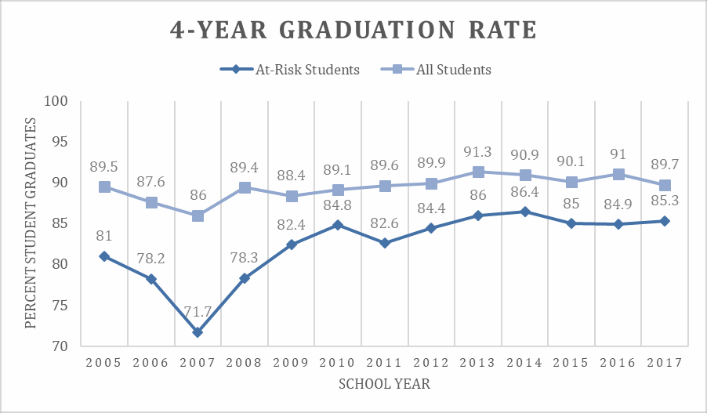
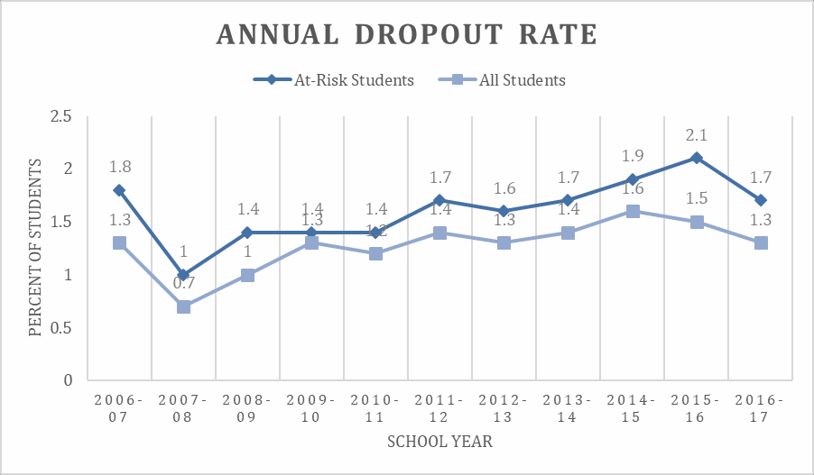

Source: Texas Education Agency, Longitudinal Completion Rates, Grades 9-12, 2005 – 2016; Texas Education Agency, Longitudinal Completion Rates, Grades 9-12, by Instructional Program and Special Populations, 2005 – 2016; Texas Education Agency, Annual Dropout Rates, by Grade Span 2006 – 2016; Texas Education Agency, Annual Dropout Rates, by Instructional Program, Special Population, and Grade Span, 2006 - 2016

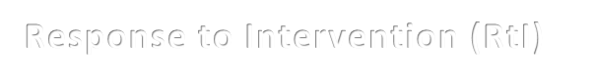
Response to Intervention (RtI)
The district’s Response to Intervention (RtI) process supports the success of At-Risk students and their teachers on every campus by providing data-driven intervention plans which address individual student needs. Teams meet regularly to monitor student progress and adjust support services and intervention plans as needed. Over 250 Problem Solving Team (PST) members attend RtI professional development each fall semester. Our strong RtI process insures that At-Risk staff members know each student who is struggling and has a specific plan in place to meet the student’s needs, which creates an environment for that student to be successful.
PST Meetings
6000

5000

4000

3000

2000

1000

0
Initial Meetings

Elementary
Follow-up Meetings
Middle
High
Number of Meetings
5328

 | 3034
 |  |  |  |  | 1293
 |  | 288 | 473 |  | 1293
 |  | 288 | 473 | 365

Impact Reports
At-Risk teams highlighted their positive impact on at-risk students through Impact Reports during the 2017 -2018 school year. Teams discussed accomplishments, challenges, and plans for continued growth for campus programs, and were demonstrated direct connections between the work they do and the impact is has on students. The following are some excerpts from campus Impact Reports.

Secondary
Intensive-Targeted STAAR Pullouts – collaboration with instructional specialists to provide added support for Math and Science STAAR exams; student saw significant gains and reported increased confidence

Escalera – program to prepare students interested in STEM-related fields and professions for life after high school and college

Stallion Swap – initiative which allows students to correct non-flagrant dress code issues by exchanging an item for the dress code item; students who walk to school in the rain or damage their clothes while at school are also served

Elementary
PST Collaboration with Behavior Specialist – process to by which Behavior Specialists conduct observations and provide feedback with targeted interventions for cases in which a student’s behavior did not improve with initial intervention

Positive Support Parent Conference – parents are contacted with positive information about their child and meet with school personnel who discuss support opportunities and prevention strategies



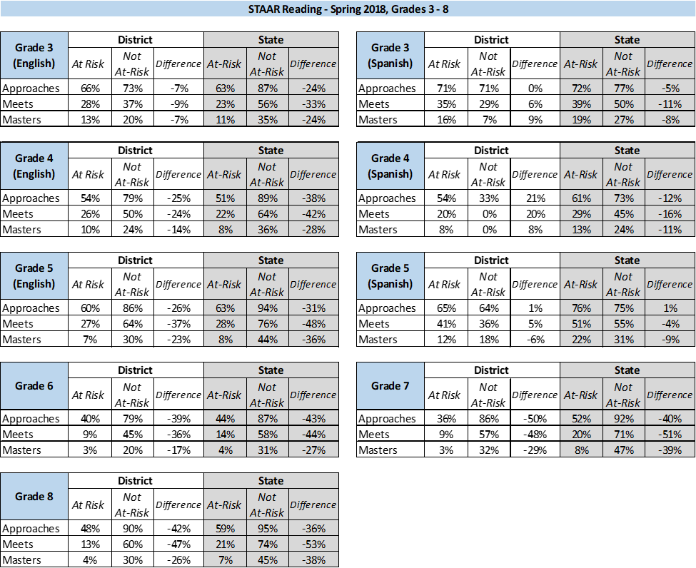
State Assessment Performance

  - STAAR Reading Grades 3 – 8 scores are notable, with many grades above 50% in Approaches performance area
  - Not At-Risk students generally performed better than At-Risk students in STAAR 3 – 8 subject tests

Source: Texas Education Agency, State Assessment of Academic Readiness (STAAR) Summary Reports, Grades 3 – 8, 2017 - 2018

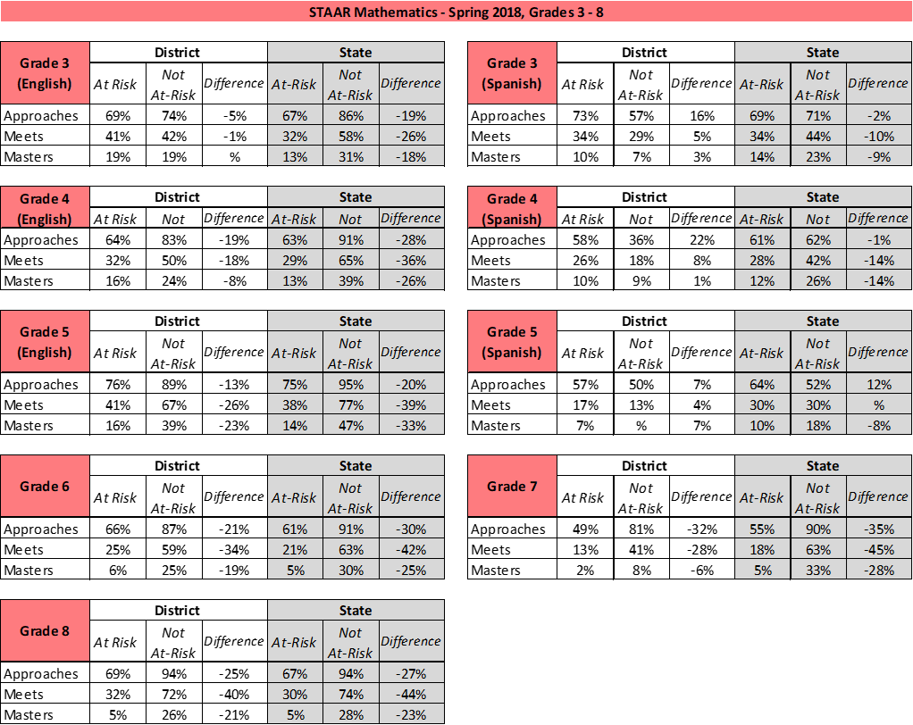

State Assessment Performance
  - District At-Risk students in grades 3 – 8 show significant performance on STAAR Mathematics, scoring above 60% in Approaches performance area for most grade levels
  - At-Risk students matched or exceeded state performance in Approaches performance category in grades 3, 4, 5, 6, and 8, as well as in
grade 3 Spanish

Source: Texas Education Agency, State Assessment of Academic Readiness (STAAR) Summary Reports, Grades 3 – 8, 2017 - 2018

State Assessment Performance

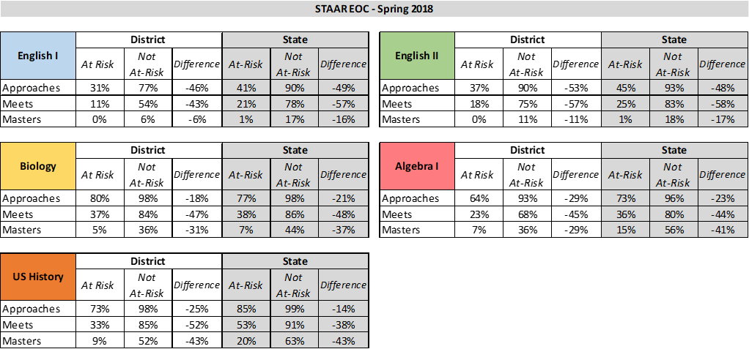
- At-Risk students in MISD are exceeding the state in Approaches performance category in Biology
- Over 70% of At-Risk students meet Approaches performance in US History
- Over 60% of At-Risk students meet Approaches performance in Algebra I

Source: Texas Education Agency, State Assessment of Academic Readiness (STAAR) Summary Reports, English I, English II, Algebra I, Biology, US History, 2017 - 2018


Homeless Student Services
Data shows that the number of students identified as homeless under NCLB, Title X, Part C, Section 725(2) has increased over the last four school years and is beginning to show evidence of stabilization. At-Risk staff and other school community members help to identify, monitor, and provide various levels of support for students, including school supplies, backpacks, clothing, transportation, food for meals at home, and other family assistance.
Students Identified as Homeless
928
913
879
667
515
475
319
379
434
2009-2010
2010-2011
2011-2012
2012-2013
2013-2014
School Year
2014-2015
2015-2016
2016-2017
2017-2018
Number of Students

Source: MISD Homeless Student Database, 2009 - 2017

Mesquite ISD served 58 students through the Pregnancy Related Services (PRS) program during the 2017-2018 school year. Eligible students receive supports through Compensatory Education Homebound Instruction (CEHI), as well as other At-Risk Program services upon return to campus. Supports through the PRS program allow students to continue their education in a way that offers structure and flexibility to assist pregnant or parenting students in overcoming barriers to academic success and timely graduation.
Pregnancy Related Services
Source: MISD PRS Student Database, 2009 - 2017

ReadPlayTalk information

CEHI

Parenting Education

Child Care Financial Assistance

Health Support Services

Extended Learning Opportunites

Groups & Counseling Services

Flexible scheduling
Pregnancy Related Services


DAEP Placements and Transitions
Number of Students
The number of students assigned to the DAEP has decreased over the last five years and is beginning to stabilize. Students assigned to the Learning Center for any period are identified as At-Risk. These students receive support from At-Risk staff members to re- engage them in the home school community, and identify additional areas of need in behavior and/or academics.
District DAEP Placements
1438
1435
1194
898
880
935
909
641
669
2009-2010
2010-2011
2011-2012
2012-2013
2013-2014
School Year
2014-2015
2015-2016
2016-2017
2017-2018


LEP Student Services
6824
6936
7072
7638
Students identified as Limited English Proficient (LEP), a steadily growing population in the district, qualify for supplemental services and programs through the At-Risk Program. Students may receive the benefits of the ESL or Bilingual Education program and also qualify for services, such as, basic course extensions (i.e. Algebra labs, extended writing labs), intensive supplemental reading programs and extended learning opportunities (i.e. before, during, or after school tutoring).
8979
LEP Students

9219
9769
10037
8260

2009-2010
2010-2011
2011-2012
2012-2013
2013-2014
School Years
2014-2015
2015-2016
2016-2017
2017-2018

Sources: Texas Education Agency TSDS PEIMS Disaggregation of PEIMS Student Data 2017-2018; PEIMS Edit+ Preliminary Report, 2015-2016; Texas Education Agency, PEIMS Edit+ Reports, 2014-2015; Texas Education Agency, Texas Academic Performance Report (TAPR), 2012 – 2017; Texas Education Agency, Academic Excellence Indicator System (AEIS) Reports, 2009 - 2011
Number of Students

At-Risk December 2018



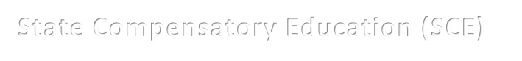State Compensatory Education funds are supplemental to the regular education program for students identified as being at risk of dropping out of school to increase academic achievement on state assessments and reduce the dropout rate.
State Compensatory Education (SCE)

2017-2018
Total cost (salaries and supplies) for the Learning Center | $2,717,945.94
Total cost (salaries and supplies) for the Mesquite Academy | $1,776,683.11
Salaries for all other personnel (not at the Academy or Learning Center) | $12,931,485.68
Supplies for all other At-Risk programs (other than the Academy or Learning Center) | $1,148,617.00
Miscellaneous Contracted Services | $1,053,945.68

TOTAL | $19,628,677.41

At-Risk December 2018



The At-Risk Program looks to the future and utilizes the evaluative process to facilitate continued program growth and efficiency, with the objective of delivering enhanced and effective programs and services for all of MISD’s At-Risk students. Developing intentional, targeted, and innovative approaches to support At-Risk students is vital because it empowers each of them to forge a path for academic success.

Our vision for the future includes:
Streamline and strengthen the RtI process to ensure students receive academic and behavioral support that is impactful. Transition to electronic forms and improve ease of access to intervention plans for implementation by teachers.
Develop a transition program for At-Risk students matriculating from elementary to middle school, and strengthen the transition plan for middle school to high school.
Continued strengthening of district framework for the At-Risk Program, which includes program standards, best practices and role clarity to increase program effectiveness and greater outcomes for At-Risk students.
Collaborate with families and community members to develop innovative strategies to ensure that all students are reading on-grade level by the end of every grade.

Dyslexia Department December 2018

“Reading is the fundamental skill upon which all formal education depends. Research now shows that a child who doesn’t learn the reading basics early is unlikely to learn them at all. Any child who doesn’t learn to read early and well will not easily master other skills and knowledge and is unlikely to ever flourish in school or life.” – Louisa Moats, 1999
Research from the National Institutes of Health, as well as, Yale University shows that up to 1 in 5 people, or 15-20% of the population, struggle with reading despite having average to superior intelligence. These students continue to struggle with reading, despite appropriate or intensified instruction. These difficulties are typically a result of a deficit in the phonological component of language. This type of specific learning disability is identified as dyslexia. The Dyslexia Handbook, Revised 2014, is the latest in a series of handbooks issued by TEA to help guide school districts in how to appropriately identify and serve these students.
Mesquite ISD has a long history of supporting students who are dyslexic and offering the appropriate interventions necessary to help these students see success in reading and spelling. The dyslexia department follows the guidelines in the TEA Dyslexia Handbook regarding the procedures for appropriate assessment of dyslexia and the provision of a specialized, research and evidence-based instructional program.
The intervention program used by Mesquite ISD is called Multisensory Teaching Approach, or MTA. This program was designed by an Academic Language Therapist specifically for dyslexics, and meets all the criteria established by the state handbook for an effective dyslexia intervention program. It is not a general reading curriculum; rather, it is a sequential, cumulative reading therapy which uses explicit, multisensory procedures to teach the rules of the English language. MTA instruction implements diagnostic teaching to automaticity within each of the concepts and procedures necessary to become a fluent reader.


Achievements
  - Following state guidelines in the identification of dyslexia within 504 and ARD meetings
  - Maintaining a 45 school-day timeline for dyslexia testing
  - Emphasizing early identification by increasing referrals of 1st and 2nd graders in the last 6 years
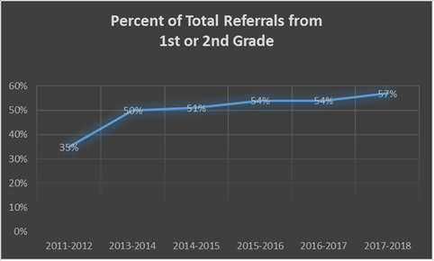
Source: MISD Dyslexia Database
  - Greater involvement of the MTA teachers in the Response to Intervention (RtI) process for students with reading problems
  - Implementation of state mandated Dyslexia Screener for Kindergarten and 1st grade
  - Identifying and instructing diverse populations – Bilingual and ESL; 23% of our identified dyslexic students are English Language Learners (14% Bilingual, 9% ESL). This is an increase of 3% from last year. Additionally, 16% of students served in elementary schools also receive Special Education services.

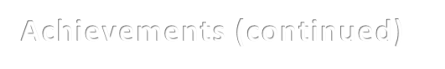
Achievements (continued)
  - Educating school staff members on the definition and common risk factors associated with dyslexia, so they can determine which students should be referred for assessment
  - Increasing the number of students tested and identified over a 10-year period
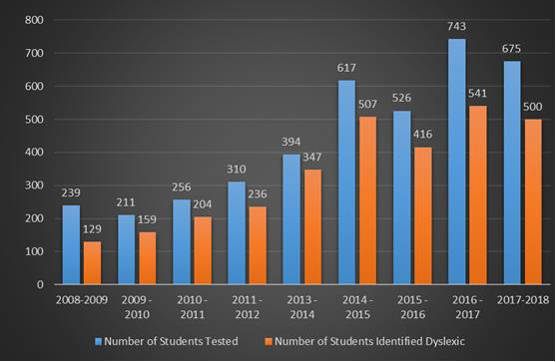
Source: MISD Dyslexia Database






Achziger Austin Beasley Black Cannaday Florence
Floyd Galloway Gentry Gray Hanby Henrie Hodges Kimball Lawrence Mackey McKenzie
McWhorter
Moss Motley Pirrung Porter Price Range Rugel Rutherford Seabourn Shands Shaw Smith Thompson Tisinger Tosch
Source: Skyward
Goals
•
Appropriately identify and serve students with dyslexia.
Percentage
of
Dyslexic Students
Campus
at
Each
Elementary
13.00%
12.00%
11.00%
10.00%
9.00%
8.00%
7.00%
6.00%
5.00%
4.00%
3.00%
2.00%
1.00%
0.00%
26



Goals (continued)

  - Every campus will use the state mandated screener to assist in early identification of students with dyslexia
  - Provide guidance and staff development to campuses on how to recognize the characteristics of dyslexia in bilingual students
  - Students will complete the MTA program before going to middle school. To accomplish this, our goals are to identify more students in 1st and 2nd grade and have smaller group sizes

Challenges

  - Reducing group size – almost one third of our groups across the district have seven or more students – program descriptors indicate that an appropriate group size is less than seven students. Larger group sizes slow progress and hinder students from reading on grade level. In order to keep group sizes from becoming unmanageable, MTA class time was decreased to 40 minutes a day and teachers served 8 groups during the day. As a result, groups sizes were maintained from the previous year
  - Providing dyslexia intervention to students who are not proficient in English
  - Insuring the highest quality of dyslexia instruction at the secondary level

Dyslexia Department December 2018

The purpose of the Mesquite ISD Dyslexia Department is to identify and provide services for students with dyslexia, as outlined in the State Dyslexia Handbook, Revised 2014. The process includes:

- gathering data on a student when parents, PST or ARD committees suspect the student has dyslexia

- conducting formal assessments (including both formal and informal data) in order for a committee to determine if the student demonstrates a pattern of evidence for dyslexia; we currently have 2,818 students identified as dyslexic across the district

- presenting the assessment to the ARD or 504 committees and explaining the state guidelines regarding the identification of dyslexia as found in the Dyslexia Handbook, Revised 2014

- collaborating with the 504 or ARD committee in determining appropriate accommodations for students the committee has identified as having dyslexia

- providing additional evidence-based specialized instruction as appropriate for the reading needs of the student with dyslexia

- implementing dyslexia intervention with the following components: phonological awareness, sound-symbol association, syllabication, orthography, morphology, syntax, reading comprehension and reading fluency

- delivering the appropriate content consistently with these research-based principles of effective intervention: Simultaneous, multisensory (visual, auditory, kinesthetic-tactile); Systematic and cumulative; Explicit instruction; Diagnostic teaching to automaticity; Synthetic instruction (presenting morphemes to teach how the word parts work together to form a whole); Analytic instruction (presenting the whole and teaching how it can be broken down into its components)

- keeping careful records of the progress of students who are receiving dyslexia intervention

- assisting students in providing appropriate accommodations when administering state and district assessments

- educating parents, teachers and other staff members about the characteristics of a student with dyslexia, the benefits of early identification and intervention, and appropriate accommodations for a student with dyslexia

- helping students with dyslexia be advocates for themselves in the school setting and for the future

- being knowledgeable about the most current research regarding dyslexia, its causes, and effective interventions so as to implement "best practices" with the resources of our department

- using staff and district funds as efficiently as possible to create a high quality dyslexia program for the student

The staffing structure includes:

Two Dyslexia Facilitators who have experience teaching MTA and further training with dyslexia assessment. Primary responsibilities include testing students for dyslexia, writing dyslexia reports, attending ARD and 504 dyslexia identification meetings, and interpreting the results of the assessments for the committee to help make an informed decision about dyslexia. Additionally, the Dyslexia Facilitators provide staff development for MTA teachers, keep records on dyslexics throughout the district, gather data for students identified as dyslexic outside our district who are now attending one of our schools, keep the inventory and order department supplies, and are responsible for the many administrative duties associated with maintaining the department and supporting the MTA teachers.
One Dyslexia Tester who is responsible for the assessment of students, writing dyslexia reports and checking in new referrals from campuses. One Bilingual Dyslexia Tester who is responsible for language proficiency assessments and dyslexia testing for all students in bilingual classes, as well as writing dyslexia reports on both sets of testing, and checking in new referrals from campuses.

36 Elementary MTA teachers who are experienced classroom teachers who have successfully completed at least 30 hours of MTA training and are supported by experienced department mentors for one year. The MTA teachers have the following responsibilities:
- teach eight groups of MTA each day, possibly at more than one campus depending on the needs of the district
- gather data for students the campus has recommended for dyslexia testing
- mentor new MTA teachers closely for one year after hire (including reviewing lesson plans and teacher observations) as needed
- assist campuses with administering testing accommodations to students
- meet with campus staff to educate teachers about the characteristics of dyslexia, early identification, the referral process, and appropriate accommodations for students with dyslexia
- serve as a resource for PSTs

5 Middle School MTA teachers who have also completed 30 hours of MTA training and are supported by experienced department mentors for one year. Middle School MTA teachers teach 6 groups of MTA at two middle schools each day.

Four of our 41 MTA teachers have obtained further certification as a Certified Academic Language Therapist (CALT). They have additional responsibilities as department instructional leaders. The CALTs act as a resource for our MTA teachers in implementing the MTA program and plan instructional staff development to hone the teachers’ therapeutic skills.

High School - The Scottish Rite Literacy Program for Adults is offered as an elective for dyslexic students.

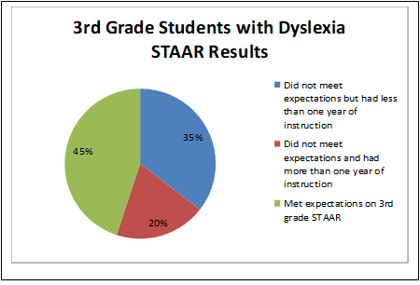
Dyslexia Department December 2018

State Assessments such as STAAR are primarily comprehension tests. The typical dyslexic student has the ability to comprehend text, if he or she can decode fluently enough to comprehend what they read. MTA instruction teaches decoding skills that are necessary to read text fluently and understand what is read. Within our dyslexia population, 80% of the third graders who took STAAR for the first time in 2018 either met expectations, or had less than one year of MTA instruction when they took the test. The ability to decode more difficult material increases the further the student progress through the MTA curriculum. Early identification will increase the likelihood of students reading on grade level by 3rd grade.

Source: STAAR Data gathered by MTA teachers

Over the last seven years, the district has produced two short, five minute videos of interviews with school staff, parents, and students about how dyslexia intervention has affected their lives. They are posted on the Mesquite ISD YouTube page. Mesquite ISD should be very proud of their investment of resources in recognizing and providing appropriate intervention for the dyslexic student; and the employees in the Dyslexia Department feel very blessed to have a part in this important endeavor. Here are links to view these videos.

Video: https://youtu.be/ZiGHboZObek

Video: https://youtu.be/Gsrq3dmViWc
The dyslexia department also hosted a Family Engagement Presentation where parents were invited to visit informative stations with groups of MTA teachers. The evening was very well attended by parents, exceeding all expectations.

Dyslexia Department December 2018



The 2018-2019 program cost for dyslexia services are:

Salaries

35 MTA Teachers | $2,478,033.00
2 Dyslexia Evaluators and 2 Facilitators | $251,494.00
Total Salaries | $2,729,527.00

Supplies

Teaching/ Testing Supplies | Approx. $50,000.00

Dyslexia Department December 2018



- Increased awareness of dyslexia
- Reach our goal of identifying and serving all students who struggle with dyslexia
- All primary teachers recognize the characteristics of dyslexia in the younger grades, so that students are identified no later than the end of first grade or the beginning of second grade
- Students progressing far enough through the MTA curriculum to read on grade level by third grade
- Dyslexia intervention offered in English and Spanish to best meet the needs of our students

Section 504
December 2018


Section 504 of the Rehabilitation Act of 1973 is a civil rights law, enforced by the U.S. Office of Civil Rights, that prohibits discrimination against persons with disabilities and applies to public and private schools that receive any federal funds. The law requires school districts to provide students with physical or mental impairments that substantially limit one or more major life activity with a free and appropriate public education in the least restrictive environment to the maximum extent appropriate to their needs; reasonable accommodations to enable students to participate and learn in the general education program, opportunities to participate in extra-curricular and non-academic activities; and opportunities commensurate with those of their non-disabled peers.
The ADA Amendments of 2008 amplified §504 eligibility by expanding the traditional list of major activities to also include all body functions and systems, along with additional life activities. An expansion of the definition also included a consideration for substantial limitation.
An eligible student is a person who: (a) is of mandatory school age and resides within the boundaries of Mesquite ISD or is enrolled and attending classes in Mesquite ISD; and (b) who (i) has, (ii) has a record of having or (iii) is regarded as having a physical or mental impairment that substantially limits a major life activity such as caring for oneself, performing manual tasks, seeing, hearing, eating, sleeping, walking, standing, lifting, bending, speaking, breathing, learning, reading, concentrating, thinking, communicating, and working.
A major life activity also includes the operation of a major bodily function such as functions of the immune system, normal cell growth, digestive, bowel, bladder, neurological, brain, respiratory, circulatory, endocrine, and reproductive functions.




Accomplishments
  - Increased identification through the Child Find process
  - Improved annual training of all campus personnel
• 4,894 §504 meetings in 2017-2018
  - Full Implementation of SuccessEd
  - Migrating service plans from Eduphoria to Skyward to streamline receipt, implementation and verification of 504 Services plans

Challenges
  - Large number of meetings that involve counselors, administrators, teachers, and other campus personnel
  - Students identified under §504 have grown 23.5% from the 2014-2015(2670 students) school year to the 2017-2018(3494 students)
  - No state or federal funding
  - Lack of federal regulations governing 504 programs – Guidance is morphed through litigation, OCR Letters of Guidance, and Q&A documents
  - Implementation of Service Plans is difficult to monitor for compliance
  - Numbers of students identified under §504 continue to rapidly increase straining personnel and resources
  - Growing criteria for identification, including high numbers of mental health concerns and broader parameters for eligibility across the board

all students with disabilities to be properly identified in a timely manner and all teachers and campus personnel to apply the triggers for the district’s duty to evaluate
Goals
- For
  - For §504 Service Plans to be completely implemented and evaluated for effectiveness

  - To have administrators and counselors monitor plans for classroom implementation and compliance

  - For all Service Plans, whether new or updated, uploaded in Skyward and verified in a timely manner

  - For all campuses to fully implement electronic distribution and verification of Service Plans

Section 504
December 2018


Section 504 is a federal law that protects students with disabilities from being discriminated against at school. It requires the school to give a student the same opportunities as students without disabilities and entitles disabled students to a free appropriate public education (FAPE) by providing reasonable accommodation or modification. The public school has the duty to locate children with disabilities through a process called Child Find, which mirrors the same process utilized for special education under IDEA. This responsibility to locate and identify students with disabilities applies to all public school personnel and includes locating students not currently in a public school setting. Referrals may be made by parents, guardians, or school personnel.
When a §504 referral has been initiated, information is gathered from a variety of sources which then goes to the §504 Committee. The §504 Committee is a group of persons that includes a person knowledgeable about the child, a person that knows the meaning of the evaluation data, and a person that knows about placement options. It typically includes a campus administrator, the §504 campus coordinator, which is a campus counselor, one or more teachers knowledgeable about the student and other personnel as may be appropriate. The §504 Committee may also include, but is not required to include, the child’s parent or guardian.
The evaluation for §504 eligibility focuses on review and consideration of various sources of relevant data and may or may not include formal assessment. Data that is frequently reviewed includes IQ scores, aptitude and achievement tests, student grades, teacher recommendations, physical or medical reports, progress reports, parent and teacher observations, anecdotal reports and scores from state assessments. The review also includes consideration of the effectiveness with which the student meets the standards of personal independence and social responsibility expected of his or her age and cultural group. Periodic reevaluation is also required at least every three years but local regulation requires an annual review. Reevaluation is also needed prior to significant changes in placement including manifestation determinations prior to disciplinary changes in placement.

If a student is determined as an eligible §504 student, the Committee then determines if a Student Services Plan is warranted. A Services Plan assures that disabled students have educational opportunities and benefits equal to those provided to nondisabled students. Services or accommodations may be needed in the area of academics, behavior management, transportation and/or areas as identified by the Committee. The goal is to “level the playing field” for the disabled student so that the student has equal opportunity when compared to non-disabled peers.
One program that falls under §504 is General Education Homebound. Currently, 16 students are being served under this program. Dyslexia is an identified disability that often falls under the §504 umbrella. At this time, 2001 MISD students are identified as dyslexic and the majority of these are also identified as §504 eligible.
A student’s §504 Services Plan is routinely implemented in the general education setting.
To understand §504, it is helpful to see how it relates to other relevant laws concerning students with disabilities including ADA and IDEA or special education. ADA is a federal law which provides civil rights protections to all individuals with impairments in our society. The Section 504 definition is much broader, including any physical or mental disability that substantially limits one or more major life activities including, but not limited to, learning. Special education (IDEA) defines eligible students as those who have certain specific types of disabilities and need specially-designed instruction and related services in order to benefit from their education.

The chart below provides a comparison of these three disability laws.

Issues | Section 504 | Special Education-Individuals with Disabilities | Americans with Disabilities (ADA)
Type | A Civil Rights Law | An Education Act | A Civil Rights Law
Title | The Rehabilitation Act of 1973 | In Individuals with Disabilities Education Improvement Act (IDEA) 2004 | Americans with Disabilities Act of 1990 (ADA)
Purpose | Is a civil rights law that protects the rights of individuals with disabilities in programs and activities that receive federal financial assistance from the U.S. Department of Education. | Is a federal funding statute whose purpose is to provide financial aid to States in their efforts to ensure a free appropriate public education for students with disabilities. | Provides a clear and comprehensive national mandate for the elimination of discrimination against individuals with disabilities
Responsibility | General education, but shared with special education | Special education, but shared with general education. | Public and private schools, business establishments, and public buildings (services)
Funding | State and local responsibility (no federal funding) | State, local, and federal IDEA funds. IDEA Funds cannot be used to serve students eligible only under Section 504. | Public and private responsibility (no federal funding)
Administrator | Section 504 Coordinator (Systems with 15 or more employees) to coordinate efforts to comply with this law | Special education director or designee | ADA Coordinator is required to coordinate efforts to comply with this law.
Service Tool | Accommodations and/or services | Individualized Education Program (IEP). Some IEPs will include accommodations similar to those in a Section 504 plan necessary for success in the regular classroom. | Reasonable accommodations and legal employment practices



Identification | A student is identified so long as she/he meets the definition of a qualified person with disabilities, i.e., currently has or has had a physical or mental impairment that substantially limits a major life activity. | A student is only eligible to receive special education and related services if the multidisciplinary team determines that the student has a disability under one of the 13 qualifying conditions of the IDEA and requires special education services. | A person is identified so long as she/he meets the definition of a qualified person with disabilities, i.e., currently has or has had a physical or mental impairment that substantially limits a major life activity or is regarded by others as having a disability. The student is not required to need special education services in order to be protected.
Free Appropriate Public Education | A student could receive services and/or accommodations through a Section 504 Plan | A student must first be eligible and need special education before he or she is entitled to special education and related services. Services are based on the student's unique needs as provided by an Individualized Education Program (IEP) | Addresses education in terms of accessibility requirements. Requires private and public entities not to use employment practices that discriminate on the basis of a disability.
Accessibility | Federal regulations regarding building and program accessibility require that reasonable accommodations be made. | Requires that modifications must be made if necessary to provide access to a free appropriate public education to an eligible student. | Requires that public programs be accessible to individuals with disabilities.
Procedural Safeguards | Both require notice and rights to the parent or guardian with respect to identification, evaluation, programming, and placement. |  | Makes provisions for public notice, hearings and awarding attorney fees.
Notice and Consent | Notice is required before a "significant change in placement." Written consent would be considered a best practice. | Written notice is required prior to any change in placement. Written consent is required before the initial evaluation and reevaluation. | Does not apply to this category.




Evaluations | Evaluation draws on information from a variety of sources in the area of concern. Decisions are made by a group knowledgeable about the student, evaluation data, and placement options. Requires written parental notice. Written parental consent is considered a best practice. Requires periodic reevaluations. Reevaluation is required before a significant change in placement. No provision is made for independent evaluations at district expense. The school district should consider any information regarding the student. | A full comprehensive evaluation is required assessing all areas related to the suspected disability. The student is evaluated by a multidisciplinary team within 60 days of written parent consent.  Requires reevaluations to be conducted at least every three years if determined appropriate by the team. A  reevaluation is not required before a significant change in placement, but an IEP meeting is.  Provides for a request for an independent educational evaluation. | All schools should conduct or update their Section 504 evaluations regarding services, accessibility, practices, and policies to ensure discrimination is not occurring with any individual with disabilities under the ADA.
Services | When interpreting evaluation data and making services decisions, both laws require districts to do the following:  Draw upon information from a variety of sources.  Ensure that all information is documented and considered.  Ensure that the service decision is made by a group of persons including those who are knowledge about the student, disability, the meaning of the evaluation data, and placement options.  Provide notice and evaluation before any change of services.  Ensure that the student is educated with his/her nondisabled peers to the maximum extent appropriate (Least Restrictive Environment-LRE)
Review of Program | Accommodations should be reviewed periodically. | An IEP review meeting is required at least annually or before any significant change.
Local Level Grievance Procedures | Requires districts to provide a local grievance procedure for parents, students, and employees. | Does not require a local grievance procedure. Provides for state-level IDEA complaint procedures and due process hearings. | Any school district shall adopt and publish grievance procedures for resolution of ADA complaints.

Formal Complaint Procedures | An individual or organization may file a complaint with the Office for Civil Rights (OCR). An OCR complaint must be filed, in writing, within 180 days after the violation has occurred. In certain cases OCR will consider the complaints where more than 180 days have elapsed. | A formal complaint process is required. Parents can file a complaint with the State. A decision must be provided within 60 days. | An individual or organization may file a complaint with OCR. An OCR complaint must be filed, in writing, within 180 days after the violation has occurred. In certain cases, OCR will consider complaints where more than 180 days have elapsed.
Due Process | Both statutes require districts to provide impartial hearings for parents or guardians who disagree with the identification, evaluation, or placement of student with disabilities. School districts or parents can initiate due process hearings. Requires that the parent have an opportunity to participate and be represented by school counsel. Other details are left to the discretion of the local school district or state law. Policy statements should clarify specific details and delineate specific requirements. |  | Due process hearing can be initiated by either party. The court may allow a reasonable attorney's fee for the prevailing party.
Mediation | Not required. However, mediation should always be suggested. | Meditation and resolution sessions are available for the parties in a dispute and are encouraged as a way to resolve a state-level complaint or due process hearing. | Not Required. However, mediation should always be suggested.
Exhaustion of Remedies | Administrative hearing is not required prior to OCR involvement or court action. | The parent or guardian should exhaust all available administrative remedies before seeking court action. | An administrative hearing is not required prior to OCR involvement or court action.
Enforcement | Enforced by the U.S. Office of Civil Rights. Regional offices are located throughout the United States. The office is part of the U.S. Department of Education. | Enforced by the U.S. Office of Special Education Programs (OSEP) and the State as the enforcement arm of OSEP. | Enforced by the U.S. Office for Civil Rights under an agreement with EEOC.

Besides understanding the differences in the programs for students who have disabilities, it is also valuable to understand the process that most campuses utilize when a student experiences difficulties in the classroom setting, especially in the area of learning. Since not all learning difficulties are disabilities, the process below shows the continuum of services and how they escalate from the least restrictive learning environment to the most restrictive learning environment.

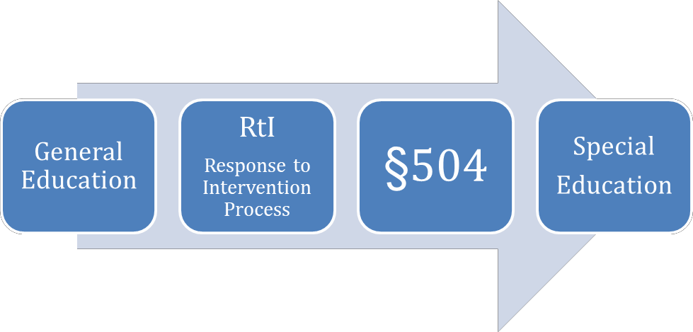

Section 504
December 2018

Mesquite ISD currently serves 3494 students through the Section 504 Services.
When comparing the definitions and expectations of §504 and IDEA- Special Education, the larger number of students should be in the §504 program. Currently, 10.8% of MISD students are identified as special education and 8.65% are identified as
§504.

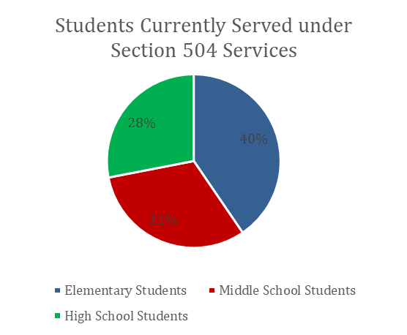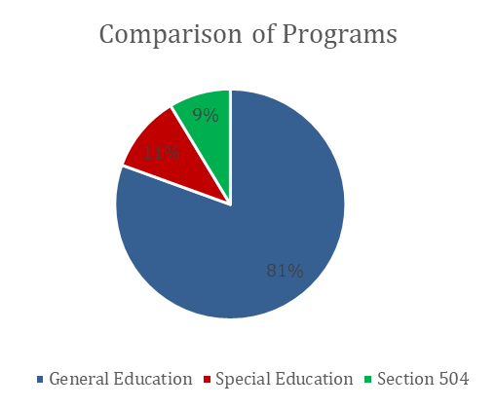

In the last 5 years, there has been over a 350% increase in the number of campus §504 meetings. In 2017-2018, 4894 meetings were held.
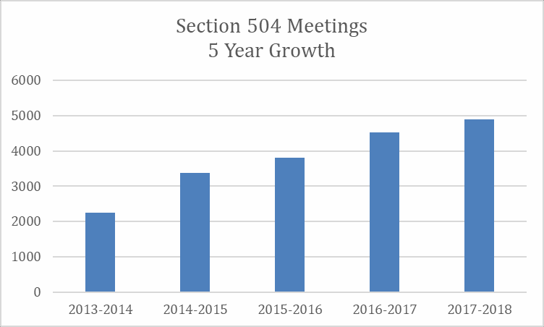

Besides the identification of an increasing number of students, campus §504 coordinators also held a record number of meetings. These meetings were for the purpose of initial identification, annual review or re-evaluation, or manifestation determinations for discipline purposes.
Each campus coordinator annually trains campus personnel so that staff understands their Child Find obligation and so that teachers and staff members have a general understanding of §504 eligibility, the referral process, and can discuss it with parents as needed. Training this year was revised to provide a better understanding of §504. Additional materials have also been provided to assist with training for campus coordinators new to the position. The better the understanding that staff members have of the program and process, then the better the likelihood of appropriate identification.
Implementation of student Services Plans is imperative to the success of a §504 student. This plan not only includes services/accommodations that take place in the general education classroom but may also include accommodations on state and local assessments. Compliance with this legal responsibility is difficult to monitor but limited complaints in this area provide assurance that the training and expectation have been successful and that compliance is occurring on a regular basis.

Section 504
December 2018


While the §504 program is unfunded, there are associative costs that must be provided through local monies to provide any necessary accommodations for individuals with disabilities. IDEA funds may not be used to serve a student found eligible only under
§504.
Mesquite ISD currently has a $43063.50 budget for Section 504. This budget includes $38,063.50 for SuccessEd and $5000 allotted to offset expenses associated with services such as FM Amplification System for students with hearing loss.
Administration of the §504 program takes many campus people including counselors, administrators, and teachers. These salaries are not included as part of the cost of the program.

Section 504
December 2018

Ideally, all students with a suspected disability should be evaluated for §504 through the Child Find process and an appropriate Services Plan developed for qualifying students. These students with disabilities will then have the same opportunity for success as their non-disabled peers, which is the purpose of Section 504.
Full Implementation of SuccessEd software will streamline §504 record keeping and integrate with Skyward which will improve the overall accuracy of information and support greater compliance to §504 guidelines as well as reporting §504 students in PEIMS.
Additional personnel are needed to assist counselors and administrators in many tasks associated with §504. Counselors who serve as campus §504 coordinators, and administrators who are responsible for monitoring implementation and compliance of Service Plans, could greatly benefit from an intervention specialist on each campus. A position such as this would contribute to the success of not only §504, but also many other programs where individualized intervention is required such as RtI and Special Education. An intervention specialist could also help with coordination and preparation for the high number of meetings being held on each campus. Ultimately, our students will be better served with additional personnel to monitor for compliance and implementation of individualized plans.

Special Education December 2018


The special education department in Mesquite ISD coordinates services to 4,367 students ranging in ages from birth to 21 years of age. The program provides a process for referral, identification of needs and services, and continual monitoring of progress for these students. Meeting individual needs in the least restrictive environment is the foundation of the special education program and is accomplished through a variety of instructional settings ranging from minimal support of the student in the general education setting to full physical, emotional, and academic services in a special education classroom. An inclusive model for providing special education services ensures most students receive the majority of their services in the general education setting.

In addition to services provided directly to students, the special education department delivers staff development to both general and special education personnel who teach and support our students. Training is based on the needs of the special education students as identified through evaluation of students, both as individuals and as groups and based on student performance data.

In addition to classroom instruction, MISD special education staff also provides:

- Speech Therapy for 2,206 students
- Occupational Therapy for 169 students
- Physical Therapy for 89 students
- Audiology Services for 186 students
- Counseling Services for 91 students
- Vision Services for 87 students
- Assistive Technology Services for 69 students
- Nursing Services for 32 students
- In-home Training for 12 students
- Orientation and Mobility Services for 24 students
- Music Therapy for 9 students
- Recreation Therapy for 1 student

Our challenges include:
- hiring, developing, and retaining highly qualified, highly effective teachers and paraprofessionals for our students
- meeting state and federal expectations while ensuring individual student needs are being met
- competing with private industry in hiring and retaining personnel
- ensuring each student’s IEP is appropriate and implemented with fidelity and that progress is monitored and documented appropriately
- providing training for staff regarding procedural requirements of special education paperwork and documentation
- keeping current with changes in special education requirements based on recent court decisions and ensuring those are reflected in district policies and practices
- planning for constantly changing student needs, particularly for move in students
- finding resources when unique student needs arise
- implementing the additional requirement of TEA’s Strategic Action Plan
- responding to potential litigation in a way that minimizes the impact on student services
- preparing for likely changes in special education laws with the expected reauthorization of IDEA
- achieving the expectations of the state’s Performance Based Monitoring and Analysis System while ensuring student needs are met
- meeting the needs of students with increasingly disruptive and violent behaviors resulting from our inadequate mental health system in Texas

Special Education December 2018

The goal of the Special Education program in Mesquite ISD is to ensure that all children with disabilities have available to them a free appropriate public education that emphasizes special education and related services designed to meet their unique needs and prepare them for further education, employment, and independent living. (34 CFR§300.1(a))
Our program currently serves 4,367 students ranging in age from birth to 21. These students are served at all 49 MISD facilities as well as in their homes. These services are provided by 279 special education teachers, 297 special education paraprofessionals, 24 special education related service providers, and 7 special education coordinators.
As required by law, each student’s services are based on his/her needs as identified through a Full and Individual Evaluation. Each student is evaluated prior to admission into Special Education and at least every three years while continuing in the special education program. Last year, our 35 diagnosticians, 5 psychologists and 44 speech personnel completed 1,908 Full and Individual Evaluations.
For students served in Special Education, an ARD committee made up of general and special education teachers, evaluation personnel, related service providers, a campus administrator, the student’s parents, and the student (when appropriate) meets to develop an Individualized Education Program at least annually to develop the student’s Individualized Education Program. Last year, our campuses conducted 9,347 ARD meetings. ARD meetings last an average of an hour and have at least three staff members involved, which means at least 14,020 hours (or 350 forty hour weeks) were spent in developing individualized plans to ensure we meet the needs of each of our special education students.

The services each student’s ARD committee deems appropriate are provided for that student in the least restrictive environment, ensuring that to the greatest extent possible the student remains in the general education setting with their age appropriate peers, receiving rigorous instruction from teachers who are content experts while still allowing the student to have the support needed to progress on his/her individual goals. In Mesquite ISD, these services are provided in a continuum of instructional settings, each designed to meet the needs of the specific students being served.
The following chart depicts the different instructional arrangements MISD currently uses to provide services for special education students from least to most restrictive. Following the chart, each instructional setting is briefly described.

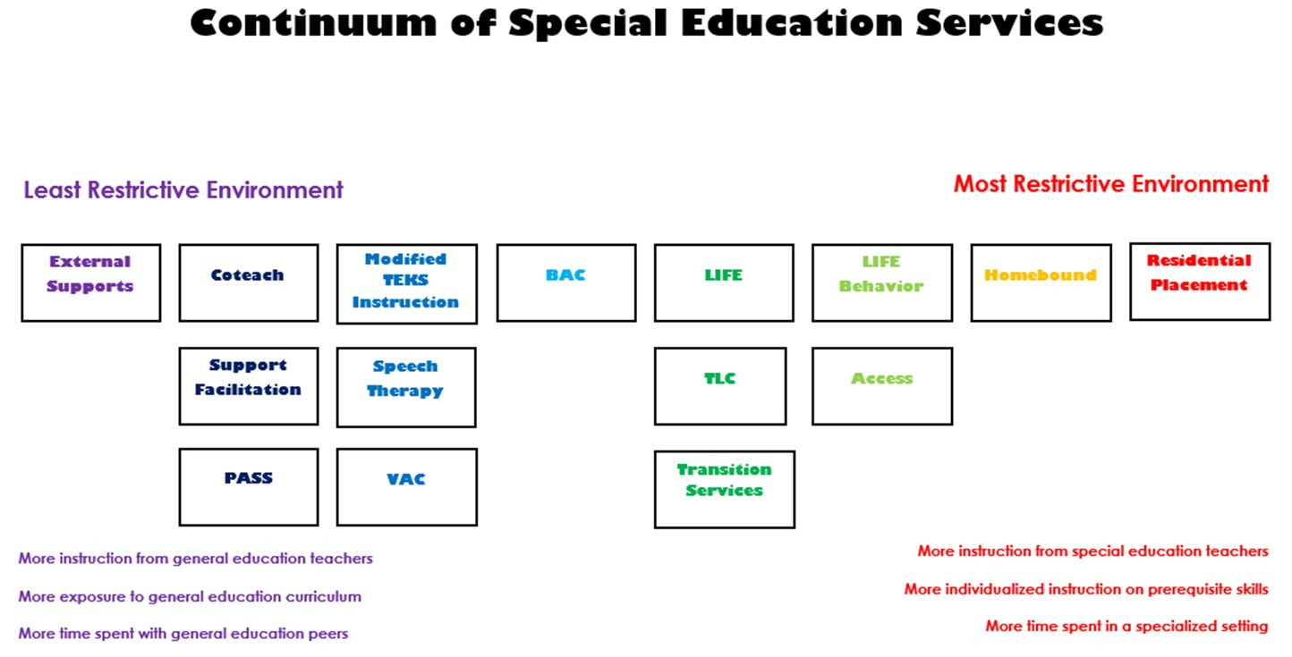

External Supports refers to supports provided for a student prior to instruction. These supports are those accommodations or scaffolds the student needs to be successful in the general education classroom. Services are provided by a special education teacher who may be assisted by a paraprofessional. Students receiving external supports are responsible for the same curriculum as are all students at their assigned grade level.
Support Facilitation refers to support provided to a student in core curriculum areas affected by their disability during instruction in the general education classroom. This support is formally scheduled based on the needs of each student but is not needed daily for the entire class period. The support is provided by a special education teacher assisted by a paraprofessional. Students receiving support facilitation are responsible for the same curriculum as are all students at their assigned grade level.
Co-teach refers to support provided when two certified teachers jointly deliver instruction throughout the class period every day. A co-teach class is taught by a general education teacher and a special education teacher. Students receiving co-teach services are responsible for the same curriculum as are all students at their assigned grade level.
Modified TEKS Instruction (MTI) refers to special education classes provided for students who are unable to master the TEKS on grade level. The modified curriculum focuses on the prerequisite skills identified in the student’s FIE which are necessary for success with the general education curriculum in core content areas. MTI is provided by a special education teacher who may be assisted by a paraprofessional. At the elementary level, students generally receive MTI classes for about half of the time required for instruction in that subject area and do not attend MTI classes each day of the week. Elementary MTI students participate in the general education curriculum for the remainder of the scheduled time in each subject area with instruction provided by the general education teacher. At the secondary level, MTI classes are scheduled for the same frequency and duration as general education classes for that subject area.

Speech therapy refers to services provided for students with a communication disorder. Speech therapy is provided by a certified speech and language pathologist or certified speech assistant in the areas of articulation and/or language. Services may be provided within the general or special education classroom or may be provided in a speech therapy classroom.
Vocational Adjustment Class (VAC) refers to services provided to high school students who wish to demonstrate employability skills to satisfy graduation requirements. Students served in this class work on job skills and also receive job coaching at their workplace from a special education teacher. These students are also working on core academics to earn the needed credits for graduation.
Behavior Adjustment Class (BAC) and Positive Approach to Student Success (PASS) refer to the programs designed for students who have behavior problems directly related to their disability. PASS classrooms at the elementary level and BAC classrooms at the secondary level are highly structured and provide individualized instruction in all academic areas as well as in social skills. While students’ schedules vary based on their individual needs, the goal of both programs is to help students develop the skills they need so that they can participate in general education classes to the maximum extent possible. Most of our PASS/BAC students spend 50% or more of their day in general education with support from PASS/BAC staff, which includes a special education teacher and paraprofessional. Our PASS/BAC students may be working on grade level curriculum or may be receiving modified TEKS instruction based on prerequisite skills needed to be successful on grade level curriculum.
Total Language Classroom (TLC) refers to a program which utilizes specific methodologies based on research and best practices for students with autism. Generally, our TLC classrooms provide instruction on prerequisite skills needed for success on grade level curriculum; however, some of our TLC students work on grade level curriculum. Services are provided by a special education teacher and paraprofessionals. While the majority of our TLC students are served in the TLC classroom for most of their day, this varies based on individual student needs. Our goal is for our TLC students to spend at least a portion of the day with general education peers, often in classes such as art, music, PE, or at lunch and recess.

Learning in Functional Environment (LIFE) classes provide academic and functional instruction for students who require a small, structured learning environment. The program is designed for students with moderate to severe cognitive deficits or developmental delays. The focus of instruction is functional academics and independent living skills. Students receive modified TEKS instruction based on prerequisite skills needed to be successful on grade level curriculum and functional skills in all academic areas. Services are provided by a special education teacher and paraprofessionals. Three of our LIFE classrooms serve students who are medically fragile with multiple disabilities and also require the services of a special education nurse. While the majority of our LIFE students are served in the LIFE classroom for most of their day, this varies based on individual student needs. Our goal is for our LIFE students to spend at least a portion of the day with general education peers, often in classes such as art, music, PE, or at lunch and recess.
LIFE Behavior refers to a class which is structured, staffed, and designed for the same types of students as our LIFE classes, but serves students who have significant behavioral needs in addition to their cognitive deficits. Our LIFE Behavior students are typically served in the LIFE classroom for the entire school day.
Alternative Campus Classroom Emphasizing Social Skills (ACCESS) refers to a program for students at the high school level who need a more structured setting with a smaller teacher to student ratio. It is located at Mesquite Academy. Students may be working on general education curriculum with supports or may be working on individualized IEP goals and objectives. Services are provided by a special education teacher and paraprofessional.
Transition Services is a program designed for students who continue in services after age 18 and focus on vocational skills. Students receive instruction based on their IEP goals with a focus on employability, independent living, and socialization as they transition into adult life. Services are provided in a special education classroom and in the community by a special education teacher and paraprofessionals. The frequency and duration of services is determined by each student’s ARD committee based on his/her individual needs. Most Transition Services students attend daily for four to five hours.

Homebound services are provided to students who are determined to be unable to attend school for a period of time of four weeks or greater by a medical doctor. Special education homebound students are served by a special education teacher in their home.
The frequency and duration of services is determined by their ARD committee. Most students receive homebound services for an hour or more per day two or three times per week. Special education students work on the goals in their IEP and may be receiving supports in the general education curriculum or may be working on individualized goals and objectives.
Residential Placements are used when students are placed in private facilities outside the school district because they need services the district is unable to provide. These students work on IEP goals and objectives determined by their ARD committee. Their instruction is provided by special education teachers and paraprofessionals.
Preschool Program for Children with Disabilities (PPCD) refers to any special education services provided for students ages 3-5. PPCD students may receive speech therapy only, may be served in a general education classroom with support facilitation, or may be served in a self-contained setting such as TLC or LIFE. Services are provided by a special education teacher (or speech and language pathologist) who is assisted by a paraprofessional. The frequency and duration of services vary based on student needs and ARD committee recommendations, but are generally for half day unless the student is in Kindergarten, in which case most students receive full day services. MISD has one PPCD which serves our medically fragile students who have multiple disabilities and require the services of a special education nurse. Some PPCD students are served in our Employee Preschool classes, which are made up of the children of MISD employees who pay tuition to attend the program along with special education PPCD students. Our PPCD students benefit from learning in an inclusive environment alongside the employee children who provide age appropriate role models.

Behavior Supports
Special education serves students with a variety of disabilities which require additional support in the area of behavior. Students in any of our instructional settings may exhibit behaviors that interfere with their learning or with the learning of their classmates. The special education department strives to support the students and their teachers in the least restrictive setting by working with the general and special education staff, campus administrators, parents, and students to put in place effective positive behavior supports which increase the student’s appropriate behavior. If these supports are not effective, the campus develops an individualized Behavior Intervention Plan for the student outlining specific strategies and supports to be utilized in helping the student learn appropriate behavior. If the student continues to struggle, a request may be made to the special education behavior specialist, who will visit the campus, review student records, interview staff members, and observe the student in the classroom.
The behavior specialist provides suggestions to the campus for additional strategies and supports to be utilized with the student. If the situation warrants, the behavior specialist may remain at the campus for a period of time, typically one to two weeks, working with the student and staff to develop an effective plan, then training campus staff in effectively implementing the plan. Students may also need additional special education supports, such as counseling or social skills training. For students who continue to struggle, a change of placement to a more restrictive classroom setting may be required, but only after multiple attempts have been made to provide additional support in the current setting. MISD has several classroom settings specifically designed to serve our students who require intensive behavioral supports, including LIFE Behavior Classes, Positive Approach to Student Success Classes (PASS), Behavior Adjustment Classes (BAC), and ACCESS. Due to the likelihood that a special education student’s behavior is linked to their disability, special education support staff including instructional specialists, behavior specialists and coordinators consult with campus staff throughout this process to ensure there is adequate support from the special education team for the campus and the student.

Special education students may also receive instructional supports in the areas below. For some students, these services are provided directly by the therapist or specialist while others receive consult services, when the therapist or specialist works with the teacher to ensure the students’ needs are being met throughout the school day by special and general education staff.

Speech Therapy Physical Therapy Occupational Therapy Counseling Services
Adapted Physical Education Vision Services
Auditory Services
Assistive Technology Music Therapy Recreation Therapy
Orientation and Mobility Training Parent Education Services
In-home Training Nursing Services

All MISD staff working with special education students, including general education teachers, special education teachers, administrators, and transportation services personnel, are also supported by the following special education staff on an as needed basis throughout the year:

4 Instructional Specialists
4 Behavior Specialists
2 Behavior Support Paraprofessionals 1 Autism Specialist
1 Augmentative Communication Specialist

In addition, MISD houses the Regional Day School for the Deaf, a Shared Service Arrangement for 9 surrounding districts. Through the RDSPD, 12 teachers, 8 interpreters, and 10 paraprofessionals provide services to 69 students in our Deaf Education program.
RDSPD also provides 7 itinerant teachers who serve 113 students in 9 neighboring districts. With the increasing use of cochlear implants over the past 10 years, the number of students served in RDSPD as full time students has steadily declined. We have seen an increase from 16 students with cochlear implants in 2005 to 46 students with cochlear implants or similar devices in 2018. Deaf education services begin at birth, and at age three students are eligible for PPCD. By grade 1, most of our students have gained the skills needed to be successful on their home campuses with the support of an itinerant deaf education teacher. The RDSPD has one audiologist, one speech therapist, one full time and one part time diagnostician, one ARD chair, one secretary, and one coordinator who provide support services for the program.
As required by IDEA, MISD must set aside a percentage of federal funds to provide services to students who attend private schools within MISD. Currently, three part-time teachers and two part-time speech therapists provide services to 28 private school students through Proportionate Share Services.
Special education teachers, general education teachers serving special education students, support staff, administrators, and parents are also supported by special education coordinators. The duties of the 7 special education coordinators include:
- supporting special education staff, general education staff, and administrators for a group of schools
- supporting special education teachers and paraprofessionals working with specific special education populations
- supervising special education itinerant and related service providers
- monitoring compliance with local, state, and federal regulations and reporting requirements
- responding to parent concerns
- ensuring special education students and staff have needed resources to implement students’ IEP goals and objectives

- providing training for general and special education teachers, paraprofessionals, support staff, and administrators through formal staff development sessions, monthly meetings, and consultation
- coordinating with other MISD departments to ensure the provision of services for our students


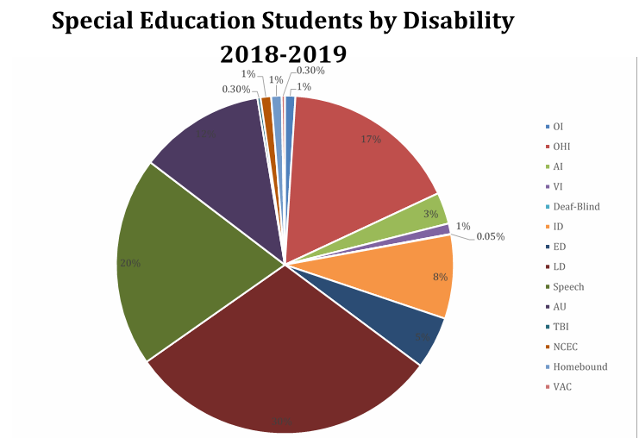

Special Education December 2018

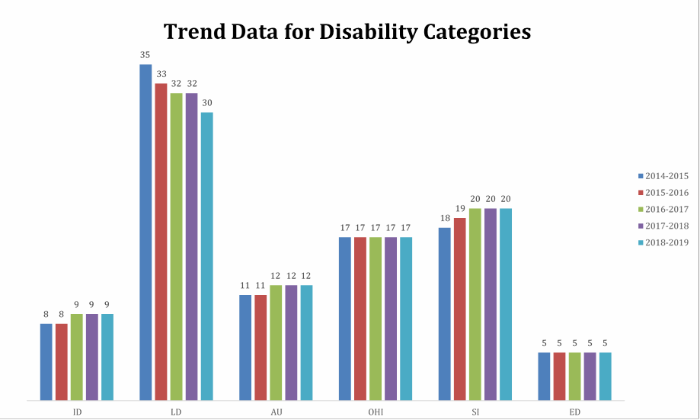

While TEA no longer has a performance target for special education representation, new indicators have been added to the Performance Based Reporting and Analysis System (PBMAS) to identify significant disproportionality by either racial/ethnic group or by a particular racial/ethnic group in a specific disability category. Mesquite ISD had no areas of significant disproportionality identified in our 2018 PBMAS report.
Special Education Representation
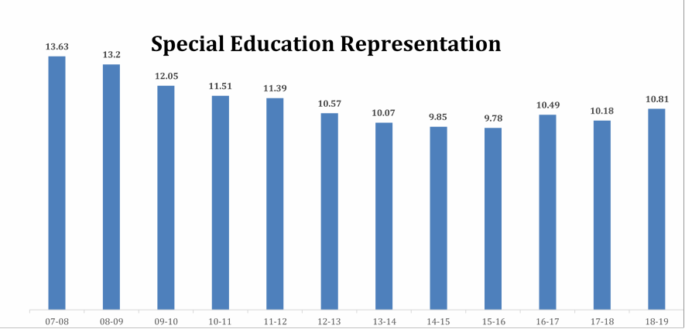

Instructional Setting
The Individuals with Disabilities Education Act (IDEA), very clearly states that the expectation is that we serve students in the least restrictive environment. Our state monitors this through PBMAS. The state target is that we serve 30% of students ages 3-5 and 70% of students ages 6-21 in the general education classroom for the majority of their day.
The next two charts depict the current instructional settings for our special education students and the trend data for our special education students ages 3-5 and 6-21 who are receiving at least 80% of their instruction in a general education classroom. As a district, we are achieving the state target with our students ages 6-21, but we are still below the target for our students ages 3-5.

Instructional Setting
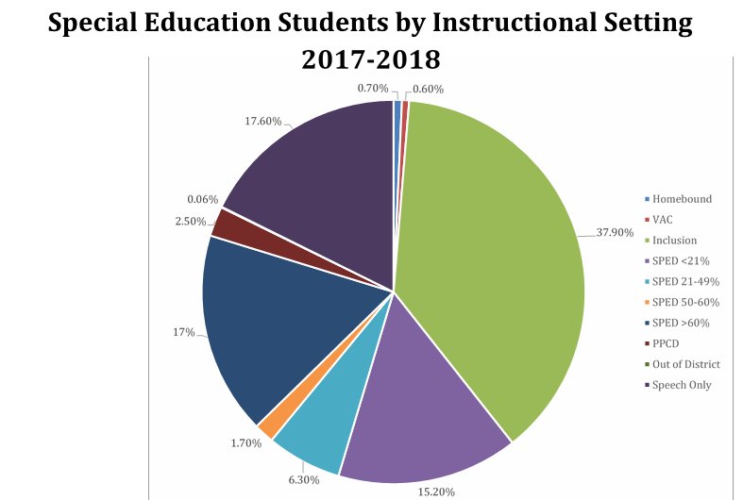

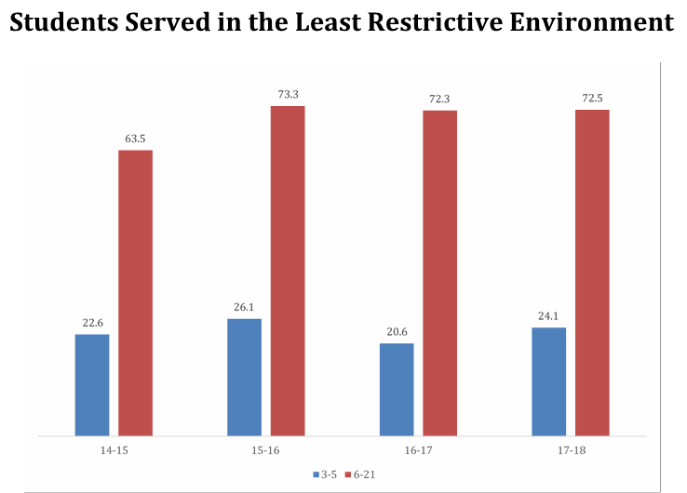


STAAR Performance
Across the district, the performance of our special education students as compared to non-special education students in 2016-17 improved in all subject areas. The gap between special education students and non-special education students was reduced in Reading by 3%, in Math by 8%, in Writing by 3%, in Science by 4%, and in Social Studies by 2%. The performance of special education students improved in every subject area except writing, which decreased for special education students as it did for all students; however, special education students still closed the performance gap in that area.
We continue to see a decreased gap between the performance of our special education students and our non-special education students since our district moved to an inclusive service delivery model in 2015. Having our special education students receive the majority of their instruction in the general education setting as opposed to in a special education setting continues to prove an effective way to ensure our students benefit from the content expertise of their general education teachers while receiving specially designed instruction and support from the special education staff.

Special Education December 2018


Special Education Budget 2017-2018
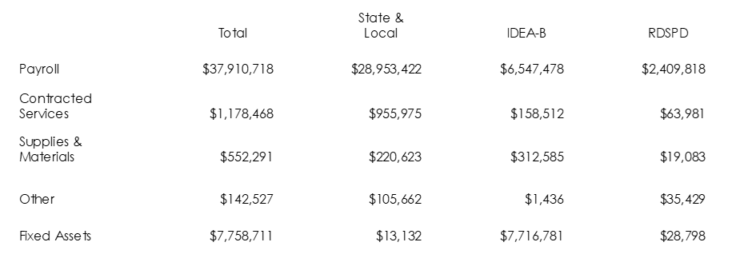


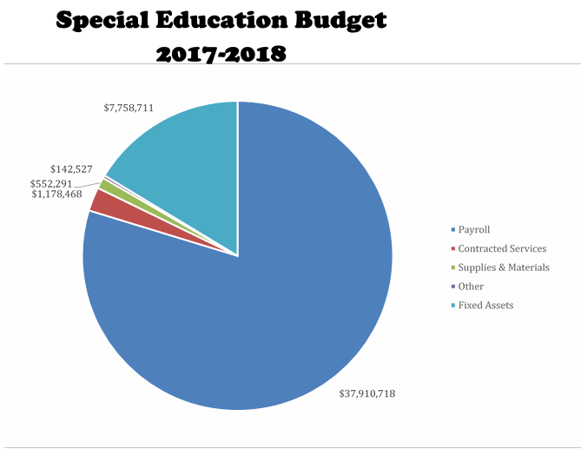

Special Education December 2018


The vision for the future of MISD special education is that each student identified for services is provided with a program that pushes the student to achieve to his or her fullest capabilities. No matter the disability or limitation, the student will acquire the skills to participate in decisions about his or her future and will have the academic, social and emotional ability to be able to continue learning and growing after leaving the public school setting.
To accomplish this goal, we will need to:
- Employ a highly qualified, highly effective teacher and paraprofessional in every special education position dedicated to the vision for our special education students
- Ensure our general education teachers have the training and support needed to provide differentiated instruction for all students, including special education students, in their classrooms
- Utilize district level instructional specialists to support special education professionals in implementing students’ IEPs
- Provide behavioral supports for special education students and teachers so that there is no discrepancy in general and special education discipline data
- Provide services for special education students on their home campuses
- Increase the amount of time special education students are served within the general education setting and reduce the need for services in self-contained settings
- Cooperatively plan all staff development for teachers with the curriculum department to ensure a rigorous and appropriate curriculum for special education students



- Provide a high quality program for students who are served past the age of 18 that focuses on building a sustainable plan for adult life that includes choices and self-actualization
- Use a workload based staffing model rather than a caseload based model to ensure campuses have the staff needed to meet the needs of their students
- Provide highly effective, research based programs to be used with students receiving Modified TEKS Instruction

