Self-Control Group

Goals
- To build up skills to manage emotions.
- To gain self-awareness and learn coping skills to manage emotions.
Session 1
Begin with a review of group norms (handout: what happens in group stays in group; be respectful; always try your best and participate.). Discuss the purpose of the group (self-control: building our ability to manage ourselves and our emotions). Build rapport through a get to know you activity. Introduce the M&M feelings activity as a way to get to know each other. Give each students a mini bag of MnM’s. For every color of MnM they say one thing:
- Green- something that tastes gross
- Orange- one cool trick or a fact about you
- Red- one thing you feel angry about
- Brown- one song you like
- Yellow- one thing you love to do
- Blue- one thing you feel sad about.
During this time counselor creates links among members. One of the first steps in self-control is knowing what we can and can’t control. Give each student a piece of paper and ask them to draw a big circle on it. Outside of the circle have students write things they can’t control, and discuss (weather, other people, what time school starts, etc.). Inside the circle, have them write things they can control, and discuss (personal thoughts, emotions, actions). Tell students it’s a myth that we can’t control our emotions/anger. Have students share what they know about emotions. Guide students to realize that we can feel more than one emotion at a time, and that all emotions are accepted, it’s what we do with those emotions. Show students the concrete brain, and review the flip your lid hand model. Have the students pay attention to where their “lid” is.
Session 2
Review norms. Have students share one moment where they noticed their lid starting to flip this last week. Give each student an emoji page. Define self-awareness (knowing what’s going on with me). Have students think about times when they felt each emoji. Using emoji lights (battery operated touch lights with emoji faces drawn on), press a light and have students share a time when they felt that emotion. Link among students. Go through different emojis. Talk about what their action was when they felt each emotions. Start linking feelings to behaviors. Students can write down on the sheet or take it with them to fill out at a later time. Have students pay attention to what emotions they feel this week.
Session 3
Review norms. Have students share what emotions they noticed last week. Show students the bottle of soda. Shake it up. Stand near a student, and pretend to open it. Process the reaction; what happens if I open it? Now shake up the water and open it. How is it different? One explodes under pressure and one doesn’t (can also tie in “thinking clearly” versus flipped lid). Pass out the Anger Warning Signs page. Go over each warning sign and have students color in the ones that apply to themselves. Talk about how these warning signs are clues to what’s going on with us, and can signal that you are close to flipping your lid. We can use these clues to help ourselves before we explode like the soda. Students can share a time when they have seen someone flip their lid or maybe done it themselves. Process what it was like to watch/feel that happen. Have students pay attention to their warning signs this week.
Session 4
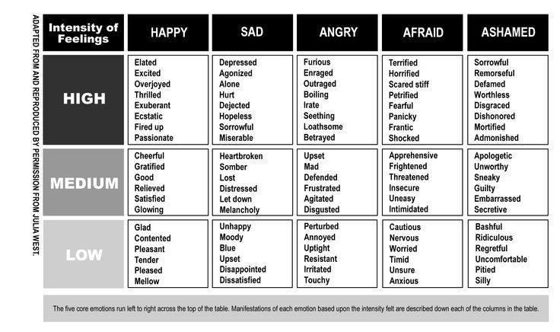
Review norms. Show students the large anger thermometer. (Teacher model is made out of wrapping paper tube, student model is made of paper towel tube). Ask them what a thermometer does? (Tells temperature.) This thermometer gages levels of feelings. Come up with a 1-10 list of levels of anger, sadness, and fear using the table below.

Guide student through making the anger thermometers. Have students cut a window out of the paper towel tube. Have them label it 1-10. Give each student a piece of red construction paper to roll up and put in the tube.
Give each student a flow chart strip to fill out with the following: 1. Emotion 2. Warning sign 3. action????. The space between warning signs and emotions is where we want to make a choice. Have students pay attention to the choices they make this week.

Session 5
Review norms. Have students share choices they made this week. Review the flow chart of how our emotions lead to actions. Guide students in creating a self-control/self-regulation foldable “fortune teller/cootie catcher” using the blank template below. Have students use their coping strategies in the week between sessions.
Session 6
Review norms. Have students review coping strategies they tried and how they worked. Encourage students to keep trying until they find one that works to calm down their brain/body. Have students play Self-control task card game (available from TPT). Have students share what they will take away from this group. Fill out and present completion certificates. Students can pick a prize/candy.

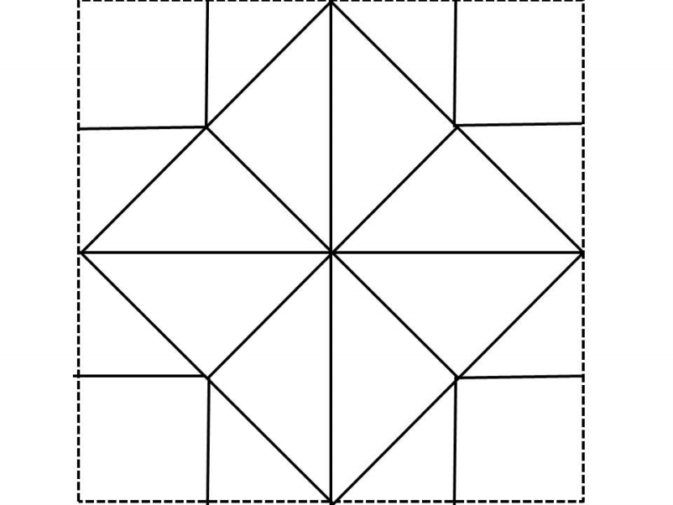
Yellow
Green
Red
Blue
2
Feelings
3
Coping Skills
4
Feelings
1
Coping Skills
5
Coping Skills
6
Feelings
7
Coping Skills
8
Feelings

