Character Trait Lessons
Counselor bulletin board:
(SPEECH BUBBLES) Trait in the center with speech bubbles around. Each class gets a speech bubble on colored paper (different colors for different grade levels). The class can read a book, discuss the trait, and come up with their definition. Post speech bubble definitions on the bulletin board. Change traits every 6 weeks.
(PACMAN) Pacman trait. Each of the white “food” pieces are a way to do the selected character trait. Each class gets a page of bubbles. The class can read a book, discuss the trait, and/ or combine with Cultivating Culture/Mesquite United. Change traits every 6 weeks.
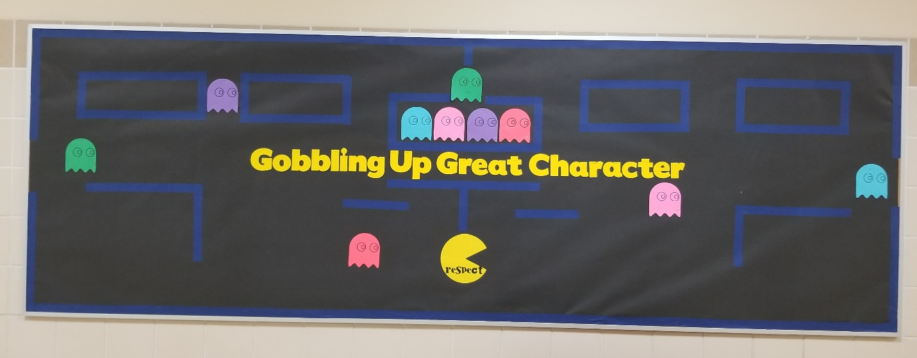

Email to teachers:
Hey everyone!
It’s time for our ____ Character Trait: __________________!
We will be introducing a new character trait every 6 weeks. With the exception of the first trait, each Character Counts trait will be paired with a trait from Mesquite United Cultivating Culture. These are required! You will introduce the traits in your Monday Morning meeting or in a whole group circle.
What: There will be a basket of already cut bubbles in the work room. Take what you need! BIG shout out to Mrs. Lefan’s class for punching all those circles for us!!! Way to show service!!! In your Monday Morning Meeting, discuss what the traits mean with your class, and come up with ways to show the character trait on the bubbles. Return the bubbles to me!
How: Show your kiddos the word or a picture book and have a discussion. Show your kiddos the required video of the book (first link). You can also use the additional resources to help start the discussion.
Use the following links to find suggestions for picture books!

REQUIRED: ___________ video (you’ll recognize the reader!):
(add in link to the book for this 6 weeks)

Additional resources:
(Add in the corresponding link from below and delete this note)
https://ats.apsva.us/wp-content/uploads/legacy_assets/ats/e7c909cc71-character-traits-hfj.pdf
Thanks to everyone who turned in their bubbles!

Respect
https://www.romper.com/p/9-childrens-books-that-teach-your-child-what-respect-really-means-17435
https://talkingtreebooks.com/best-character-education-resources/books-respect.html

Caring/EMPATHY
Stand in My Shoes
http://www.the-best-childrens-books.org/teaching-compassion.html
https://www.scholastic.com/teachers/blog-posts/genia-connell/100-books-build-character/#Caring and Compassion

Citizenship/SERVICE
Harry the Happy Mouse
http://www.doinggoodtogether.org/bhf-book-lists/picture-books-about-citizenship
https://www.scholastic.com/teachers/articles/teaching-content/citizenship-books-and-activities-13-terrific-titles-and-what-do-them/

Responsibility/GRIT
Perseverance: I have Grit
https://www.pragmaticmom.com/2014/04/books-kids-responsible/
https://talkingtreebooks.com/best-character-education-resources/books-responsibility.html

Fairness/EMBRACING DIVERSITY
Do I Look Odd to You https://www.youtube.com/watch?v=FLu3IAZklpE OR https://www.youtube.com/watch?v=XLKxn9OUsp0
https://www.librarything.com/tag/fairness
http://readingyear.blogspot.com/2014/08/picture-books-10-for-10-fairness.html
Send this picture too
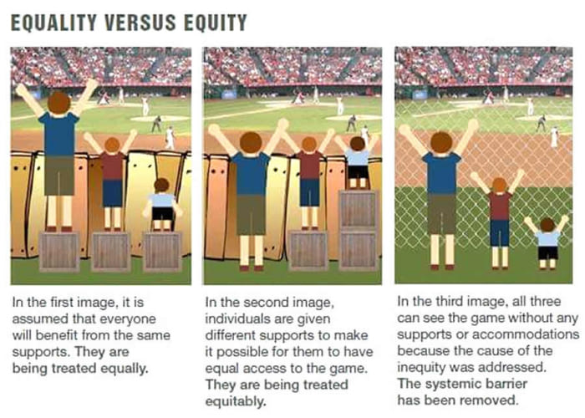
Trustworthiness/INTEGRITY
Stand Tall-A Book about Integrity https://www.youtube.com/watch?v=GAzCxLAnBR8
https://www.scholastic.com/teachers/blog-posts/genia-connell/100-books-build-character/#Honesty
https://www.earlychildhoodeducationzone.com/best-childrens-books-about-honesty/

