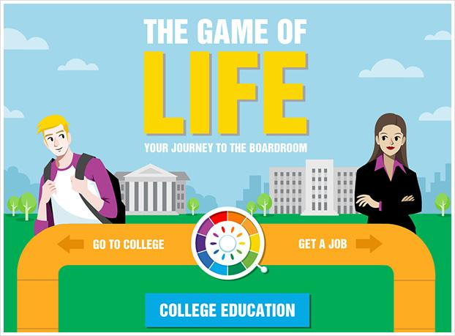
Guidance Plan: Rugel Elementary

(This is an example of a guidance plan before we
added the brain lessons and settle your glitter.)

Character Education: MISD Cultivating Culture, PBIS, Circles & R-Time

Character Education: PBIS & R-Time

College Week #1: Sept. 19-23 Bully Aware. Week: Nov. 14-18
Red Ribbon Week: Oct. 24-28 College Week #2: Feb. 6-10
Donation Week #1: Oct. 31-Nov. 4 Donation Week #2: March 6-10

K-2 General Topics

*Interpersonal Relationships:
Personal space, Feelings, Manners, Cooperation, Friendships, Listening to others
*Self-Esteem
*Safety
*WHO (2nd)
*Career Exploration (PAWS in Jobland - 2nd)
*Tattling vs. Telling
*Problem Solving
*Making decisions
*Describe the relationship between behaviors & good/bad consequences
*Being self-disciplined

K-2

K-2 Bully Prevention

*Empathy
*Respect for Others
*Conflict Resolution
*Understanding similarities/differences

August
K
Kindergarten

- The Counselor’s Role: Meet Mrs. Keezel, Potato Head. I memorize student names by end of class. “Learning each other’s names makes us feel special” (Ron Clark). Teach the “Goodbye Song”.

September
- Brain Lesson-Introduce parts, puppy puppet for amygdala, importance of calming and preview about how. Brain song. (will be tied in to all lessons as applicable)

October
- Revisit brain. The Way I Feel. Apple Talk Game about feelings using “I Statements”. Song, “When you’re mad and you know it say I’m mad…” “Friends use words to tell how they are feeling.” (different wording)

November
- Personal Space: “Tad Too Close” story. Personal Space Song and Hokie Pokie practice. “People Don’t Like it When You’re Too Close”
- Possibly some management training and following directions.

- “Will You Play with Me?” (from Social Studies Alive) Friendship/Refusal Skills. “Friends let friends play with OTHER friends.”
December
- SafeSide Super Chick-All together
- Helping vs. Hurting (tattling vs. telling)

January
- Manners: “Interrupting Isaac”.

February
- Manners: Vinnie says “Excuse Me”. Vinnie practices “Excuse Me”. (two parts back to back). Teach “Herman the Worm” Song.

March
- Careers/College: Career Puppets. Connections between careers and college. Rhino Talk Game: “I’m going to college, so I can be a __________.”
April
- “Four Key Steps to Solving a Problem” song. Lucky Ladybug & Buddy Bee skit. (From Social Studies Alive)

May
- “The Boy Who Cried Wolf” story with puppets. Honesty.
- The Great Lego Challenge (culminating activity)

August/September
- “The Counselor’s Role”-Potato Head. Further explanation of my role, some personal pictures, meeting new students,
recalling names of returning students.

October
- Howard B. Wigglebottom Learns to Listen. Wear rabbit ears to illustrate. Activity: “If Game”. Attentiveness/Self Control. Review personal space/song. Hokie Pokie practice w/o getting in other’s space.
1
First Grade

- Being self-disciplined: Can’t/Try, fit the class in a piece of paper

November
- Problem Solving. Review 4 Key Steps and Song. Practice Activity. (from Social Studies Alive) Review.
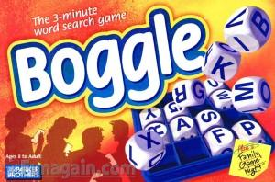
- Elmer the Elephant. Self Esteem, Differences. How are we different? How should friends treat each other when we’re different? Activity: Decorate Elmer for the Elmer’s Day Parade. All designs must be unique.

December
- SafeSide Super Chick-All together
- Helping vs. Hurting (tattling vs. telling) –Red/Green?

January
- Safety: Officer Buckle and Gloria, book and puppet. (same day)

February
- Roses are Pink, Your Feet Really Stink. Teasing, put-downs. Communication. Tear the heart activity. Empathy.

March
- Career Puppets. College to career connection.

April
- Safety: “Safe Side Super Chick” video. Comprehensive coverage of safety including bike safety. (put classes together)…Longer lesson.
- (Administering STAAR Test)

May
- Tower Challenge w/ straws and tape. Or Teamwork Challenge: The Great Lego Challenge. Problem Solving. (Culminating Activity)

2
Second Grade

August/September

2
Second Grade

- “The Counselor’s Role”-Power Point. Further explanation of my role, some personal pictures, meeting new students, recalling names of returning students.

October
- Personal Space Camp, by Julia Cook (self-control)
- STAR (Stop Think Act Review). Make posters for school as well.
- Give information about threats, talk of fights, “groups”, “B” word (bully investigation)

November
- Enemy Pie. Friendship, empathy, problem solving.
December
- Simons’s Hook and TeaseProof Steps

January
- How to Lose All Your Friends. Tie in to empathy. Activity with water, die, bowl, etc. (pushing friends
away) (Other grade level?)

February
- Don’t Squeal Unless It’s a Big Deal, with puppet and pipe cleaner reminders for pencils. Tattling vs. Telling.
- OR Helping vs. Hurting (red/green)

March
- Career Puppets and College (Rhino Talk Game)

April
- Matching Manners Activity. Twin Talk. “If I want __________ then I need to ________________________. Or People want __________________ just like I want __________________” Golden Rule (bring something golden…maybe each time…a hat?) Do this activity with various lessons.
- (Administering STAAR Test)

May
- PAWS in Jobland

3-6
3-6 General Topics

*Cliques
*Decision Making
*Problem Solving
*Diversity and disability awareness (3rd & as needed)
*Career Exploration
*Anxiety/Stress (identifying & managing- including testing anxiety)
*Feelings (recognize, express, & manage their feelings in different situations)
*Positive feelings of their self-worth (positive self-talk)
*Internet, social media, and cell phone safety (4th-6th)
*Developing academic potential
*Goal setting (short-, intermediate-, and long-term)
*Peer Pressure/Refusal Skills
*Taking responsibility for their own behavior
*Sexual Harassment (5th and/or 6th)
*Dating Violence (6th)
*Transition to Middle School (6th)

3-6 Bully Awareness

*Empathy
*Respect for Others
*Conflict Resolution
*Bystanders
*Cyberbullying

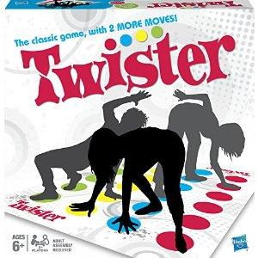

August
3
Third Grade

- “The Counselor’s Role”-Power Point. Further explanation of my role, some personal pictures, meeting new students, recalling names of returning students.

September
- Bully, by Judith Caseley. Review Tease Proof Steps.
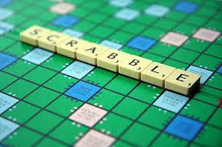
- Bully Busters Bingo
- Give information about threats, talk of fighting, “B word” (bullying investigations)

October
- STAR (Stop Think Act Review). Make posters for school as well. ???

November
- Simons’ Hook and TeaseProof Steps

December
No formal lesson. Lessons upon request and as need.

January
- Solution/Problem (student roles)

February
- Differences/Diversity (Lessons from Kristie Smith-Armand)

March
- College and Career Puppets-student partners present using puppets

April
- Different, Just Like Me!, Lori Mitchell. “Mingle, Mingle” Activity.

May
- (STAAR Testing)
4
Fourth Grade

August
- “The Counselor’s Role”-Kahoot! Further explanation of my role, some personal pictures, meeting new students, recalling names of returning students.

September/October
- What if Everybody Did That?

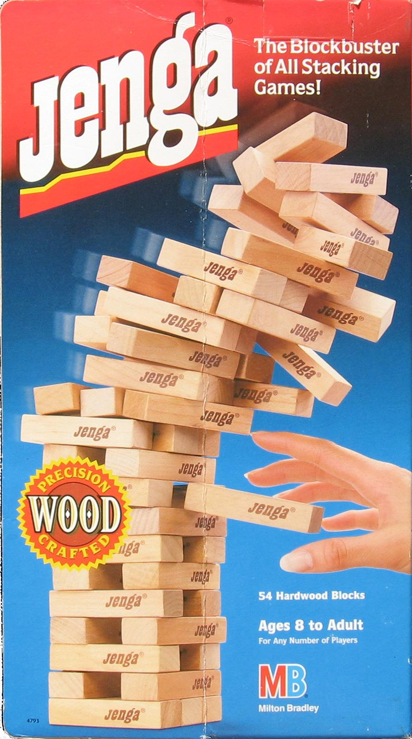
October
- Internet Safety/Netsmartz

November
- Bullying. Peer pressure. Being a by-stander: The Bully Blocker’s Club. Review the Tease Proof Steps.
(maybe a different delivery)

December
- Lessons upon teacher request.

January
- Drug Prevention/Awareness: LETS-Law Enforcement Teaching Students

February
- Drug Prevention/Awareness: LETS-Law Enforcement Teaching Students

March
- College and Career Puppets-student partners present using puppets (more detailed)

April-chose from
- “M&M Madness” from Activities that Teach. Decision-making, peer pressure. Goals.
- Character BINGO , maybe other
- Jeopardy Review Game.

May
- (STAAR Testing)

5
Fifth Grade

August
- “The Counselor’s Role”-Kahoot! Further explanation of my role, some personal pictures, meeting new students, recalling names of returning students.
- Growth Mindset

September
- Suicide Prevention: MISD Video and I am/You Are Activity
- Salt in His Shoes (about Michael Jordan). Perseverance. Focus on the Goal, not the Obstacle. Mind Power Activity from Activities that Teach (washers on a string). Positive self-talk.

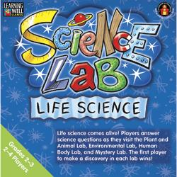
October
- Bullying: definition, types, roles, what to do. Review Teaseproof Steps. (maybe before Broken Toy)?
- The Broken Toy: Bullying

November
- Drug Monster lesson

December
- Human Growth and Development Video (with girls while nurse teaches the boys).

January
- What if Everybody Did That?

February
- Anxiety/stress- “Stress Test”. Discussion: What is stress? How do I react to stress? Things that cause me stress. Ways to handle stress.

March
- (STAAR Testing)

April
- “Values Auction” (from Activities that Teach)…Longer lesson

May
- Jeopardy: Culminating all of the skills we’ve talked about this year (maybe)

6
Sixth Grade

August
- “The Counselor’s Role”-Kahoot!. Further explanation of my role, some personal pictures, meeting new students, recalling names of returning students.
- Growth Mindset

September
- Suicide Prevention: MISD Video and I am/You Are Activity

October
- All-Bullying review: types, including female aggression, courageous bystanders, help from adults. Give information about threats, talk of fighting, and “B Word” (bully investigations). “ More here…..(reverse November order?)

November
- Should I Say Anything?”: Being a part of the solution, not the problem. Interactive discussion on Promethean Board, including secret voting.

December
- Human Growth and Development Video (with girls while nurse teaches the boys)

January

February
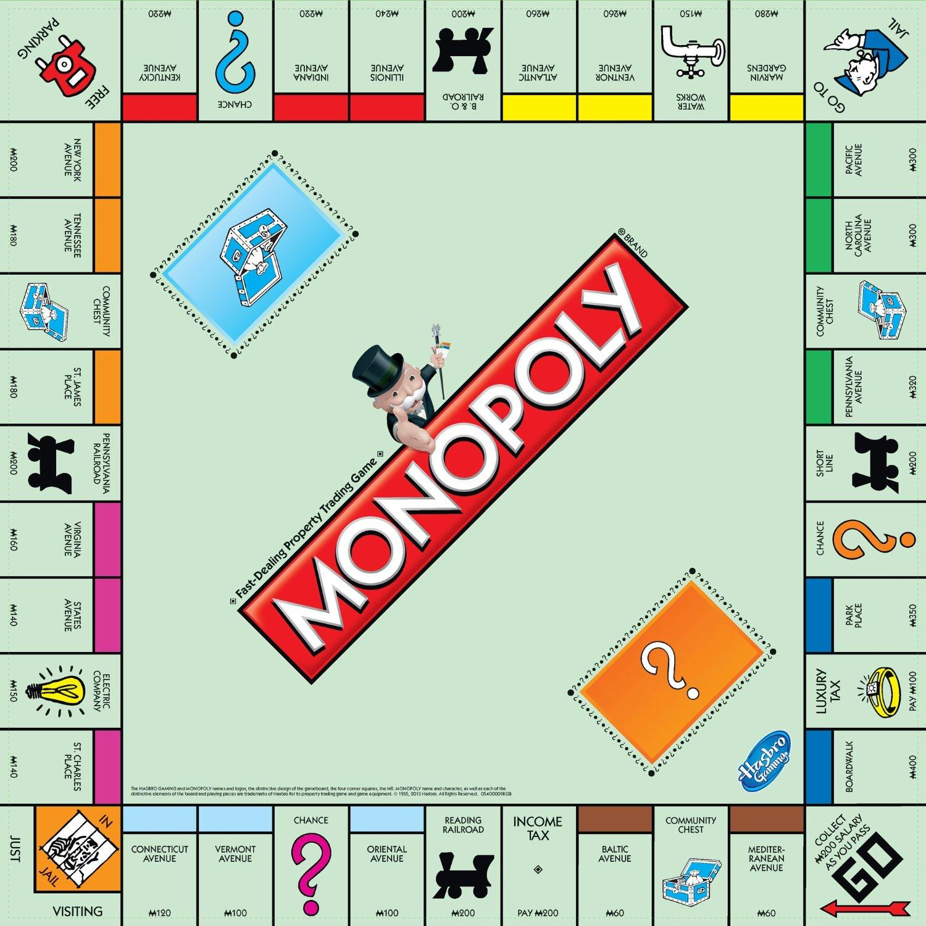
- The Sneetches. Cliques, differences, prejudice, peer pressure./Trevor Romain, “Cliques…”? Empathy.

March
- Transition to Middle School: Moving On books and discussion/questions, combination locks

April
- MISD Career and Technology booklets.
- Visit from MMS Registrar, Class Registration

May
- (STAAR Testing)
- Virtual College Field Trip/Virtual Career Field Trip (move this to before registrar visit?)

Extra Lessons for Various Grade Levels:
“
Bad Case of the Strips (tie in to empathy and bullying/teasing, accepting self)
Character BINGO”. Inventory of what we have already and what we need to work on.
Mr. Peabody’s Apples. Rumors. Activity: Telephone Game
Jeopardy: Culminating all of the skills we’ve talked about this year.
“Yellow Dyno” video (safety)…certain parts
Armadillo Tattletale. Rumors. (Leave class with writing assignment.)
Teaseproof Steps (review for different grade levels when necessary)
Mert the Blurt
Some Smug Slug (obedience)
“Elbert’s Bad Day” (video)…preview again
Mystery Careers “Living Statues”
(Memory game-On second round, students must remember all who went before them.)
How to Lose All Your Friends. Friendship skills, appropriate behavior.
It’s a Spoon, Not a Shovel. Manners.
“Alexander and the Terrible, Horrible, No Good, Very Bad Day”-video
Different Just Like Me. Diversity. Accepting differences.
Quest
TeaseProof and introducing myself

Lessons available as needed:

Perfectionism
Procrastination
Peer Relations
Expectation of others
Expectations of Self

The Fish Who Cried Shark (pop-up book). Honesty.
The Wolf Who Cried Boy. “Tell the Truth” song. Honesty.
Bob and Otto. Friendship (spring related)
“Sally Strawberry” with finger puppets. Stealing/Honesty.
Trevor Romain Videos
Getting Along Series Videos
Stop Bullying Now Video
“Toby the Test Taking Toucan” story and activities.
I statements. Golden Rule.
Do Unto Otters
Eggbert. Put ups/downs.
“I Was Just Kidding” video, Sunburst Media
Jelly Heart activity.
Conflict Resolution Training
Conflict Resolution Song, “Let’s Work it Out”
Peer Mediation Training
Boundaries Activity. Discussing ages. (from Developmental Assets.) Milling Activity
Million Dollar Activity (drugs), from “Activities that Teach”.
Dear Abby Letters/Dear ______ Grader (with drug and decision making scenarios)
Back to Back Drawing. Communication. Activities that Teach pg. 76
STAR (Stop Think Act Review). Make posters for school as well.
Is there Really a Human Race? (older kids? Preview again.)
6-ball Toss. Helping each other with crowd control. “The more you can handle, the more your teacher will be able to let you do.”
Hunter and His Amazing Remote Control (self-control)

