Secondary Transition:
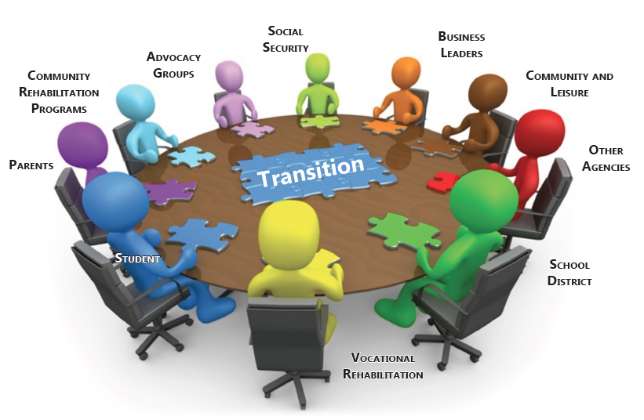

A Collaborative Planning Process

Table of Contents

What is Transition?
Transition At-a-Glance
Career Development
Secondary Transition and IDEA Requirements
Definitions
Secondary Transition
Exit Options
Considerations for Secondary Transition
Transition Planning
The Role of the IEP Committee Members
Transition Planning Process
Step 1: Measurable Post-Secondary Goals
Step 2: Present Levels of Academic Achievement and Functional Performance
Step 3: Transition Services
Step 4: Measurable Annual Goals
Changing Graduation Options
Age of Majority
Considerations for Students with Significant Cognitive Disabilities
Person-Centered Planning
Evaluating Your Transition IEP
Resources
References
Appendix
Appendix A: Student-Directed Summary of Performance
Appendix B: District-Directed Summary of Performance
Appendix C: Transition Portfolio
Appendix D: Mississippi Accountability Standards Appendix A
Appendix E: Mississippi Occupational Diploma
Appendix F: Mississippi Accountability Standards Appendix G
Appendix G: Mississippi Occupational Diploma Any Combination Worksheet
Appendix H: Mississippi Accountability Standards Appendix C
Appendix I: NCAA Division I and II Initial-Eligibility Requirements
Appendix J: Transition Worksheet
Appendix K: Sample Transition Activities Pre-school to Adulthood
Appendix L: Transition Assessments for Students with Significant Disabilities
Appendix M: Indicator 13
Appendix N: My Interests, Hopes and Dreams
Appendix O: Applying Personal Preference Indicators
Appendix P: Job Characteristics I Like Worksheet
Appendix Q: Life Skills Inventory
Appendix R: Modified Informal Assessments from the Quickbook of Transition Assessments
- Student and Family Interview
- Parent Interview
- Student Interest Questionnaire
- Competencies to Pursue: Supported Employment
- Competencies to Pursue: Vocational Training
- Competencies to Pursue: Four Year College
- Competencies to Pursue: Competitive Employment
Appendix S: Modified Informal Assessments from Prince Edward Schools
- Teacher Observation
- School and Community Skills Checklist
- Community Information Summary
- Communication Summary Form
- Adolescent Autonomy Checklist
- Questions to Guide the Transition Process
- Learning Style Preference Inventory
- Self-Determination/Self-Advocacy Checklist
- Describe Yourself!
Appendix T: Sample Forms from Hudspeth Regional Center
- Communication Guide
- Modes of Communication/Communication Functions
- Comprehensive Functional Assessment Vocational Skills
- Self-Direction/Banking Skills
- Music and Art Ideas for Leisure Time
- Resource Materials for Individuals with Developmental Disabilities
Appendix U: Sample Forms from DeSoto County Schools
- Student Invitation to an IEP and/or Transition Meeting
- Academic Achievement Record Review
- Exit Option Fact Sheet
- DeSoto County Schools Transition Planning Form
- Steps for a Student Conducted IEP Meeting
Appendix V: Sample Forms from Oxford County
- Transition Planning Assessment: Middle School/Junior High School
- Transition Planning Assessment: High School
Appendix W: Sample Forms from Lamar County School District
- Student Invitation to IEP Meeting
- Special Education Exit Option: Certificate of Completion
- Transition Planning: Parent Survey
- Special Education Exit Option: General High School Diploma
- Graduation/Exit Options Fact Sheet
- Exit Summary of Performance
- Special Education Exit Option: Mississippi Occupational Diploma
- Mississippi Occupational Diploma Courses
- Parent Letter for Transition Planning (SCD)
- Parent Transition Survey (SCD)
- Parent Letter for Transition Planning (Middle and High School)
- Parent Transition Survey (Middle and High School)
- Graduation Requirements
- Student Survey (SCD)
- Student Survey (High School)
- Student Survey (Middle School)
Appendix X: Sample Forms from Jackson County School District
- Community-Based Learning Non-Paid Work Experience
- Employment Plan
- Job Analysis Form
- School-to-Career: Job Shadowing
- Job Shadowing Interview Form
- Job Shadowing Employer Evaluation Form
- Peer Mentor Goals
- The Golden Rules of Employment
- Demographic Information
- Post-School Survey
- Vocational Transition Assessment: Third-Fifth Grades
- Vocational Transition Assessment: Sixth-Eighth Grades
- Vocational Transition Assessment: Ninth Grade – 21 Years

What is Transition?

Merriam-Webster dictionary defines transition as the passage from one stage or place to another. For all children, transition occurs from preschool to elementary school, elementary school to middle school, middle school to high school, and high school to adulthood. For student with disabilities, each stage in transition requires thoughtful planning to ensure that the students with disabilities are able to transition from one level to next level smoothly. The ultimate goal for these students is to exit high school to their desired post-secondary outcome.

Even though, Policy 7219 requires transition services to begin at age 14, or younger if determined appropriate by the IEP committee, transition for all students begins much earlier.

Transition At-a-Glance
Preschool-Elementary School
- Career Awareness
- Acquisition of general knowledge
- Development of emerging social skills, decision-making skills, and self-advocacy skills
- Development of work ethic and responsibilities

Middle School
- Career Exploration
- Acquisition of general knowledge
- Development of social skills, decision-making skills, self-advocacy skills, and self-determination skills
- Development of work ethic and responsibilities
- Identification of preferences, needs and interests
- Complete the iCAP
- Development of Transition Plan (Age 14)
High School
- Career Preparation
- Demonstrate of general knowledge
- Implementation of social skills, decision-making abilities, self-advocacy skills, and self-determination skills
- Demonstration of work ethic and responsibilities
- Implementation of Transition Plan
- Review/revise iCAP
Post-Secondary Outcomes
- College or University | - Military
- Job Corps | - Career/Technical School
- Competitive Employment | - Apprenticeships/Internships
- Supported/Integrated Employment | - Customized Employment

Transition and Career Development

Career development is an essential component of transition. Donald Zunker (1994) refers to career development as “a lifelong process of developing beliefs and values, skills and aptitudes, interests, personality characteristics, and knowledge of the world of work. Specifically, the terms reflect individually developed needs and goals associated with stages of life and with tasks that affect career choices and subsequent fulfillment of purpose.” (Zunker, 1994, p. 3).

Career Awareness

Career awareness includes an understanding of the world of work and the knowledge and skills needed for traditional and nontraditional jobs and careers. Students are aware of opportunities, options, and roles that interest them in the world of work. They gain an awareness of the importance of personal responsibility, good work habits, and how people work.

Activities for the students includes, but is not limited to:
- Understanding the importance of working
- Acquainting students with local places of employment
- Understanding the need for cooperation and teamwork

Career Exploration

Career exploration includes investigation of the workplace and an understanding of the relationships among personal abilities, education, and knowledge and skills needed to pursue occupations and careers. Students learn about the variety of careers available and the types of jobs that would best fit their preferences, needs, and interest and explore the requirements related to those jobs.

Activities for the students includes, but is not limited to:
- Becoming aware of personal characteristics, interests, aptitudes, and skills
- Development of an awareness of and respect for the diversity of the world of work
- Understanding the relationship between school performance and future employment options
- Development of a positive attitude towards work

Career Preparation

Career preparation includes the purposeful planning of activities that help students transition from the school to the world of work and higher education. It includes learning about different careers and exploring skills needed to be successful in those careers, implementing skills that have been fostered and developed while in school and the successful transition from the secondary to post-secondary environment.

Activities for the students includes, but is not limited to:
- Volunteer
- Service Learning Activities
- Apprenticeships/Internships
- Job Shadowing
- Part-time/Full-time Supported Employment and/or Integrated Employment
Secondary Transition and IDEA Requirements

Individuals with Disabilities Education Act (IDEA) 2004 defines secondary transition services as a coordinated set of activities for a student with a disability that is designed within a results-oriented process focused on improving the academic and functional achievement of the student with a disability to facilitate movement from school to post-school activities, including post-secondary education, vocational education, integrated employment (including supported employment), continuing adult education, adult services, independent living, or community participation. The coordinated set of activities include instruction, related services, community experiences, development of employment and other post-school adult-living objectives and, if appropriate, acquisition of daily living skills and a functional vocational evaluation. These activities are based on the individual student’s needs, taking into account the student’s strengths, preferences and interests.

Definitions

Coordinated set of activities is a planned and organized sequence of activities based on the student’s preferences and interests, which promotes the movement of a student from school to post-secondary adult living. It involves a collaborative effort among various agencies to provide transition services to the student.

Results-oriented process is a series of meaningful events to assist the student in achieving desired post-secondary outcomes.

Post-secondary education is an organized educational program provided by qualified personnel that is available beyond secondary education including community colleges, vocational-technical colleges and four-year colleges and universities.

Vocational education is specialized instruction and practice, by qualified personnel, in a specific field to prepare students to enter into, continue, or upgrade employment in recognized trades or occupations.

Integrated employment is paid work in sites and settings that are not unique to individuals with disabilities.

Supported employment is paid work that requires the use of designated personnel to assist individuals with disabilities in acquiring and maintaining site-specific skills.

Secondary Transition

Secondary transition is a component of the IEP that should be addressed by age fourteen (14) years old, or younger if determined appropriate by the IEP committee. The IEP will include:

- Appropriate measurable post-secondary goals based upon age-appropriate transition assessments related to training, education, employment, and, where appropriate, independent living skills;
- Transition services (including courses of study) needed to assist the student in reaching post-secondary goals identified on the IEP.

A student with a disability must be invited to participate in his or her IEP meeting if the purpose of the meeting is to consider post-secondary goals for the student and to identify transition services needed to assist the student in goal attainment. If the student is unable to attend the meeting, the public agency must ensure that the student’s preferences and interests are considered.

When students exit from special education, public agencies are required to provide them with a Summary of Performance (SoP) or Transition Portfolio to facilitate their transition to desired post-secondary settings.

- Summary of Performance: Public agencies will ensure that a SoP is created for a student that has exited with a standard high school diploma or due to exceeding the age of eligibility. It provides a summary of academic achievement and performance along with recommendations concerning how to assist the student in meeting post-secondary goals. The SoP is to assist the student in the transition from high school to higher education, training and/or employment. (See Appendix A: Student-Directed Summary of Performance and Appendix B: District-Directed Summary of Performance)

- Transition Portfolio: Public agencies will ensure that a Transition Portfolio is created for each student with a disability who exits secondary school without a standard high school diploma (Mississippi Occupational Diploma or Certification). It documents the preparation of students with disabilities for independent adult living. The Transition Portfolio is intended to be a practical tool for documenting the efforts of the student, his or her family, teachers and other service providers to ensure a smooth transition to post-school opportunities. (See Appendix C: Transition Portfolio)

Exiting Options for Consideration

The IEP Committee is required to identify a student with a disability’s exiting option. The options afforded are as follows:

- Standard High School Diploma: There are three pathways to achieve a standard high school diploma: Traditional, District, and Career Pathways. (See Appendix D: Mississippi Accountability Standards Appendix A)

  - The Traditional option requires students to earn a minimum of twenty-four (24) Carnegie Units and achieve a passing score on required high school examinations.
  - The District option requires students to earn a minimum of twenty-one (21) Carnegie Units and achieve a passing score on required high school examinations.
  - The Career Pathways option requires students to earn a minimum of twenty-one (21) Carnegie Units, of which four (4) of the Carnegie Units have to be in Career and Technical Education, and achieve a passing score on required high school examinations.

- General Educational Development (GED): The GED Option is a program that is offered by a select number of school districts. This is a viable option for students who have the capabilities to complete high school requirements, but are behind in the credits needed to graduate with their class and are at risk of leaving school.

- Mississippi Occupational Diploma (MOD): The MOD requires a student with a disability to earn 21 credits by successfully completing selected courses from the general education curriculum, vocational education programs, MOD portfolio objectives or a combination of these courses, create an occupational diploma portfolio, and successfully complete a two-year Career/Technical (Vocational) Program or document a minimum of five hundred forty (540) hours of successful, paid employment. Its primary focus is to teach employability skills and prepare students with disabilities for competitive employment. (See Appendix E: Mississippi Occupational Diploma; Appendix F: Mississippi Accountability Standards Appendix G; Appendix G: Mississippi Occupational Diploma Any Combination Worksheet)

- Certificate: A student with a disability that is unable to meet the requirements of the above exiting options will exit with a Certificate.

Considerations for Secondary Transition

There is a disconnect between secondary and post-secondary expectations because parents and students with disabilities are not well informed of the differences in the rights and responsibilities of schools and students between secondary school and post-secondary settings (e.g., colleges/university and employment); and educators and parents are unaware of the policy differences between IDEA at the secondary level and Section 504 and Americans with Disabilities Act (ADA) at the post-secondary level. Schools must provide students and parents information so that they can make informed decisions about their child’s future options and prepare for life after high school. Considerations are as follows:

- Secondary personnel, parent(s), and student(s) need to be aware that post-secondary level institutions/environments have different expectations and obligations than secondary schools.
- It has to be clear that the specific accommodations or supports are just recommendations that do not limit the independent decision-making of personnel at the post-secondary level.
- Section 504 and the ADA require students to self-identify and provide documentation of their disability in order to be eligible for accommodations and services in post-secondary settings. As a result, students with disabilities must have opportunities to make choices and decision and to practice self-advocacy skills to prepare to transition after high school.
- Post-secondary schools provide supports based on what is reasonable rather than what is appropriate or least restrictive. Support services and accommodations are based on providing access to content and reduction of barriers to learning rather than promoting achievement.
- Documentation of disabilities varies widely between post-secondary schools and students must be aware of those requirements as they apply to the different schools.
- Most post-secondary schools do provide some level of support, but the type and scope of this support varies widely among institutions.

Comparison of Secondary Education and Post-secondary Education

Secondary Education | Post-Secondary Education
- Individuals with Disabilities Act 2004 (IDEA)  - School districts are not required to complete evaluations before a student exits high school  - Focuses less on formal testing and more on monitoring student progress (e.g., progress monitoring) | - Americans with Disabilities Act Amendments Act (2008)  - Most IHLs require documentation that identifies specific disabilities and current functional levels  - Most adhere to documentation guidelines that specify types of information required to receive disability services
Comparison of Secondary Education and Vocational Rehabilitation

Secondary Education | Vocational Rehabilitation
- Individuals with Disabilities Act 2004 (IDEA)  - Mandated with Child Find  - Mandated to evaluated if a student is suspected to have a disability  - Eligibility determined by:  - Meeting the criteria for one of the 12 disability categories identified by IDEA and State Board Policy 7219; and  - The student requires special education and related services to progress in the general education curriculum. | - Section 504 of the Rehabilitation Act of 1973  - Consumer must self-identify their disabilities  - Consumer must provide documentation to become eligible for services  - Eligibility determined by:  - A physical or mental impairment that constitutes or results in a substantial impediment to employment;  - Consumer benefits from VR services in terms of employment outcome; and  - Consumers require VR services to prepare, secure, retain or regain employment.

Transition Planning

Transition planning is the process that provides assistance to students, parents, and school personnel as they discuss and plan transition from school to adult life. This planning will include assessing interest and strengths; setting transition goals; and selecting the course of study and exit option; and services and agency linkages needed to meet the transitional goals for students with disabilities. Transition planning can begin as early as elementary school. School personnel should begin the process with students and parents to discus the educational progress and needs of the student, taking into consideration the expectations and aspirations of the student. The process should include discussions concerning future goals and the skills that are needed to support the transition goals.

When the student is in middle school, school personnel should begin using career assessments to identify the career interests, abilities and needs of the student. The assessment data should be utilized to develop appropriate programming including the courses of study that focus on preparing the student to meet his/her post-secondary goals. Public agencies/schools must provide information to students and parents regarding different diploma/exit options for students with disabilities.

The transition planning process is an ongoing process that can change over time, depending on the student’s preferences, strengths, and interests. Further discussions and information sharing can and should be covered during the IEP meeting held before the student enters 9th grade.

The Role of the IEP Committee Members

Student’s Role

Beginning at age 14, or earlier if appropriate, students with disabilities should participate in the development of their individualized education programs. During the eighth-grade IEP Committee meetings, students should take an active role in selecting their graduation option and determining the needed courses of study based on their post-school outcomes.

Students with disabilities must learn and use self-determination/self-advocacy skills to become active participants in making educational decisions that will affect their future. The student must learn to identify his/her strengths and needs and have an understanding of his/her rights.

The student should:
- Participate actively in all discussions and decisions.
- Communicate his/her strengths, preferences and interests.
- Communicate his/her areas where help is needed.
- Communicate how he/she is doing in classes and what accommodations, modifications and supports to be successful in the general education classes.
- Communicate how he/she is doing with his/her community experiences and what accommodations, modifications and supports to be successful in those environments.
- Take the opportunity to lead his/her own IEP meetings. This participation will likely require coaching, training and practice.

Parents’ Role

Parents must be advocates for their children. They are responsible for keeping the committee focused on the student’s transitional needs and goals. Parents’ many responsibilities in transition include the following:
- Learn all you can about the post-high school options and resources available to the student.
- Discuss with the student his/her future goals.
- Determine how much assistance the student will need to acquire independence.
- Share information with the IEP Committee about the student’s strengths, needs, and preferences.
- Assist the student in the development of self-advocacy skills.
- Provide supplemental support for the student, e.g., providing transportation to and from a job site if appropriate.
- Ensure that the IEP goals are being accomplished.
- Ensure that academic advisement is provided for students choosing post-secondary education as a post-school outcome.
- For students not bound for post-secondary education, ensure that their IEP addresses community-based vocational training/mobility and travel training/community-based life skills instruction.
- Help ensure that needed curriculum adaptations and environmental modifications are made.
- Monitor student’s progress on goals that are stated in the IEP and transition plan.

School’s Role

Special Education Teacher:
- Provide information on the student’s strengths, past achievements and progress on the current IEP.
- Provide strategies for effectively teaching the student, including appropriate accommodations and/or modifications so the student can successfully access and progress in the general curriculum.
- Suggest courses of study and educational experiences that relate to the student’s preferences and interests and that provide a foundation and skills to help the student achieve his or her desired post-school goals.
- Identify needed related services.
- Provide appropriate input into transition service needs and post-secondary agencies, services and/or supports and incorporate those into the IEP.
- Link students and parents to the appropriate post-school services, supports or agencies before the student leaves high school.
- Coordinate all the people, agencies, services or programs in the transition planning.

LEA Representative:
- Support the special and general education staff.
- Allocate the necessary resources to ensure that the IEP is implemented.

Regular Education Teacher:
- Assist in planning the courses of study in the general curriculum that will assist the student in achieving his or her desired post-secondary goals.
- Assist in identifying and providing needed modifications, adaptations and supports for school personnel to assist the student in the regular education setting and on State- and district-wide assessments.
- Assist in identifying and providing needed positive behavioral strategies or interventions to assist the student in the regular education setting.

Agency’s Representative

- Provide information about services and eligibility criteria for community or adult services and supports (e.g., college support services and financial aid, vocational rehabilitation services, family services, social security work incentives).
- Help explain the differences between the entitlement of school programs and eligibility of adult services.
- Assist in identifying community or adult services that may assist the student in achieving his or her post-school goals.
- Assist the student and his or her family in application processes for supports and services at colleges, training institutions, or adult services, as appropriate.
- Alert families and the school to potential waiting lists for services.
- As appropriate, provide services to the student prior to exiting the school system.

Best Practices for Student-Directed IEPs:

- Provide instruction in the classroom setting on self-determination/self-advocacy skills and skills related to understanding the purpose of the IEP process.
- Provide instruction on the legal rights of an individual with a disability and the impact of having a disability.
- Provide instruction on the transition services required under the Individuals With Disabilities Education Act (IDEA).
- Include students with disabilities in the development of their four-year educational/career plan.
- Role-play IEP meetings to help students understand the IEP process and requirements.
- Encourage the students to advocate and conduct their IEP Committee meeting.
- Encourage students to communicate with school personnel to monitoring progress toward the IEP goals.

Transition Planning: The Process

Step IV:
Measurable Annual Goals
Step III:
Transition Services
Step II:
Present Levels of Academic Achievement and Functional Performance
Step I:
Measurable Post-Secondary Goals
IDEA 2004
IEP Results Process for Transition Services
(See Appendix J: Transition Worksheet)
Ed O’Leary ©Copyright
Includes: Course of Study

Includes:
- Instruction
- Related Services
- Community Experiences
- Employment and other Post-School Adult Living Objectives

When appropriate:
- Daily Living Skills
- Functional Vocational Evaluation
- Training
- Education
- Employment
- Independent Living Skills – where appropriate
Age-Appropriate Transition Assessments

Step 1: Determine the student’s measureable post-secondary goals.

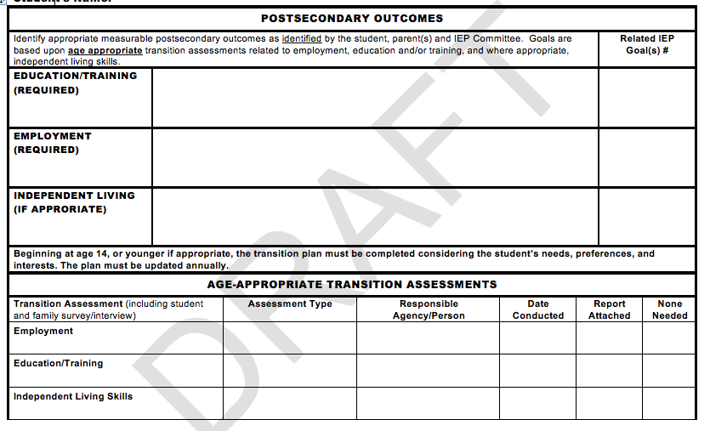

IDEA 2004 requires school districts to determine the student’s post-secondary goals in the areas of employment, education or training, and independent living (if appropriate) based on age-appropriate assessments. Measurable post-secondary goals is the desired outcome that will occur after the student leaves high school and will answer the question: What will a student do after graduation (enroll, attend, work, etc.) in the areas employment, education/training, and independent living skills, where appropriate? The goal statement addresses what the student will be doing in following areas:

- Education/training – The student will…
  - Attend a community college.
  - Enroll in a university.
  - Enroll in Job Corps.
  - Attend Technical School.
  - Receive on-the-job training with Vocational Rehabilitation.

- Employment – The student will…
  - Work part-time.
  - Work full-time.
  - Volunteer at …

- Independent living – The student will…
  - Use public transportation to get to work.
  - Live independently with a roommate.
  - Join a community recreation team.
  - Attend sporting events.

The IEP committee must review post-secondary goals annually and revised if need based on the student’s strength, preferences, and interests.

Age-Appropriate Assessments

IDEA 2004 requires student’s measurable post-secondary goals to be based upon age-appropriate assessments related to training, education, employment, and where appropriate, independent living skills [§300.320(b)(1)]. The Division on Career Development Transition defines transition assessment as an ongoing process of collecting data on the individual collecting data on the individuals needs, preferences, and interests as they relate to the demands of current and future working, educational, living and personal and social environments. The age-appropriate assessments (formal and informal) will be used to identify student’s needs, preferences, and interests as they relate to the demands of current and future working, educational, living, and personal and social environments.

There are two types of assessments: formal and informal assessments. Formal assessments are standardized tests that have specific procedures for administration, scoring and interpreting and generally compared to other students. Informal assess are not as structured, nor are they compared to other students.

Formal Assessments | Examples
Adaptive Behavior/Daily Living Skills -helps identify the type and amount of support a student may need | Vineland Adaptive Behavior Scales  The Adaptive Behavior Scales
Aptitude Tests – measures skills and abilities | Armed Services Vocational Aptitude Battery  OASIS-III Aptitude Survey  Wiesen Test of Mechanical Aptitude  Test of Adult Basic Education (TABE)
Achievement Tests - measure learning of general or specific academic skills | Woodcock Johnson III  Kaufman Test of Individual Achievement

Interest Inventories - provide information about a student’s preferences for certain careers, occupational activities, or types of work. | My Future –  http://www/myfuture.com/toolbox/work  intrest.html  I Oscar – www.ioscar.org  Career Clusters – www.careerclusters.org  Department of Labor –  www.onetcenter.org
Intelligence Tests - assess a student's cognitive performance | Weschler Intelligence Scale for Children-IV  Weschler Adult Intelligence Scale-III  Standford-Binet
Temperament Inventories - identify student’s dispositions towards various types of careers and work (e.g., careers that emphasize data, people, or things) | Environmental Job Assessment (E-Jam)  Vocational Integration Index
Self-Determination Assessments – assesses a student’s readiness to make decisions related to his/her post-secondary ambitions | AIR Self Determination Assessment -  http://education.ou.edu/zarrow
Transition Planning Inventories - identify transition strengths and needs in various aspects of adult living, including employment, post-secondary schooling and training, independent living, interpersonal relationships, and community living | Pro-Ed - www.proedinc.com  Opening Doors -  http://dpi.wi.gov/sped/pdf/tranopndrs.pdf
Career Maturity/Employability Test - assess developmental stages or tasks on a continuum | Armed Services Vocational Aptitude Battery

Informal Assessments | Examples
Interviews/Questionnaires –used for the purpose of gathering information to be used to determine a student’s strengths, needs, preferences, and interests relative to anticipated post-school outcomes | Transition Planning Inventory  Enderle-Severson Transition Rating Scales – Third Edition

Direct Observation – also called community-based or situational assessment; its and observation of the student’s performance within the natural environment, or school, employment, post-secondary, or community setting | Task Analysis
Curriculum-based Assessments - designed by educators to gather information about a student’s performance in a specific curriculum and to develop instructional plans | Life Centered Career Education  Brigance Life Skills Inventory  Brigance Transition Skills Inventory  Brigance Employability Skills Inventory  Choice Maker Set
Environmental Assessments – also called ecological assessment and/or job analysis, involves carefully examining environments where activities normally occur. | Becker Work Adjustment Profile – Profile: 2  Work Personality Profile  Job Observation and Behavior Scale

Results of the assessments should clarify which measurable post-secondary goals to address and provided information that can be notated on the Present Levels of Academic Achievement and Functional Performance. For each measurable post-secondary goal, you must identify the goal(s) AND at least one (1) transition service that will be linked to it.
Step 2: Present Levels of Academic Achievement and Functional Performance

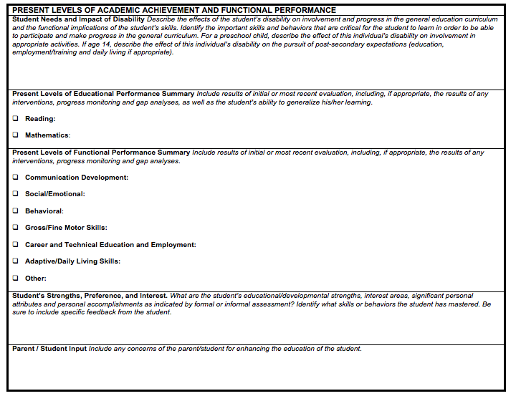
The IEP committee must identify where the student is functioning (strengths and needs) in relationship to what he/she plans on doing after exiting high school. Include the results of any assessments that were used to identify areas of strengths and needs.

The present levels of performance and academic achievement provide the IEP committee a snapshot of a student’s abilities at the time the IEP was developed. The IEP committee must identify where the student is functioning (strengths and needs) in relationship to what he/she plans on doing after exiting high school. Include the results of any age-appropriate assessments that were used to identify areas of strengths and needs.

The students functional performance MUST be linked to his/her post-secondary goals that are based on age-appropriate assessments.

Step 3: Identify Transition Services

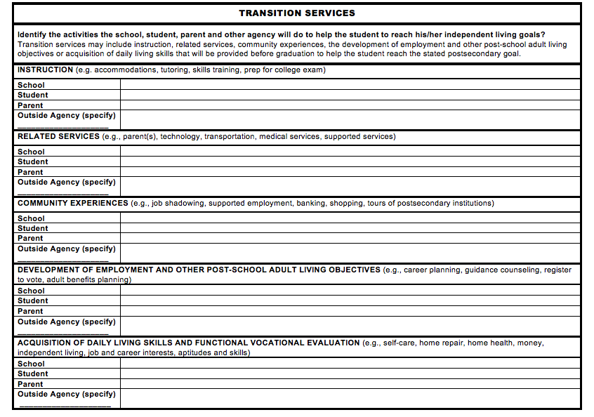

Transition Services. Transitions services is defines as a coordinated set of activities for a child with a disability that:
- Is designed to be within a results-oriented process, that is focused on improving the academic and functional achievement of the child with a disability to facilitate the child’s movement from school to post-school activities, including post-secondary education, vocational education, integrated employment (including supported employment); continuing and adult education, adult services, independent living, or community participation;
- Is based on the individual child’s needs, taking into account the child’s strengths, preferences, and interests; and
- Includes instruction, related services, community experiences, the development of employment and other post-school adult living objectives, and, if appropriate, acquisition of daily living skills and functional vocational evaluation. [§34 CFR 300.43 (a)].

IDEA 2004 requires the IEP committee to develop a “coordinated set of activities” to promote the movement of a student from school to post-secondary adult living in the areas of (1) instruction, (2) related services, (3) community experiences, (4) development of employment and other post-school adult living objectives, and (5) acquisition of daily living skills and functional vocational evaluation.
- Instruction – identifies the need for the student to receive in specific areas to complete needed courses and to be successful in the general education curriculum (e.g., accommodations, tutoring)
- Related services – identifies the needs the student may need to continue post-high school (e.g., medical, transportation)
- Community experiences – identifies experiences that will be provide outside of the school campus (e.g., supported employment, job shadowing, tours of post-secondary institutions)
- Development of employment and other post-school adult living objectives – identifies what the student needs in order to successfully achieve his/her post-secondary (e.g., career planning, register to vote)
- Acquisition of daily living skills (when appropriate) - includes any daily activity an adult does to function independently (e.g., self-care, home repair, money)
- Functional vocational evaluation (when appropriate) - assessment process that provides information about career interests, aptitudes, and skills.

To identify appropriate transition services, the IEP committee needs to consider:
- What services, supports or programs does the student CURRENTLY need?
- What services, supports or programs will the student need IN THE FUTURE in order to achieve their post-school goals?
- Is the student linked to the needed post-secondary services, support, or programs before they leave the school setting?

The transition services MUST be linked to the student’s post-secondary goals and his/her Present Levels of Academic Achievement and Functional Performance.

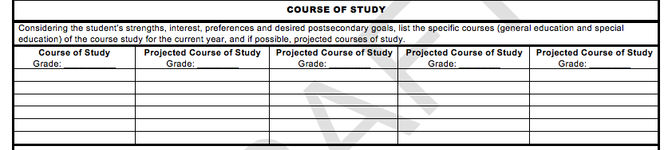

Course of Study. A course of study is a list of courses the student requires to achieve their desired exit option. There should be a direct correlation between the types of courses a student takes to their post-secondary goals. To determine a student’s course of study, the student’s general education teacher and the guidance counselor need to be part of the collaborative effort, especially for those students who plan on attending a college/university. (See Appendix D: Mississippi Accountability Standards Appendix A; Appendix F: Mississippi Accountability Standards Appendix G; Appendix G: Mississippi Occupational Diploma Any Combination Worksheet; Appendix H: Mississippi Accountability Standards Appendix C; Appendix I: NCAA Division I and II Initial-Eligibility Requirements)

When selecting the course of study for the student, the IEP committee must consider the requirements for each exit options. For example:
- If a student’s post-secondary goal is to join the military, he/she must receive a standard high school diploma.
- If a student’s post-secondary goal is to attend a four-year university immediately after high school, he/she must receive a traditional high school diploma.

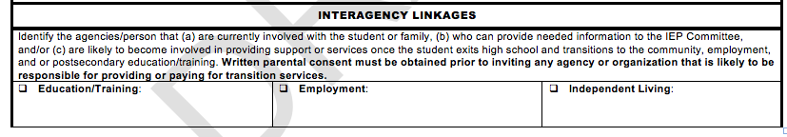

Agency Linkages. Agency linkages are the agencies/person who (a) are currently involved with the student or family, (b) who can provided needed information to the IEP committee, and/or (c) are likely to become involved in providing support or services once the student exits high school and transitions to the community, employment, and/or post-secondary education/training.

Common community agencies include:
- Vocational Rehabilitation Agency (VR) assists persons with cognitive, sensory, physical, or emotional disabilities to attain employment and increased independence. Funded by Federal and State money, VR agencies typically operate regional and local offices. VR services typically last for a limited period of time and are based on an individual’s rehabilitation plan.

- Mental Health Agencies provide a comprehensive system of services responsive to the needs of individuals with mental illness or Intellectual Disabilities. Federal, State, and local funding are used to operate regional Offices, with local funding often being the primary source. Services are provided on a sliding payment scale.

- Independent Living Centers (ILC) help people with disabilities to achieve and maintain self-sufficient lives within the community. Operated locally, ILCs may charge for classes, but advocacy services are typically available at no cost.

- Social Security Administration operates the Federally-funded program that provides benefits for people of any age who are unable to do substantial work and have a severe mental or physical disability. Several programs are offered for people with disabilities, including Social Security Disability Insurance (SSDI), Supplemental Security Income (SSI), Plans to Achieve Self-Support (PASS), Medicaid, and Medicare.

- Department of Health Agencies help individuals with physical or mental disabilities to obtain employment and live more independently through the provision of such supports as counseling, medical and psychological services, job training and other individualized services.

- The Mississippi Council on Developmental Disabilities, which funded by the Federal Administration on Developmental Disabilities support nine area programs for students and parents of students with disabilities: Child Care, Community Supports, education and Early Intervention, Employment, Health, Housing, Transportation, Quality Assurance and Recreation.

Step 4: Develop measurable Annual Goals

Identify goals that relate to the students measurable post-secondary goals.

IDEA 2004 requires student to have measurable annual goals and, for SCD students, short-term objectives/benchmarks that address a student’s area of need. In the IEPs that address transition, the IEP committee must identify and link the goals to the student’s measurable post-secondary goals. Annual goals related to transition services can be transition–linked academic or transition-skill goals.

Transition-linked academic goals are those, which address the disabilities area(s) in which the student qualified for services. Transition–skill goals are those that address specific transition needs. For example:

- John qualified with a specific learning disability (SLD) in math application. His post-secondary employment option is to become a long-haul truck driver. An example of a measurable annual goal that can be linked to his post-secondary transition goal is:

  - Given 10 computation problems, John will calculate rate and distance with 90% accuracy in 5 out of 5 trials.

- Sarah qualified as other health impairment (OHI) due to ADHD. She would like to attend culinary arts school for her post-secondary education option. An example of a measurable annual goal that can be linked to her post-secondary transition goal is:

  - Given 5 multi-step tasks within 90 minutes, Sarah will complete all task with 100% accuracy in 5 out of 5 trials.

- Peggy’s post-secondary employment goal is to become a pet groomer. An example of a measurable annual goal that is skilled-based is:

  - After being assigned 5 dogs, Peggy will wash and dry each dog and maintain a log of each pet’s owner with 100% accuracy in 5 out of 5 trials.
Changing Graduation Options

When considering the diploma/exit option for a student with a disability, the IEP committee should review the student’s employment and community living goals to ensure that the appropriate diploma/exit option and course of study are selected. When there is indecision regarding which diploma/exit option would be the most appropriate for the student, the IEP Committee is strongly encouraged to select the higher of the options being considered. The IEP committee should review the diploma/exit option selected annually, if necessary, for changes needed to the student’s course of study and/or program supports. Please note however, that changes in diploma options in the student’s high school program may result in additional time needed to obtain the credits required to graduate.

Age of Majority

Beginning at least one year before the child reaches the age of majority under State law (age twenty-one (21)), the student’s IEP must include a statement that the student has been informed of his or her rights under IDEA that will transfer to the student on reaching the age of majority. If the public agency receives notice of the student’s legal incompetency, so that no transfer of rights to the student at age twenty-one (21) occurs, the IEP need not include the statement.

Considerations for Students with Significant Cognitive Disabilities

Secondary transition for students with significant cognitive disabilities (SCD) can be challenging. It is best practice to begin identifying transition needs and begin addressing those needs early, especially for SCD students.

The following are some guided questions when addressing transition for students with significant disabilities.
- Can the young adult express interests? If no, get information from parents and caregivers to develop transition plan.
- What are special health care needs?
- What equipment is necessary to meet the needs of the student?
- What are needs/challenges preventing the young adult from working outside the home?
- Who can provide education/training to assist the young adult?
- What can the young adult accomplish without assistance?
- What areas does the young adult need assistance?
- What else could the young adult accomplish if assistance were provided by a job coach, habilitation training specialist (HTS), or other caregiver?

Best practice indicates that a person-centered planning approach is one of the best ways to address secondary transition for students with disabilities, especially for those with significant cognitive disabilities. A person-centered plan is “an individualized approach that helps the person with developmental disabilities discover what he or she really wants. It is transformational, moving from an approach geared towards fixing or solving problems, to one focused on providing opportunities, avenues for self-actualization, personal freedom, meaningful interdependence, and community involvement.” There are a variety of person-centered planning tools, including but not limited to Discovery, Making Action Plans (MAPs), Planning Alternative Tomorrows with Hope (PATH), Essential Lifestyle Planning (ELP), and Personal Futures Planning (PFP).

There are four (4) steps to Person-centered Planning modified from the article Person-Centered Planning: A Tool for Transition:
- Choosing a Facilitator
- Preparing for the Planning Meeting
- Holding the Meeting
- Planning and Strategizing at Follow-Up Meetings

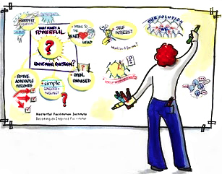
Step 1: Choosing a Facilitator

The facilitator is the individual that is trained to facilitate the person-centered process. He/she needs to be a good listener who is willing to work creatively to help shape the dreams of the student by discovering the capabilities of the student. The facilitator needs to be able to identify community resources and have the ability to engage those resources on the behalf of the student.

Step 2: Preparing for the Planning Meeting

It is important to identify the key individuals in the student’s life and invite those individuals to the planning meeting, and to identify a date, location and time for the meeting. The facilitator and family should meet prior to the planning meeting to make those decisions. At the preparation meeting the family will:
- Identify key individuals in the student’s life that they want to invite to the meeting.
- Identify a date, time, and location for the person-centered planning meeting and additional follow-up meetings.
- Discuss strategies that increase participation of all individuals involved.
- Decide who will take the lead in gathering information about the student.
- Determine which person-centered planning process will be used (e.g. Discovery, MAPs, PATH, ELP, PFP).
- Develop a history or personal life story or profile of the student. This includes, but is not limited to, critical events, medical issues, major developments, important issues, and important relationships.
- Describe the quality of the student’s life by exploring the following: community participation, community presence, choices/rights, respect and competences.
- Describe the personal preferences of the student. (See Appendix ____: The Sample Document My Interest, Hopes and Dreams).

Step 3: Holding the Meeting

During the meeting, the participants will:
- Review the personal profile and make additional comments and observation.
- Identify ongoing events that are likely to affect the focus person’s life (e.g. medical conditions).
- Share visions for the future. Brainstorm ways to increase outcomes for the student.
- Identify obstacles and opportunities that give the vision a real-life context.
- Create an action plan that identifies what needs to be done, what materials/equipment are needed, who will do it, when the actions will occur, and when the participants will meet again. It is best to identify steps that can be completed in a short period of time.

Step 4: Planning and Strategizing at Follow-Up Meetings

After the meeting, the participants should begin implementing the action plan. This can require participants to be creative and problem-solve depending on the required actions. Periodically, the team needs to meet to discuss what parts of the plan are working and what parts are not working. By the conclusion of the following-up meeting, the participants must identify next steps, which include what needs to be done, who will do it, when the actions will occur, and when the participants will meet again.

For each follow-up meeting, the team must:
- Identify participants for the follow-up meetings.
- Identify a date, time, and location for the follow-up meetings.
- List all activities that had occurred previously.
- List all challenges and barriers that occurred.
- Brainstorm new ideas and strategies for the future.
- Set priorities for the next agreed-upon time period (e.g. 6 months, 12 months).
- Establish renewed commitment of participants.
- List five (5) to ten (10) concrete steps for each participant to follow.
- Always celebrate the success!

Evaluating Your Transition IEP

The Mississippi Department of Education, Office of Special Education has identified the Indicator 13 Checklist (See Appendix L) as the tool to evaluate your transition IEP. Indicator 13 measures "Percent of youth with IEPs aged 16 and above with an IEP that includes appropriate measurable post-secondary goals that are annually updated and based upon an age appropriate transition assessment, transition services, including courses of study, that will reasonably enable the student to meet those post-secondary goals, and annual IEP goals related to the student's transition services needs. There also must be evidence that the student was invited to the IEP Team meeting where transition services are to be discussed and evidence that, if appropriate, a representative of any participating agency was invited to the IEP Team meeting with the prior consent of the parent or student who has reached the age of majority." (20 U.S.C. 1416(a)(3)(B))

The checklist asks the following questions:
- Are there appropriate measurable post-secondary goals in the areas of training, education, employment, and, where appropriate, independent living skills?
- Are the post-secondary goals updated annually?
- Is there evidence that the measurable post-secondary goals were based on age appropriate transition assessment(s)?
- Are there transition services in the IEP that will reasonably enable the student to meet his or her post-secondary goals?
- Do the transition services include courses of study that will reasonably enable the student to meet his or her post-secondary goals?
- Is (are) there annual IEP goal(s) related to the student’s transition services needs?
- Is there evidence that the student was invited to the IEP Team meeting where transition services were discussed?
- If appropriate, is there evidence that a representative of any participating agency was invited to the IEP Team meeting with the prior consent of the parent or student who has reached the age of majority?

Resources
Mississippi Resources | National Resources
Mississippi Department of Human Services  The Mississippi Department of Human Services assist individuals in applying for disabilities claims, developing skills necessary to budget and manage their monies, and to live independently.  http://www.mdhs.state.ms.us/ | Social Security Disability Resource Center  The goal of SSDRC.COM, the Social Security Disability Resource Center, is to inform readers about how the Social Security Disability and SSI Disability process works from start to finish. This includes what to expect before, during, and after a disability application has been processed, common mistakes that need to be avoided, and what to do and how to react in specific situations (for example, receiving notices of denial, obtaining the status of the claim at different points, providing needed evidence, and undergoing a disability interview with a Social Security Claims Representative).  http://www.ssdrc.com/
Social Security Administration – Mississippi Area  The Social Security Administration- Mississippi Area assists individuals with employment support, applying for Social Security benefits.  http://www.ssa.gov/atlanta/southeast/ms/mississippi.htm | Social Security Administrators  SSA’s Work Site offers employment support for people with disabilities by providing a focus on matters affecting the employment of Social Security beneficiaries with disabilities.  http://www.ssa.gov/SSA_Home.html
Mississippi Department of Rehabilitation Services  The Mississippi Department of Rehabilitation Services provides resources to help Mississippians with disabilities find new careers, live more independently, overcome obstacles and face new challenges. Their motto “ Providing the Freedom to Live”  http://www.mdrs.state.ms.us/ | Rehabilitation Services Administration  The Rehabilitation Services Administration (RSA) oversees formula and discretionary grant programs that help individuals with physical or mental disabilities to obtain employment and live more independently through the provision of such supports as counseling, medical and psychological services, job training and other individualized services.  http://www2.ed.gov/about/offices/list/osers/rsa/index.html

Mississippi State Department of Health  The Mississippi State Department of Health partners with the Transportation Coalition to help individuals with physical or mental disabilities to obtain employment and live more independently through the provision of such supports as counseling, medical and psychological services, job training and other individualized services.  http://www.msdh.state.ms.us/ | Office of Vocational and Adult Education  Office of Vocational and Adult Education (OVAE) administers Career and Technical Education, commonly known as vocational education, is a massive enterprise in the U.S. Thousands of comprehensive high schools, vocational and technical high schools, area vocational centers, and community colleges offer vocational education programs.  http://www2.ed.gov/about/offices/list/ovae/index.html?src=oc
Mississippi Division of Medicaid  Mississippi Division of Medicaid assist individuals in filing for Medicaid benefits.  http://www.medicaid.ms.gov/ | Medicaid  http://medicaid.gov/
Mississippi Department of Mental Health  Mississippi Department of Mental Health support programs aimed at making a difference in the lives of individuals with mental health issues, substance abuse and intellectual or developmental disabilities.  http://www.dmh.state.ms.us/ | CareerOneStop  CareerOneStop is a U.S. Department of Labor-sponsored Web site that offers career resources and workforce information to job seekers, students, businesses, and workforce professionals to foster talent development in a  global economy.  http://www.careeronestop.org/
Mississippi Department of Education, Office of Special Education  http://www.mde.k12.ms.us/special-education | Social Security Online – The Redbook  The Redbook provides information on the employment support for individuals with disabilities under the Social Security Disability Insurance (SSDI) and Supplemental Security Income (SSI) programs.  http://www.socialsecurity.gov/redbook/eng/main.htm

Mississippi Council on Developmental Disabilities

The Mississippi Council on Developmental Disabilities, which funded by the Federal Administration on Developmental Disabilities support nine area programs for students and parents of students with disabilities: Child Care, Community Supports, education and Early Intervention, Employment, Health, Housing, Transportation, Quality Assurance and Recreation.

http://www.mscdd.org/

Institute for Disabilities Studies (IDS)

IDS, which is housed at the University of Sothern Mississippi, is the managing partner with the Mississippi Partnership for Employment and provides assistance for parent engagement for parents of students with disabilities.

http://www.usm.edu/disability-studies

References

Career Development

Hanover Research. Effective Career Awareness and Development Programs for K-8 Students. Rep. N.p.: n.p., 2012. Print.

Zunker, Veron G. "Career Counseling" Google Books. Brook/Cole Publishing Company, n.d. Web. 27 Mar. 2013.

Considerations for

Kochhar-Bryant, C., & Izzo, M. (2006). Access to post-high school services: Transition assessment and the summary of performance. Career Development for Exceptional Individuals, 29, 70-89.

Lamb, P. (2007). Implications of the summary of performance for vocational rehabilitation counselors. Career Development for Exceptional Individuals, 30, 3-12.

Shaw, S.F., Keenan, W.R., Madaus, J.W., & Banerjee, M. (2010). Disability documentation, the Americans with Disabilities Act Amendments Act, and the summary of performance: How are they linked? Journal of Post-secondary Education, 22(3), 142-150

Secondary Transition

Austin, Patricia. Transition Planning Guide: Preparing for Life After School. Publication. N.p.: n.p., 2013. Print.

Florida Department Education Bureau of Exceptional Education and Student Services. Transition Planning for Students with Disabilities: A Guide for Families. Publication. N.p.: n.p., 2011. Print.

Storms, Jane, Edward Eugene O'Leary, and Jane Williams. Transition Requirements a Guide for States, Districts, Schools, Universities and Families. [Eugene, OR]: Western Regional Resource Center, College of Education, University Affiliated Program, University of Oregon, 2000. Print.

Transition Services Liaison Project. Technical Assistance Guidance for Transition in the IEP. Publication. N.p.: n.p., 2009. Print.

Transition Assessments

Division on Career Development Transition. Age Appropriate Transition Assessment. Tech. N.p.: n.p., n.d. Print.

National Secondary Transition Technical Assistance Center. Age Appropriate Transition Assessment Toolkit. Tech. N.p.: n.p., n.d. Print.

Transition for Students with Severe Disabilities

Martin, Jim, Ph.D., and Lorrie Sylvester, Ph.D. "Transition Assessments for Students With Severe and Multiple Disabilities." Teleconference. 24 May 2011.

National Center on Secondary Education, and PACER Center. "Parent Brief.” Promoting Effective Parent Involvement in Secondary Education and Transition. N.p., February 2004. Web. 15 Apr. 2013.

National Secondary Transition Technical Assistance Center. "Part B Indicator 13 & Students with Sever Disabilities." Teleconference. 9 Sept. 2008.

Sonoran University Center for Excellence in Developmental Disabilities. Person-centered Planning: Pathways to Your Future. Publication. Sonoran UCEDD, 2011. Web. 15 Apr. 2013.

Storms, Jane, Edward Eugene O'Leary, and Jane Williams. Transition Requirements a Guide for States, Districts, Schools, Universities and Families. [Eugene, OR]: Western Regional Resource Center, College of Education, University Affiliated Program, University of Oregon, 2000. Print.
Storms, Jane, Edward Eugene O'Leary, and Jane Williams. Transition Requirements a Guide for States, Districts, Schools, Universities and Families. [Eugene, OR]: Western Regional Resource Center, College of Education, University Affiliated Program, University of Oregon, 2000. Print.
Storms, Jane, Edward Eugene O'Leary, and Jane Williams. Transition Requirements a Guide for States, Districts, Schools, Universities and Families. [Eugene, OR]: Western Regional Resource Center, College of Education, University Affiliated Program, University of Oregon, 2000. Print.
Division on Career Development Transition. Age Appropriate Transition Assessment. Tech. N.p.: n.p., n.d. Print.
Division on Career Development Transition. Age Appropriate Transition Assessment. Tech. N.p.: n.p., n.d. Print.
Transition Services Liaison Project. Technical Assistance Guidance for Transition in the IEP. Publication. N.p.: n.p., 2009. Print.
Transition Services Liaison Project. Technical Assistance Guidance for Transition in the IEP. Publication. N.p.: n.p., 2009. Print.
National Secondary Transition Technical Assistance Center. "Part B Indicator 13 & Students with Sever Disabilities." Teleconference. 9 Sept. 2008. Teleconference.
Sonoran University Center for Excellence in Developmental Disabilities. Person-centered Planning: Pathways to Your Future. Publication. Sonoran UCEDD, 2011. Web. 15 Apr. 2013.
National Center on Secondary Education, and PACER Center. "Parent Brief.” Promoting Effective Parent Involvement in Secondary Education and Transition. N.p., February 2004. Web. 15 Apr. 2013.

