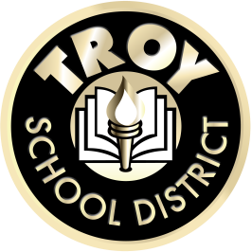

Accessible Digital Text

Students can be provided accessible digital text if they qualify as having a print disability. A student with a print disability is one who cannot access text in a traditional manner due to a learning (reading) disability, a visual disability or a physical disability that prevents them from using a printed book. There are many organizations that provide accessible digital text.
Learning Ally is a non-profit volunteer organization operating nationwide in the United States. It produces and maintains a library of educational accessible audiobooks for people who cannot effectively read standard print because of visual impairment, reading disability, or certain physical disabilities.
Learning Ally also offers a robust digital audiobook library that includes the world’s largest collection of audio textbooks. The library includes a broad variety of specialty and academic subjects, from kindergarten through post-graduate and professional.
Textbook and literature titles are digitally recorded by human narrators and produced in downloadable audio files in a specialized format.
LearningAlly.org
Bookshare is an organization that provides accessible text to students with print disabilities. Currently, this is provided free of charge through a grant. A student with a print disability is one who is unable to access text in a traditional manner due to a reading disability, a visual disability or a physical disability that prevents them from being able to turn a page in a book

Bookshare is available to students who qualify and who have an IEP or a 504 Plan. However, only students with an IEP qualify to have Bookshare access to textbooks. Textbooks are provided through NIMAC (National Instructional Materials Access Center.) NIMAC was created by IDEA 2004 and is a federally funded, searchable online file repository of K-12 print textbooks.

Bookshare.org

There are many additional organizations that provide accessible digital text. Three of the most often used are:
Gutenberg.org
Mel.org
Troypl.org

If you think your child may need to access digital text, contact your child’s teacher or special education provider.

