  Return sealed envelope to:  Shawnee Mission Unified Schools  Purchasing Department  8200 W. 71st Street  Shawnee Mission, Kansas 66204  ATTN: EVERETT MORGAN  E-MAILED OR FAXED BIDS  WILL NOT BE ACCEPTED. | DATE: June 19, 2017 BID NO. 17-027  BID TITLE: MODULAR CARPET TILE PURCHASE  WITH INSTALLATION-RISING STAR  ELEMENTARY  Bids will be accepted until and then publicly opened on:  Date: JUNE 29, 2017  Day: THURSDAY  Time: 10:00 A.M.  Terms, conditions and specifications under which bids are requested are included. Please review thoroughly.

You are invited to bid on: MODULAR CARPET TILE PURCHASE WITH INSTALLATION
for the Shawnee Mission Unified Schools per the enclosed terms, conditions and specifications, F.O.B. to Destination, Freight Prepaid and Added. FREIGHT COSTS TO SMSD PROJECT LOCATION MUST BE INCLUDED IN THE BID PRICE(S).

We are enclosing only one copy of the bid specifications. Please return (2) completed bid form(s).

Bid price is to be lump sum base bid for the carpet tile and installation thereof, including all materials, equipment, labor, insurance, fees, transportation, storage, services and supervision for the work identified per the specification and drawings herein. Payment will be made ON COMPLETION of Purchase Order. DO NOT INCLUDE SALES TAX.

Any questions regarding the bid documents should be directed to Operations & Maintenance, via email to scottmoore@smsd.org, or by phone at (913) 515-7823, no later than three days prior to the bid opening.

Questions regarding bid procedures may be directed in writing to the Purchasing Department; Attn: Everett Morgan via E-Mail, everettmorgan@smsd.org ; or FAX: 913/993-6225.

THIS BID IS NOT TRANSFERABLE

NOTE: Bid Number and Name of Bidder must appear on the front of sealed envelope. Faxed bids will not be accepted. Bids must be received in the Purchasing Office prior to bid opening. If sending by U.S. Postal Service, please allow a minimum of 24 hours for your bid to be processed and delivered to the Purchasing Office by the Administrative Mail Center. It is the responsibility of the bidder to ensure delivery of bids to the Purchasing Office. Bidders shall hold all bid prices firm for acceptance for 90 calendar days after date of bid opening.

Bid results will be posted on the smsd.org website within approximately 5 working days after the bid opening. Go to Public Information; Purchasing/Bidding; Bids and Bid Summaries. Additionally, you may review the bid results in the Purchasing Office during the hours of 8:00 AM to 4:30 PM.

NOTICE OF “NO RESPONSE FORM”

BID NO. 17-027

VENDORS WHO RESPOND TO THIS INVITATION WITH A COMPLETED NOTICE OF “NO RESPONSE” FORM WILL REMAIN ON OUR MAILING LIST, IF REQUESTED.

VENDORS MAKING NO RESPONSE AT ALL WILL BE REMOVED FROM OUR MAILING LIST.

Dear Vendor:

Please check () the appropriate box below, complete the remainder of this form and return it NO LATER THAN the scheduled Bid/Proposal/or Quote Date and Time.

Our company cannot provide the products, supplies and/or services listed in this bid, proposal or
quote. Please MOVE our name and address to the following category(ies) so that we may bid at a later date ____________________________________________________________________
______________________________________________________________________________

We have chosen NOT to submit a response at this time, but would like to remain on your bid list
for this product category. We did not submit a response because:

Reason(s): _____________________________________________________________________
______________________________________________________________________________

Please REMOVE our name from all SMSD bid lists until further notice.

Reason(s): _____________________________________________________________________
______________________________________________________________________________

COMPANY NAME:____________________________________________________

REPRESENTATIVE (please print):________________________________________

ADDRESS: _______________________________ PHONE (_____)____________

AUTHORIZED SIGNATURE: ____________________________________________

TITLE: ______________________________________ DATE: ______________________

PLEASE RETURN THIS FORM ONLY TO:

Shawnee Mission Unified School District #512
Purchasing Department

Notice of “NO RESPONSE”

8200 W. 71st Street
Shawnee Mission, KS 66204
OR
Fax to: 913/993-6225

SHAWNEE MISSION PUBLIC SCHOOLS
8200 W. 71st. Street
SHAWNEE MISSION, KS 66204

5% BID SECURITY FORM

Bid Security issued to: Shawnee Mission Public Schools, in the amount of 5% of the total amount of your Bid shall accompany your Bid as a guarantee that, if awarded all or part of the Bid, your firm will enter into contract to supply the items per the Bid Specifications. Cashier checks & certified checks should be made payable to Shawnee Mission USD #512.

This Bid Security is to be made payable to Shawnee Mission Public Schools. If the firm awarded the Bid defaults in entering into a contract for the purchase of those items as specified, the Bid Security will become the property of the School District. Bids not accepted within ninety (90) days after the time set for submission will have their Bid Securities returned.

PLEASE NOTE: Should you submit a cashiers or certified check instead of a bid bond, the following steps will be used by SMSD in the handling of that check:
- SMSD will deposit your check into a SMSD bank account within 2-3 days after bid opening.
- Within four (4) weeks after board approval of the bid, a district check shall be mailed to the non-successful bidder(s) to reimburse them for the exact amount of their cashiers/certified check.
- Within four (4) weeks after the completion of a formal written and properly signed contract, or the issuance of a SMSD purchase order, a district check shall be mailed to the successful bidder(s) for the exact amount of their cashiers/certified check.

NOTE: IF SUCH SECURITY IS NOT ENCLOSED WITH THE BID, IT WILL BE CAUSE FOR REJECTION OF THE BID.

______________________________ $ _______________________________
Company Amount of Total Bid

_______________________________ $ _______________________________
Address Amount of Bid Bond

_______________________________

City, State, Zip Code

________Bid Security attached to this form. (Please send the two together.)

_________________________________ _________________________________
Signature of Authorized Rep. Phone

_________________________________ _________________________________
Please Print Name Position

BID FORM

BID NUMBER 17-027

BID OF:

A CORPORATON ORGANIZED AND EXISTING UNDER THE LAWS
OF THE

A PARTNERSHIP CONSISTING OF

PARTNERS:

OR: A SOLE PROPRIETOR; HERINAFTER CALLED THE BIDDER.

TO: SHAWNEE MISSION PUBLIC SCHOOLS
ATTN: MR. EVERETT MORGAN
8200 W. 71st St.
SHAWNEE MISSION, KANSAS 66204

The undersigned acknowledges that he has received and familiarized himself with the following:

Request for Bid for Modular Carpet Tile Purchase with Installation for:
Rising Star Elementary School
8600 Candle light Lane
Shawnee Mission Public School District #512
Bid Number 17-027

ADDENDA NO(s): Received

In submitting this bid, the undersigned agrees:

- To furnish all material necessary to fulfill the requirements of the bid documents.

- To honor the bid for sixty (60) days after bid opening and to accept the provisions of the instructions to bidders, including the instructions on bid security.

- This Bid is genuine and not made in the interest of or on behalf of an undisclosed person, firm, or corporation and is not submitted in conformity with an agreement or rules of a group, association, organization, or corporation; Bidder has not directly or indirectly induced or solicited another Bidder to submit a false or sham Bid; Bidder has not solicited or induced a person, firm, or corporation to refrain from bidding; and Bidder has not sought collusion to obtain for itself an advantage over the Owner.

Name of Carpet Manufacturer and Carpet Line or Style______________________________________
If other than specified, samples must be provided.
Contractor must verify the slab AFTM F710 or equal.

Project completion prior to August 1, 2017.

LUMP SUM BID FOR 4,704 SQUARE FEET INSTALLED ________ _______Dollars

In submitting this bid, it is understood that the right to reject any and all bids and to waive irregularities in the bidding has been reserved by the owner.

Date this day of , 2015.

Name of Bidder

Street Address of Bidder

Authorize Officer

Area Code/Telephone Number

GENERAL CONDITIONS
A. Bid Requirements and Considerations:
- The Board of Education reserves the right to reject any or all Bids, to accept any item or items in the Bid, and to waive any informality in Bids.
- Each Bid must be completed on SMSD Bid forms.
- Alternate Bids will be considered only if the alternate properly meets specifications outlined in the Bid.
- Each Bid shall be accompanied by Bid Security in the amount of five percent (5%) of the base Bid, made payable unconditionally to the school district. This security will be submitted as evidence of good faith as a guarantee that, if awarded the Contract, the Bidder will execute required bonds and insurance within ten (10) days after receipt of Notice to Proceed.
- Each Bidder shall carefully examine the Bidding Documents and thoroughly inform himself with all requirements prior to submitting a Bid. Should a Bidder find discrepancies or ambiguities in, or omission from Bidding Documents, or should he be in doubt as to their meaning, he will at once and at least three business days prior to Bid date, notify the school district in writing. Any subsequent addenda sent to Bidders will become part of the Contract Documents.
- Prior to submitting a Bid, each Bidder shall examine and thoroughly familiarize himself with all existing conditions; including applicable laws, codes, ordinances, rules, and regulations that will affect his work. Contractors and/or Bidders are required to check in with building authorities at the school immediately upon entering the school premises.
- Prices quoted are to be free of all Federal, state, and local taxes, unless otherwise imposed by a governmental body and applicable to the Work or material. The school district will obtain from the State of Kansas a sales tax exemption certificate number. The sales tax exemption certificate will permit the Contractor to purchase materials for incorporation into this project without paying sales tax, provided that the Contractor furnishes the certificate number to the supplier.
- When submitting a substitute article as equal, the full name and illustrated description must be given. The Board of Education reserves the right, however, to decide upon its suitability for the intended use. Samples of substitute articles must be submitted along with the substitution form in these Bidding Documents and any supporting information.
- Envelopes containing Bids must be sealed and marked on the lower-left hand corner with the firm name and address of the Bidder, Bid number, Bid opening date, and Bid opening time:
  - No special effort shall be made to sort incoming mail for potential Bids.
  - Bids not at the appointed place at time of Bid opening will be rejected.
  - Faxed Bid/Proposals will not be accepted as sealed Bids.
- If Bid is accepted, USD #512 must be supplied with seller’s employer identification number of social security number, per IRS regulations.
- Each Contractor is responsible for his/her own worker’s compensation and liability insurance coverage. Shawnee Mission Unified School District #512 assumes this COVERAGE IS INCLUDED IN THE PRICE OF EACH BID TOTAL.
- Any catalog, brand name or manufacturer’s reference used herein is intended to be descriptive and not restrictive. Offers on any reputable manufacturer’s regularly produced product which is similar and substantially equivalent will be considered. The substitution form must be submitted. Shawnee Mission Public Schools reserves the right to make final decisions as to the acceptability of comparable items.
- Vendors who do not bid, but wish to remain on our bid list, should notify the Shawnee Mission USD #512 Purchasing Department in writing using the enclosed “Notice of No Response” form. Failure to do so may result in removal from this list.
- If required by the Bid form, the Contractor shall submit with his Bid a list of subcontractors and other persons or organizations that will perform Work on this project.
B. Form and Requirements of the Contract:
- The form of Contract will be a Purchase Order issued by Shawnee Mission School District. In submitting his Bid for consideration, each Bidder agrees to commence Work as soon as practical upon receipt of the school district purchase order and subsequent execution of applicable bonds and certificates of insurance.
- The district shall not be responsible for any goods delivered or services performed without its purchase order signed by an authorized representative of the Purchasing Department.
- For projects with a value of $20,000 or more; subsequent to award, the Contractor shall furnish Performance Bond, Labor and Materials Payment Bond, and Kansas Statutory Bond covering the faithful performance of the Contract and the payment of all obligations arising thereunder. All such bonds shall be submitted to the school district prior to the commencement of any Contract work. (NOT REQUIRED FOR THIS BID.)
- Contracts entered into on the basis of submitted Bids are revocable if contrary to law.
- The laws of the State of Kansas shall govern any Contracts resulting from this Bid. Actions must be filed in the Johnson County Courthouse in Johnson County, Kansas.
The seller shall provide the standard patent infringement indemnity clause which shall hold and save the Board of Education and its officers, agents, servants, and employees, harmless from liability of any patented, or unpatented invention, process, article, or appliance manufactured, or used, in the performance of the Contract, including its use by the Board of Education.

SHAWNEE MISSION PUBLIC SCHOOLS
ACCOUNTS PAYABLE SCHEDULE
School |  | Payments
Cut Off |  | Released
7/13/2017 |  | 7/25/2017
8/4/2017 |  | 8/15/2017
9/15/2017 |  | 9/26/2017
10/13/2017 |  | 10/24/2017
11/17/2017 |  | 11/28/2017
12/8/2017 |  | 12/19/2017
12/20/2017 |  | 1/9/2018
1/12/2018 |  | 1/23/2018
2/16/2018 |  | 2/27/2018
3/9/2018 |  | 3/27/2018
4/13/2018 |  | 4/24/2018
5/11/2018 |  | 5/22/2018
6/15/2018 |  | 6/26/2018

MODULAR CARPET TILE
SPECIFICATIONS

PART 1 GENERAL

  - CARPET WARRANTY

1. Warranty to be sole source responsibility of the Manufacturer. Second source warranties and warranties that involve parties other than the carpet manufacturer are unacceptable.

2. If the product fails to perform as warranted when properly installed and maintained, the affected area shall be repaired or replaced at the discretion of the Manufacturer.

3. Chair pads shall not be required for carpet warranty coverage.

4. Warranty shall be for at least fifteen, non-prorated years.
- The warranty shall cover against and specifically define the following:
  - Excessive Surface Wear: More than 15% loss of pile fiber weight
  - Excessive Static Electricity: More than 3.0 kV per AATCC 134
  - Delamination
  - Edge Ravel

PART 2 COMMERCIAL MODULAR CARPET TILES

  - CARPET TILE DESCRIPTION

1. Preferred carpet tile is a non-directional or quarter turn, commercial grade tile, suitable for elementary and secondary school use. The carpet shall have superior wear and stain resistance and shall be capable of successfully withstanding 12 – 15 years of heavy use, with proper installation and maintenance. The carpet and adhesive system shall meet or exceed indoor environmental quality standards set by CRI Green Label and State of Washington standards.

2. The Owner has determined that for this bid, only Patcraft, PDQ2 Design Weave, Style: Big Splash, Color: 00603 Angle 24” x 24” will be considered or approved equal.

If submitting other than specified:

3. Fiber Characteristics shall be as follows:

- Nylon, Type 6,6 or 6
- Fiber shall be solution dyed.
- Tufted Loop or Tufted Textured Loop construction.
- Gauge: 1/12, +/- 2
- Face weight: 17 oz. or greater
- Minimum acceptable average density: 5400
- Durable stain inhibitor applied. Minimum 300 ppm Fluorine per CRI TM-102.
- Carbon-core filaments for permanent static control (AATCC 20)

4. Backing Characteristics shall be as follows:

- The backing structure shall be constructed and proven to:
  - Securely hold the carpet fiber face, preventing raveling
  - Have the dimensional stability and durability of reinforced PVC backing systems, or better
  - Be a fully-fused, sandwich backing design to prevent delamination
  - Provide sufficient resiliency to reduce crushing effects on the fiber face, thereby extending the carpet life cycle.

5. Adhesive System

- The adhesive shall be a low VOC emission glue, meeting or exceeding CRI Green Label criteria.
- The glue will be applied full spread to prevent tiles from being pulled up easily.
- The age of the adhesive shall be new enough that the adhesive will not exceed its shelf life prior to the amount of time it will take to install the 5,000 sq. yd. of material being purchased based on the rate of purchases.

  - CARPET PERFORMANCE CHARACTERISTICS

1. Test reports for the following performance assurance testing shall be submitted upon request. The carpet must meet or exceed the following tests:

- Radiant Panel: ASTM E-648/NFPA 253: Class 1 (CRF: 0.45 watts/sq cm or greater)

- Federal Flammability: CPSC FF 1-70: Passes

- Smoke Density: ASTM E-662/NFPA 258: </= 450 Flaming Mode

- Electrostatic Propensity: AATCC 134 (Step & Scuff): 3.0 kV or less

- Static Coefficient of Friction: ASTM C-1028: Passes ADA requirements for accessible routes (minimum 0.60)

- Delamination of Secondary Backing of Pile Floor Coverings: ASTM D-3936
No delamination

- Lightfastness: AATCC 16E: >/= 4 @ 100 hours

- Vetterman Drum: ASTM D-5417: Minimum 3 @ 22,000 cycles

- VOC Chamber Testing: ASTM D-5116: Passes State of Washington Indoor Air Quality Specification for Carpet

- Dimensional Stability: Aachen/ISO 2551: Maximum change +/- 0.149%

PART 3 EXECUTION

  - SELECTION CRITERIA

1. Bidders shall include with the bid the carpet manufacturer’s specifications and adhesive manufacturer’s cut-sheets, detailing adhesive spread rate and application methods.

- Any deviation from these bid specifications must be documented and submitted with the Bid Form. Include any description and justification necessary to compare and fairly evaluate the proposed carpet to the bid specifications.

2. The selected product will be the one that most closely matches the technical specifications and performance characteristics and is the lowest initial cost for the owner.
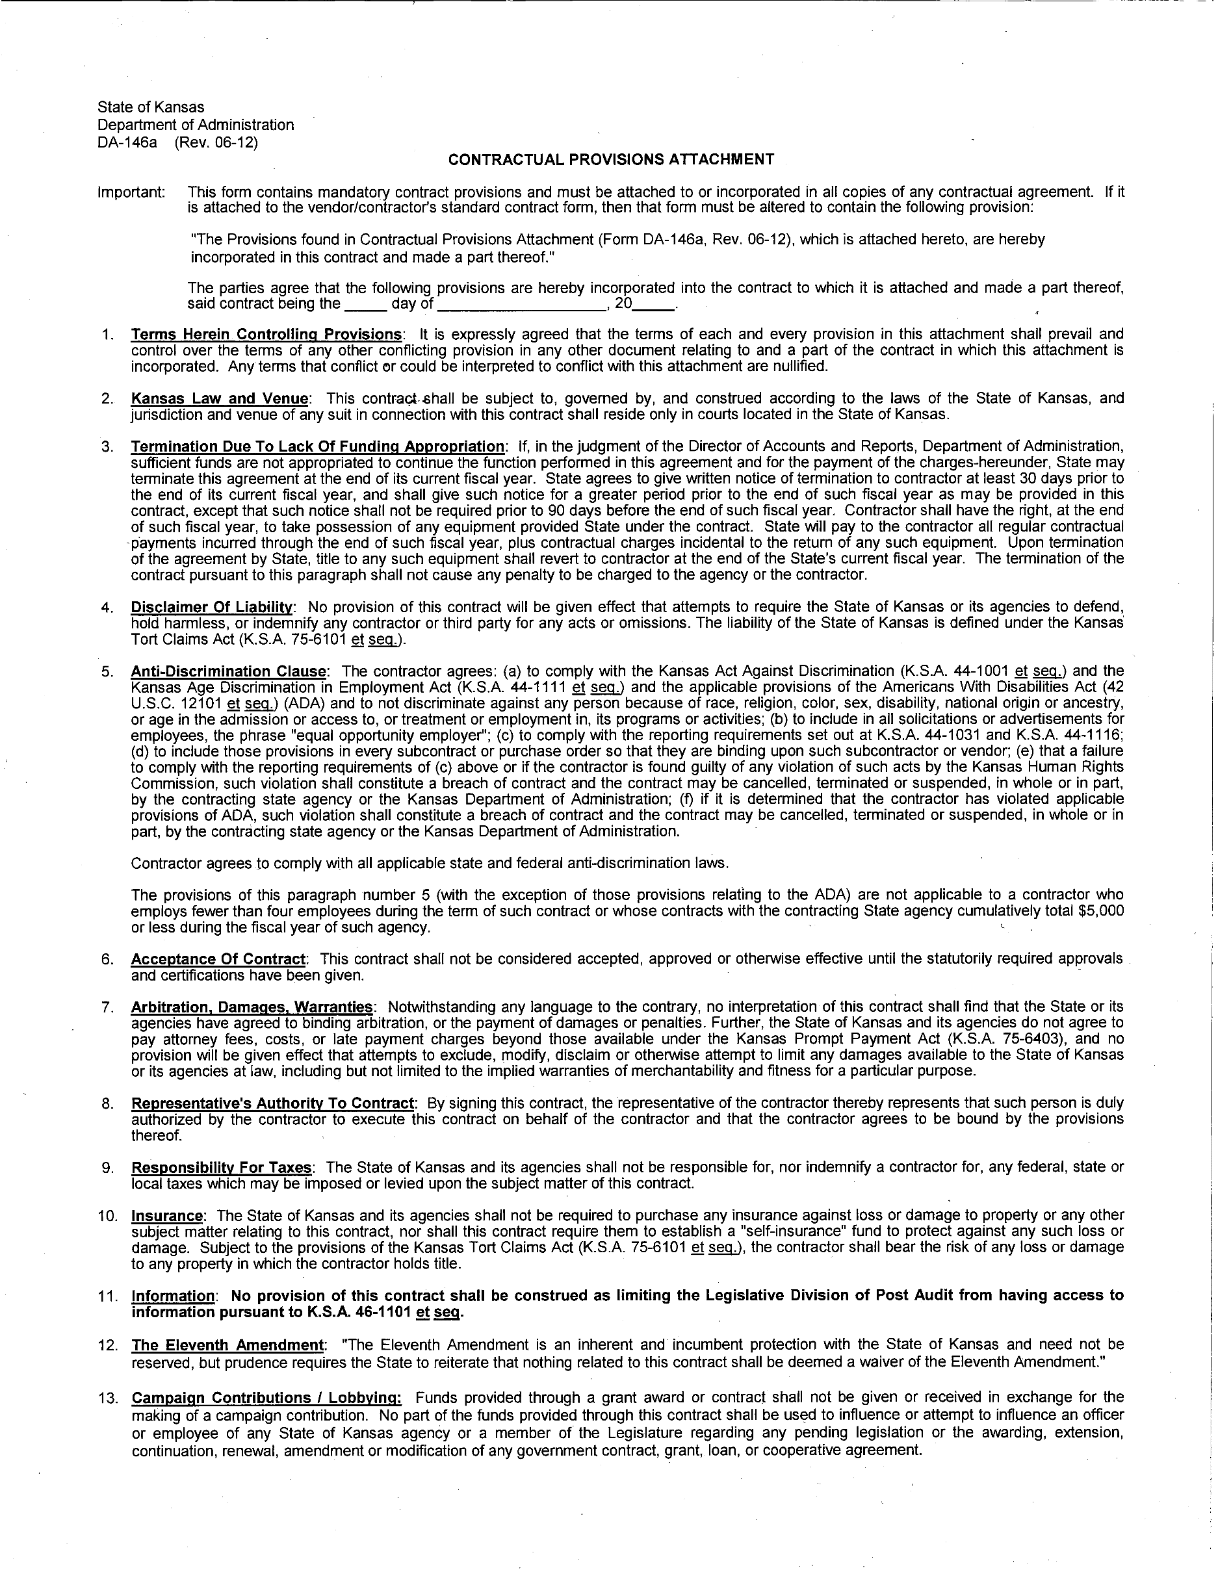

Company

Address

City State ZIP

Phone Fax

Email Address Website Address Tax ID #

AUTHORIZED SIGNATURE

PLEASE PRINT NAME Date

