Describe the steps taken to ensure an effective school-wide program has been established by addressing each of the four components, based on your School Improvement Plan documentation
Reg. 200.25-28 and Sec. 1114.

Title I School-Wide School Improvement Plan Components
SWP Component #1: A comprehensive needs assessment of the entire school that takes into account information on the academic achievement of children in relation to the challenging State academic standards, particularly the needs of those children who are failing, or at-risk of failing, to meet the challenging State academic standards and any other factors as determined by the local educational agency; [1114(b)(6)]

Things to consider:
◻ What types of qualitative and quantitative data are being collected?
o Examples include culture/climate, demographics, student performance, student attendance, behavior, and family and community involvement.
o Where necessary, a school should attempt to engage in interviews, focus groups, or surveys, as well as review data on students, educators, and schools to gain a better understanding of the root causes of the identified needs.
◻ What are the strengths of students, teachers, school and community? What are their needs?
◻ What are the contributing factors to academic strengths and needs?
◻ How is the data being used by administration, teachers and parents to guide decisions and instruction?
◻ How is data being reviewed in a disaggregated format to look at progress and needs of all student groups?
◻ How is the needs assessment used for a cycle of ongoing continuous improvement engaging all stakeholders?

Needs Analysis/SIT Goals
The CSE School Improvement Team (SIT) met in July 2026 to review end of year school wide data, county data, and to create goals for our School Improvement Plan. The following data was reviewed by the team:
- County May ELA data and compared to January 2026 data
- Acadience Scores for Kindergarten to 3rd grade
- MAP Growth data for 2nd – 5th grade
- ELA Comprehension Benchmark Assessment data with writing scores
- May Math Benchmark data for grade Pre-K to 5

Overall, our ELA data did show successes in growth, but also shows a need for growth opportunities. 1st grade met the county average for Acadience composite scores. 2nd and 3rd grade met or exceeded the county expectation on the MAP Growth assessment. Pre-Kindergarten, Kindergarten, 4th grade, and 5th grade did not meet the goal for 80% of students to meet grade level expectations. 2nd grade achieved 80% of students meeting 80% or better on the Benchmark Advance writing assessment. Overall, writing scores did not meet county averages. Therefore, writing is an area of need. We continue to see struggles in the areas of phonics on the CCPA assessment, students meeting the county expectation on Acadience and MAP Growth. Accuracy and automaticity (fluency) are a key area of need for our school. As a team we discussed possible reasons for the data scores and strategic actions we can use to address the concerns.

Our Title 1 students in preK and 1st grade met our CSE goal of 90% or greater on the End of Year Benchmark. Kindergarten and 2nd grade did not meet the goal of 90%. Kindergarten had a difficult time with the standard, number and operations in base 10. 2nd grade had a difficult time with the standards of operations and algebraic thinking and numbers and operations in base 10. 3rd through 5th grades did not meet our county goal of 80% or greater on the End of Year Benchmark. 3rd grade could benefit from more opportunities to address measurement and geometry. 4th grade could benefit from more reinforcement in the standards of numbers in base 10 and fractions. 5th grade’s lowest scoring standards were fractions and measurement.

The School Improvement Team meets twice a month where one of those meetings focuses on reviewing WIG data, progress monitoring, and setting smart goals for interventions. Interventionists have an opportunity to share out data, students of concerns, and the team plans for next steps. Our WIGs are aligned with SIP goals driven by our school wide and county data. This year each team will meet weekly with the ELA and Math specialists to review data, plan, and provide strategies to implement during weekly instruction. Teams will change their instructional strategies based on assessment data collected for WIGs, SLOs, and the SIP. The monthly WIG data for reading, writing, and math will be displayed publicly through a scoreboard in each grade level hallway.

ELA End of Year Data

ELA MCAP Data Spring 2026:
English Language Arts
2025-2026 School Year
3rd Grade
School = 60%  FARMS = 49% | District = 62%  FARMS= 44% | State = 50.4%
Level 1 à 7.2%
Level 2 à 43.5%
Level 3 à 43.9%
Level 4 à 6.4%
4th Grade
School = 59%  FARMS=36% | District = 65%  FARMS = 46% | State = 48.6%
Level 1 à 11.7%
Level 2 à 39.7%
Level 3 à 38%
Level 4 à 10.6%
5th Grade
School = 50%  FARMS = 26% | District = 60%  FARMS = 40% | State = 46.8%
Level 1 à 13.9%
Level 2 à 39.3%
Level 3 à 39.7%
Level 4 à 7.1%

ELA SIP Goal: We will have 80% of students reading on grade-level as measured by local assessments.
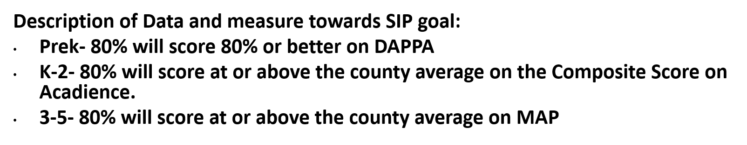
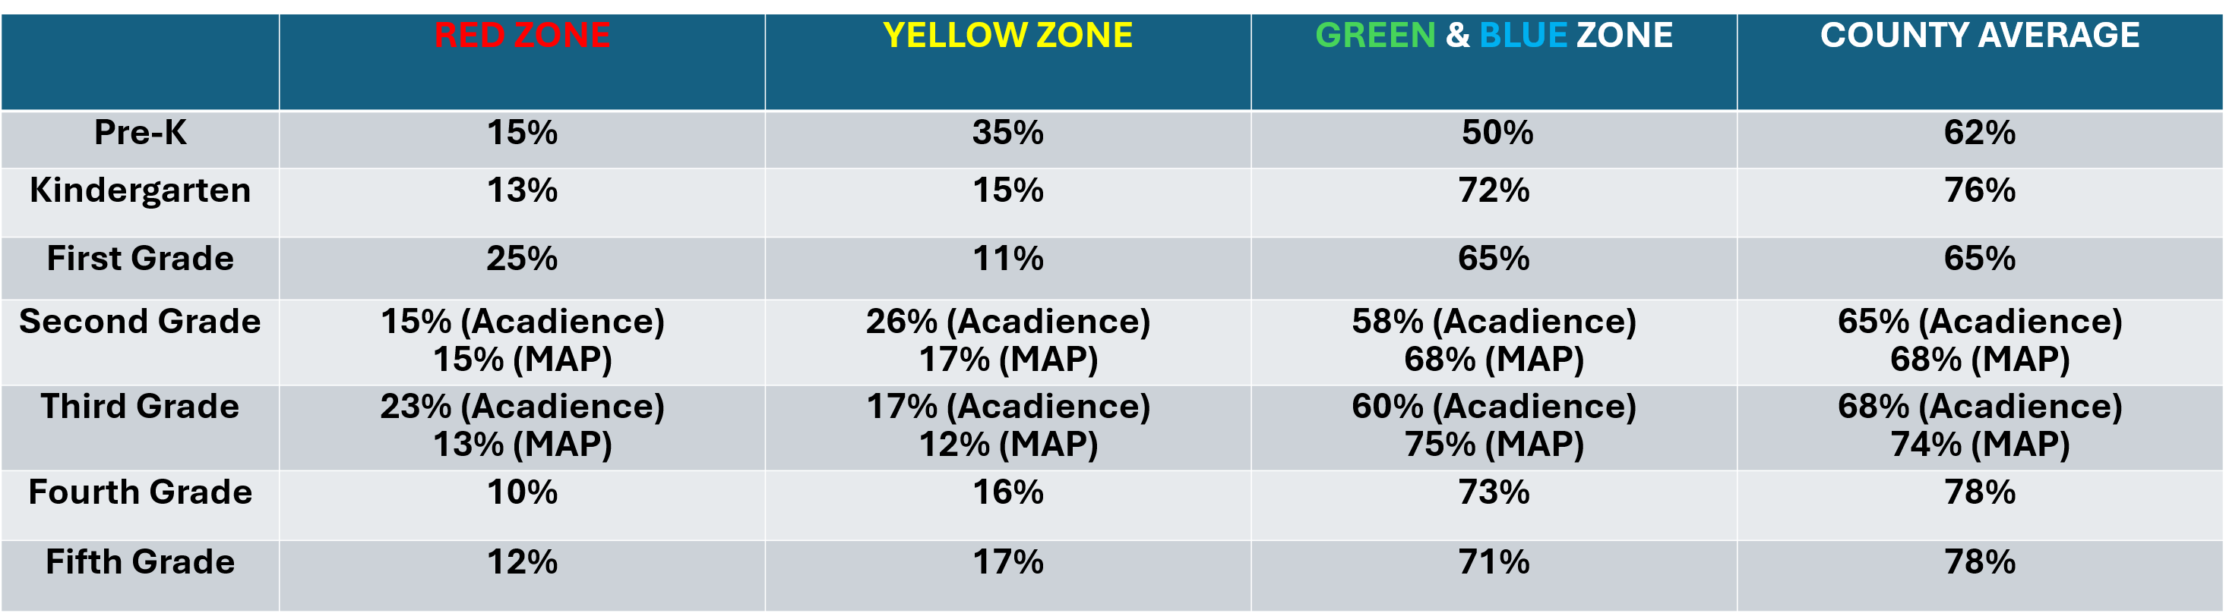

First grade met the county average for Acadience composite score. Second and third grade met or exceeded the county average for Map Growth scores.
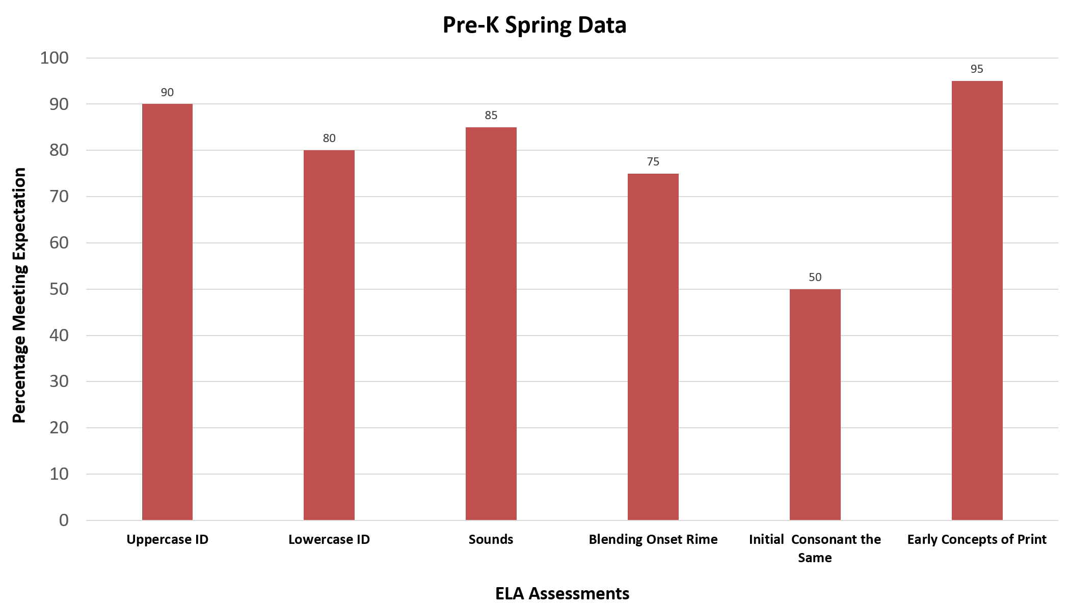
Pre-K End of Year Data:
Strengths – Identifying upper and lowercase letters, letter sounds, and early concepts of print
Areas of Need – Blending Onset Rime and identifying initial consonants the same

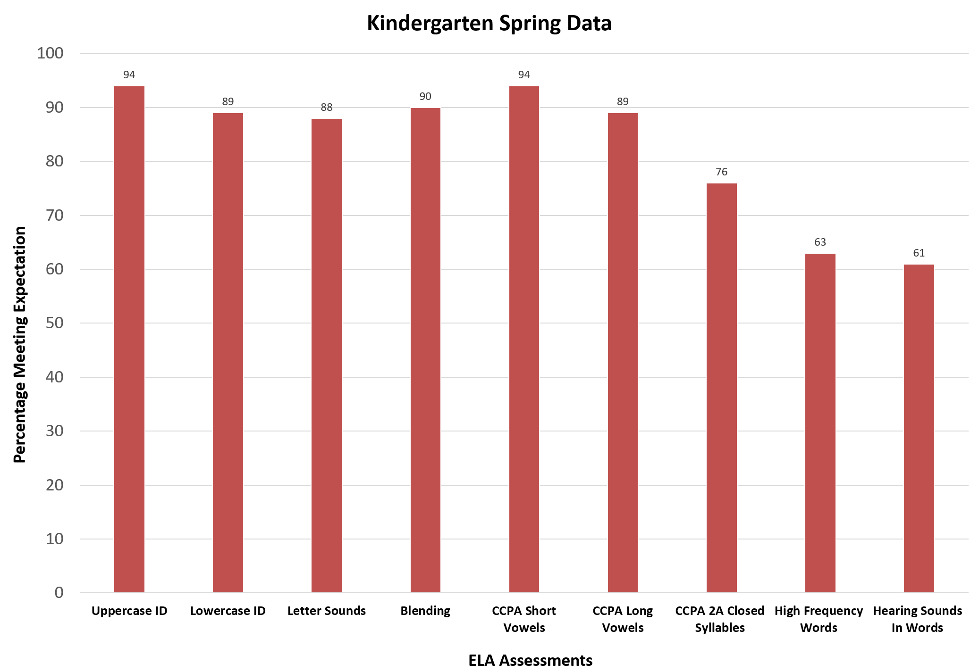
Kindergarten End of Year Data:
Strengths – Identifying upper and lowercase letters, letter sounds, blending, identifying short and long vowel sounds
Areas of Need – Reading closed syllable words, reading high frequency words, and writing a dictated sentence for hearing sounds in words

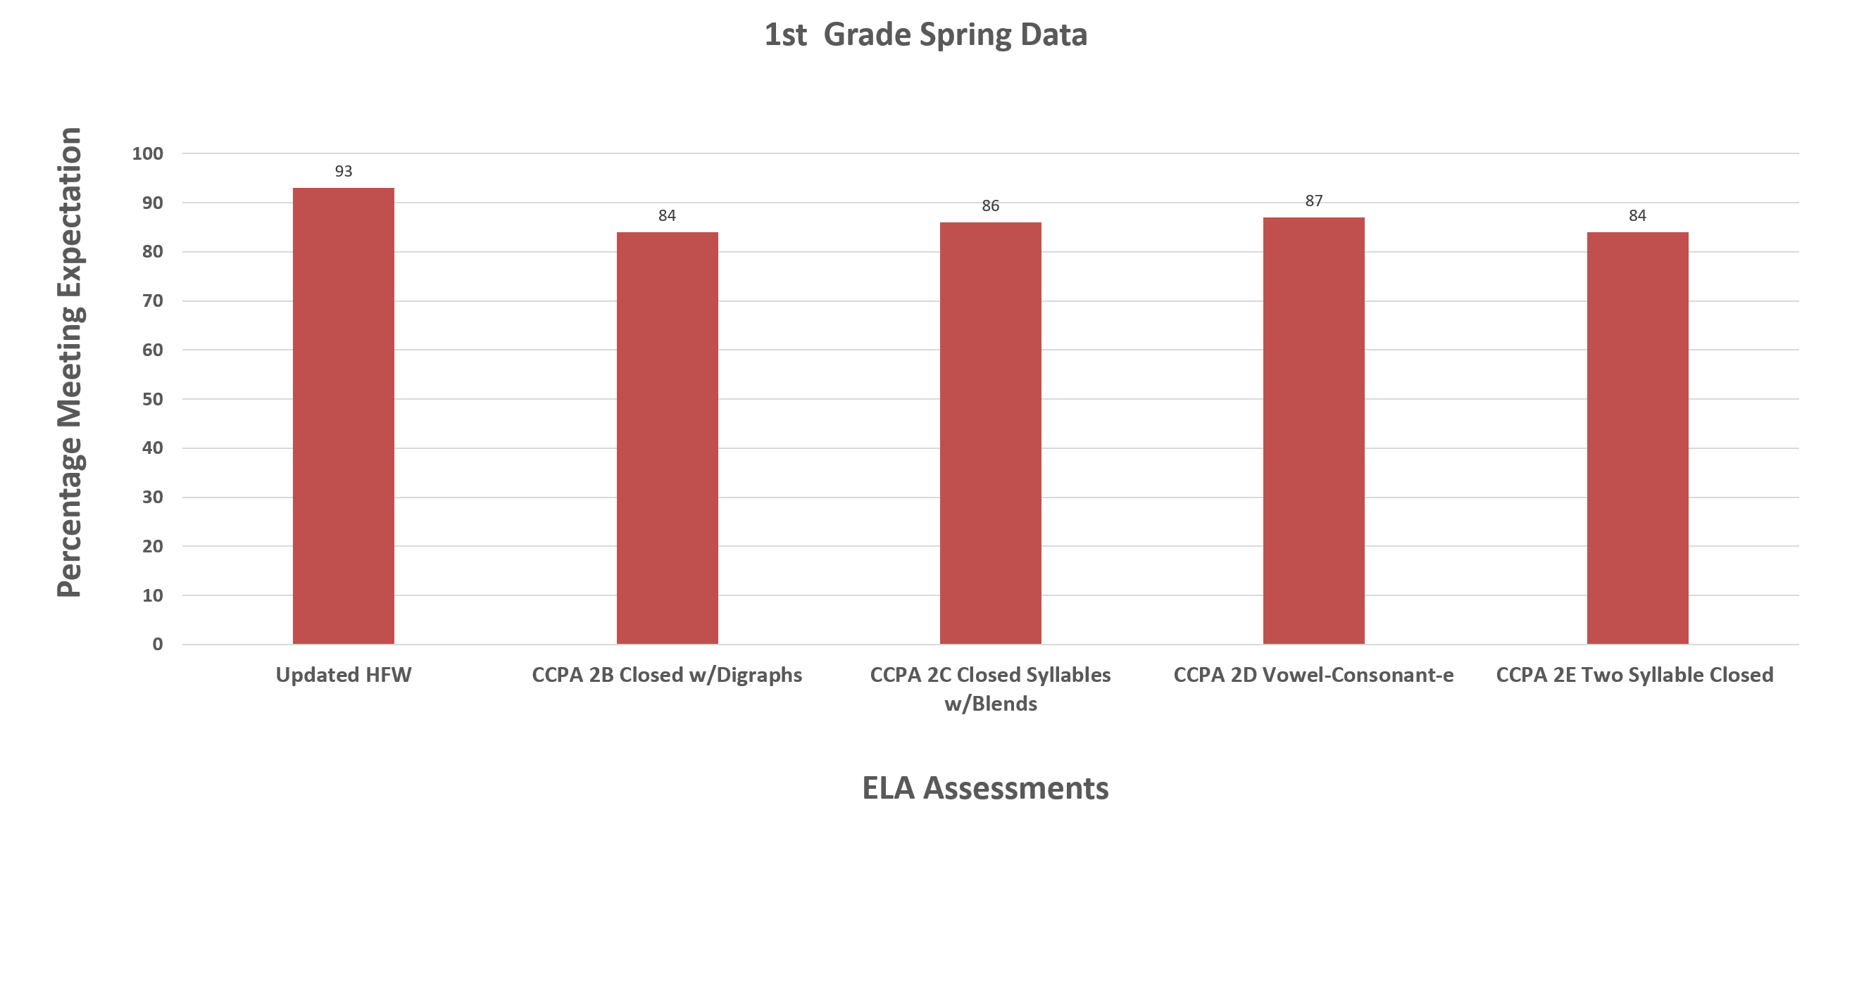
1st Grade End of Year Data:
Strengths – 80% of students met 80% or better on all the assessments.
Areas of Need – continue to build on students phonics skills to increase the number of students meeting 80% or better
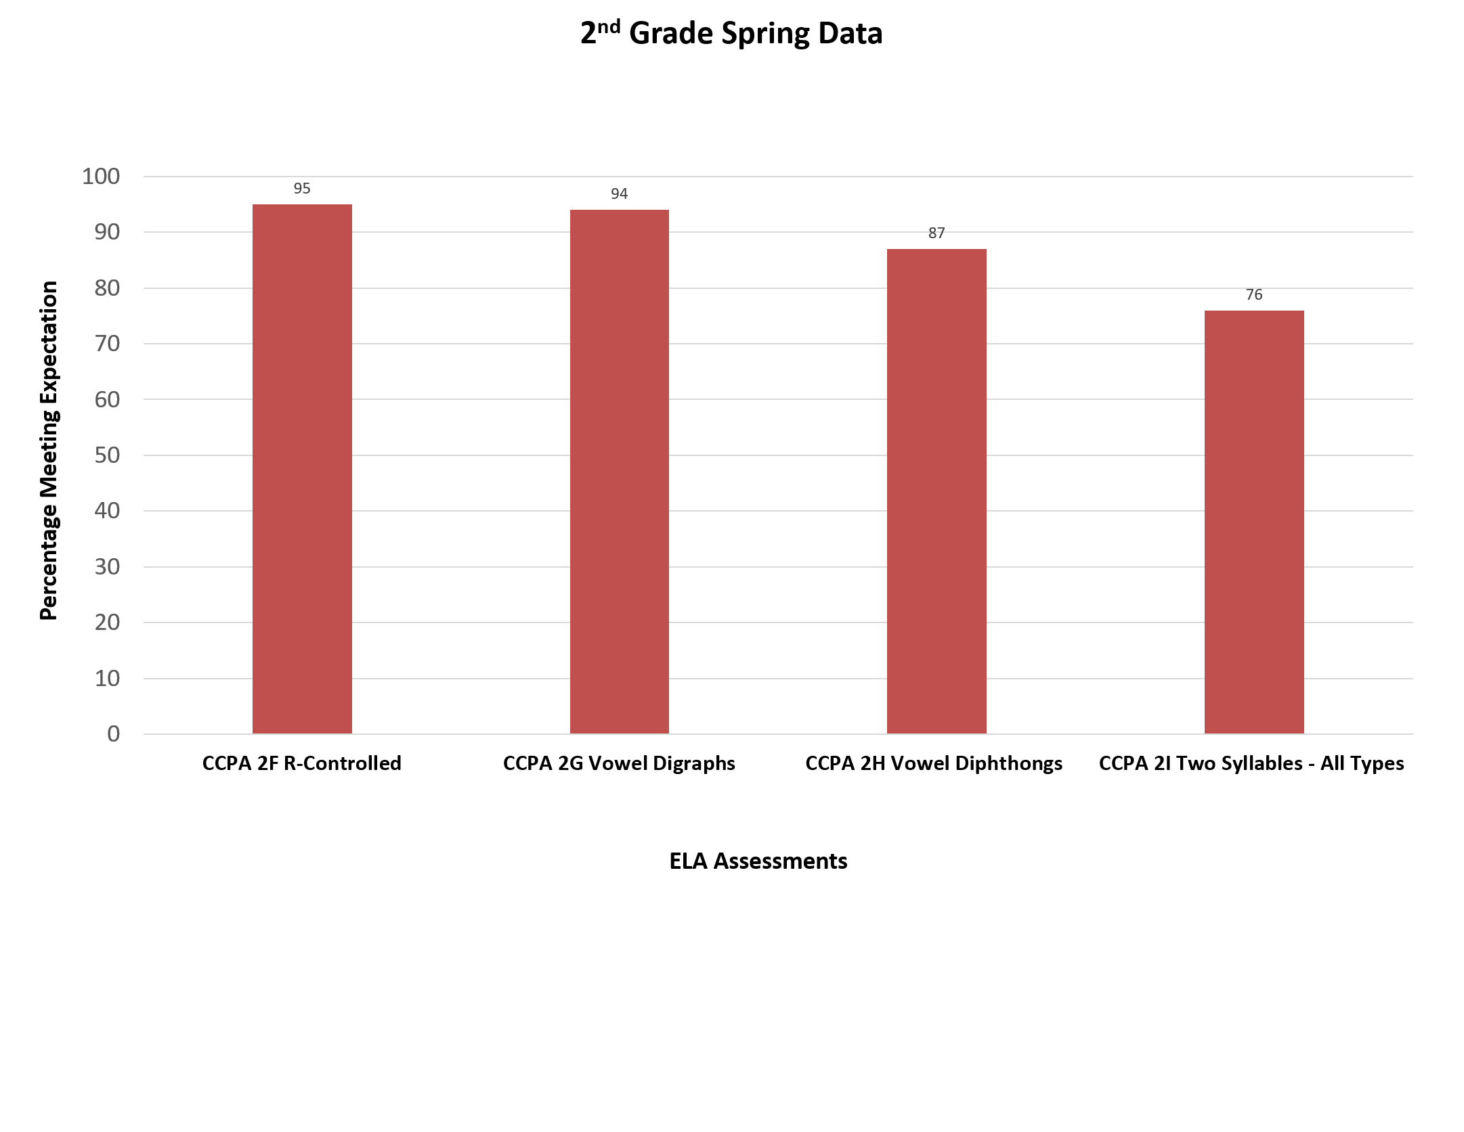
2nd Grade End of Year Data:
Strengths – All assessment areas have 80% of students meeting the expectation, except CCPA 2I Two Syllables Mixed
Areas of Need –Only 76% of students are passing the Carroll County Phonics Assessment (CCPA) in the area of 2I Two Syllables Mixed types. Students read a list of 5 real words and 5 nonsense words with the r-control pattern. They must score 8/10 to pass the section.

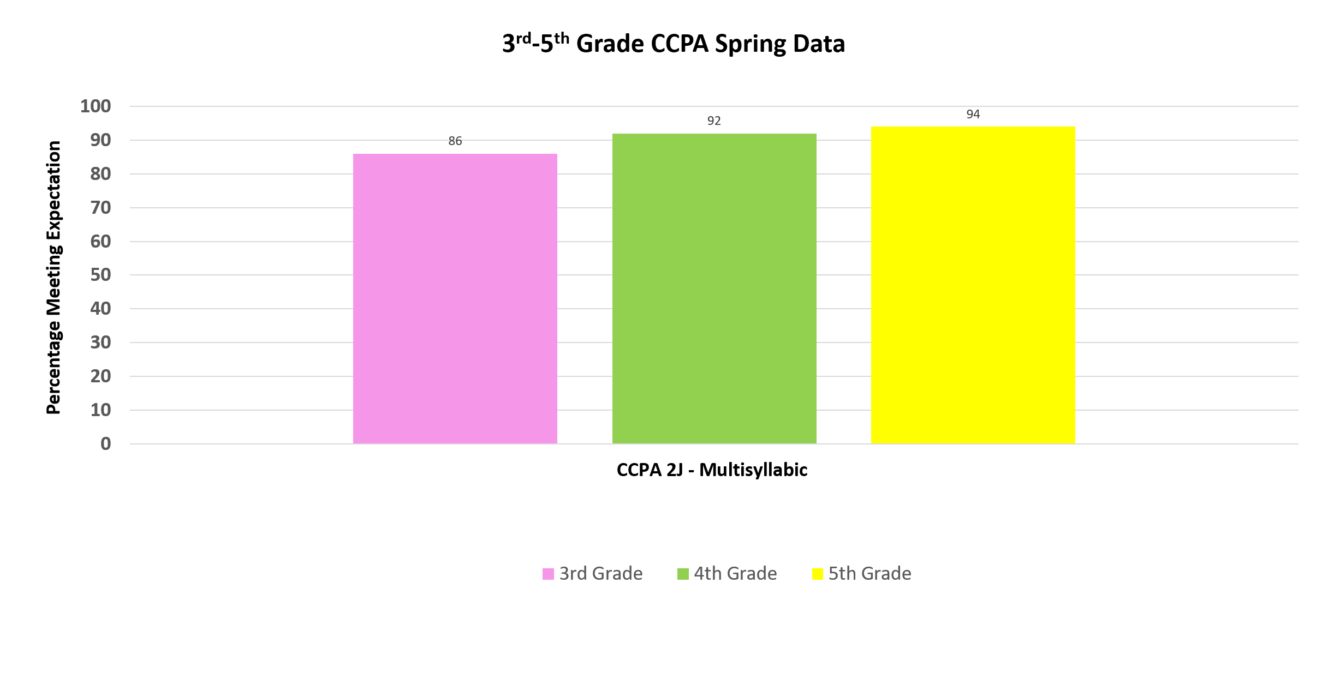
3rd – 5th Grade End of Year Data:
The expectation is students pass the Carroll County Phonics Assessment by fall of 3rd grade year. There are still a percentage of students at each grade level 3rd-5th that are still working toward mastering this assessment.

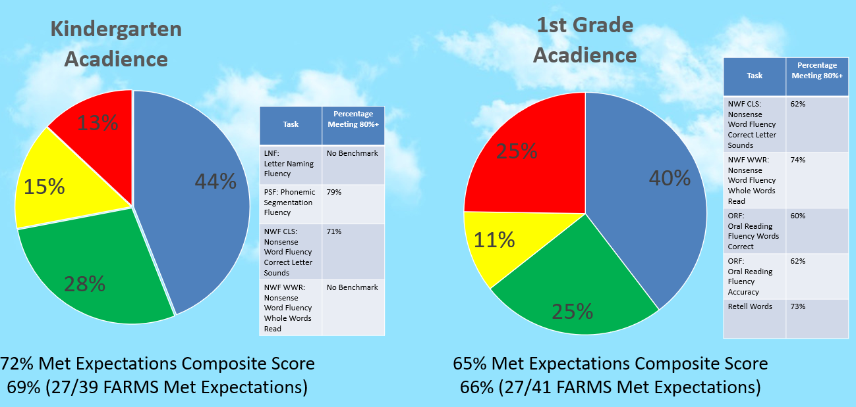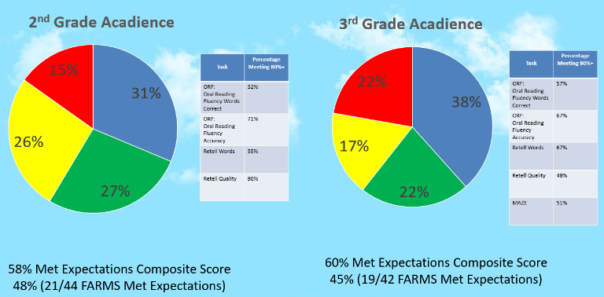

Acadience Kindergarten to 3rd Grade:
The data shows that students need instruction and practice in the area of fluency. This would include the number of words read correctly in one minute and the accuracy of the words read. Students will use fluency folders and a fluency routine to build these skills.

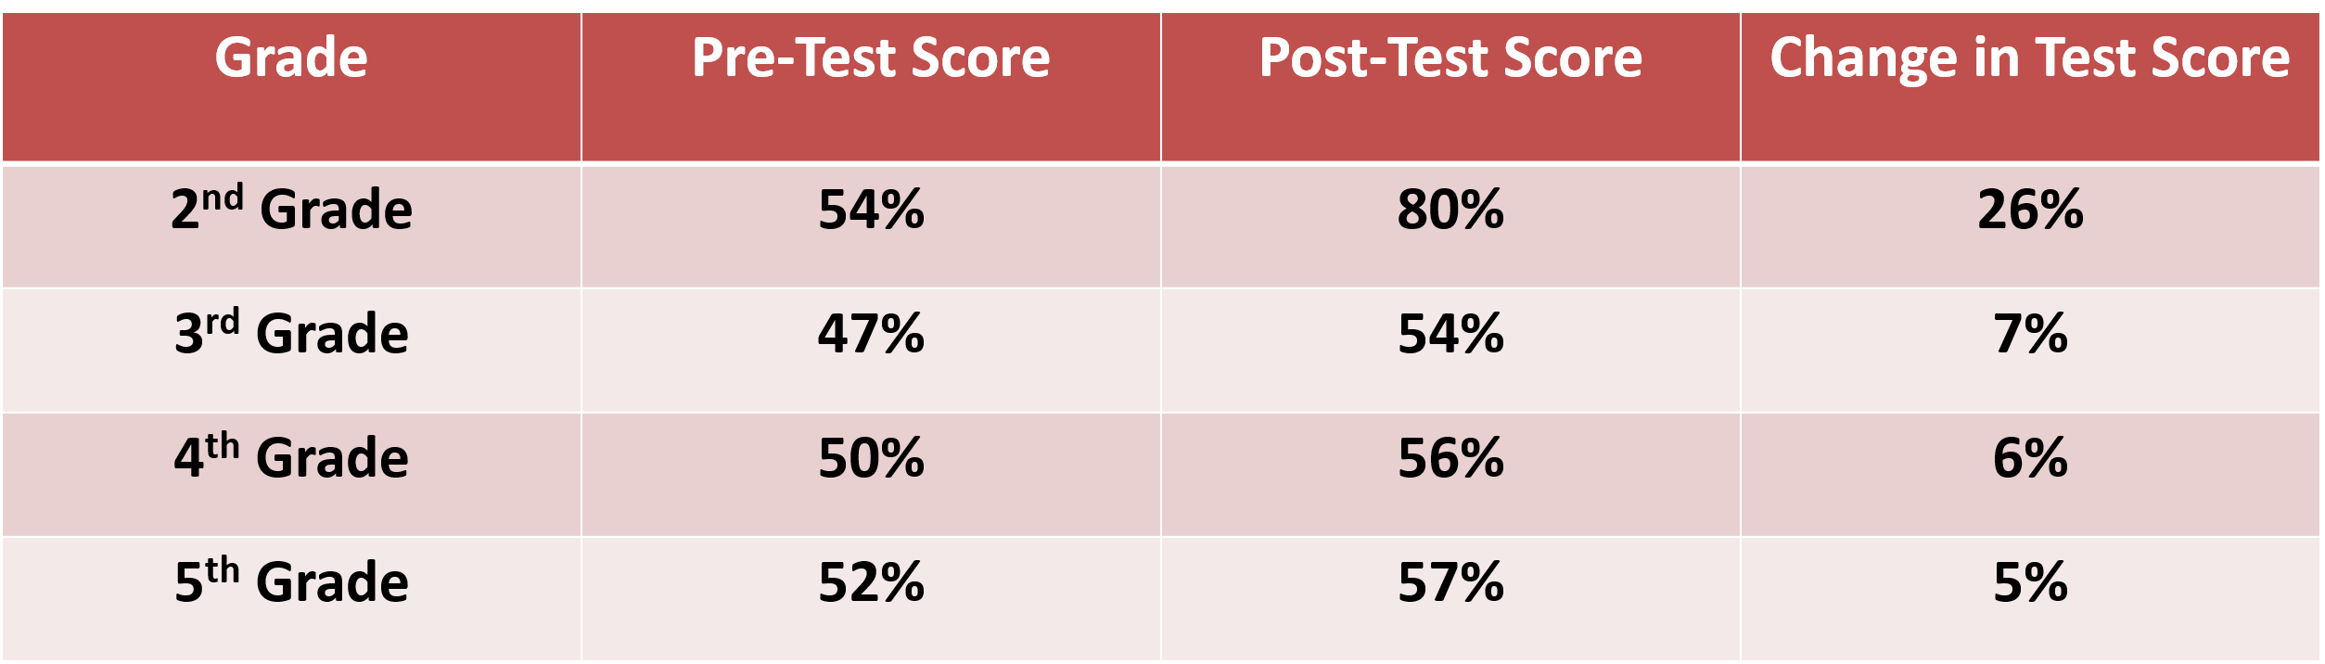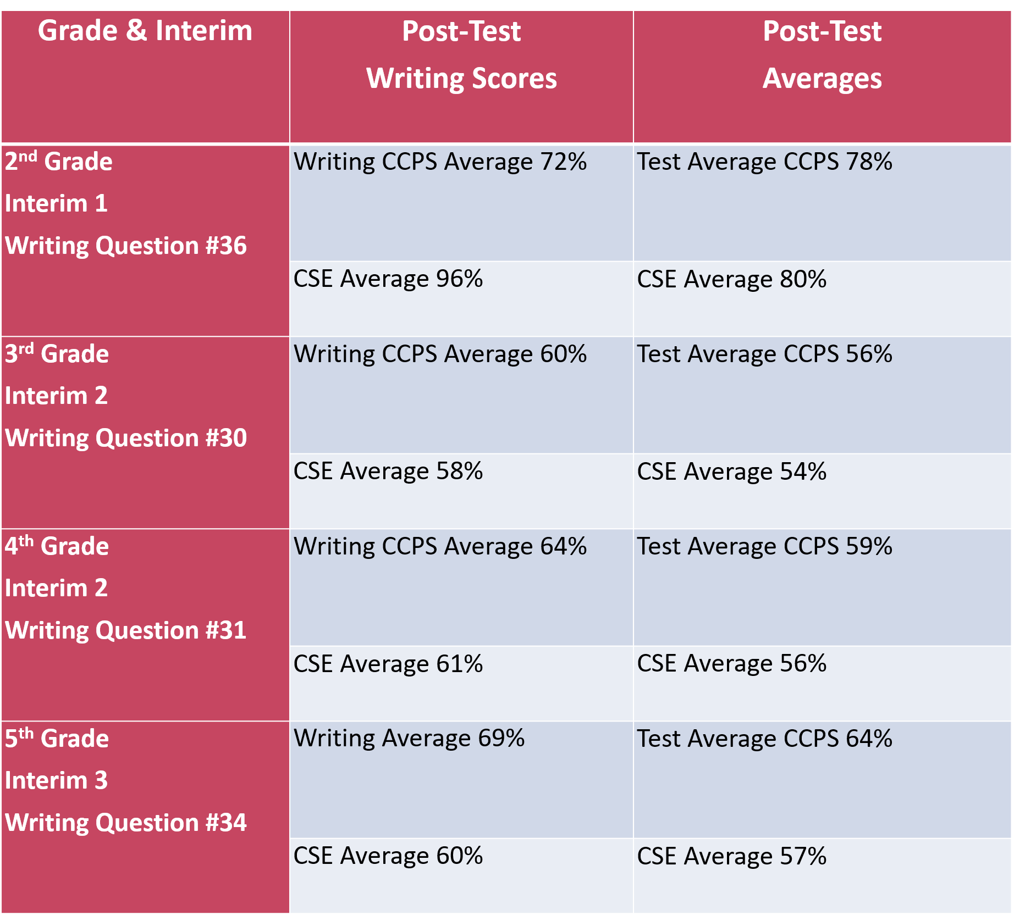
Benchmark Advance Comprehension and Writing Assessment:
Strengths: Students showed growth from October to April in the areas of comprehension through answering multiple choice questions. 2nd grade exceeded the county average for writing scores.
Areas of Need: Students continue to show a need for consistent writing instruction and time to practice learned skills.

Math End of Year Data

Math MCAP Data Spring 2026:
Math
2025-2026 School Year
3rd Grade
School = 53% | District =67% | State = 42.6%
Level 1 à 21.1%
Level 2 à 36.3%
Level 3 à 37.3%
Level 4 à 5.4%
4th Grade
School = 43% | District = 57% | State =34.8%
Level 1 à 22.2%
Level 2 à 43.1%
Level 3 à 31.2%
Level 4 à 3.6%
5th Grade
School = 33% | District = 45% | State =30.2%
Level 1 à 18.9%
Level 2 à 50.9%
Level 3 à 28.3%
Level 4 à 1.9%

Math SIP Goal - 80% of Students will score 80% or Greater on the May Benchmark.
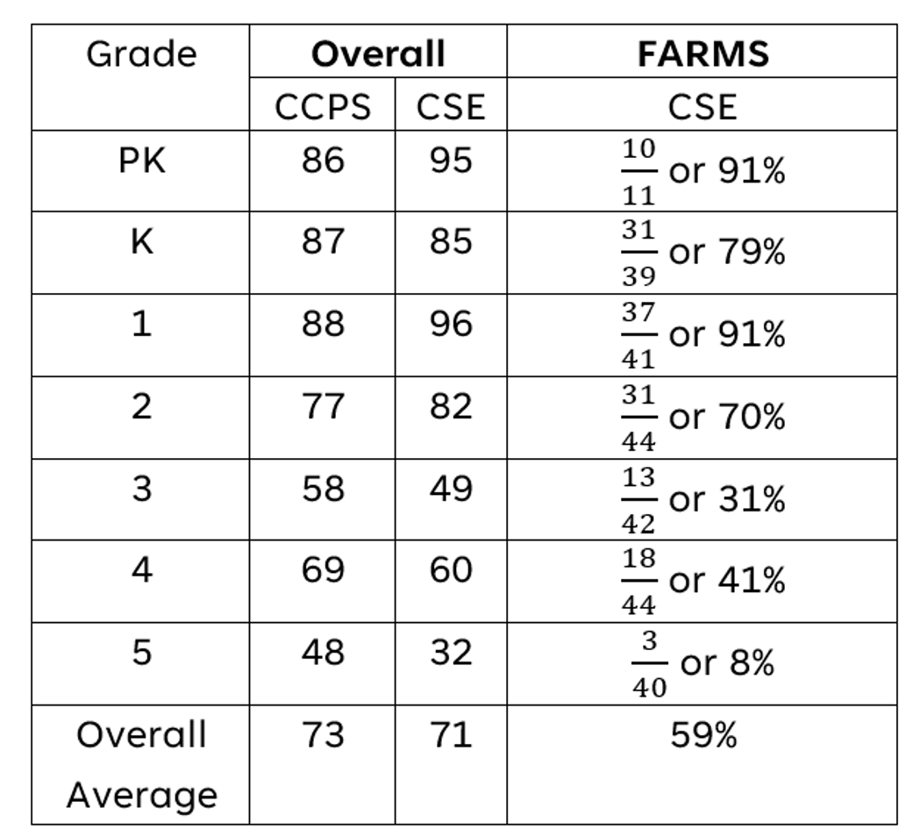
May Benchmark Mean Score Comparison 2023-2026
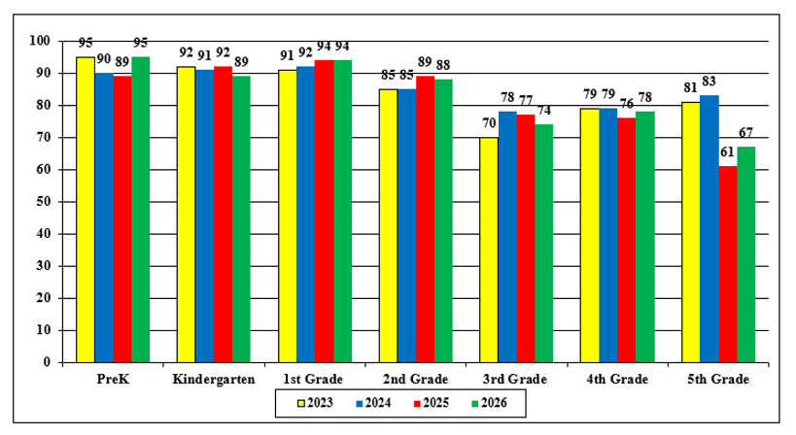
May Benchmark Mean Score Comparison 2022-2026:
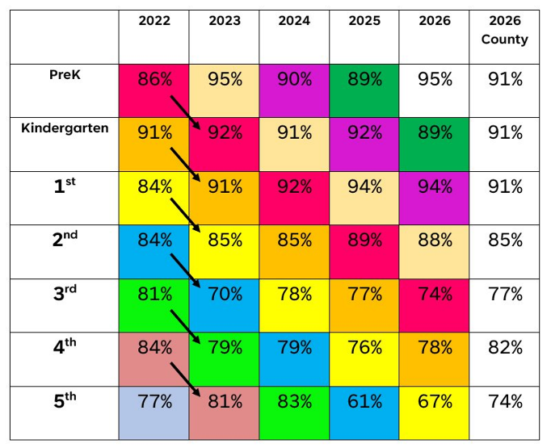

May Benchmark Percent Meeting 80% Comparison 2023-2026
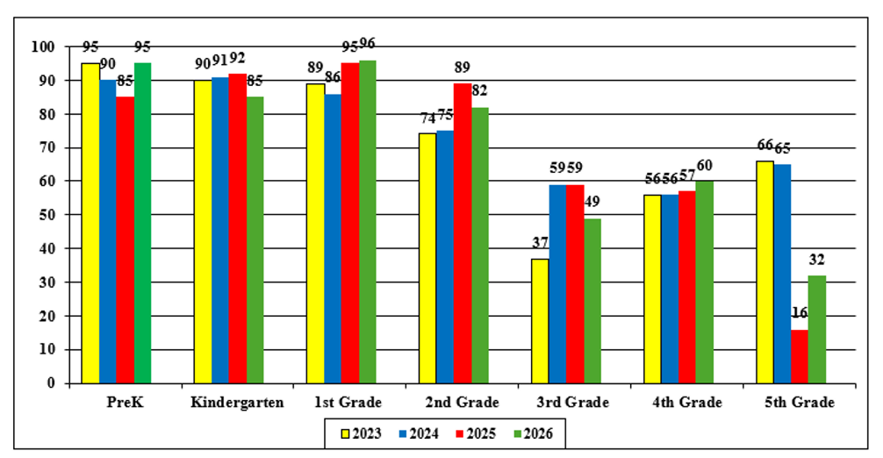
May Benchmark Percent Meeting 80% Comparison 2022-2026
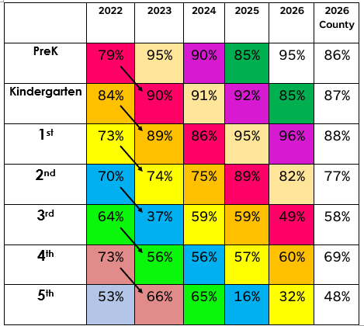
Math End of Year Grade Level Data:
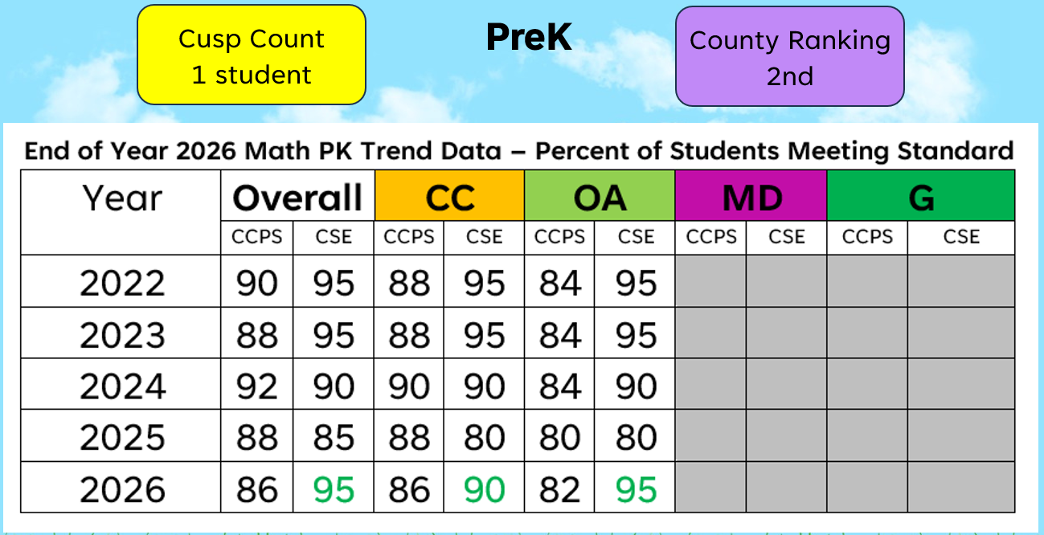
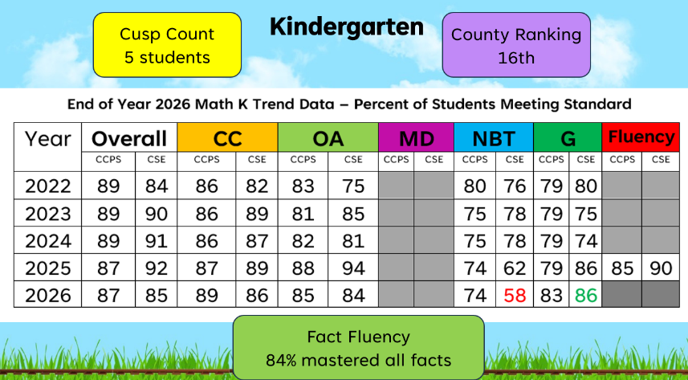
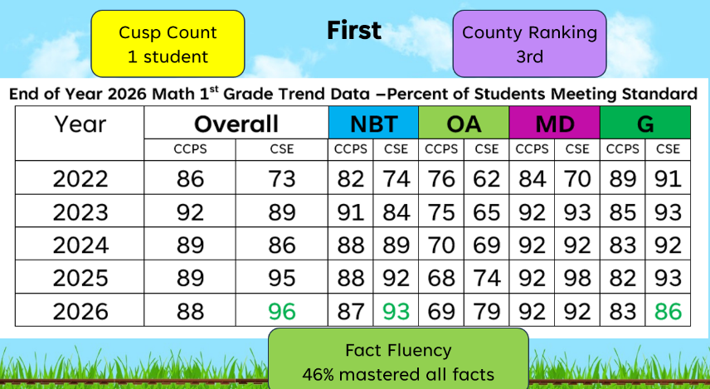
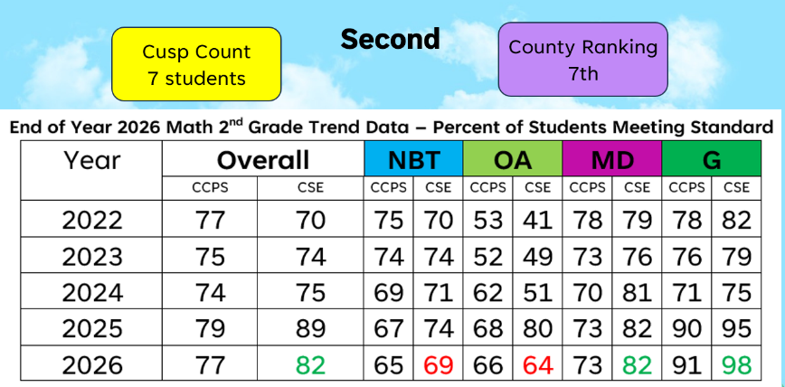
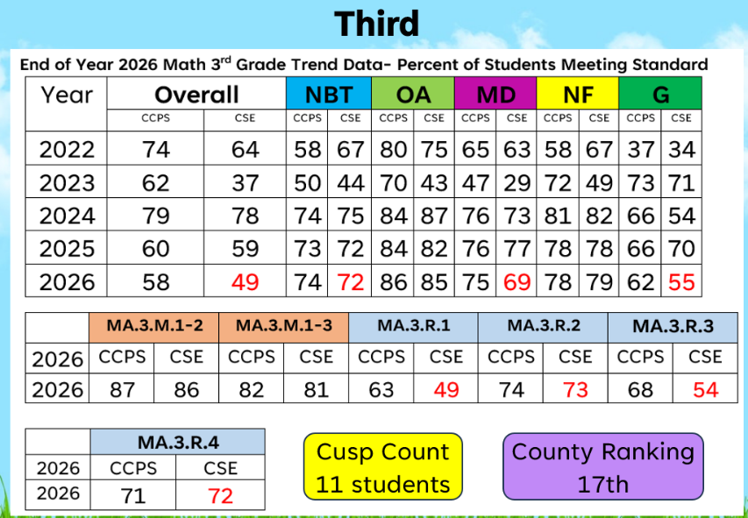
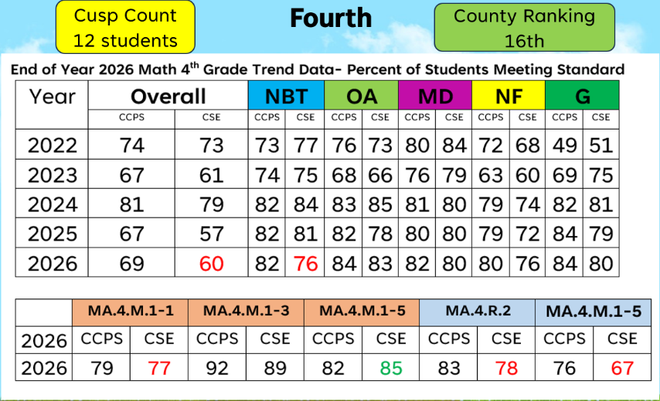
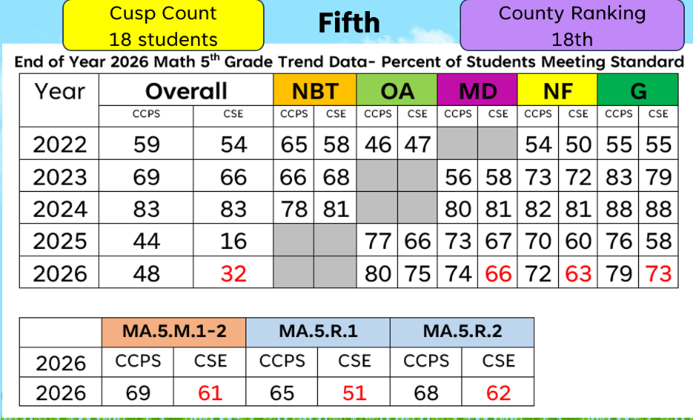
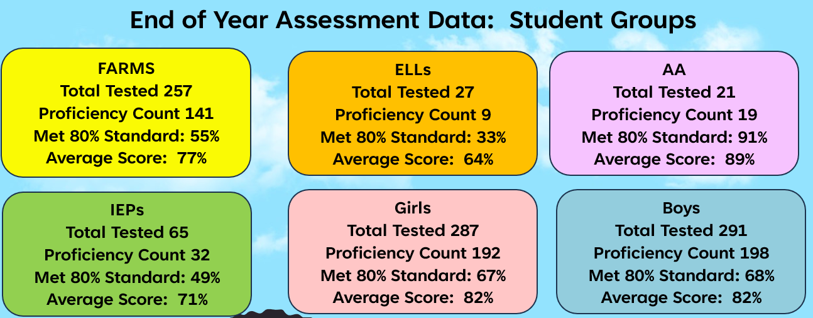
Fact Fluency Data:
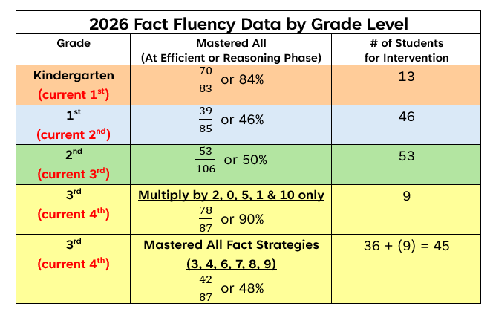

SWP Component #2: A school-wide reform strategy that:
- Provide opportunities for all children, including each of the subgroups of students as defined in section 1111(c) (2) to meet the challenging State academic standards; (1114(b)(7)(A)(i);
- use methods and instructional strategies that strengthen the academic program, in the school, increase the amount and quality of learning time and help provide an enriched and accelerated curriculum, which may include programs, activities and courses necessary to provided well rounded education; (1114(b)(7)(A)(ii);
- address the needs of all children in the school, but particularly the needs of those at risk of not meeting the challenging State academic standard, through activities which may include (1114(b)(7)(A)(iii)
- Counseling, school-based mental health programs, specialized instructional support services, mentoring, and other strategies to improve students’ skills outside the academic subject
- Preparation for and awareness of opportunities for postsecondary education and the workforce, which may include career and technical education programs and broadening secondary school student access to coursework to earn postsecondary credit while still in high school (such as Advanced Placement, International Baccalaureate, dual or concurrent enrollment, or early college high schools);
- Implementation of a school wide tiered model to prevent and address problem behavior, early intervening services, coordinated with similar activities and services carried out under the Individuals with Disabilities Education Act (20 U.S.C.1400 et seq.);
- Professional Development and other activities for teachers, paraprofessionals, and other school personnel to improve instruction and use of data from academic assessments, and to recruit and retain effective teachers, particularly in high need subjects;
- Strategies for assisting preschool children in the transition from Early childhood programs to local elementary school programs;
- Delivery of Service (optional) - the services of a schoolwide program under this section may be delivered by nonprofit or for-profit external providers with expertise in using evidence-based or other effective strategies to improve student achievement.
- Dual Enrollment (optional)
- In General -A secondary school operating a schoolwide program under this section may use funds received under this part to operate dual or concurrent enrollment programs that address the needs of low-achieving secondary school students and those at risk of not meeting the challenging State academic standards
- Flexibility of funds- a Secondary school using funds received under this part for dual or concurrent enrollment program described in paragraph (1) may use such funds for any cost associated with such programs including the cost of –
(A) training for teachers, and joint professional development for teachers in collaboration with career and technical educators and educators from institutions of higher education, where appropriate, for the purpose of integrating rigorous academics in such program;
(B) tuition and fees, books, required instructional material for such programs, and innovative delivery methods; and
(C) transportation to and from such program
f. Rule of construction-nothing in this subsection shall be constructed to impose on any State and any
requirement or rule regarding dual or concurrent enrollment programs that is inconsistent with State law.
Things to consider:
◻ How do the schoolwide reforms increase the quality and quantity of instruction using evidence-based methods and strategies?
◻ How do the reform strategies align with the needs assessment and address the needs of all students including low achieving, accelerated, etc.?
◻ What evidence is being collected to demonstrate the effectiveness of reforms?

Needs Analysis/SIT Goals | Strategic Actions | Measures of Success/Desired Performance Level | Time Line
By June 2027, we will have 80-90% of students reading on grade-level as measured by local assessments or students will meet the county average. | 1.a-The Pre-Kindergarten teacher will implement letter/sound correspondence matching lessons and activities in small groups using Heggerty, LETRS, and Science of Reading: Shifting the Balance. | 1.a - Daily teacher observation in small flexible groups. The teacher will give a monthly WIG check-in that assesses letter ID knowledge. | 1.a  Daily
 | 1.b-Kindergarten – 3rd grade teachers will implement sight word lessons and phonics instruction following the Fundations curriculum explicitly to include the trick words. Teachers will also incorporate Elkonin/sound boxes, decodables texts, and word chain lessons from Heggerty, LETRS, and Science of Reading: Shifting the Balance resources. Teachers will progress monitor through Fundations and Benchmark Advance Fluency weekly and unit check-ins. Teachers will progress monitor the application of encoding skills by using weekly and unit dictation sentences. | 1.b – Teachers will follow he Fundations manual and give the weekly and Unit Fundations check-ins. This information will be discussed monthly at data meetings to ensure progress. | 1.b  Weekly
 | 1.c - Kindergarten- 5th grade teachers will increase student fluency by modeling a fluency routine. Teachers will monitor and assess fluency progress with repeated readings, timed reads, and Fundations Fluency resources. Teachers will utilize fluency folders for each student with daily and weekly practice for tracking data. | 1.c – WIG goals will be aligned with assessing students on close reading strategies. Formative assessments will be given monthly to determine progress. Review Comprehension Benchmark Assessment data (taken 4 times a year). Teachers will choose a multiple-choice assessment in Benchmark Advance as a formative assessment for the WIG monthly check-in. Benchmark Advance has a weekly assessment and unit assessment to choose for this assessment. | 1.c  Weekly
 | 1.d - Kindergarten - 5th grade teachers will explicitly model and implement strategies for close reading by utilizing the LETRS Comprehension planning checklist. Teachers will progress monitor comprehension through weekly comprehension formatives from Wonders for Kindergarten and 1st grade and the Benchmark Advance weekly assessments in 2nd – 5th grade.times a week. | 1.d - WIG goals will be aligned with assessing students on close reading strategies. Formative assessments will be given monthly to determine progress. Review Comprehension Benchmark Assessment data (taken 4 times a year). Teachers will choose a multiple-choice assessment in Benchmark Advance as a formative assessment for the WIG monthly check-in. Benchmark Advance has a weekly assessment and unit assessment to choose for this assessment. | 1.d  Weekly/Monthly
 | 1.e - WIG data will be presented at the monthly SIT meetings. Artifacts will be shared to demonstrate common errors and problem solve to determine next steps. | 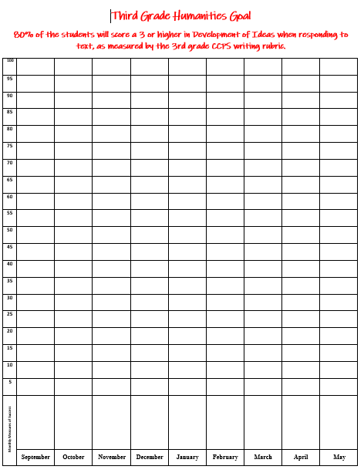  1.e -Grade levels will track and share out WIG data each month and display the results in the hallway or classroom. | 1.e  Monthly
 | 1.f - Pre-K to 5th grade teachers will utilize the Plan-Do-Study-Act cycle during weekly planning meetings to monitor and adjust instruction. | 1.f – Sharepoint folders are created for each grade level in ELA to plan out all components of the lessons for the week. We will discuss and write objectives that align with the formative and summative assessments for the lessons. | 1.f  Weekly
 | 1.g - Teams will have monthly smart goal meetings with special educators and interventionists to analyze data, identify areas of need, develop commitment statements and strategic actions, and review implementation. Data and notes from all grade-level performance meetings will be entered in Sharepoint. | 1.g – Interventionists will be working with resource staff to set smart goals for each group and track data daily specifically related to the goal. Interventionists will share out at monthly data meetings on progress or lack of progress using specific data points aligned with the goal.  Beginning LEXIA levels in September will be compared to May LEXIA levels for each student to demonstrate growth. 100% of students will be expected to show one year’s growth if meeting attendance expectations of 90% or better. Administration, resource staff, interventionists, and the special ed team will meet 3 times a year to review students who are not meeting smart goals in Tier 2 interventions. | 1.g  Monthly
 | 1.h - Administrators will complete walk through observations to monitor and provide feedback on MQI for first pass instruction. | 1.h - Data and notes from all grade-level performance meetings will be entered in SharePoint. Monthly WIG data will be used as a formative data piece at the SIT meetings. | 1.h  Weekly
 | 1.i - Kindergarten – 5th grade students will have a WEN (What Everybody Needs) time each day. Students will be strategically placed in intervention, supplemental, or extension groups. | 1.i - Teams will review data to determine what intervention groups are needed and how to place students in those groups. Teams will plan instruction using county approved intervention materials and track data using formative assessments. | 1.i  Daily
By June 2027, We will have 80% of students writing on grade-level as measured by local assessments. | 2.a - K -2nd grade teachers will practice letter and sound identification/correspondence by having students record dictated sentences. | 2.a – Incorporate daily dictation practice in planning for the ELA block. Teachers will use informal small group observation, collect independent practice, and give formative assessments on a weekly or bi-weekly basis. | 2.a  Weekly
 | 2.b - All content teachers will provide opportunities for students to respond to writing prompts that support identified grade level standards and needs. Writing prompts will be graded with the writing rubric and they will share the data as part of their monthly writing WIG goal. | 2.b – Each team will choose a writing prompt monthly in different content areas (science, math, ELA, and/or social studies) to formally assess students with the informational county writing rubric. This data will be shared at monthly data meetings and recorded on WIG scoreboards in the hallway. | 2.b  Weekly
 | 2.c - Reading resource teacher will meet with teachers (grades 3-5) to review curriculum with a focus on content standards, appropriate expectations, and long range planning for writing instruction in both Humanities and STEM blocks. | 2.c – Weekly planning charts will be created in a SharePoint to align instruction with the objectives and purpose of meeting 80% or better on writing rubrics. | 2.c  Quarterly
 | 2.d - Teachers will explicitly develop and instruct students on how to self and peer evaluate written responses and utilize rubrics in writing conferences and formal grading practices. Teachers will monitor progress. | 2.d – Teachers will set routines and expectations at the beginning of the year for the writing block. They will explicitly teach and utilize the rubrics when students are completing writing projects. Students will use the self and peer checklists when students complete longer writing assignments in narrative, opinion, and informational writing pieces. | 2.d  Weekly
 | 2.e - Students will utilize the “Unlocking the Prompt” strategies in grades 2-5 to improve their ability to comprehend and respond to text. After unlocking the prompt, students will use Benchmark Advance writing organizers in the planning stage. | 2.e. – Teachers will use the Do-What format for writing responses and larger writing assignments. Students will make the chart on the side or back of the prompt. | 2.e  Weekly
 | 2.f - WIG data will be presented at the monthly SIT meetings. Artifacts will be shared to demonstrate common errors and problem solve to determine next steps. | 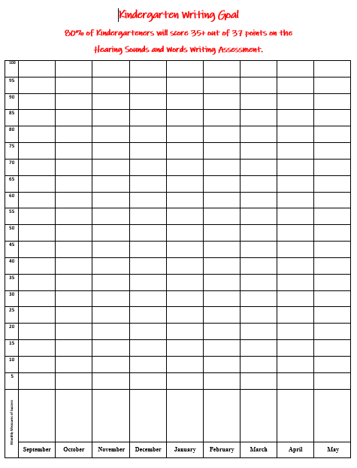  2.f -Grade levels will track and share out WIG data each month and display the results in the hallway or classroom. | 2.f  Daily
 | 2.g - Pre-K to 5th grade teachers will utilize the Plan-Do-Study-Act cycle during weekly planning meetings to monitor and adjust instruction. | 2.g – Sharepoint folders are created for each grade level in ELA to plan out all components of the lessons for the week. We will discuss and write objectives that align with the formative and summative assessments for the lessons. | 2.g  Monthly
 | 2.h - Wonders writing and grammar curriculum will be implemented with fidelity in grades K and 1st grade. | 2.h – Teachers will follow the Wonders grammar and writing lessons using the teacher’s manual. Materials from the Wonders curriculum will be utilized during instruction. | 2.h  Weekly
By June 2027, We will have 80-90% of students meeting 80% or higher on the May Math Benchmark Assessments. | 3.a - All grade level math teachers will facilitate daily math routines and number talks that support number sense. Teachers will collect and monitor student strategies 2 times a week to analyze in collaborative planning meetings. | 3.a -The Mentor Teacher and Math Resource Teacher will observe a classroom number talk. Using the coaching model, the mentor teacher and math resource teacher will provide feedback and determine next steps. | 3.a  Daily/ Weekly
 | 3.b - All grade level math teams will incorporate fact fluency instruction within whole group/small group and independent practice. All students will have weekly mini-lessons based on the fact fluency strategies. Games and technology will be used to reinforce fact strategies.  Students who did not master fact fluency expectations in 25-26 will participate in fact interventions. | 3.b -Monthly WIG data will used as a formative data piece at the SIT meetings. SMART goals will be created for students not meeting with success. | 3.b  Daily/Weekly
 | 3.c - Classroom Teachers will explicitly teach students how to unpack a math story and/or math prompt so that students can improve their ability to comprehend and accurately solve the problem. Students will be assessed through their WIG check ins, formative assessments and common assessments each week. | 3.c– Interventionists will be working with resource staff to set smart goals for each group and track data daily specifically related to the goal. Interventionists will share out at monthly data meetings on progress or lack of progress using specific data points aligned with the goal. | 3.c  Weekly/Monthly
 | 3.d - All grade level math teams will meet each week to review formative assessment data to collaboratively plan for differentiated instruction. All teachers will continue professional learning using Answers to Your Biggest Questions about Teaching Elementary Math and will be given professional development during planning to ensure that all math lessons incorporate essential components and hands-on manipulatives. PD will include a detailed agenda along with | 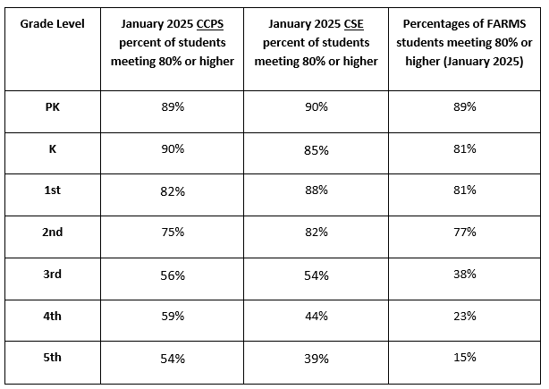  3.d - Students in grades K through 3 will be assessed individually on all of the fact strategies at the end of the year. | 3.d  Weekly
 | 3.e - All grade level math teams will meet each week to review formative assessment data to collaboratively plan for differentiated instruction. All teachers will continue professional learning using Answers to Your Biggest Questions about Teaching Elementary Math and will be given professional development during planning to ensure that all math lessons incorporate essential components and hands-on manipulatives. PD will include a detailed agenda along with teacher survey.Teachers in first through fifth grades will incorporate reasoning and modeling tasks embedded in the curriculum, 2 times a week. | 3.e - Students will be assessed through their WIG check-ins each month. Data will be compiled and presented at each grade level’s data meeting. | 3.e  Weekly
 | 3.f - WIG data will be presented at the monthly SIT meetings. Artifacts will be shared to demonstrate common errors and problem solve to determine next steps. | 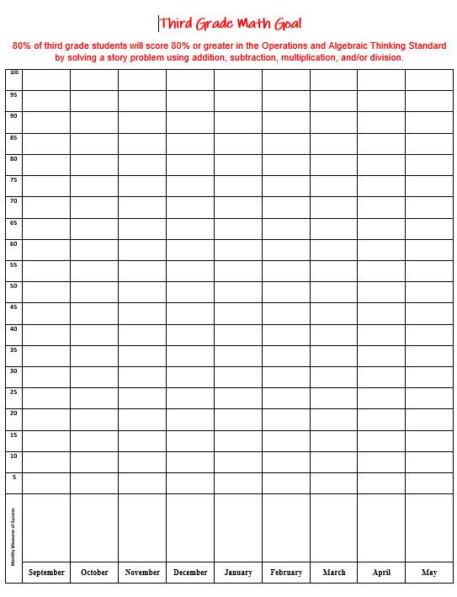  3.f – Grade levels will track and share out WIG data each month and display the results in the hallway or classroom. | 3.f  Quarterly
 | 3.g - Teams will have monthly smart goal meetings with special educators and interventionists to analyze data, identify areas of need, develop commitment statements and strategic actions, and review implementation. Data and notes from all grade-level performance meetings will be entered in Sharepoint. | 3.g - The equity liaison will develop, monitor, and share out updates to the Equity Plan during SIT and Faculty meetings. | 3.g  Monthly
 | 3.h - Pre-K to 5th grade teachers will utilize the Plan-Do-Study-Act cycle during weekly planning meetings to monitor and adjust instruction. | 3.h – Sharepoint folders are created for each grade level in Math to plan out all components of the lessons for the week. We will discuss and write objectives that align with the formative and summative assessments for the lessons. | 3.h  Weekly
 | 3.i - Students in first through fifth grades will document their math achievement through a math data binder. | 3.i – Students will graph their unit test scores throughout the year. Families will look through the binder after unit tests are complete. Students in 1st – 3rd grade will also be tracking their math fact progress using this binder. | 3.i  Monthly
By June 2027, The percentage of FARMS students scoring proficient on ELA county assessments and Math benchmark data will be within 10% of our non-FARMS population scores. | 4.a - Title I and Compensatory Interventionists will pull and implement intervention based on student need and data analysis. Interventionists will develop goals and monitor progress through formative assessments and pre, and post assessments. | 4.a - The instructional leadership team and the special education team leader will meet at the end of each 10 week intervention period to discuss progress and next steps for students not meeting their goals. Students who are identified as FARMS and not meeting goals will be monitored | 4.a  Daily
 | 4.b - Behavioral support specialists and mental health therapist will provide necessary interventions to maintain the classroom environment and instructional implementation. | 4.b - Reports will be presented biweekly at SST. Teams report behavior data each month on the data meeting agendas. | 4.b  Daily
 | 4.c - Support room and behavioral staff will analyze data and support strategies to minimize disruptions to instruction and individual student time out of the classroom. Reports will be present biweekly at SST. |  | 4.c  Weekly
  Grade | January 2025  Referrals | June 2026  Referrals
  Pre-K | 10 | 59
  K | 22 | 213
  1st | 95 | 16
  2nd | 41 | 195
  3rd | 21 | 167
  4th | 70 | 122
  5th | 15 | 68
 | 4.d - Equity liaison will provide professional development to all staff that will support a diverse population with a focus on poverty. | 4.d - The equity liaison will develop, monitor, and share out updates to the Equity Plan during SIT and Faculty meetings. | 4.d  3 times a year
 | 4.e - Title I parent liaison will plan and provide enrichment opportunities for families of designated students. | 4.e – Sign in sheets will be proved for each activity to verify participation and receipt of resources. | 4.e  Once a quarter
 | 4.f - Ensure that all teachers demonstrate cultural proficiency and responsiveness in their classroom to inform strategies and reach ALL students. The Equity liaison will develop, monitor, and share out updates to the equity plan during SIT and/or staff meetings monthly.
 | 4.g - Staff will explicitly teach expected behaviors by referring to the school wide On-Track Behavior Matrix and utilize school wide positive behavior incentives. Staff will use strategies through the progression of the intervention process to support students in the red zone.
 | 4.h - Staff will participate in a book study using the text, “Relationship, Responsibility, and Regulation”. |  | 4.h  Monthly PD in Fall
 | 4.i - School counselor and School Mental Health Therapist will select yellow zone FARM students to meet for targeted intervention on learning behaviors. |  | 4.i  Monthly

SWP Component #3: Parent and Community Involvement - the plan is developed with the involvement of parents and other members of the community to be served and individuals who will carry out such plan, including teachers, principals, other school leaders paraprofessionals present in the school, (administrators of the programs described in other parts of this title), the local educational agency, to the extent feasible, tribes and tribal organizations present in the community, and if appropriate, specialized instructional support personnel, technical assistance providers, school staff, if the plan relates to secondary school, students, and other individuals determined by the school ; 1114(b)(2)

Things to consider:
◻ How will parents, families, and community members be involved in developing the school wide plan?
Parent representatives join faculty at SIT and faculty meetings and help develop our home-school learning compact. Parents share feedback for school wide plans through parent surveys and provide input and action through PTA meetings.
◻ How will teachers, principals, and other school staff be involved in developing the school wide plan?
SIT team meets during the summer. Representatives from each grade level department are represented. Plan is shared school wide during pre service week.

Needs Analysis/SIT Goals | Strategic Actions | Measures of Success/Desired Performance Level | Time Line
Reading, Writing, and Math | Focus Group-Parents will meet together to review current Title 1 documents | Review and offer feedback for the Home/School Compact and Parent and Family Engagement Plan | Annual review in spring, shared with families in the fall
Reading, Writing, and Math | PTA Meetings | Attendance sheets collected to monitor number of families represented | monthly
 | Parent Representatives | Parent involvement at county level meetings (Citizen Advisory Council, Curriculum Council, Special Education, Citizen Advisory Council | Bi-monthly
Reading, Writing, and Math | Early Childhood Advisory Council | Administrator representative on council to share resources | Quarterly

SWP Component #4: Coordination with other Federal, State and local services, resources and programs -
if appropriate and applicable, is developed in coordination and integration with other Federal, State, and local services, resources and programs, such as programs supported under this Act, violence prevention programs, nutrition programs, housing programs, Head Start programs, adult education programs, career and technical education programs, and schools implementing comprehensive support and improvement activities or targeted support and improvement activities under section 1111(d). 1114(b) (5)

Things to consider:
◻ Identify all federal, state, and local programs and services.
◻ How are federal, state, and local resources blended to maximize the impact of the school wide plan?

Needs Analysis/SIT Goals | Strategic Actions | Measures of Success/Desired Performance Level | Time Line
Equity Goal | Partner with local groups to provide services to students, such as, Dentists in the School, Hearing and Vision Screenings, school volunteers, and bus safety | Increase the number of students participating in these programs. | On-going
Reading Goal | Partner with Carroll County Library.  - Book mobile to visit our PreK  - Battle of the Books competition with our 4th and 5th graders.  - CCPL summer reading program. | Increase the number of students participating in these programs. | On-going
 | Partner with local mental health counselors to offer families both consults and services. | The number of referrals given by school staff to community agencies. | On-going
Equity | Partner with local fire company to teach our PreK about Fire safety. | Increase the number of students participating in these programs. | On-going
Reading, Writing, and Math | Host parent focus groups to provide support with academics and socio-emotional concerns/topics | Increase the number of parents participating and attending these meetings. Use parent feedback to determine topics | On-going

Additional notes:

