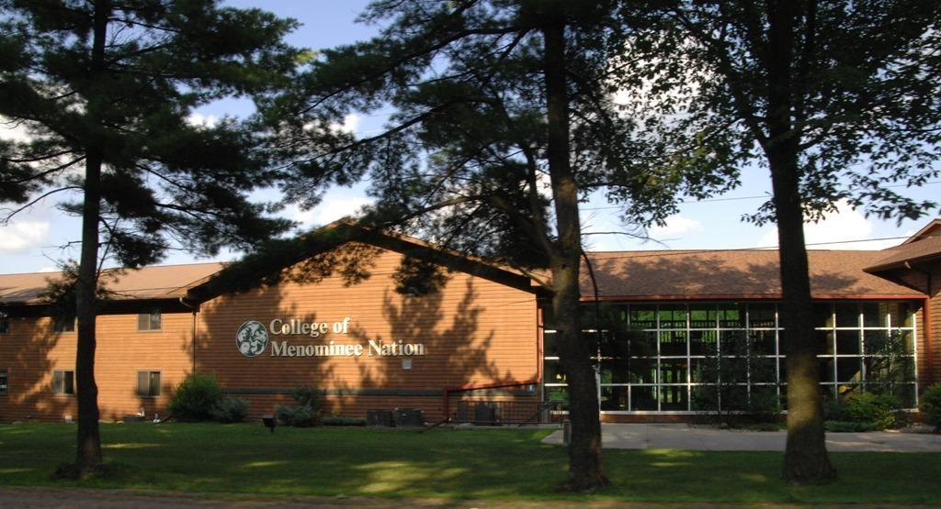

COLLEGE OF MENOMINEE NATION
2026 Annual Campus Security and Clery Compliance Report 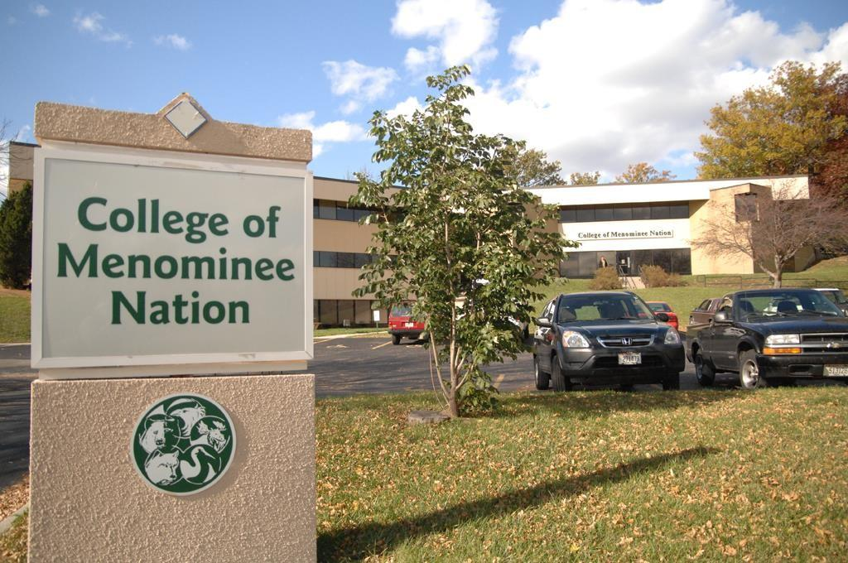
The information in this document complies with the Jeanne Clery Disclosure of Campus Security Policy and Campus Crime Statistics Act, a federal law known as the Clery Act. This Safety Report provides information about safety-related policies, procedures and practices in effect as of September 30, 2026. The policies and procedures may be updated or revised after the date of this report; the most recent documents are available on the College’s website. The Report also incorporates statistical data about certain criminal offenses for each campus of the College of Menominee Nation for the previous three years, by College Campus

TABLE OF CONTENTS
Introduction 2
Geographic Locations 3
Important Contact Information 4
Crime Statistics: Classifying and Counting Clery Act Crimes 4
Collecting Statistics: Authorities and Law Enforcement Agencies 5
The Daily Crime Log 6
Campus Policies, Procedures and Programs 7
Reporting Criminal Actions 7
Student Conduct 8
Employee Policies 8
Weapons on Campus Policy 8
Alcoholic Beverages/ Illegal Drugs 9
Campus Facility and Building Access 9
Campus Safety and Security on the Keshena Campus 10
Campus Safety and Security on the Green Bay/Oneida Campus 10
Security Considerations in the Maintenance of Facilities 10
Emergency Telephones 11
Security Cameras 11
Programs 11
Sexual Assault, Dating Violence, Domestic Violence and Stalking 12
Title IX Coordinator 12
Sex Offender Registration 13
Wisconsin Sex Offender Registry 13
Access to the Registry 14
Important to Know 14
The Annual Security Report/Data 14
Data 15
Chart I: Keshena Campus 15
Chart II: Green Bay/Oneida Campus 16
Missing Person Inquiry 17
Fire Safety 17

INTRODUCTION
The College of Menominee Nation (CMN) was chartered by the Menominee People in 1993, and was authorized by the United States Congress in 1996 as one of only three land grant colleges in Wisconsin. CMN operates two campuses. Its main campus is located in Keshena, Wisconsin, on the Menominee Reservation, and the second campus is in an urban location in metropolitan Green Bay, Wisconsin.

The College of Menominee Nation is an equal opportunity educator and an equal opportunity employer. CMN is accredited by the Higher Learning Commission (www.hlcommision.org) and chosen for the HLC’s prestigious Academic Quality Improvement Program. CMN is a tribal college with affiliations including membership in the American Indian Higher Education Consortium (AIHEC).

CMN is committed to providing all students with a quality educational experience. It is the goal of CMN to make the students, faculty, staff and visitors to the College as safe as possible. To accomplish this, the College understands that it is important to engage the entire campus communities of both locations in the shared obligation of safety through partnerships.

This document contains the College of Menominee Nation’s annual compliance and security report for its’ Keshena and Green Bay, Wisconsin campus. This information is distributed as an electronic link to all active email accounts of students, faculty and staff. The report is also posted in a public location on the CMN Internet and CMN Intranet websites. This information is also available to prospective students and/or employees upon request. All students and employees are encouraged to familiarize themselves with these compliance reports.

The College of Menominee Nation prepares this report to comply with the Jeanne Clery Disclosure of Campus Security Policy and Crime Statistics Act. This report is prepared in cooperation with the local law enforcement agencies surrounding both the Keshena, Wisconsin, and Green Bay, Wisconsin, campus. Campus crime, arrest and referral statistics include those reported to the local law enforcement agencies. These statistics may also include crimes that have occurred in private residences or businesses. All Clery Act geography is located on the campus of the College of Menominee Nation as outlined below:

GEOGRAPHIC LOCATIONS
College of Menominee Nation, Keshena Campus, located on the Southern corner of the Menominee Indian Reservation along State Highway 47-55.

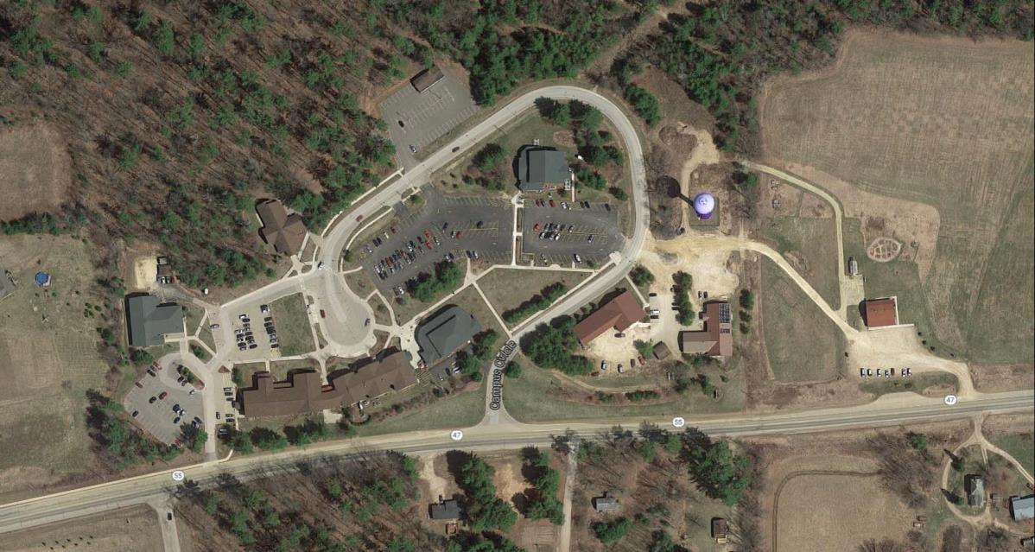

College of Menominee Nation, Green Bay/Oneida Campus- Green Bay, Wisconsin
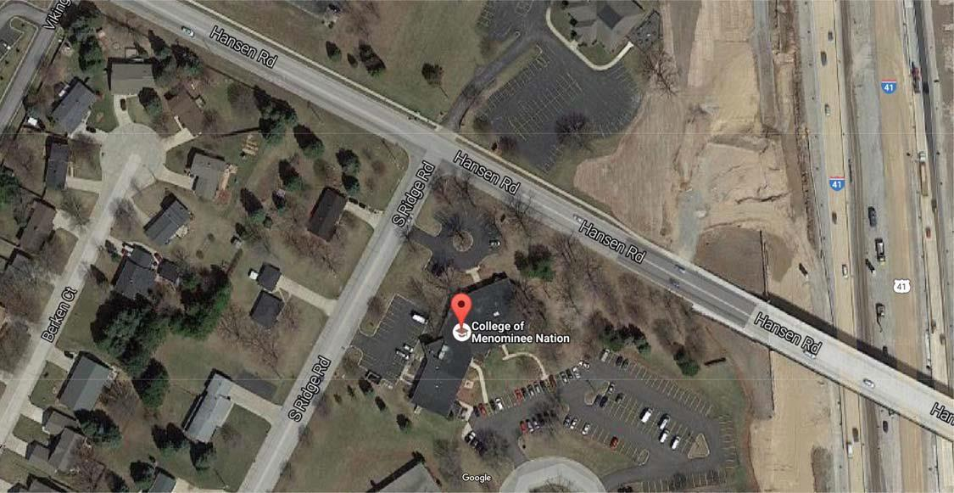

Important contact information
Main CMN Phone Lines – (715) 799-5600 or Toll Free 1 (800) 567-2344

Keshena Campus (In Case of Emergency: 911)
Chief of Staff: (715) 799-6226, ext. 3040
Chief Academic Officer: (715) 799-6226, ext. 3084
Human Resources: (715) 799-6226, ext. 3037
Menominee Tribal Police: (715) 799-3321
Menominee County Sheriff Department: (715) 799-3357
Shawano County Sheriff Department: (715) 526-3111
In Case of Emergency: 911

Green Bay/Oneida Campus (In Case of Emergency: 911)
Receptionist: (920) 965-0070 or Toll Free 1 (800) 567-2344
Chief Academic Officer: (715) 799-6226, ext. 3084
Reception (715) 799-6226, ext. 4000
Student Achievement Specialist: (920) 965-0070, ext. 3067
Ashwaubenon Public Safety Department: (920) 492-2312

CRIME STATISTICS: CLASSIFYING AND COUNTING CLERY ACT CRIMES
The College of Menominee Nation is required to report crime statistics from the following four (4) categories:
- Criminal Offenses-Criminal Homicide, including Murder and Non-negligent.
Manslaughter and Manslaughter by Negligence; Sexual Assault, including Rape, Fondling, Incest and Statutory Rape; Robbery, Aggravated Assault; Burglary; Motor Vehicle Theft; and Arson.
- Hate Crimes- Any of the above-mentioned offenses, and any incident of Larceny Theft, Simple Assault, Intimidation, or Destruction/Damage/Vandalism of Property that were motivated by bias.
- VAWA Offenses-Any incidents of Domestic Violence, Dating Violence and Stalking.
(Note: Sexual Assault is also a VAWA Offense but is included in the Criminal Offenses category for Clery Act reporting purposes.).
- Arrests and Referrals for Disciplinary Action for Weapons-Carrying,
Possessing, Etc. Law Violations, Drug Abuse Violations and Liquor Law Violations.
Under the Clery Act, for the purposes of counting and disclosing Criminal Offenses, Hate Crimes, Arrest and disciplinary referral statistics; CMN must do so based on definitions provided by the Federal Bureau of Investigation’s (FBI’s) Uniform Crime Reporting (UCR) Program. For the categories of Domestic Violence, Dating Violence and Stalking, the Clery Act specifies that CMN must use the definitions provided by the Violence Against Women Act (VAWA) of 1994. Included with these statistics is the number of all reported offenses, no matter what the findings.

Collecting Statistics: Authorities and Law Enforcement Agencies
The College of Menominee Nation is required to identify its institutional Campus Security Authorities (CSA’s). The CMN CSA’s are the following:

Theresa Martin, Coordinator
College of Menominee Nation
P.O. Box 1179
Keshena WI 54135
(715) 799-6226, ext. 3210
tmartin@menominee.edu

George Otradovec, Co-Coordinator
College of Menominee Nation
P.O. Box 1179
Keshena, WI 54135
(715) 799-6226, ext. 3035
gotradovec@menominee.edu

Melinda Cook, Chief of Staff
College of Menominee Nation
P.O. Box 1179
Keshena, WI 54135
(715) 799-6226, ext. 3040 melcook@menominee.edu

It is the responsibility of CMN to collect information from individuals and organizations associated with the College about crimes, arrests and referrals that have been reported, and requesting crime and arrest statistics from local law enforcement agencies.
It has been determined that the CSA’s (indicated above) within the institution will work with other staff and faculty who have significant responsibility for students and events that occur on campus. They are as follows: Campus Support Staff to include Housekeeping, Maintenance, Receptionist, Purchasing Manager, Administrative Assistant and Director.
Other individuals within the institution to whom community, students or employees can report criminal offenses are: CMN Deans, Directors and Managers to include but not limited to staff, Dean of Continuing Education, Dean of Letters & Science, Library Director, and the Dean of Retention.
The designated office to coordinate and oversee the CSA’s is:
Melinda Cook, Chief of Staff
College of Menominee Nation
P.O. Box 1179
Keshena, WI 54135
(715) 799-6226, ext. 3040 melcook@menominee.edu

The Chief of Staff, through the use of the Safety Committee and response team, and the Menominee County/Reservation Emergency Management Team (MCREMT) coordinates, attends and participates in meetings as opportunities to discuss campus safety and security issues as well as to discuss and coordinate training for staff, faculty and students. Training examples include: Roles and Responsibilities of CSA’s, Active Shooter, CPR/First Aid/AED, Lockdowns, Fire Drills, Tornado Drills and bad weather preparedness, to name a few All reports of crime are forwarded to the Chief of Staff for documentation, follow up and investigation.

In addition to collecting crime reports from Campus Security Authorities (CSA’s) the Clery Act requires the College of Menominee Nation to make a “reasonable” effort to obtain Clery Act crime statistics from all local law enforcement that have jurisdiction over CMN’s Clery Act geography. A formal letter on CMN letterhead is written to request Clery Act statistics from local law enforcement agencies such as: Menominee Tribal Police, Menominee County Sheriff Department and Shawano County Sheriff Department for the Keshena campus and the Ashwaubenon Public Safety Department for the Green Bay/Oneida campus. The letter contains a spreadsheet detailing the specific Clery Act statistics needed to complete this report.

The Daily Crime Log
The College of Menominee Nation does not have campus police. Currently, security services are provided through an outside agency for evening hours on both campuses. Staff members do have the authority to ask persons for identification and to determine whether individuals have lawful business at the College but do not possess arrest power.

Criminal incidents are referred to the Tribal or local police who have jurisdiction on the campus. The Menominee Tribal Police Department, the Menominee County Sheriff Department, Menominee County/Tribe Emergency Management, Shawano County Sheriff Department and Ashwaubenon Public Safety are the major elements in a crime-prevention network that includes the Chief of Staff and Campus Support staff.

Students attending the College of Menominee Nation benefit from the cooperative relationship with county, local, tribal, and town law enforcement agencies/governments. The College of Menominee Nation relies on these relationships for support on several levels. In addition to passing critical information to one another, CMN’s Chief of Staff and Campus Support Department has immediate contact with the Menominee Tribe/County as well as Shawano County Emergency Operations/911 Center for the Keshena campus and Ashwaubenon Public Safety/911 Center for the Green Bay/Oneida campus. This arrangement allows unfettered access to mutual aid and support from the Menominee Tribal Police, Menominee County Sheriff, Shawano County Sheriff, Fire Department, and Emergency Medical Services for the Keshena campus and Ashwaubenon Public Safety for the Green Bay/Oneida campus. Menominee Tribal Police officers, Menominee County Sheriff deputies, Shawano County Sheriff deputies and Ashwaubenon Public Safety Officers regularly patrol the town streets that border and pass through both the Keshena and Green Bay/Oneida campuses.

CAMPUS POLICIES, PROCEDURES AND PROGRAMS
The College of Menominee Nation is committed to providing a safe learning and working environment. In compliance with federal laws, policies and procedures have been adopted to raise awareness, prevent, and respond to incidents of sexual assault, domestic violence, dating violence, and stalking involving members of the campus community. These guidelines apply to all students, faculty, staff, contractors and visitors.

Reporting Criminal Actions
The College encourages anyone who is a victim or witness to any crime to promptly report the incident to the College or Tribal or other local law enforcement agency. Depending on the type of crime and campus location, the reporter’s desire for confidentiality may be subject to any requirements of that jurisdiction.
Students are provided resources and access to their rights and responsibilities regarding any safety and security issues, including consequences for their own behavior. Staff and faculty are also subject to the College’s Human Resources Department Personnel Policies and Procedures.
The College of Menominee Nation encourages all students, staff, faculty and other CMN community members to be fully aware of safety issues on its campuses and to take action to prevent and report emergency situations, illegal and inappropriate activities. Personal awareness and applying personal safety practices are the foundations of a safe community.
These are the preferred individuals to be contacted regarding crimes committed on campus.

Keshena Campus (In Case of Emergency 911)
Main Phone Line: Receptionist (715) 799-5600 or Toll Free 1 (800) 567-2344
Chief of Staff: Melinda Cook (715) 799-6226, ext. 3040
Human Resources: (715) 799-6226, ext. 3037
Menominee Tribal Police: (715) 799-3321
Menominee County Sheriff Department: (715) 799-3357
Shawano County Sheriff Department: (715) 526-3111
In Case of Emergency: 911

Green Bay/Oneida Campus (In Case of Emergency: 911)
Receptionist: (715) 799-6226 Ext. 4003
Chief Academic Officer: Geraldine Sanapaw, (715) 799-6226, ext. 3084
Reception: 715-799-6226 Ext. 4000
Ashwaubenon Public Safety Department: (920) 492-2312

Students are encouraged to contact the Chief Academic Officer if there is a need for pastoral and/or professional counseling for any crimes committed on campus. A list of local and community resources will be referenced on a case by case basis called: CMN Family Resource Listing.

Timely Warning Reports to Campus Community
In the event that a situation arises, either on or off campus, that, in the judgment of the Campus Safety Authorities (CSA’s) constitutes an ongoing or continuing threat, a campus-wide “timely warning” will be issued. The warning will be issued to students, faculty, and staff through the College’s School Messenger System that includes a paging system, text messages, e-mail system, website and the information monitors at both campuses.
Depending on the nature of the situation and need for more immediate notification, a copy of the notice is posted at the exterior doors of each campus building or on classroom doors.
Anyone with information warranting a timely warning should report the circumstances to the Campus Support Director:
Keshena Campus Support: (715) 851-5443
Keshena Campus Receptionist: (715) 799-5600, ext. 3000
Green Bay/ Oneida Campus Receptionist: (715-799-62262 ext. 4000

The College Safety Committee has developed a comprehensive list of Emergency Procedures
to immediately notify the campus community in the event of an emergency situation including criminal activity, fires, gas leaks or severe weather. All students, staff and faculty are encouraged to familiarize themselves with the location and content of these procedures. The Emergency Procedures contain specific instructions for each type of emergency and tested at least one or more times per semester.

Student Conduct
CMN Student Handbook outlines the expectations of students.

Employee Policies
The College of Menominee Nation Human Resources Department provides Policies and Procedures that outline the expectations of staff and faculty.

Weapons on Campus Policy
Possession or use of weapons in buildings owned or controlled by the College is prohibited. Weapons include, but are not limited to, firearms, ammunition, knives (except small pocket knives), BB guns, and pellet guns, fireworks, or other dangerous objects or substances. Law enforcement officials may be exempt from this rule.
Students, staff, faculty, and employees are allowed to keep firearms in their vehicles in the parking area ONLY if consistent with their legal status (licensed or unlicensed) and consistent with Federal, State, and Tribal laws. No firearms allowed in buildings or job sites, with no exceptions.
Members of our campus are encouraged to report potential violations to law enforcement authorities and notify campus personnel to insure the safety of others.

Alcoholic Beverages/ Illegal Drugs
Students, staff and faculty are prohibited from possessing or consuming alcohol or illegal drugs while on campus or at campus-sponsored activities. Underage drinking is included in this policy. Penalties for such actions are found in College procedures. These penalties include College disciplinary action as well as criminal prosecution, fine and imprisonment for violation of Federal, State, Tribal, local laws or ordinances. A family resource listing is available to students, staff and faculty who encounter Alcohol and other Drug Abuse issues.
The Drug Free Schools and Communities Act Amendments of 1989, Public Law 101-226, requires that each institution of higher education shall annually distribute to each student and employee information that clearly sets forth institutional policy regarding the prohibition of illicit drugs and alcohol. CMN subscribes to the goals of the Drug Free Schools and Communities Act and takes this opportunity to alert students and employees to the College’s expectations.
The College of Menominee Nation prohibits the unlawful possession, use, distribution, manufacture, or dispensing of illicit drugs and alcohol by students and employees on campus property or as part of campus activities. CMN reports any alleged non-academic misconduct to the Dean of Student Services for potential action by Dean or referral to a hearing process through the CMN Judicial Council. Violation of these provisions by a student may lead to the imposition of a disciplinary sanction, up to and including suspension or expulsion.

The College of Menominee Nation has also adopted a Tobacco-Free Campus Policy in keeping with its interest in improving public health.

Campus Facility and Building Access
Keys and security codes are issued to key personnel for the opening/closing of buildings as well as the need to enter building after normal business hours.

CMN ensures that all buildings and parking areas are well lit. When not in use, buildings will be locked. In the evening only certain exterior doors in the classroom buildings can be entered. The numbers of all classrooms and exterior doors are labeled on the outside of the building to aid in identification during an emergency

Each of the major buildings on the Keshena campus has a distinct fire number for use in the event of a necessary emergency response. The Green Bay/Oneida campus is part of metropolitan Green Bay and has a street address in the event of necessary emergency response. The Campus Safety Maps are updated and shared with law enforcement and fire departments.

The College of Menominee Nation regularly seeks the advice of law enforcement, fire department, emergency government, insurance safety experts, and other campus security departments in maintaining and improving campus security and safety.

During typical business hours, the College is open to students, parents, employees, contractors, guests, and invitees.

Campus Safety and Security on the Keshena Campus
Daytime visitors to the campus must register at the reception desk for Keshena located near the main entrance in the Atrium. The Green Bay/Oneida campus main reception desk is located at the end of the main corridor immediately to the left.
Administrators at both the Keshena and Green Bay/Oneida campus expecting campus guests need to inform the receptionist of that requirement so that a record of visitors and guests can be maintained. It is important that the campus is aware of the presence of those not part of the campus community both for security purposes, as well as to assure that those guests receive the appropriate assistance or services of the College.
The College of Menominee Nation’s campus safety and security protocols at the Keshena campus include designation of a campus “Emergency Response” team chaired by the Safety Committee. This team has the lead responsibility for mobilizing the campus in the event of a campus safety or security emergency.
Keshena campus facilities are equipped with a security system and security access system. Administrators and other key staff are provided with access via ID cards. A Campus Support number is available, posted in each classroom and is as follows: (715) 851-5443 or via the Receptionist:
(715) 799-5600, ext. 3000

Campus Safety and Security on the Green Bay/Oneida Campus
Off-hours access to the Green Bay/Oneida Campus is restricted to employees of the College of Menominee Nation, and personnel on that campus are equipped with radios to quickly communicate any threat or emergency situation. Contact is available via the Receptionist: (715) 799-5600, ext. 4000.

Security Considerations in the Maintenance of Facilities
Maintenance and Housekeeping staff at both campuses are alert to safety and security issues at all times. Staff members ensure that lighting and security systems are operational. Hallways, classrooms and exterior grounds are well lit and all doors are secure and emergency generators and fire suppression systems are inspected and maintained. Maintenance and housekeeping staff members also serve on the Emergency Response Team and have the proper training.

Emergency Telephones
Security and safety for the College includes the use of an emergency blue button that are centrally located on the Keshena Campus in the main areas of buildings, student parking lot and within a call box located on the pathway between south and central campus location. Pushing the button immediately alerts local authorities to an emergency.

Security Cameras
Security cameras have been placed in numerous locations at both campuses. These cameras are continuously recording with a 30 day memory capacity. These security cameras are monitored by staff. Security cameras have proved useful in deterring crimes as well as aiding in identification of those responsible for crimes committed.

Programs
A common theme of all awareness and crime prevention programs is to encourage students and employees to be aware of their responsibility for their own security and the security of others. During the orientation for new students each semester, new students are advised of the College’s Emergency Procedures posted in all classrooms. The College also recommends the following measures to safeguard your personal security:
- Be aware of your surroundings. Watch for any situations that might encourage unsafe or criminal behavior.
- Be cautious when walking or working alone in any building, classroom or on the walking trail, especially at night. Work or walk with a friend or coworker.
- Protect your office. Keep valuables locked in your desk and lock your offices when you are absent.
- Never open locked exterior doors for strangers. Never prop open doors when no one is monitoring the door.
- Always lock your vehicle doors and don’t leave private property in a visible area

Drug and Alcohol Abuse Education Program
The College of Menominee Nation does not operate an independent Drug and Alcohol Education Program. The College can make referrals and obtain resources from Wisconsin Tribes and County Agencies.

Emergency Response and Evacuation
The College Emergency Response Team has developed a comprehensive list of Emergency Procedures to immediately notify the campus community in the event of an emergency situation including criminal activity, fires, gas leaks or severe weather. All students, staff and faculty should familiarize themselves with the location and content of these procedures which are found on the CMN website.

SEXUAL ASSAULT, DATING VIOLENCE, DOMESTIC VIOLENCE AND STALKING
Sexual Assault, Dating Violence, Domestic Violence and Stalking are issues of significant concern across all college campuses, including those of the College of Menominee Nation. In compliance with Title IX and the Clery Act, as amended by the Violence Against Women Act (VAWA), the College responds to all allegations of sexual misconduct, including sexual harassment, non-consensual sexual contact, non-consensual sexual intercourse, domestic violence, dating violence and stalking in a prompt and unbiased manner.
The College of Menominee Nation Student Services, Human Resources and Campus Support departments are responsible for preventing and responding to reports of sexual misconduct include departments. Specific individuals who have a proactive duty to assist individuals who make allegations of sexual misconduct include the following:

Title IX Coordinator
Pursuant to Title IX and its regulations (34 C.F.R. part 106), the College of Menominee Nations’ Title IX Coordinator is the designated College official with primary responsibility for coordinating the College’s compliance with Title IX and other federal and state laws and regulations relating to sex-based discrimination. The Title IX Coordinator is responsible for ensuring that student conduct matters, including investigations of student sexual misconduct, are fair, prompt and effective.

The Title IX Coordinator:
- Promotes the creation of policies, procedures and notifications designed to ensure College compliance with Title IX;
- Oversees implementation of complaint (grievance) procedures, including investigations and dispositions of complaints;
- Answers questions and provides guidance about Title IX compliance and the College’s related policies and procedures;
- Is a liaison to the U.S. Department of Education’s Office of Civil Rights and other state and federal agencies that enforce Title IX;
- Helps ensure the campus community and employees with Title IX compliance responsibilities are adequately trained and educated; and
- Monitors all other aspects of the College’s Title IX compliance.

The College of Menominee Nation’s Title IX Coordinator is:

Dean of Student Success
College of Menominee Nation
P.O. Box 1179
Keshena, WI 54135
(715)799-6226, ext.

The College of Menominee Nation also has Title IX Co-Coordinators:

George Otradovec, Co-Coordinator
College of Menominee Nation
P.O. Box 1179
Keshena, WI 54135
(715) 799-6226, ext.3035
gotradovec@menominee.edu

Melinda Cook, Chief of Staff
College of Menominee Nation
P.O. Box 1179
Keshena, WI 54135
(715) 799-6226, ext. 3040
melcook@menominee.edu

The Title IX Coordinator and Co-Coordinators are responsible for receiving reports, conducting investigations, assisting survivor with interim measures for safety and support services as indicated in the Sexual Harassment, Sexual Assault, Sexual Misconduct, Relationship (Dating) Violence, Harassment and Stalking Policy.

Sex Offender Registration
In accordance to the "Campus Sex Crimes Prevention Act" of 2000, which amends the Jacob Wetterling Crimes Against Children and Sexually Violent Offender Registration Act, the Jeanne Clery Act and the Family Educational Rights and Privacy Act of 1974; requires institutions of higher education to issue a statement advising the campus community where law enforcement information provided by a State concerning registered sex offenders may be obtained. It also requires sex offenders already required to register in a State to provide notice of each institution of higher education in that State at which the person is employed, carries a vocation, or is a student.

Wisconsin Sex Offender Registry
A Service to Help Protect Wisconsin's Citizens Beginning June 1, 1997, Wisconsin Act 440, the Sex Offender Registration and Community Notification Law, provides the public with automated access to information about offenders who are required to register with the Department of Corrections. Registration serves as a means for monitoring and tracking an offender's whereabouts, providing access to the Registry information for law enforcement agencies, victims, public/private organizations and the general public is intended to promote public safety and help detect and prevent crime. Access to the Registry is provided by the Department of Corrections through the Sex Offender Registry System.

Access to the Registry
Access is available through a toll free 24-hour automated information system (available in both English and Spanish) designed to provide community organizations, employers, and the general public with a means to directly access the Registry to find out whether a specific person is a registered sex offender. The Registry can be accessed at:
http://offender.doc.state.wi.us/public/proginfo/sor.jsp

Important to Know
It is illegal to use information obtained through the Registry to commit a crime against any registrant or to engage in any illegal discrimination or harassment. The registrant's address will not be provided, nor will any victim information be disclosed. The Registry will not provide information or identify those individuals who were adjudicated under a juvenile court proceeding or who are under the age of 18.

THE ANNUAL SECURITY REPORT/DATA
The Chief of Staff at the College of Menominee Nation prepares this report to comply with the Jeanne Clery Disclosure of Campus Security Policy and Crime Statistics Act of 1998. This report is prepared in cooperation with local law enforcement agencies responsible for our campus locations. Campus locations include the main campus located in Keshena, Wisconsin, and an urban location, the Green Bay/Oneida Campus in metropolitan Green Bay, Wisconsin.
Internally departments such as Student Services, Human Resources and others provide information to comply with the Act. Campus crime, arrest and referral statistics include those reported to CMN, the Campus Support Director, designated campus officials and local law enforcement agencies. The types of crimes, arrest and/or offenses include: homicide, manslaughter, arson, hate crimes, assault, robbery, burglary, dating violence, domestic violence, stalking, forcible and non-forcible sex offenses and motor vehicle theft.
The College of Menominee Nation does not currently have any off-campus student organizations or operate any off-campus facilities; students, staff and faculty are subject to College policies when on travel or engaged in College sponsored off campus activities.

DatA

Chart I: Keshena Campus- Keshena, Wi.
OFFENSE | ON CAMPUS |  |  | HATE CRIMES |  |  | PUBLIC PROPERTY
OFFENSE | 2023 | 2024 | 2025 | 2023 | 2024 | 2025 | 2023 | 2024 | 2025
MURDER / NON-NEGLIGENT MANSLAUGHTER | 0 | 0 | 0 | 0 | 0 | 0 | 0 | 0 | 0
NEGLIGENT MANSLAUGHTER | 0 | 0 | 0 | 0 | 0 | 0 | 0 | 0 | 0
SEX OFFENSES, FORCIBLE | 0 | 0 | 0 | 0 | 0 | 0 | 0 | 0 | 0
SEX OFFENSES, NON-FORCIBLE | 0 | 0 | 0 | 0 | 0 | 0 | 0 | 0 | 0
ROBBERY | 0 | 0 | 0 | 0 | 0 | 0 | 0 | 0 | 0
AGGRAVATED ASSAULT | 0 | 0 | 0 | 0 | 0 | 0 | 0 | 1 | 0
BURGLARY | 0 | 0 | 0 | 0 | 0 | 0 | 0 | 0 | 0
MOTOR VEHICLE THEFT | 0 | 0 | 0 | 0 | 0 | 0 | 0 | 0 | 0
ARSON | 0 | 0 | 0 | 0 | 0 | 0 | 0 | 0 | 0
LIQUOR LAW ARRESTS | 0 | 0 | 0 | 0 | 0 | 0 | 0 | 0 | 0
LIQUOR LAW VIOLATIONS  REFERRED FOR DISCIPLINARY ACTION | 0 | 0 | 0 | 0 | 0 | 0 | 0 | 0 | 0
DRUG LAW ARRESTS | 0 | 0 | 0 | 0 | 0 | 0 | 0 | 0 | 0
DRUG LAW VIOLATIONS  REFERRED FOR DISCIPLINARY ACTION | 0 | 0 | 1 | 0 | 0 | 0 | 0 | 0 | 0
ILLEGAL WEAPONS POSSESSION ARRESTS | 0 | 0 | 0 | 0 | 0 | 0 | 0 | 0 | 0
ILLEGAL WEAPONS POSSESSION  VIOLATIONS REFERRED FOR DISCIPLINARY ACTION | 0 | 0 | 0 | 0 | 0 | 0 | 0 | 0 | 0
VAWA Offenses:
Domestic Violence | 0 | 0 | 0 | 0 | 0 | 0 | 0 | 0 | 0
Dating Violence | 0 | 0 | 0 | 0 | 0 | 0 | 0 | 0 | 0
Stalking | 0 | 0 | 0 | 0 | 0 | 0 | 0 | 0 | 0

Chart II: Green Bay/Oneida Campus – Green Bay, WI.

OFFENSE | ON CAMPUS |  |  | HATE CRIMES |  |  | PUBLIC PROPERTY
OFFENSE | 2023 | 2024 | 2025 | 2023 | 2024 | 2025 | 2023 | 2024 | 2025
MURDER / NON-NEGLIGENT MANSLAUGHTER | 0 | 0 | 0 | 0 | 0 | 0 | 0 | 0 | 0
NEGLIGENT MANSLAUGHTER | 0 | 0 | 0 | 0 | 0 | 0 | 0 | 0 | 0
SEX OFFENSES, FORCIBLE | 0 | 0 | 0 | 0 | 0 | 0 | 0 | 0 | 0
SEX OFFENSES, NON-FORCIBLE | 0 | 0 | 0 | 0 | 0 | 0 | 0 | 0 | 0
ROBBERY | 0 | 0 | 0 | 0 | 0 | 0 | 0 | 0 | 0
AGGRAVATED ASSAULT | 0 | 0 | 0 | 0 | 0 | 0 | 0 | 0 | 0
BURGLARY | 0 | 0 | 0 | 0 | 0 | 0 | 0 | 0 | 0
MOTOR VEHICLE THEFT | 0 | 0 | 0 | 0 | 0 | 0 | 0 | 0 | 0
ARSON | 0 | 0 | 0 | 0 | 0 | 0 | 0 | 0 | 0
LIQUOR LAW ARRESTS | 0 | 0 | 0 | 0 | 0 | 0 | 0 | 0 | 0
LIQUOR LAW VIOLATIONS  REFERRED FOR DISCIPLINARY ACTION | 0 | 0 | 0 | 0 | 0 | 0 | 0 | 0 | 0
DRUG LAW ARRESTS | 0 | 0 | 0 | 0 | 0 | 0 | 0 | 0 | 0
DRUG LAW VIOLATIONS  REFERRED FOR DISCIPLINARY ACTION | 0 | 0 | 0 | 0 | 0 | 0 | 0 | 0 | 0
ILLEGAL WEAPONS POSSESSION ARRESTS | 0 | 0 | 0 | 0 | 0 | 0 | 0 | 0 | 0
ILLEGAL WEAPONS POSSESSION  VIOLATIONS REFERRED FOR DISCIPLINARY ACTION | 0 | 0 | 0 | 0 | 0 | 0 | 0 | 0 | 0
VAWA Offenses:
Domestic Violence | 0 | 0 | 0 | 0 | 0 | 0 | 0 | 0 | 0
Dating Violence | 0 | 0 | 0 | 0 | 0 | 0 | 0 | 0 | 0
Stalking | 0 | 0 | 0 | 0 | 0 | 0 | 0 | 0 | 0

MISSING PERSON INQUIRY
The College of Menominee Nation does not have on-campus student housing and are not required to report this information.

FIRE SAFETY
The College of Menominee Nation (CMN) does not have on-campus student housing and are not required to report this information. CMN does complete Fire Drills to monitor emergency evacuation procedures in case of a fire.

