
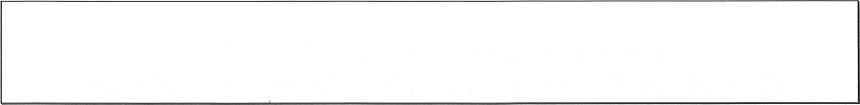

r-'-\-.-
al---.
l-
,-
'a-.
-, --

q

DISTRICT #13
EMPLOYEE HEALTH AND SAFETY
PROGRAM HANDBOOK
Pev. 12/13, 3/23
FOR MORE INFORMATION, CONTACT
James Phillippi Manager of Buildings and Grounds 763-528-4525
Rev. Dates: 1/03, 4/05,4/07, 10/07. 9/O9, 9/11, 12/13, 3/23
Columbia Heights Health and Safety Programs
Page 2
POLICY STATEMENT
It is the policy of the Columbia Heights Public School District to provide a safe and healthy work and learning environment for all employees and students. The District will provide appropriate equipment, safeguards, personal protection, and administrative support to protect employee and student safety and health. District employees will be trained to work safely and will be required to comply with all safety rules and standards.
BACKGROUND
SUMMARY
Details of the AWAIR Program are to be communicated to employees so they can participate and take an active role in health and safety. Employers with more than 25 employees are expected to form a joint health and safety committee to involve employees in the program.
The Minnesota Occupational Safety and Health program (MNOSHA) requires employers with higher than average injury and illness rates to develop a comprehensive written health and safety program. Although these programs are considered optional for most schools, the MN Department of Education (MDE) has encouraged school districts to develop and implement accident and injury reduction programs and other health and safety management programs.
The purpose of A Workplace Accident and Injury Reduction (AWAIR) Program is to reduce employee injuries and illnesses by identifying, analyzing and controlling hazards. Under this program, all accidents and near misses are to be investigated and measures are to be taken to correct problems. Employers are expected to develop and enforce mandatory safe work practices, while providing the equipment and safeguards necessary for employees to work safely.
The Columbia Heights Public School District has developed A Workplace Accident and Injury Reduction (AWAIR) Program to establish and implement a written program promoting safe and healthful working conditions based on clearly stated goals and objectives. This program includes requirements covered under Minnesota Statutes 182.653, A Workplace Accident and Injury Reduction Act.
Rev. Dates: 1/O3,4/05,4/07,1O/O7, 9/O9, 9/11, 12/13, 3/23
Columbia Heights Health and Safety Programs
Page 3
AWAIR PROGRAM GOALS
The District has established the following goals for the AWAIR program:
The District AWAIR program is managed by the Manager of Buildings and Grounds with oversight by a District-wide Safety Committee. Responsibilities for implementation of District health and safety programs are assigned as follows:
Manager of Buildings and Grounds:

PROGRAM OBJECTIVE5
RESPONSIBILITIES

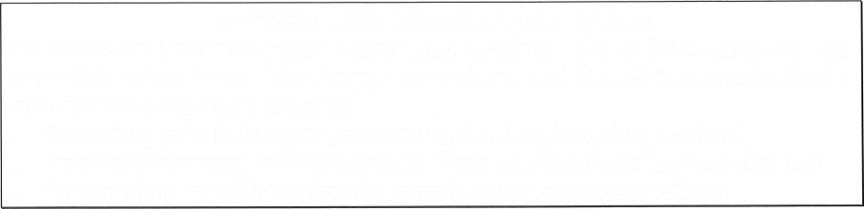
- Requests funding to maintain effective health and safety programs
- Oversees and coordinates implementation of AWAIR program
- Oversees new employee orientation
- Monitors program effectiveness
- Evaluates and updates AWAIR program annually
- Conducts routine inspections
- Performs follow-up to verify problems are corrected promptly
- Oversees accident and incident investigations
- Oversees scheduling of health and safety meetings/training sessions
- Oversees distribution of Safety Committee agendas and minutes
- Oversees distribution of Safety Committee agendas ond minutes
- Encourages and reinforces employee participation in health and safety matters
Copies of the District AWAIR Program are to be available to employees upon reguest.
1. Continuously strive to reduce the annual lost workday incident rate for each District location below the level for the previous year.
2. Commit the resources to bring each District building into compliance with applicable occupational safety and health (MNOSHA) regulations.
3. Implement continuing, effective health and safety programs to provide District employees with a safe and healthful workplace.
4. Encourage communication between District employees and members of the Safety Committee.
The District has identified the following steps for accomplishing these goals:
1. Assign responsibilities.
2. Establish systems for identifying, analyzing and controlling hazards.
3. Communicate program effectively and encourage employee participation.
4. Investigate all incidents.
5. Enforce safe work practices and rules.
The Manager of Buildings and Grounds oversees implementation of health and safety management programs and MNOSHA compliance activities. Routine site visits are to be conducted at each District building to verify compliance or identify hazardous conditions and work practices.

Health and safety topics that apply to District employees include:
Pev. Dates: 1/O3,4/05,4/07, 1O/O7, 9/09, 9/11, 12/13, 3/23
Columbia Heights Health and Safety Programs
- Hearing Conservation
- Indoor Air Quality
- Integrated Pest Management
- Laboratory Safety
- Lead in Drinking Water
- Lockout/Tagout (Hazardous Energy Control)
- OSHA Inspections and Recordkeeping
- Personal Protective Equipment Program
- Playground Safety
- Technology Education Safety/Machine Guarding
- Radon
- Asbestos Management (AHERA)
- Bloodborne Pathogens
- Community Right-to-Know
- Compressed Gas Safety
- Confined Space Entry
- Emergency Action and Fire Prevention
- Employee Right-to-Know
- Ergonomics
- First Aid/CPR
- Hazardous Waste Management
- Art Safety & Health
IDENTIFYING, ANALYZING AND CONTROLLING HAZARD5
- Provide comments, ideas, and suggestions about safety
- Report all accidents and incidents
- Attend required safety training and meetings
District Employees:
- Attend committee meetings
- Complete assigned tasks determined by committee (inspections, job hazard assessments, accident investigations, etc.)
- Ask co-workers for suggestions and input
- Communicate with co-workers about safety issues and encourage safe behavior
- Recommend corrections and follow-up to be sure actions are taken
Safety Committee Members:
Page 4

To ensure safe work practices and rules are consistently enforced, the Manager of Buildings and Grounds oversees these measures:

- Overseeing consistent enforcement of safe work practices and rules among District employees
- Overseeing employee retraining if initial training appears to be ineffective
- Enforcing and documenting a progressive discipline program

ENFORCING SAFE WORK PRACTICES AND RULES

In addition, Safety Committee members are asked to:

• Routinely ask co-workers for suggestions and input
• Communicate about safety issues and encourage safe behavior
Rev. Dates: 1/O3.4/05,4/07, 10/07, 9/09, 9/11, 12/13, 3/23 Columbia Heights Health and Safety Programs
District employees are encouraged to speak up about their health and safety concerns. If questions or problems cannot be resolved at the building level, employees should contact the Manager of Buildings and Grounds or a member of the Safety Committee for assistance.
Employees are encouraged to get involved in the District health and safety programs. Health and safety information and training are provided to employees through the annual District calendar, this handbook, and departmental training sessions.
COMMUNICATING PROGRAMS TO DISTRICT EMPLOYEES
Hazardous Incident/Accident Investigations

All hazardous incidents (“near misses”) and accidents are to be investigated and corrective actions taken. The Manager of Buildings and Grounds is to oversee health and safety investigations, including:

• Maintaining form(s) to report, document and analyze hazardous incidents
• Promptly performing hazardous incident (“near miss”) and accident investigations
• Implementing corrective actions to prevent repeat hazardous incidents
Hazard Controls

Steps taken by the Manager of Buildings and Grounds to implement and maintain required safety controls, include:

• Assign highest priority to safety-related maintenance work orders
• Oversee purchase of needed controls such as equipment/product replacement
• Oversee purchase of appropriate personal protective equipment
• Provide additional employee training as needed

Page 5

Rev. Dates: 1/03.4/05,4/07, 10/07, 9/09, 9/11, 12/13, 3/23 Columbia Heights Health and Safety Programs
Page 6

Goal #3- To monitor District compliance with applicable health and safety regulations, and encourage enforcement of safe work practices and rules.
Activities:
• Discuss results of mock OSHA audits, agency inspections and compliance activities
• Recommend District-wide activities to achieve or maintain compliance
Goal #2- To reduce work-related accidents and illnesses among District employees, by identifying and analyzing hazards, and recommending control strategies.

Activities:
• Discuss strategies for maintaining required records, such as SDS sheets and inventories
• Research options for annual employee health and safety training, such as web-based programs.
• Discuss trends in accidents/illnesses and analyze OSHA Log Summary information
• Identify district-wide strategies for prevention and control
• Evaluate successes of prevention and control strategies
Goal #1- To represent District employees on health and safety matters. To help communicate program details and encourage employee involvement in the District health and safety programs.

Activities:
• Communicate committee activities to District employees
• Bring questions and concerns from co-workers to committee
• Encourage District employees to report health and safety problems and complaints
The District has chosen to develop a joint management-labor Safety Committee. The Manager of Buildings and Grounds maintains records of committee activities, including meeting minutes and documentation of follow-up activities. The Safety Committee is scheduled to meet four times during the school year to address health and safety issues.

The goals of the committee and corresponding activities include:
SAFETY COMMITTEE

Rev. Dates: 1/03,4/05,4/07, 10/07, 9/09, 9/11, 12/13, 3/23 Columbia Heights Health and Safety Programs

Page 7

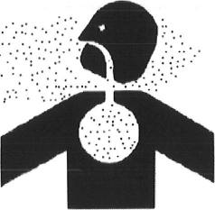

ASBESTOS MANAGEMENT
BLOODBORNE PATHOGENS- EXPOSURE CONTROL

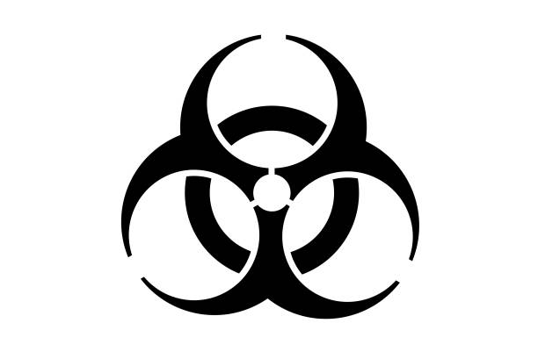
Districts are required to implement these programs to protect employees from exposure to Hepatitis B Virus (HBV), the Human Immunodeficiency Virus (HIV) and other bloodborne pathogens. The following employees have potential occupational exposure to bloodborne pathogens because of their assigned job duties, and are to be included in the District Bloodborne Pathogens Program:
The Minnesota OSHA program (MNOSHA) requires employers to establish policies and procedures for work involving occupational exposure to blood or other potentially infectious materials.

Employers must develop an Exposure Control Plan that includes:

- Determination of who is exposed because of their assigned job duties
- Employee exposure controls
- Requirements for personal protective equipment
- Schedules and procedures cleaning and sanitizing contaminated surfaces
- Hepatitis B vaccinations
- Post-exposure follow-up procedures
- Employee training
- Recordkeeping
District #13 has been inspected for asbestos following AHERA requirements. Written management plans detailing locations, descriptions, periodic inspections, and response actions involving asbestos-containing materials, are to be maintained on site for each district facility subject to the regulations. Routine maintenance areas in District buildings are posted with asbestos caution labels, and all asbestos maintenance, repair, or removal activities are performed from a state licensed contractor hired through the school district.

This program covers District activities for asbestos management as required under the Environmental Protection Agency (EPA) Asbestos Hazard Emergency Response Act (AHERA), the EPA rules governing disposal of asbestos containing materials enforced by the Minnesota Pollution Control Agency and the MNOSHA rules regarding asbestos in buildings. To access our annual notification, below is the link: https://www.colheights.k12.mn.us/Page/3347

Rev. Dates: 1/03, 4/05,4/07, 10/07, 9/09, 9/11, 12/13, 3/23 Columbia Heights Health and Safety Programs
Page 8
COMMUNITY RIGHT-TO-KNOW
COMPRESSED GAS SAFETY
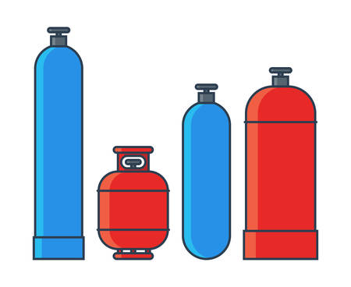
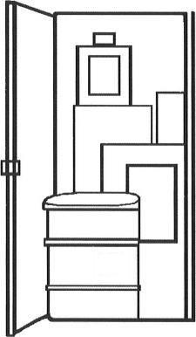
Employee handling of compressed gases is regulated by MNOSHA. Transportation requirements are covered by Department of Transportation (DOT) regulations. The District is responsible for training employees, inspecting cylinders for proper labeling, compiling hazard information, following safe storage and handling procedures, and maintaining required records.
Under the federal and state Emergency Planning and Community Right-to-Know Acts (Title III), the Minnesota Department of Public Safety Emergency Response Commission (ERC) gathers fees and information related to hazardous materials storage, such as fuel oil.
The District must submit an annual Turnaround Report and fee for any District facility storing fuel oil quantities over 10,000 pounds. The annual fee is based on the number of chemicals reported at each facility, and supports the Minnesota emergency one-call spill reporting number and hazardous chemical data management programs. A copy of the annual Turnaround Report must also be submitted to the local fire department. The Manager of Buildings and Grounds is to oversee submission of the Turnaround Report and payment of the Hazardous Chemical Inventory Fee.
Other District employees are to be provided with awareness training or information on universal precautions, and instructed that their assigned job duties do not include rendering first aid. For inquiries about Hepatitis B Vaccinations, contact Human Resources at 763-528-4418.
- Secretaries/Principals (back-up for health office)
- Special Education Staff (designated employees)
- Substitute Nurses and Substitute Health Aides
- Swimming Instructors, Life Guards
- Van Drivers
- Adventure Club Staff
- Athletic Coaches
- Certified Pool Operators
- Custodians
- Paraprofessionals
- Preschool Staff (ECFE, ECSE)
- School Nurses and Health Aides
Pev. Dates: 1/03,4/05,4/07, 10/07, 9/09, 9/11, 12/13, 3/23 Columbia Heights Health and Safety Programs
Page 9

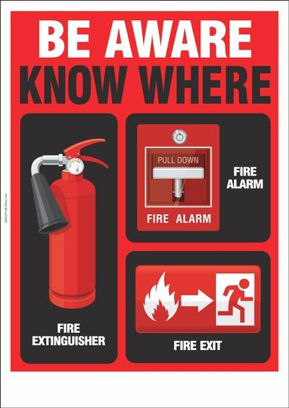
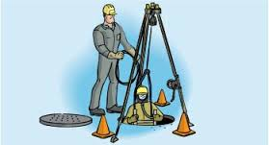
The District must implement emergency plans under MNOSHA Standard 29 CFR 1910.38, Employee Emergency Plans and Fire Prevention Plans, and 1910.151, Medical Services and First Aid. Emergency flushing facilities are required for flushing the eyes and body when employees may be exposed to injurious corrosive materials. The plans are to describe procedures to be taken to ensure District employee safety in case of fire, severe weather, chemical spill or medical emergency.
EMERGENCY ACTION AND FIRE PREVENTION
If permit-required confined spaces are identified, the District must either secure these spaces to prevent entry, or implement a Confined Space Entry Program to protect employees from confined space hazards.

MNOSHA defines a permit-required confined space to mean a confined space that has one or more of the following characteristics:

- Contains or has a potential to contain a hazardous atmosphere; or
- Contains a material that has the potential for engulfing an entrant; or
- Has an internal configuration such that an entrant could be trapped or asphyxiated by inwardly converging walls or by a floor which slopes downward and tapers to a smaller cross-section; or
- Contains any other recognized serious safety or health hazard.

Permit-required confined spaces may only be entered by qualified District or contractor employees following MNOSHA requirements for a Confined Space Entry Program.

Under MNOSHA regulations the District is required to evaluate all facilities for confined spaces.

Examples of District confined spaces include:
• Air handling units
• Boilers
• Condensate return tanks
• Crawl spaces and tunnels
• Elevator pits
• Vacuum pump pits

CONFINED SPACE ENTRY
Rev. Dates: 1/03, 4/05,4/07, 10/07, 9/09,9/11, 12/13, 3/23 Columbia Heights Health and Safety Programs
Page 10
( I I I
rl.!

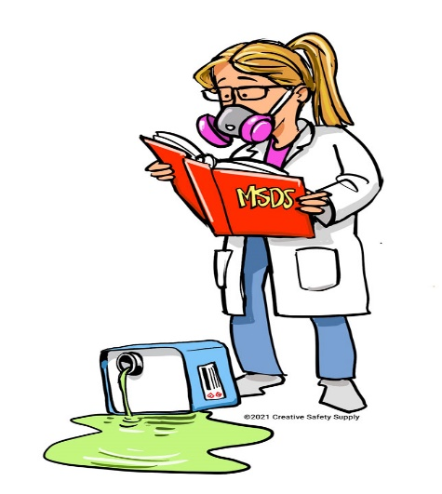
Areas of emphosis include:
- Office Ergonomics
- Kitchen Ergonomics
- Special Educotion fnjury Prevention
- Maintenance/Custodial Ergonomics

The MN Department of Education (MDE) has sponsored training workshops for District contact persons to return to their Districts and become involved in assessing employee activities and workstations. The goal is to reduce or prevent job related musculoskeletal injuries by enabling District representatives to evaluate workstations, or to identify workstations in need of evaluation by outside consultants, and to identify needed improvements. Contact Human Resources to schedule an evaluation.
I
The MNOSHA Employee Right-to-Know Standards require employers to develop and implement written programs to communicate information to employees about hazardous chemicals/agents and protective measures. The District Employee Right-to-Know Program is to cover hazardous chemicals, infectious agents, and harmful physical agents such as heat and noise.

The written plan assigns responsibilities for activities such as: container labeling, maintaining Safety Data Sheets (SDS), and employee training. Lists of hazardous chemicals are to be maintained for each building, along with the corresponding SDS sheet. Non-routine tasks must be identified and restricted to designated, trained employees. Procedures are required to communicate hazards and precautions to contractor employees performing work around hazardous chemicals or harmful physical agents in district buildings.
ERGONOMICS
- Procedures for Non-Routine Tasks (Spill Cleanup, etc.)
- Information for Contractors
- Annual Program Review

EMPLOYEE RIGHT-TO-KNOW

Key program requirements include:
• Hazardous Chemical Inventories
• Safety Data Sheets
• Container Labels and Hazard Warnings
• Employee Information and Training

Pev. Dates: 1/03,4/05,4/07,10/07, 9/09, 9/11, 12/13, 3/23 Columbia Heights Health and Safety Programs
Page 11
I N = I
HAZARDOUS WASTE MANAGEMENT

HEARING CONSERVATION

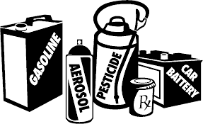
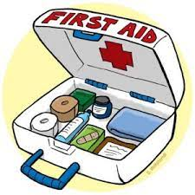
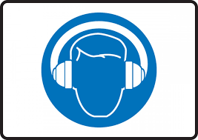
In Minnesota, the Minnesota Pollution Control Agency (MPCA) regulates hazardous wastes with assistance from the seven metropolitan counties. Under the state and county hazardous waste requirements, generators must determine the status of their wastes and manage them properly. The level of regulation that applies to a generator of hazardous waste depends upon the amount of hazardous waste generated per month. District hazardous waste generator sites are licensed and regulated by Anoka County. The Manager of Buildings and Grounds oversees proper management and disposal of hazardous wastes for the District. Light bulbs, batteries, and chemicals are properly stored in hazardous waste cabinets in each building.
Under MNOSHA regulations, employees exposed to noise levels averaging 85 decibels (dBA) or more as an 8-hour time-weighted average must be included in a Hearing Conservation Program. Hearing protection is mandatory for employees exposed to noise levels in excess of 90 dBA as an 8-hour time-weighted average, and engineering or administrative controls must be evaluated. The District is responsible for evaluating employee noise exposures, providing hearing protection, and implementing a Hearing Conservation Program for employees exposed to excessive noise levels.

MNOSHA regulations require employers to ensure the ready availability of medical personnel. MNOSHA has interpreted this to mean that if emergency response time would exceed 4-8 minutes, employees within the facility must be adequately trained to render first aid. The Manager of Buildings and Grounds is to oversee maintenance of certification for first aid providers where required, and purchase and distribution of first aid kits and supplies.
FIRST AID AND CPR

Rev. Dates: l/03,4/05,4/07, 10/07, 9/09, 9/11,12/13, 3/23 Columbia Heights Health and Safety Programs
Page 12
INDOOR AIR QUALITY

.



Good quality indoor air contributes to a favorable learning environment for students, productivity for
teachers and staff, and a sense of comfort, health, and well-being for all school occupants. The districts
management plan describes procedures and guidelines relating to indoor air quality (IAQ) for Columbia Heights Public Schools and references the Tools for Schools Action Kit from the Environmental Protection Agency (EPA). The IAQ coordinator for Columbia Heights Public Schools is the Buildings and Grounds Manager, Alex Winn. The role and authority of the IAQ coordinator is to oversee the implementation of the management plan, provide the resources needed to implement the plan, and determine if and when outside professional
assistance is needed.
Under MN Department of Education guidelines, the District is responsible for adopting Integrated Pest Management (IPM) procedures for control of structural and landscape pests. IPM principles are intended to prevent damage and/or unacceptable levels of pest activity using the most economical means and presenting the least hazard to people, property and the environment. Minnesota state law requires public and non-public K-12 schools to provide notice to parents/guardians and employees if they apply certain pesticides on school property. A general notice is to be provided to parents/guardians and employees at the beginning of each school year. The District provides this information in the fall mailing of the school calendar. The scheduled service visits for pesticide and herbicide applications by the District pest control contractor are available for review or copying at each school office. Notices will be sent home to parents who wish to be informed in advance of pesticide applications. (Some pesticides may be applied without prior notification in emergency situations.)
INTEGRATED PEST MANAGEMENT

Rev. Dates: 1/03,4/05,4/07, 10/07, 9/09, 9/11, 12/13, 3/23 Columbia Heights Health and Safety Programs
Page 13
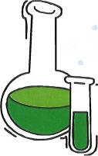
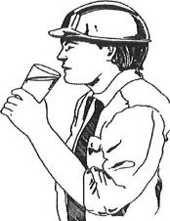
MNOSHA regulations require employers with laboratory operations to implement a Chemical Hygiene Plan to cover employee use of hazardous chemicals in laboratories.

Required steps include:
• Assign a Chemical Hygiene Officer to oversee program implementation
•Develop written standard operating procedures
• Provide personal protective equipment and adequate ventilation
• Provide employee training and information, including Safety Data Sheets
• Conduct routine classroom audits
• Arrange medical consultation or examinations if needed
• Plan for emergencies, such as chemical spills
• Maintain required records
The Minnesota Department of Health and the federal Environmental Protection Agency have published guidelines for school drinking water testing, fixture flushing, and remediation activities. Districtwide testing is recommended every five years to update inventories of high lead fixtures. Replaced fixtures must be retested, and high lead fixtures are to be flushed daily. The Manager of Buildings and Grounds is to oversee implementation of the District program.
LEAD IN DRINKING WATER
The District is responsible for implementing a Laboratory Safety – Chemical Hygiene Plan to cover employee use of hazardous chemicals in laboratories. This plan is to cover middle and high school science teachers whose jobs may include laboratory use of hazardous chemicals. Laboratory chemicals are to be stored in storage rooms with restricted access. District Custodians are to be provided chemical hazard information and training under the District Employee Right-to Know Program.

LABORATORY SAFETY- CHEMICAL HYGIENE
.

Rev. Dates: 1/03,4/05,4/07, 10/07, 9/09, 9/11, 12/13, 3/23 Columbia Heights Health and Safety Programs
Page 14
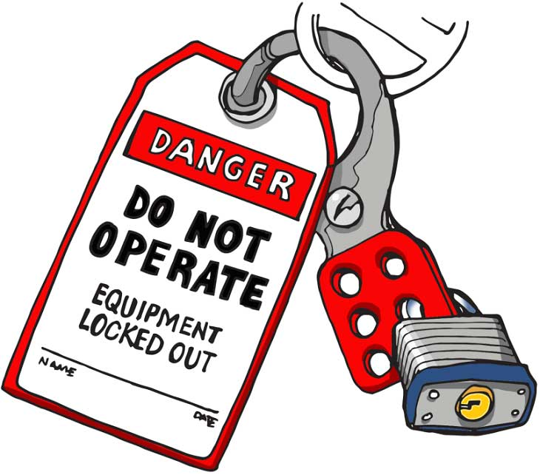

MNOSHA Inspections. MNOSHA follows a system of inspection priorities, based on whether there is an imminent danger, fatal accident or catastrophe, employee complaint, programmed inspection (special emphasis program), or follow-up inspection. MNOSHA inspections are conducted without advance notice.
District Self-Inspections. The Manager of Buildings and Grounds is to oversee routine, voluntary, walk-through inspections throughout the District to raise awareness of potential MNOSHA violations and evaluate compliance status.

MNOSHA regulations require a Hazardous Energy Control (Lockout/Tagout or LOTO) Program to control hazardous energy during servicing and maintenance of machines and equipment when unexpected energization or start up could cause injury to employees.

Requirements include:
- Mandatory lockout procedures
- Devices to ensure that equipment is stopped
- Isolated from all potentially hazardous energy sources
- Locked out before employees begin maintenance

Contractors performing work in District buildings are also required to follow lockout/tagout procedures.

OSHA INSPECTIONS AND RECORDKEEPING
MNOSHA regulations require the District to comply with health and safety standards and maintain required records.

Log of Injuries & Illnesses. The District is required to record and report work-related fatalities, injuries and illnesses. The OSHA Log of Work-Related Injuries and Illnesses and annual Summary are to be compiled and maintained for five years. The Summary is to be posted in each building annually, from February 1 – April 30. These records are intended to help employers identify problem areas, track injuries and illnesses, implement preventive measures, and involve employees in health and safety programs.

LOCKOUT/TAGOUT- HAZARDOUS ENERGY CONTROL

Rev. Dates: 1/03, 4/05, 4/07, 10/07, 9/09, 9/11, 12/13, 3/23 Columbia Heights Health and Safety Programs

Page 15


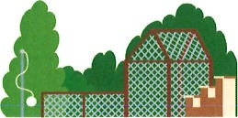
When employees are exposed to bodily hazards, MNOSHA regulations require employers to implement a Personal Protective Equipment Program to protect employees from hazardous exposures to the eyes and face, head, feet, hands, or to electrical hazards. The District is responsible for implementing a Personal Protective Equipment Program which covers District procedures for PPE hazard assessments, equipment selection, and employee training.
TECHNOLOGY EDUCATION SAFETY/ MACHINE GUARDING
Under MN Department of Education guidelines, the District conducts annual playground inspections and repairs, following guidelines available from the Consumer Product Safety Commission (CPSC). The Manager of Buildings and Grounds is to oversee implementation of the District program.

PLAYGROUND SAFETY
Under MN Department of Education guidelines, the District has developed a Technology Education Safety and Health Program that covers machine safeguarding in technology education classrooms.

This program includes:
• Safe work practices and housekeeping procedures
• Routine safety audits
• Personal protective equipment and safe clothing requirements
• Machine safeguards and color coding (machine hazard areas, guards, and emergency stops)
• Hand and power tool safety
• Electrical safety
• Compressed gas safety
• Employee Right-to-Know
• Proper storage and handling of hazardous substances
• Required safety equipment
• Emergency procedures
• Teacher training

PERSONAL PROTECTIVE EQUIPMENT (PPE)

Pev. Dates: 1/03, 4/05, 4/07, 10/07, 9/09, 9/11, 12/13, 3/23 Columbia Heights Health and Safefy Programs
ART SAFETY AND HEALTH

Page 16
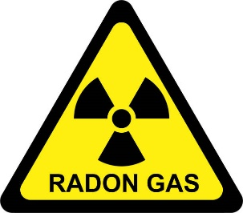
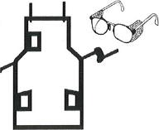
Testing Procedures include:
- Testing is conducted between November 1 and March 31
- Conduct tests with short-term tests
- Conduct testing on school days or with HVAC operating under occupied conditions
- Test all occupied and intended to be occupied rooms in contact with the ground, 10% of upper floor rooms, and other rooms specified in the ANSI/AARST standard
- Conduct follow-up testing in rooms that have radon > 4 pCi/L and other rooms specified in the ANSI/AARST standard
- Mitigate occupied and intended to be occupied rooms that have radon > 4 pCi/L
- Re-test the building after mitigation to verify radon reduction
- Report all radon test results to MDH on the ‘School Radon Testing Form’ at the conclusion of the testing project (after follow-up testing, mitigation and post-mitigation testing have been completed)
- Report radon test results at a school board meeting.
The EPA and MDH recommend all schools test for radon. Minnesota schools are not required to test for radon. Testing and mitigation in schools must be conducted by licensed individuals. Detailed testing procedures are described in the ANSI/AARST standards for radon measurement and mitigation in schools.

RADON
• Safe storage practices
• Required safety equipment
• Emergency procedures
• Teacher training
• General safety/housekeeping
• Personal protective equipment
• Equipment safeguards
• Electrical safety
• Employee Right-to-Know
District Art Teachers are responsible for use and maintenance of the safety equipment and supplies specified in this program. Equipment that is damaged or does not meet MNOSHA specifications is not to be used. Art Teachers are to implement all applicable requirements of this program into their classroom activities. Key areas described in this program include:

The District has developed and implemented an Art Safety and Health Program to cover employees in district middle school and high school art classrooms, including:

• Ceramics
• Commercial Art
• Metalworking
• Painting and Drawing
• Printmaking
• Sculpture

Rev. Dafes: 1/03,4/05,4/07, 10/07, 9/09, 9/11, 12/13, 3/23 Columbia Heights Health and Safety Programs
AHERA - Asbestos Hozord Emergency Response Act
AWAIR - A Workploce Accident ond fnjury Reduction Progrom
BBP - Bloodborne Pathogens
CPSC - Consumer Product Safety Commission
dBA - Decibels measured on the A scole (meosurement of noise levels obtoined
during noise sompling)
EPA - Environmentol Protectron Agency
ERTK - Employee Right-to-Know
IAQ - fndoor Air Quolity
IPiA - Integroted Pest Monogement
LOTO - Lockout ond Togout (for hazordous energy control)
MDE - Minnesota Deportment of Educotion
MDH - Minnesoto Department of Heolth
MNOSHA - Minnesoto Occupotionol Heolth and Sofety Progrom
MPCA - Minnesoto Pollution Control Agency
SDS - Moteriol Sofety Doto Sheet
PPE - Personol Protective Equipment
pCi/L- Picocuries per liter of air
ANSI- American National Standards Institute
SDS- Safety Data Sheets
GLOSSARY
Page 17

