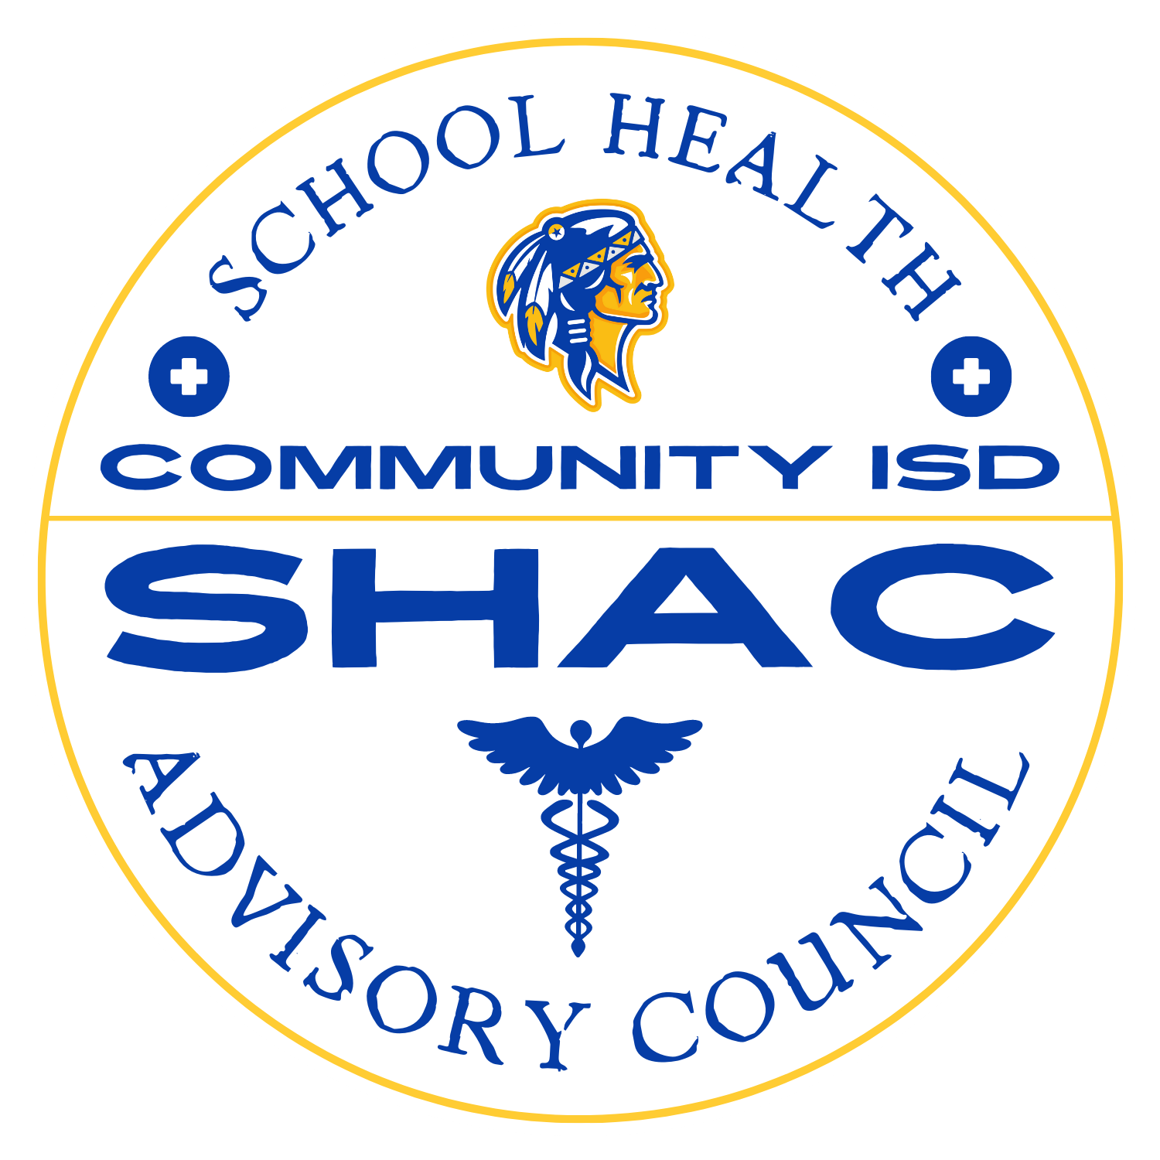

Community ISD SHAC
October 27th 2026 Meeting @10:02 AM
Community High School Cafeteria
Minutes
Attendance:
Hillary Gindrat - Health Services Coordinator
Amy Smith - Director of Child Nutrition
Mr. Brinkley - Director of Student Services
Emily - District Menu Planner
Jessica Lange - Parent Representative
Coach Chipman - Participated via Zoom

1. Call to Order and Review of Previous Minutes
a. Second SHAC meeting of the 2026-2027 school year called to order by Hillary Gindrat at 10:02 AM in the Community High School Cafeteria.
b. The agenda and August 25, 2026 meeting minutes were provided for member review.
c. The meeting focused on nutrition and updates related to implementation of the District Wellness Plan.

2. Farm Fresh Month and Nutrition Education
a. Emily presented October activities related to the Texas Department of Agriculture Farm Fresh Challenge, highlighting local produce, Texas brands, and opportunities for students to try new foods.
b. Featured menus and activities included:
i. Oktoberfest menu items and a gut health presentation at Edge Middle School, followed by a sauerkraut taste test.
ii. A jalapeno-themed menu featuring candied jalapeno pepperoni pizza and chili with cornbread.
iii. Texas breakfast favorites, including a honey butter chicken biscuit, banana yogurt parfait, and kolache.
iv. Pickle Day planned for October 28, featuring Best Maid pickles, a chicken sandwich, dill pickle nuggets, and fried pickle pasta salad.

3. Menu Taste Test and Planning
a. Members sampled whole-grain chicken and vegetable dumplings being considered for the spring menu and provided positive feedback.
b. Child Nutrition uses a three-week menu cycle; new items may be added to the regular rotation or offered as limited-time features based on student acceptance.
c. Cafeteria managers maintain daily production records to track student selections, adjust future quantities, and reduce food waste.
d. Members discussed repeating popular menu items, including turkey chili, and offering candied jalapenos with additional meals. Child Nutrition noted that menu changes must meet applicable nutrition guidelines, including limits on sodium and added sugars.

4. Nutrition Promotion and Smarter Lunchrooms Scorecard
a. A member reported that nutrition posters referenced in the Wellness Plan were not displayed in some cafeterias.
b. Members discussed using cafeteria screens for nutrition messages. Child Nutrition will partner with Communications to create a slide deck.
c. Child Nutrition reviewed the annual Smarter Lunchrooms Scorecard process. The field supervisor evaluates cafeteria practices to establish a baseline and identify areas for improvement.

5. SchoolCafe Parent Resources
a. SchoolCafe is in its second year of district use and connects online menus and parent access with student cafeteria accounts.
b. Families can view menus and nutrition information, monitor transactions, add funds, set purchase restrictions, and communicate with Child Nutrition.
c. Members shared positive feedback about the convenience of the system.

6. Food Allergy Management
a. Health Services reviews parent-reported health conditions at the beginning of the school year and as students enroll, with follow-up as needed.
b. For students with food allergies, families receive a dietary request form for physician completion to identify needed substitutions.
c. Elementary classroom allergen precautions and nurse review of food brought in for distribution were discussed.
d. Health Services communicates allergy information to Child Nutrition so student accounts display alerts during cafeteria checkout.

7. Health and Community Wellness Updates
a. The October 2 staff vaccine clinic provided 19 flu vaccines and 44 vaccines overall. Flu vaccine participation was similar to the previous year, and the clinic will continue annually.
b. Community ISD was selected as a North Texas Food Bank monthly mobile food distribution location, with distributions at Dodson from September through May.

8. Physical Activity and Campus Wellness Events
a. Members reported that elementary campuses had completed booster runs, fun runs, or similar activities. Some events were moved indoors because of heat.
b. McClendon and Ellis were participating in the 21-Day Snack Challenge.
c. Members discussed providing water bottles at future runs, including reusable district-branded bottles. Budget availability will need to be reviewed before moving forward.

9. Next SHAC Meeting and Stop the Bleed Training
a. The next SHAC meeting is scheduled for January 26, 2027, at 6:00 PM, with participation available via Zoom or in person in Hillary Gindrat's office at the Terry Pope Administration Building.
b. Stop the Bleed training for students in grades 7-12 is planned from 5:00 to 6:00 PM before the meeting. SHAC members were invited to attend.
c. Cooper Welch in Communications is expected to distribute training registration information in early December.

10. Adjournment
a. Hillary Gindrat concluded the meeting following completion of the agenda and an opportunity for questions.

11. Discussion Following Adjournment
a. The recording continued with informal discussion after the meeting was concluded.
b. Jessica suggested SHAC and Child Nutrition participation in elementary STEM/STEAM nights to increase family involvement and awareness of cafeteria programs. Ideas included pickling, seasonal food activities, and demonstrations of food science. Ellis was identified as having an event in January.
c. Additional topics included meal alternatives, student acceptance of new foods, portion sizes, food preparation requirements, and parent use of SchoolCafe purchase restrictions. No formal action was recorded.

