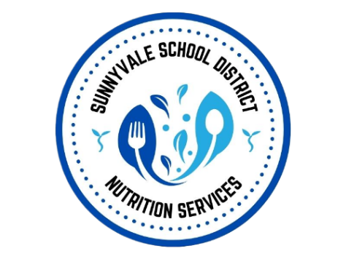
Dear Parent/Guardian,

Sunnyvale School District Child Nutrition Services is committed to providing safe & appropriate meal accommodations for students with documented medical or dietary needs.

Enclosed is the Medical Statement to Request Special Meals and/or Accommodations. This form helps our Child Nutrition team understand your child’s needs & ensures that the appropriate information is provided to the cafeteria staff responsible for preparing & serving your child’s meals.

When completing this form with your child’s medical provider, please make sure that it reflects the full scope of your child’s current dietary and meal accommodation needs.

This includes, as applicable:
- Allergies, intolerances, or other medical conditions affecting meals
- Foods or ingredients that must be avoided, along with appropriate substitutions
- Required meal, diet, or texture modifications
- Any other accommodations or adaptive equipment needed during meal service

Please be as complete & specific as possible.

The information documented on this form will be used to guide your child’s meal accommodations. To help prevent confusion and ensure that meals are prepared consistently & safely, please make sure the form includes all current dietary restrictions & accommodations that cafeteria staff should follow. If your child has multiple dietary needs, please include all of them on the form, even if some have previously been communicated directly to school or cafeteria staff. This helps ensure that everyone is working from the same, complete information.

The form provides space for the medical provider to describe the prescribed accommodation & identify specific foods to omit and suggested substitutions. Additional information may also be attached when more space is needed.

Once completed & signed by the appropriate medical authority, please return the form to child.nutrition@sesd.org

If your child’s medical or nutritional needs change, please provide updated documentation so that we can adjust their meal accommodations accordingly. The form specifically notes that its information should be kept current to reflect the participant’s medical & nutritional needs.

Thank you for helping us provide your child with a safe & successful meal experience at school.

Sincerely,
Child Nutrition Services
Sunnyvale School District
child.nutrition@sesd.org

