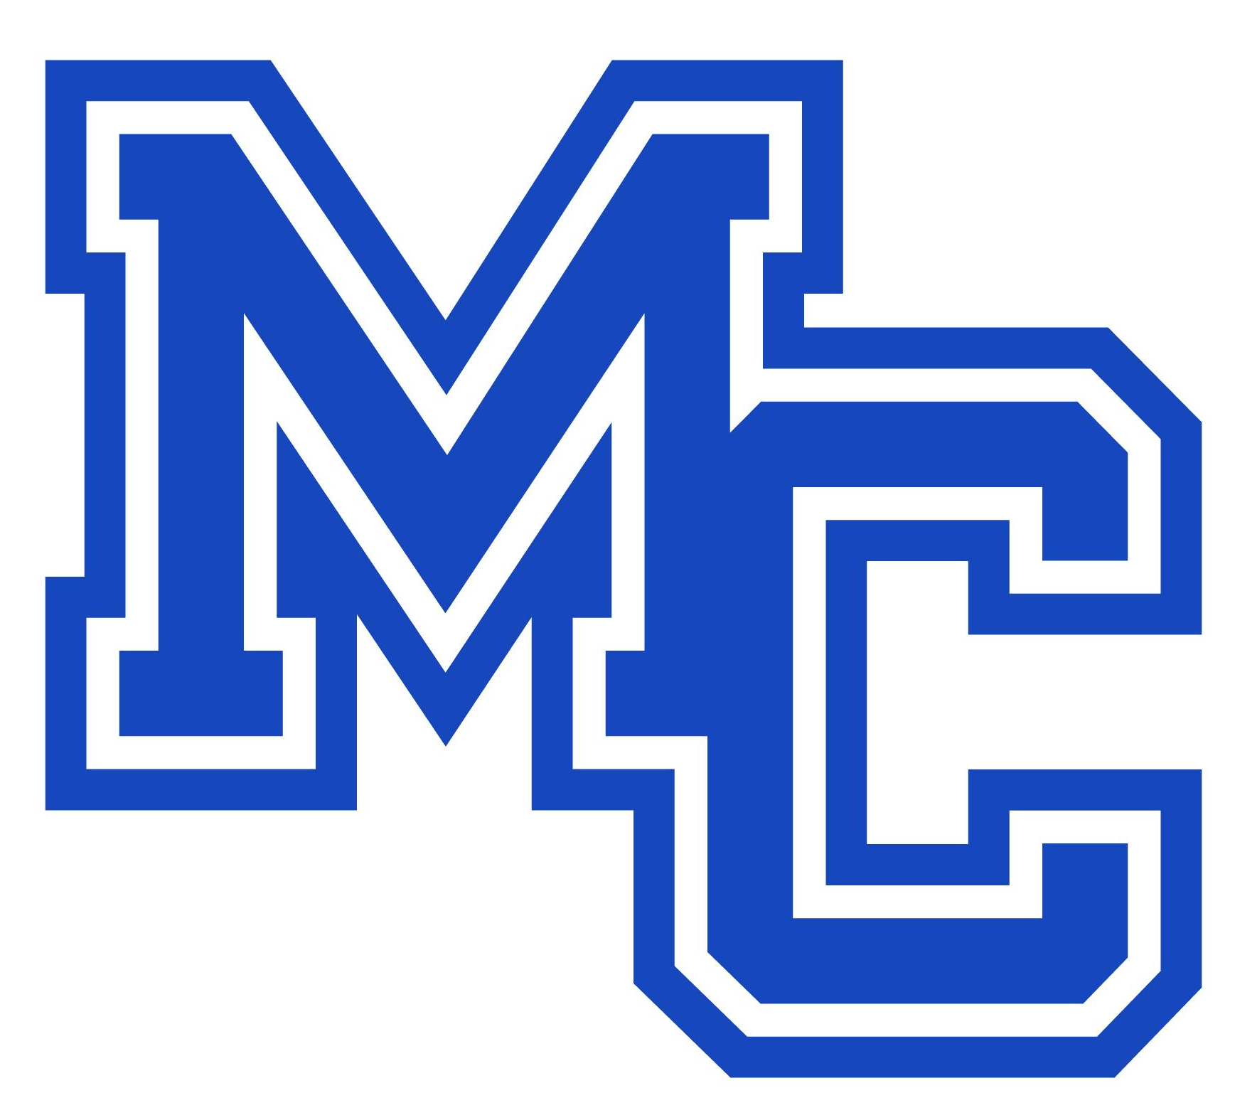

Madison County High School

Veterans Day Commemoration Video — Parent/Guardian Media Permission & Release Form

1. Event & Project Overview
Madison County High School (MCHS) is producing a special student-led Veterans Day Commemoration Video to honor family members of MCHS students and staff who have served or are currently serving in the United States Armed Forces.

Participating students will share brief stories and reflections regarding their family legacy of military service. The finalized video compilation will premiere school-wide during 1st Block on Veterans Day (November 11, 2026) and will be featured on the official school website and social media channels.

- Project Leads: Ms. Desiree Floyd (Yearbook Advisor / Room 219) & Ms. Carol White (Social Studies Lead)
- Recording Window: October 21, 2026 – October 30, 2026
- Premiere Date: November 11, 2026

2. Student & Veteran Information
(Please print clearly)

- Student Full Name: ____________________________________________________
- Grade Level: _____________
- 2nd Block Teacher & Room #: __________________________________________
- Name of Veteran / Service Member: ____________________________________
- Military Branch: ________________________________________________________
- Relationship to Student: ________________________________________________

3. Parent / Guardian Permission & Media Release
By signing below, I acknowledge and agree to the following:

- Permission to Participate: I give permission for my student named above to participate in recording an interview and video presentation for the Madison County High School Veterans Day Commemoration Video.
- Media & Image Release: I grant Madison County High School and Madison County Public Schools permission to record, edit, display, and broadcast my student's voice, photograph, image, video footage, and shared family stories.
- Distribution & Broadcasting: I understand that this recording will be broadcast during school on Veterans Day and may be published on the official school website, social media pages, and related educational publications.
- Voluntary Participation: I understand that participation in this video project is completely voluntary.

4. Parent / Guardian Consent & Signature
Please check one option below:

- [ ] GRANT PERMISSION: I give permission for my student to participate in the Veterans Day Commemoration Video recording and media broadcast as described above.
- [ ] DO NOT GRANT PERMISSION: I do not give permission for my student to participate in the Veterans Day Commemoration Video recording.

Parent/Guardian Name (Printed): ______________________________________________
Parent/Guardian Signature: ____________________________________________________

Date: __________________________________

Phone Number: ______________________ Email: _____________________________________________________

5. Return Instructions
Please return this completed and signed permission form to Ms. Floyd in Room 219 or Ms. White prior to your student's scheduled recording appointment (between October 21 and October 30, 2026).

