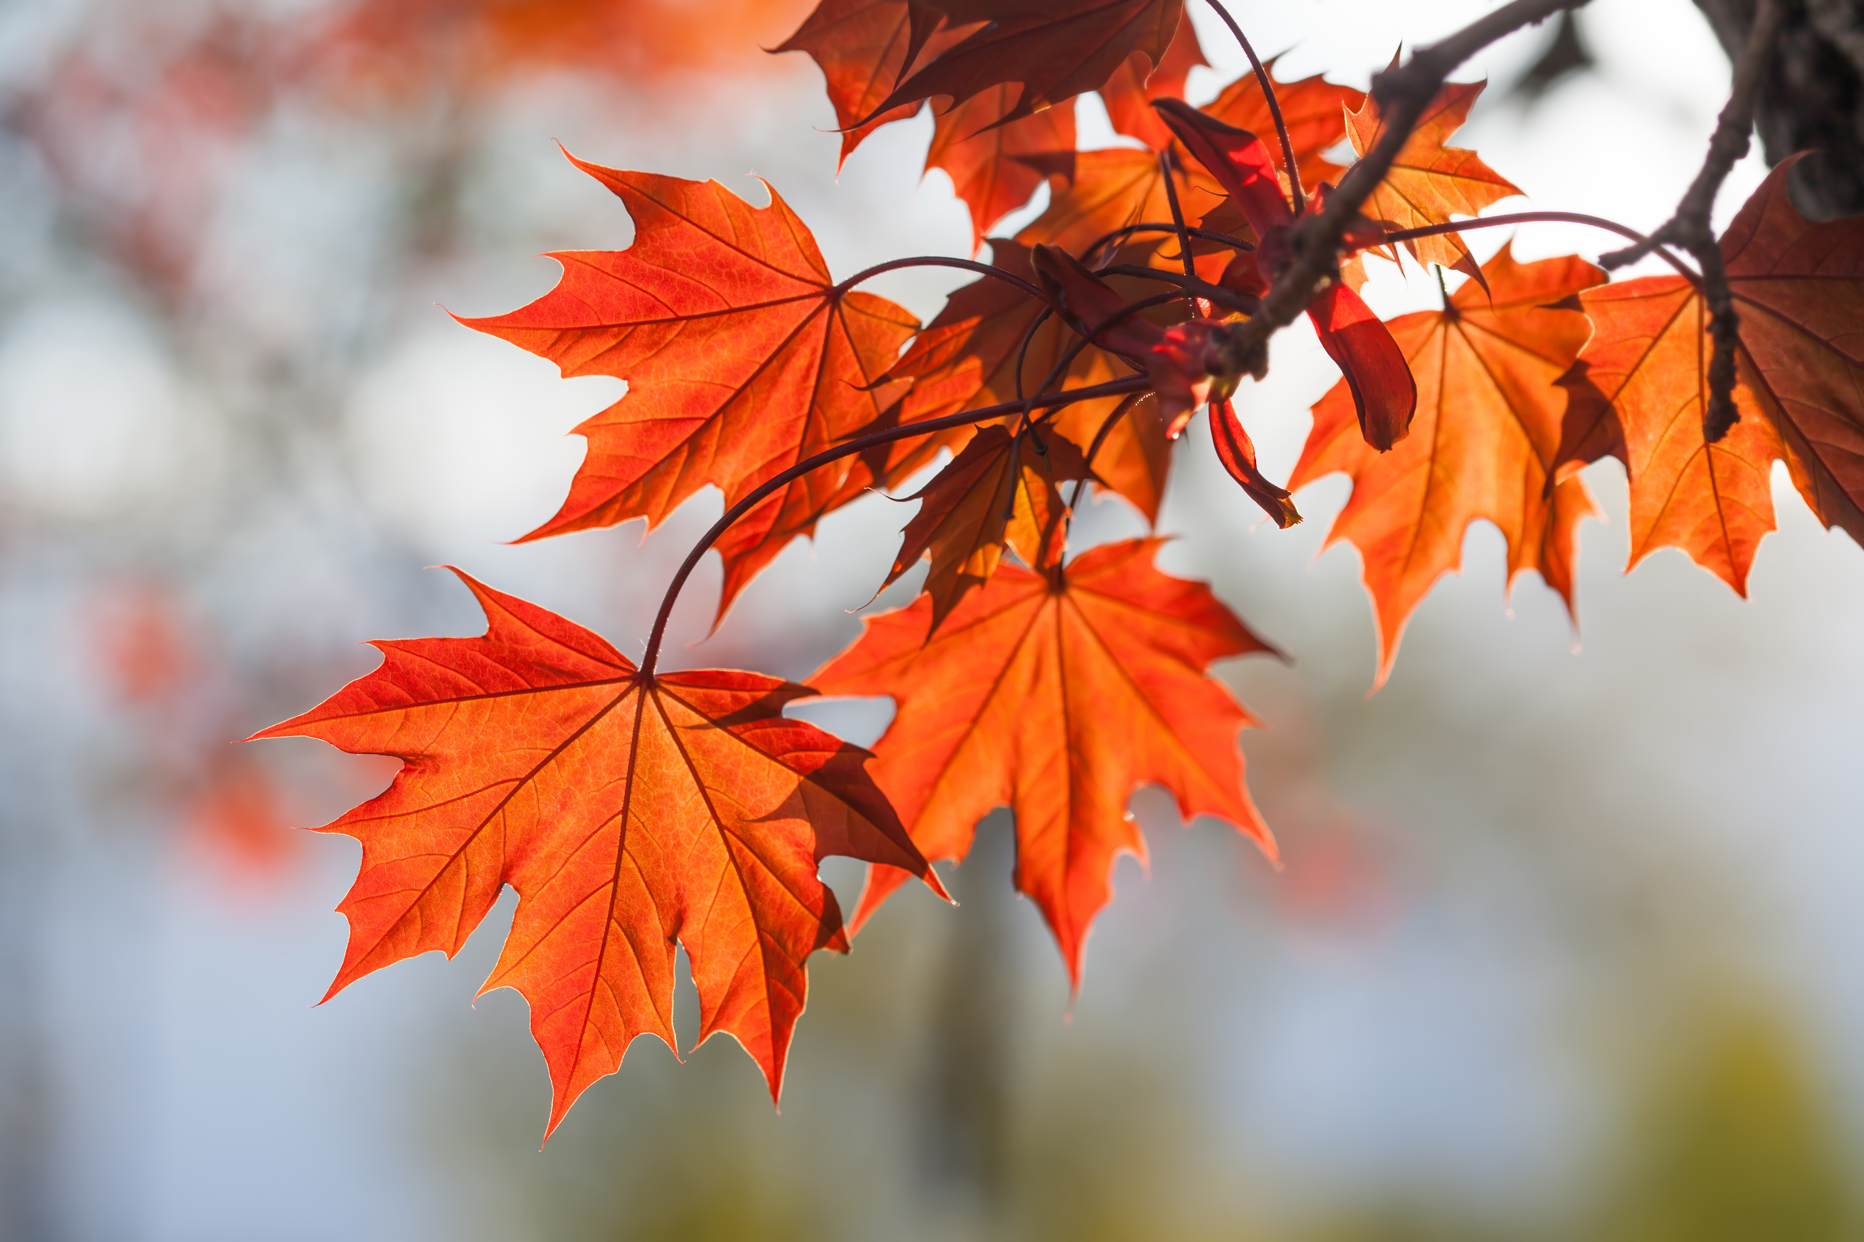 | Lincoln School Lunch Menu  November 2026  L
Mon. | Tue. | Wed. | Thu. | Fri.
2 | 3 | 4 | 5 | 6
Chicken Strips  Vegetables and Fruit  Milk | Pizza Stick  Vegetables and Fruit  Milk | Pulled Pork Subs  Vegetables and Fruit  Milk | Chicken Leg  Vegetables and Fruit  Milk | Pizza  Vegetables and Fruit  Milk
9 | 10 | 11 | 12 | 13  No School  Work Day  No
Cheeseburger  Vegetables and Fruit  Milk | Chicken Nuggets  Vegetables and Fruit  Milk | Veterans Day  No School | No School | No School
16 | 17 | 18 | 19 | 20
Grilled Cheese  Vegetables and Fruit  Milk | Cheeseburgers  Vegetables and Fruit  Milk | Beef Stroganoff  Vegetables and Fruit  Milk | Mozz Sticks  Vegetables and Fruit  Milk | Pizza  Vegetables and Fruit  Milk
23 | 24 | 25 | 26 | 27
No School | No School | No School | Thanksgiving  No School | No School
30
Fish Sticks
Vegetables and Fruit
Milk

*Students must take THREE components (Grain, Protein, Fruit, Vegetable, Milk) *One item must be a Fruit or Veggie
1% white milk & fat free milk offered, Fruit & veggies served with all meals. Menu subject to change based upon product availability.
This institution is an equal opportunity provider.

