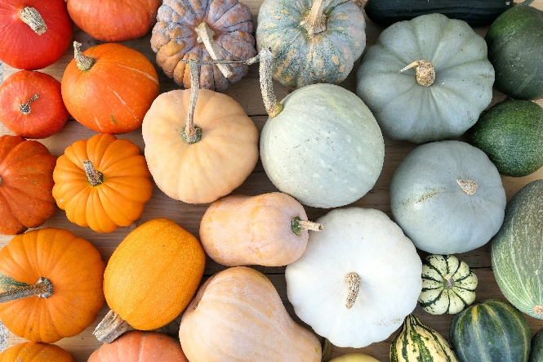 | Winter Lakes High School Lunch Menu  November 2026
Mon. | Tue. | Wed. | Thu. | Fri.
2 | 3 | 4 | 5 | 6
Grilled Cheese w/soup  Corndog  Vegetables and Fruit  Milk | Tuna Sandwich  Mozz sticks  Vegetables and Fruit  Milk | Spaghetti w/bread  Yogurt Basket  Vegetables and Fruit  Milk | Chicken Strips w/fries  Taco Salad  Vegetables and Fruit  Milk | No School
9 | 10 | 11 | 12 | 13
Pizza Sticks  Pork Rib Sandwich  Vegetables and Fruit  Milk | Fish Sticks &Cornbread  Chick/Noodle Soup w/Roll  Vegetables and Fruit  Milk | Veterans Day  No School | No School | No School
16 | 17 | 18 | 19 | 20
Corn Dog  Turkey Cheese Melts  Vegetables and Fruit  Milk | Chicken Leg w/bread  Burrito w/chip  Vegetables and Fruit  Milk | Fajita Wraps  Yogurt Basket  Vegetables and Fruit  Milk | Turkey/Gravy/ Potatoes  PB&J Packs  Vegetables and Fruit  Milk | No School
23 | 24 | 25 | 26 | 27
No School | No School | No School | Thanksgiving | No School
30
Chicken Strips
Mozz Sticks
Vegetables and Fruit
Milk

*Students must take THREE components (Grain, Protein, Fruit, Vegetable, Milk) *One item must be a Fruit or Veggie
1% white milk & fat free milk offered, Fruit & veggies served with all meals. Menu subject to change based upon product availability.
This institution is an equal opportunity provider.

