
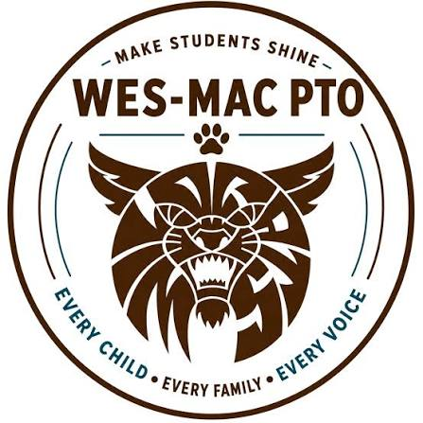 | 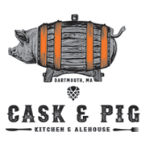

FUNDRAISING EVENT TO BENEFIT
WES-MAC PTO
Tuesday, November 3, 2026
LUNCH | DINNER | DINE-IN | TAKE-OUT
15% of Dining Bill (alcohol, tax & gratuity are excluded)
will be donated back to WES-MAC PTO
*FLYER MUST BE PRESENT or displayed on a mobile device*
Reservations for dining are highly recommended.
Reserve a table or place your takeout order online: www.caskandpig.com
CASK & PIG KITCHEN & ALEHOUSE - 780 State Road Dartmouth MA 02747 - (774) 992-0183

