Wichita High School South
701 West 33rd Street South
Wichita, KS 67217-3418

STUDENT RESOURCES
2026-2027



To engage students in a challenging curriculum
so that they will become responsible and
productive citizens who value differences
and succeed in a changing world.

ALMA MATER

Hail to thee, our Alma Mater
Hail to thee, South High.
We will sing and laud her praises
Ever to the sky.
Lift the chorus, speed it onward
Over hill and vale.
Hail to thee, our Alma Mater
Hail to South, all Hail.

SOUTH HIGH SCHOOL
Bell Schedule
2026-2027

Red Day | Time | Blue Day
1st | 8:00-9:20 | 2nd
3rd | 9:27-10:47 | 4th
Lunch | 10:47-11:28 | Lunch
5th | 11:38-12:58 | 6th
7th | 1:05-2:25 | 8th
Titan Time | 2:32-3:10 | Titan Time

SOUTH HIGH SCHOOL

EARLY RELEASE
WEDNESDAY BELL SCHEDULE

Red Day | Time | Blue Day
1st | 8:00-9:23 | 2nd
3rd | 9:30-10:50 | 4th
Lunch | 10:50-11:30 | Lunch
5th | 11:40-1:00 | 6th
7th | 1:07-2:30 | 8th

Welcome to Wichita High School South
We have created an online resource page for all school information, including academics, policies, procedures, and schedules. This page ensures students have access to the latest updates at any time. Please check the document often as updates and revisions will happen throughout the year. The faculty, staff, and administration of South High School are here to help. If you have questions or concerns, please ask.

Have a great year!
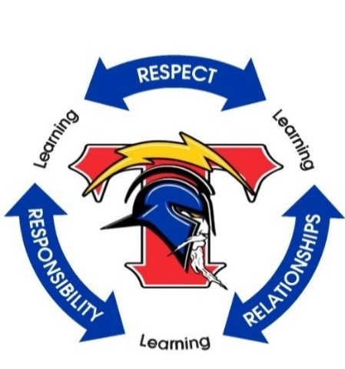
Travis Rogers
Principal

Guidelines for Success
Learning |  | Respect |  | Responsibility |  | Relationships
- Be actively engaged in classroom activities.  - Take pride in your work and actively promote your own preferred learning style.  - BRING YOUR BEST! |  | - Treat yourself, other students, the teacher, and all property with courtesy, care, and dignity.  - Allow the teacher and other students to talk without interrupting or disrupting them.  - Challenge yourself and others to obey all school rules. |  | - Be on time for class every day with all the materials you need to be "learning ready."  - Complete all homework on time and request makeup work when absent.  - Be productive whether working alone or in a group. |  | - Listen to what others have to say and respond appropriately.  - Treat others the way they want to be treated.  - Have a positive impact on others.


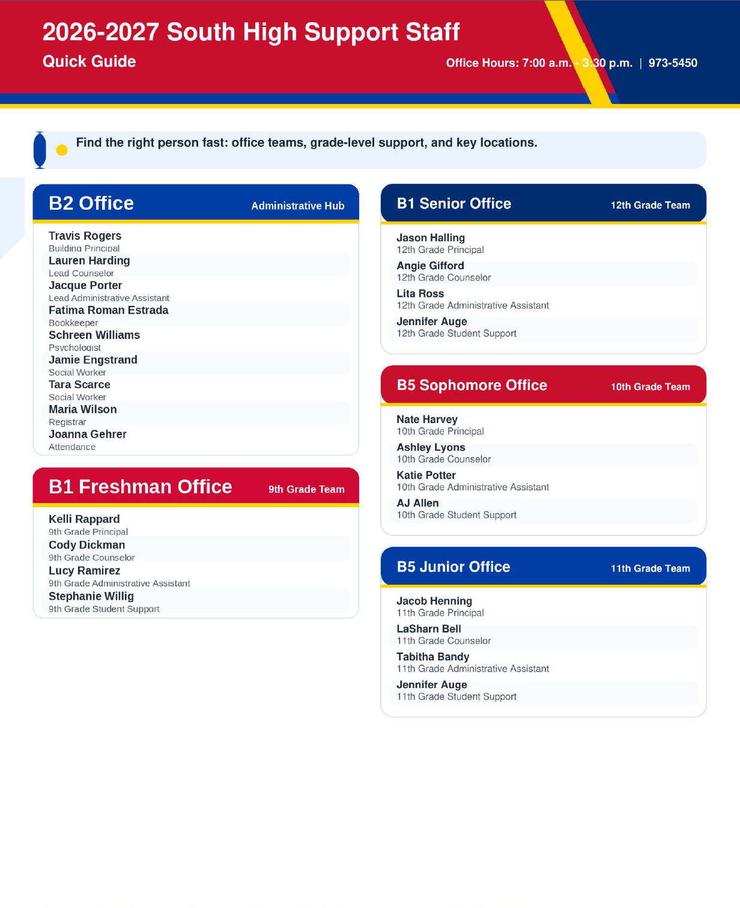
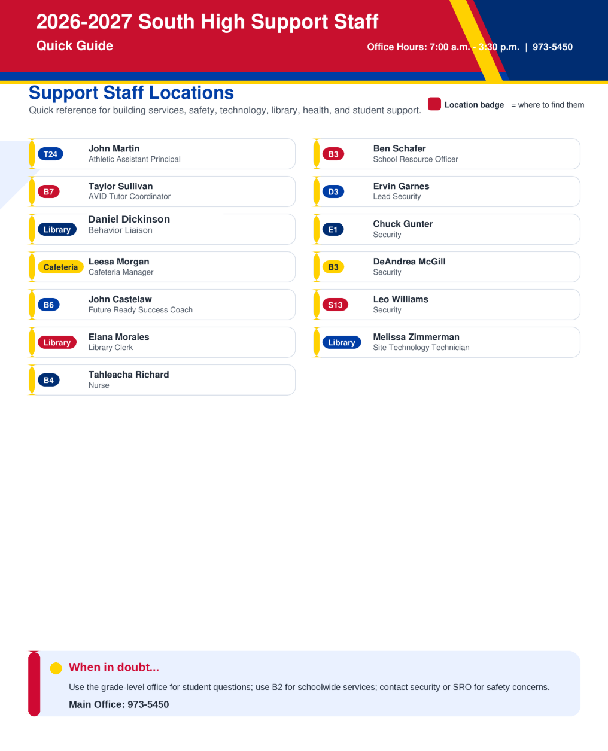

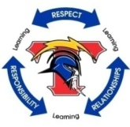
Learning
Academics

ACADEMICS FIRST

At South High School, we prioritize academic success for all students. Academics First ensures that academics remain a top focus throughout the school year. To participate in extracurricular activities, students should maintain good academic standing and seek help when needed. A list will be maintained at regular intervals to help identify students who may need extra support. Students are encouraged to stay on track by passing their classes. If a student needs help, they can take advantage of Titan Time for additional tutoring and academic support on selected Tuesdays, Thursdays, and Fridays.
Students, including those involved in athletics, Fine Arts, and dances, are encouraged to work closely with their teachers, coaches, and the Athletic Director (Mr. Martin) to stay on top of their grades. Individual programs may have their own academic expectations, which will be communicated to students and parents before the start of the season or event.
We want all students to succeed and participate in the activities they enjoy, and we're here to help every step of the way!

ACADEMIC EXCELLENCE

Students with grades of C or higher will be rewarded for their academic excellence. They can join special grade-level activities, receive awards, coupons, and prizes, and enjoy discounted ticket prices for some events.

TITAN UP GRADE

Titan Up-Grade is a free after-school support program on Mondays from 3:20 to 6:00 p.m. in the library. Teachers will provide classroom materials, and a snack will be provided to students who stay for assistance. Transportation will be provided for those who qualify.

ACADEMIC HONORS

BOE Policy 6345

Administrative Implemental Procedures for Class of 2027:

1. Enrollment requirements
a. High school students must be enrolled in at least 2.5 units of credit, except for second
semester seniors.
2. Students may not have received any grades of F. This requirement applies to all courses including those graded A through F and P–F.
3. Students must have a grade point average greater than 3.49 for selection in Honor Roll.
4. Students must have a grade point average greater than 2.99 and less than 3.50 for selection as Honorable Mention.

Administrative Implemental Procedures Class of 2028 +:

1. Enrollment requirements
a. High school students must be enrolled in at least 2.5 units of credit except for second
semester seniors.
2. High school students must have a grade point average greater than 3.0 for selection in Honor Roll. The Honor Roll levels are as follows:
a. Platinum: 4.0 +
b. Gold: 3.75 – 3.99
c. Silver: 3.5 – 3.74
d. Bronze: 3.0 – 3.49

ACADEMIC CERTIFICATES, LETTERS, BARS, STARS, NHS

Students who make the honor roll for one semester are awarded a certificate. An academic letter is awarded after a student has been on the honor roll for two consecutive semesters. After the letter has been awarded, an academic bar will be granted for each two additional consecutive semesters that the student is on the honor roll. An academic star is awarded to students who maintain a 4.0 for two consecutive semesters. Juniors and seniors with an overall grade point average of 3.5 in rigorous college prep curriculum are eligible to apply for membership in the National Honor Society (NHS). Other qualities considered for membership in NHS are citizenship, leadership, and community service.

STAY CONNECTED TO SCHOOL

Wichita South has a website at https://south.usd259.org. Use your school computer network login and password to access class information on the website. The site features calendars, announcements, events, alumni info, assignments, extended learning via podcasts and links, and discussion boards. Check out these resources!

FULL TIME STUDENTS

It is part of the philosophy of the Wichita Public Schools that students should be expected to be enrolled full-time. Kansas Law requires students to attend each day (KSA 72-1111). One reason for this is the sincere belief that there are far more educational opportunities for each student when he/she is enrolled full-time. A lesser number of hours reduces and weakens the educational experience.

The following guidelines have been established:
- All students are required to be scheduled for all nine class periods.
- The student’s scheduled periods must run consecutively. Juniors and Seniors have an open lunch and can leave campus.
- There is no free time or unscheduled time on campus.

MARKING SYSTEM OF SCHOOLS IN USD #259

A 90 - 100% - Achievement and progress are exemplary. All assigned course objectives have been mastered. The coursework has been completed and consistently demonstrates high quality.
B 80 - 89% - Achievement and progress are satisfactory. The majority of course objectives have been successfully achieved. All assigned work has been completed, most of which is of high quality.
C 70 - 79% - Achievement and progress are acceptable. Most course objectives have been mastered, important assignments completed, and work quality is satisfactory.
D 60 - 69% - Achievement is below standard with limited progress. Some objectives are met, but many key objectives are not met. Most assignments lack acceptable quality.
F 59% and below- Achievement and progress are unsatisfactory. Very few, if any, course objectives have been mastered. Course assignments were not completed.

SCHEDULE CHANGES

Each spring, the master schedule is based on student needs and course selections. Student and teacher schedules are set for the entire school year. The schedule change procedure ensures students begin their classes on the first day of the semester, boosting their chances of success.
Wichita Public Schools recognizes the reasons listed below as legitimate educational grounds for a schedule change. It is essential to carefully select courses during enrollment.

Schedule change requests may occur for the following reasons:
- Students have an incomplete schedule
- Duplication of course
- Classes are incorrectly sequenced, or student does not meet the prerequisite
- Student lacks a class needed for graduation
- Inappropriate skill level for class (teacher recommendation)
- Individual Education Plan (IEP) service and setting needs

Schedule change requests are NOT made for the following reasons:
- Preference for a different teacher, period, or semester
- Preference to be with a family member or friend
- Change of mind about taking a course
Per BOE Policy 1227, schedule change requests are to be discouraged except for valid educational reasons.

Special circumstances may require a schedule change after the beginning of the semester. To request a schedule change, please contact your grade-level counselor. The request will be considered, but not guaranteed.

PASS CARDS

Seniors may get pass cards in the second semester if they meet eligibility requirements. Students should consider missed opportunities in both class and extracurricular activities when opting for a shorter day. Parent/Guardian permission, processed by the counselor and senior administrator, is required. Students must stay out of the building during their pass card hours without permission. Class of 2027 seniors can have up to four pass cards, if eligible.

AVID

AVID students who demonstrate their Advancement Via Individual Determination can graduate with distinction and wear an honor cord. Requirements include maintaining a high GPA, taking leadership roles, serving the community, promoting AVID, completing standardized tests, and being accepted by a four-year college or university.

Graduation

REQUIREMENTS FOR HIGH SCHOOL GRADUATION

In March of 2024, the USD259 School Board updated BOE Policy 6333. Students may graduate from high school and be issued a credit-based diploma whenever the principal determines that the student has met the requirements for graduation established by the Board of Education. Note the change with the Class of 2027 and the Class of 2028 and beyond.

https://www.usd259.org/learning-services/curriculum-and-instructional-support/academic-standards

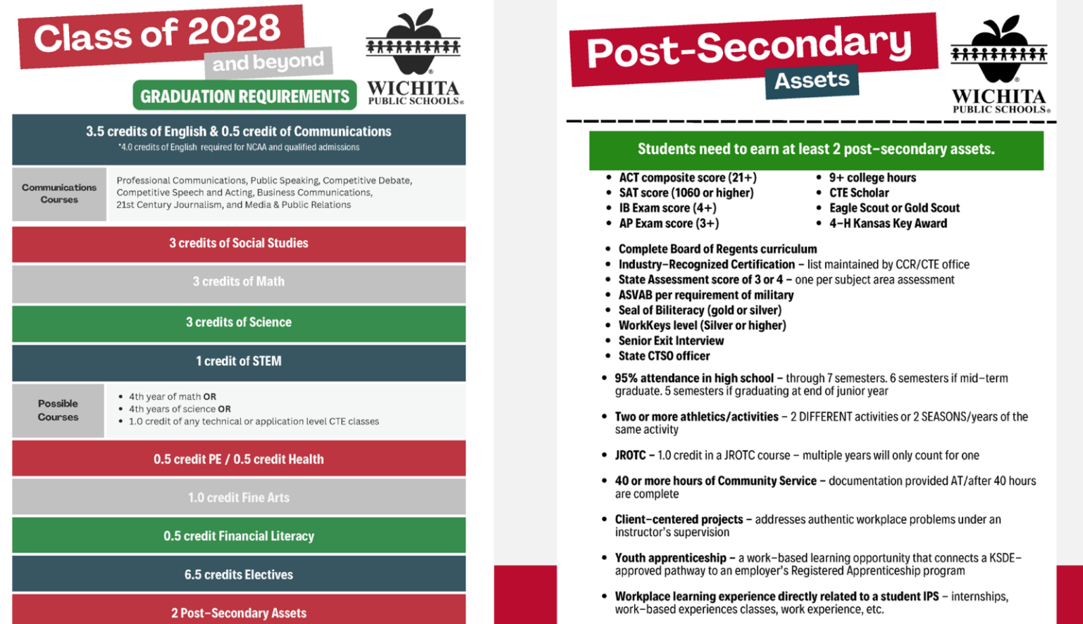

MID-TERM GRADUATES ~ DISTRICT-WIDE EXPECTATIONS

A mid-term graduate is defined as a student graduating at the conclusion of seven (7) semesters.

Requirements
- Must declare during enrollment of junior year, each school will determine process
- Principals’ discretion in August
- Must have sufficient credits
- Must submit a written plan approved by Principal
  - Plan must include:
- Coursework for seventh semester
- Post-secondary plan
  - Statement of intent; reason for the request
    - Must take Government in summer school or in seventh semester
    - Must take Financial Literacy and CTE approved course prior to or during 7th semester.
    - Must take both English courses in seventh semester
- Must be Qualified Admissions courses and cannot be taken in a Learning Center
- Must take the ACT
- Exception: Students receiving special education services – per IEP

THE LEARNING CENTER

The South Learning Center provides an alternative educational environment designed to help students meet graduation requirements by retaking selected classes they have previously failed. This Learning Center operates as scheduled during regular school hours. For further information, please consult your counselor. The Learning Center's rules are as follows:
- Location-G3
- Placement priorities are based on graduation date.
- Students are not allowed to repeat a failed class during the same semester that the failure occurred.
- All South High School rules apply to all Learning Center students.
- Students will be enrolled in one course at a time.
- All courses must be completed by the current semester of enrollment.
- Learning Center classes are not available for original credit.

College

COLLEGE & CAREER PLANNING TIMELINE
Preparing for a career and making plans to attend college after high school requires organization, planning, and preparation. Here are a few tips so that you will have the most options available to you later:
- Focus on taking challenging courses, achieving high grades, and participating in school and community activities to build a strong academic and extracurricular profile.
- Research college and career options, develop personal skills and talents, and save money for further education or training.
To get into college and prepare for a career, follow this high school timeline to stay organized and on track.

9th Grade
- Focus on academic success, create a 4-year high school plan with college prep courses, and explore career interests through various subjects.
- Engage in school clubs, extracurricular activities, and community service to strengthen your college and scholarship applications.

10th Grade
- Take advantage of Titan Time and explore elective courses to develop academic and personal interests.
- Engage in school activities, community service, and leadership roles to enhance college and scholarship applications.

11th Grade
- Explore college options by visiting with our Future Ready Success Coach, meeting with representatives, visiting college websites, and discussing costs with parents.
- Take the PSAT, consider potential majors and careers, look into scholarships, and prepare for ACT/SAT exams to enhance college readiness.

12th Grade

- Visit the Future Ready Success Coach in B6 or speak to your school counselor to explore college options, financial aid, scholarships, career paths, and review your transcript details.
- Complete college applications, scholarship applications, and financial aid forms starting in early fall, while keeping track of deadlines and maintaining communication with recruiters.
- Be aware of deadlines for awards and/or to enroll in classes of your college choice.
- Request to have your final transcript sent to your school of choice on Xello.
  - Xello Transcript Request Instructions

KANSAS BOARD OF REGENTS QUALIFIED ADMISSIONS REQUIREMENT
(High School Graduates Academic Year 2025-2026)
Honors students are encouraged to take the Kansas Scholars Curriculum as well. For more information and FAQs, visit the Board of Regents website at: https://kansasregents.gov/students/student_financial_aid/kansas_scholars_curriculum

CONCURRENT COLLEGE CREDIT - ARTICULATION AGREEMENTS (CTE) – Excel in CTE (Free Tuition Program Opportunities)
There are several opportunities at Wichita High School South for students to earn college credit prior to their high school graduation. Please see your counselor for more information.

The Wichita Public School District has entered into articulation agreements with many colleges and technical schools so that high school students who successfully complete a state approved Career and Technical Education Career Cluster Pathway will earn academic credit. For successful completion of the designated pathway, students must attain concentrator status in that pathway. Counselors have access to the programs offered at each high school.

Wichita High School South offers Free Tuition Program Opportunities through WSU Technical courtesy of Senate Bill 155. Seniors and juniors in good standing academically and on track to meet graduation requirements have the opportunity to enroll in WSU Tech Career Technical Education (CTE) Pathways that are not currently offered at Wichita High School South. Program offerings are subject to change each school year, and students must declare interest in the program by April of the previous school year. Interested students must contact their high school counselor to obtain more information regarding Senate Bill 155.

COLLEGE TESTING
Most colleges require freshmen to take the ACT or SAT. Check the College and Career Center (CCC) or university websites for specific requirements.

Registration for both tests is primarily done online. To register online you must have access to a credit card to pay the testing fee. You can register online at https://www.act.org/ for the ACT or https://www.collegeboard.org/ for the SAT.

During a student’s junior or senior year, if a student qualifies for free/reduced status, they are eligible to take each of these tests four times for free. Go to the CCC for details.

NCAA/NAIA CLEARINGHOUSE INITIAL ELIGIBILTY
Students interested in participating in NCAA Division 1 or NCAA Division 2 athletics should register with the NCAA eligibility center at https://web3.ncaa.org/ecwr3/. Students interested in participating in NAIA athletics should register with the NAIA eligibility center at https://play.mynaia.org. See your counselor for additional information.

ADVANCED PLACEMENT (AP) COURSES

Students who enroll in an AP Course(s) will not be permitted to drop the course at any time during that year. BOE Policy 1227

All students enrolled in AP classes have the following options:

- Pay the fee for the AP Exam $99 full price or $62 free or reduced price subject to change from AP) and have it scored by the College Board.
- Pay for dual credit from a local College or University ($200 approximately) if available at your school.
- Pay for both the AP Exam to be scored by College Board and dual college credit.
- Take the class for the rigor and preparation for college and pay no additional fee which means not taking the official AP Exam. You will be required to take a final exam which will be a replica/released AP Exam which will be equivalent to the amount of time of the original AP Exam.
- The replica/released AP exam scores, given by teachers, can only help student grades if the student completes the exam and does their best.
- If the replica/release AP exam is unattended or not taken by the student, then the student’s final grade will be affected.
- The scores earned on an Advanced Placement Exam will have no bearing on the grade earned in an Advanced Placement Course.

Responsibility

Grades

HOMEWORK POLICY

Homework is an activity aimed at developing self-discipline, responsibility, and learning beyond the classroom. It supports classroom work by:
- Enhancing academic skills
- Preparing for subject lessons
- Reinforcing concepts and objectives taught in class
- Developing independent study skills and self-direction.

Student Responsibilities

- Ask questions about the assignment if you do not understand what to do.
- See your teacher during Titan Time if you need help to complete your assignment(s) or make-up work.
- Set aside a regular time for studying at home.
- Produce quality work on your own.
- Complete assignments on time.
- In the event of an absence, make-up work should be completed based on BOE Policy 1472.

Teacher Responsibilities
- Assign meaningful homework that reinforces classroom learning.
- Provide clear instructions and explain the purpose.
- Give timely feedback and corrections.
- Define homework and late work policy in the syllabus.
- Document parent/guardian communication in Synergy.

Policy can be found here:
BOE Policy 1472

LATE WORK POLICY
- Excused Absences: Students will have two additional class periods to make up missed assignments or submit any work due during their absence. Students should meet with teachers after multiple days of absence for assignment details and specific deadlines.
- Late Work: Any assignments turned in after the deadline (except for excused absences) will be graded as follows
- No Make-up for Previous Grading Periods: Assignments cannot be made up for past grading periods. Be aware of the cutoff dates listed below.
Grading Period | Ending Date | Assignment Deadline
1st Nine Weeks | Wednesday, October 14, 2026 | Monday, October 5, 2026
2nd Nine Weeks (1st Semester) | Thursday, December 17, 2026 | Monday, December 7, 2026
3rd Nine Weeks | Wednesday, March 10, 2027 | Monday, March 1 2027
4th Nine Weeks (2nd Semester) | Tuesday, May 25, 2027 | Friday, May 14, 2027
Tests/Large Projects/Essays: Deadlines for tests and projects may differ from the standard cutoff dates. These will be communicated by the teacher and listed in their syllabus.
FINALS POLICY

South High will reward students who have been working hard in the classroom each semester by excusing them from the semester finals. The criteria are as follows:

- Grades: Students who maintain a grade of A, B, or C.
- Tardies: Fewer than 20 tardies throughout the semester starting on August 24th and January 7th respectively.
- Referrals: No more than 3 referrals each semester (with administrator discretion).
- Juniors: Required to have completed the ACT or an alternative approved assessment.
- AP, Concurrent, and WSU Tech classes are not included in any final’s exemption.

If Criteria are Met:

- Students who meet the criteria would be exempt from finals in certain classes and instead participate in a "Finals Event” during that timeframe.
- In classes where testing is still necessary, students would take the finals, but for those who are exempt, they could enjoy a more relaxed and rewarding environment as a celebration of their positive grades, attendance, and behavior.
- Students who qualify would still be able to take finals as desired.

ACCESSING YOUR GRADES

Students are encouraged to monitor their grades regularly through Student Vue. Parent Vue is available to parents and can be accessed through the South website at https://ks-wic-psv.edupoint.com/PXP2_Login.aspx. Passwords can be reset by an administrative assistant in the administrative offices (see page 2 for contact information).

MEETING WITH TEACHERS

Students and parents have the option to schedule a conference with a teacher. They are required to call ahead to arrange an appointment with the teacher, either directly or through the appropriate administrator. Meetings should not be scheduled during class time unless coordinated through the appropriate administrator.

Attendance

ATTENDANCE POLICY

Regular school attendance is required of all pupils enrolled in school under Kansas compulsory attendance statutes (KSA 72-1111).

Parents or guardians should call the attendance clerk at 973-5460 to report a student's absence from school. This phone line will be on voicemail from 4:00 p.m. until 7:15 a.m. Messages can be left during these hours.

We believe that attendance is essential to the success of the students and the school program. A parent/guardian is responsible for providing notice/documentation to excuse an absence within 72 hours.

Absences will be excused for the following with appropriate documentation:
- Doctor/dental appointments – medical office verification provided on professional stationery
- Court appearances – court-written documentation
- Religious holidays that appear on a standard calendar
- Illness – Any student accumulating 12 days or 96 hours of student illness will be required to provide a note from a doctor for future absences.
- College visits – written documentation
- Funerals – printed documentation
- Deployed parent – Meeting requirements per BOE Policy 1461

Regarding attendance:
- A student who is participating in school-related activities will be given an excused absence.
- Any time a student leaves campus or returns, he/she MUST check in/out through the Attendance Center.
- It is the responsibility of the pupil to make up assignments. The teacher shall make reasonable efforts to encourage and assist the pupil to make up missed assignments, shall give credit for such work, and shall allow the pupil a reasonable period of time to complete such missed assignments. Pupils with unexcused absences are encouraged to make up their work, but teachers are not required to accept such make-up work for credit. Students will be allowed two class periods for each period absent to complete the make-up work. BOE Policy 1472

TARDY POLICY

To report a tardy from school, parents/guardians need to call the attendance clerk at 973-5460.

Parents/guardians should report attendance concerns by calling the attendance clerk at 973-5460.

Students are expected to arrive to school and to each class on time. To support timely arrival, a two-minute warning bell will ring before each class period.

Tardy stations will be located throughout the building. Any student who is late when the tardy bell rings will be directed to the nearest tardy station to scan in and receive a white pass. The white pass will include the student’s name, the time the student scanned in, and the class location, including the teacher’s name, where the student is expected to report.

Students are required to have their student ID in order to scan in at a tardy station. After receiving a white pass, students should report directly to class.

The tardy station system communicates with Synergy, so teachers will not need to manually track tardies. Grade-level office staff will monitor tardy data and identify students who demonstrate repeated tardiness. Students with excessive tardies may be required to meet with an administrator and/or parent/guardian to develop a plan for improved punctuality.

ANTICIPATED ABSENCES

When you know you will be absent four or more days, students should:
- Have a note from the parent or have a parent call the attendance clerk (preferably a week in advance of the absence) stating the reason for absence and the dates to be missed. Absences due to vacation will not be excused.
- Obtain a Request to be Absent form from the attendance clerk or your administrator. Have your administrator and all of your teachers sign it. When you ask your teacher to sign the form, be sure to get the assignments that you will need to make up.
- Return the completed form to the attendance clerk. If you have a questions, see your administrator.

REPORTING TRUANCY

Pupil Attendance BOE Policy 1460
Regular school attendance is required of all pupils under Kansas Compulsory Attendance Statue (KSA 72-111). The Kansas Compulsory School Attendance Law holds parents responsible for requiring a child under their control or charge who is between seven (7) and less than eighteen (18) years of age to attend school on a continuous basis.

BOE Policy 1461
In compliance with the requirements of the Kansas Compulsory School Attendance Law, reports shall be filed with appropriate authorities when a child is not enrolled in a public school or when a child is enrolled in school and is inexcusably absent. The Board of Education has set a “Substantial Part of the School Day” as being inexcusably absent four (4) hours any part of the school day.

Inexcusably absent is defined as being absent for a substantial part of a school day on either three (3) consecutive school days, or five (5) school days in any semester or seven (7) school days in any school year, whichever occurs first.

A student’s attendance pattern must meet this rule before he/she can be reported to the Office of the District Attorney.
A valid excuse for absence is defined as follows:

- Medical or dental treatment, examination or recuperation
- Death or serious illness in immediate family
- Approval by school authorities, secured prior to the absence
- Circumstances or conditions which, in the opinion of the principal, constitute a valid excuse.

Note: Students accumulating more than 12 days or 96 hours of illness will be considered to have excessive absences and will be required to provide a doctor’s note for all future absences OR be recorded as inexcusably absent.

Procedures for Students with Excessive Student Absences

- Twelve (12) days or ninety-six (96) hours of student illness
Students that have accumulated 12 days or 96 hours of student illness will be considered to have excessive absences. A letter will be sent to the parent/guardian advising them that a doctor’s note must accompany any further student illness absences, or the absences shall be considered unexcused.
- Procedures after the student has acquired 12 days or 96 hours of student illness
After the parent/guardian has been notified, all further student illness absences must be accompanied by a doctor’s note, or the absence shall be unexcused then procedures for Truancy Referral for Students with Inexcusable Absences will be followed.

- Students sent home from school-by-school nurse
When a student is examined and deemed ill by the school nurse and the student is required to recuperate at home, this absence shall be coded as medical/dental.
- Exceptions to excessive student illness
If a student has obtained a medical diagnosis and has provided the initial documentation to the appropriate school personnel for a chronic/terminal illness such as cancer or an acute illness such as chicken pox, a doctor’s note will not be required for the days/hours accumulated beyond the 12 days or 96 hours.
- Gradual Return to Learn in School upon Concussions
Day 1: Complete at least 2 hours of self-paced homework (completed in 30-minute increments). If symptoms arise, students will be required to complete the concussion protocol.

Miscellaneous

COMPUTER USE -- LOCAL AREA NETWORK (LAN)

Appropriate use of the South network and/or Internet is defined by BOE Policy 1230. The parents of each student are asked to sign a permission form acknowledging BOE Policy 1230 regarding student use of the Internet and the network at South High School. Each South student has his/her own personal username and password. Individual passwords are not to be shared with others. Students are expected to abide by the BOE acceptable use policy referenced above. A student who has difficulty logging on to the South network should see the network administrator in the library as soon as possible. Students must present their ID card at this time. The network administrator will ascertain the cause of the difficulty and make necessary adjustments.

BOE Policy 1230 states that student use of computers, the network or Internet shall be in support of education and consistent with the district’s educational objectives. At Wichita High School South, if any student bypasses the network proxy or goes around the Internet filter to gain access to sites which have been blocked, he/she will be subject to disciplinary action. After the first offense, the student will lose computer privileges at the discretion of the acting administrator.

Students who use the South network, Internet, or computers inappropriately will be subject to disciplinary action.

DANCES
To attend any school dance, students must show their school ID. If bringing a guest, the guest must be preregistered and present a photo ID. Students must be making satisfactory progress in their classes (based on the Academics First list) and have served any tardy detentions or suspensions to be eligible to attend. Students with behavior issues resulting in In-School or Out-of-School Suspension during the week of the dance will lose the privilege of attending that event. The administration reserves the right to revoke dance privileges for any student who is not in good standing with the school.

FIRE, TORNADO, and EARTHQUAKE DRILLS

Fire
There are procedures designed for safe evacuation of the building in the event of fire or smoke. South will conduct fire drills periodically during the school year. Everyone is required to leave the building immediately when an alarm is given. Students are not permitted to go to lockers or restrooms during a drill.

Tornado
Tornado drills will be scheduled during the school year. In the event of a tornado warning, students will not be permitted to leave the building and must go to their designated FEMA shelter.

Earthquake
If inside, students should move under tables/desks and remain seated, backs toward the windows, and protecting the head. If outside, get away from the building, away from power lines, and sit down.

Students will remain calm, quiet, and attentive during drills and crisis procedures.

FEMA Safe Room
The FEMA Safe Room, the multipurpose room (T5) and the Music Suite (A21 & A23) is sized to accommodate the students and staff and is also constructed to specific performance criteria that are expected to withstand the effects of high winds and debris generated by tornadoes. The occupants who are in the shelter are protected during a weather event. The criteria used ensure us that the FEMA Safe Room is constructed in accordance with FEMA guidelines to provide a consistent high level of protection. The criteria include resistance to 250 mile per hour winds; windborne missile impact resistance on shelter walls and ceiling; FEMA tested Safe Room doors, door frames and window shutters; ventilation; emergency lighting; Safe Room sizing, and accessibility.

- In anticipation of the sirens sounding, everyone will proceed to the FEMA safe rooms via an intercom announcement.
- Once these doors are secure, they will not be opened until we are given the “All Clear” by the district.
- Any patrons that arrive at South High after we have secured the FEMA Safe Room doors will need to follow the signage that goes directly to the SECONDARY SHELTER which is in J hall restrooms.
- We will not open the FEMA doors for anyone, including parents, once they are closed. We cannot jeopardize the safety of patrons already in the Safe Rooms during this time. This location is the SAFEST place for your child to be!
- Our Secondary Shelter Area is provided for all patrons that arrive after the warning and after FEMA doors have been locked.
- The restrooms would be considered the second safest locations in our building however this area is NOT constructed according to FEMA guidelines.

HALLWAY PASSES

Synergy Hall Pass Expectations

Beginning in the 2026–2027 school year, students will use Synergy Hall Pass when leaving class during instructional time.

Students must have teacher permission before leaving the classroom. The teacher will create a digital hall pass in Synergy, which will include the student’s destination and the amount of time approved for the pass.

Students are expected to:

Ask permission before leaving class.
Leave only after the teacher creates the Synergy Hall Pass.
Go directly to the approved destination listed on the pass.
Return to class within the approved time.
Check back in with the teacher when returning to class.
Use passes responsibly and only for appropriate reasons.
Follow staff directions if stopped by hall monitors, office staff, or administrators.

The Synergy Hall Pass system allows staff and administrators to monitor active passes in the building. Students may be denied a pass if too many students are out of class, if the requested location is unavailable, or if the student has misused hall passes.

The default pass time is 5 minutes unless additional time is approved by staff.

Restroom/Office/Nurse/Locker/etc. Passes
Teachers will only issue restroom passes after the first and before the last 10 minutes of class. Pass Colors: Each hallway has its own color for restroom use. This helps you know which restroom to use throughout the day. The color passes that hallway staff will be looking for are:

- Pink: D, E, and F Hallways
- Green: A, B, and C Hallways
- Yellow: G, H, K, M, and S Hallways
- Orange: J and T Hallways
Sign In/Out: When leaving the classroom on a pass, students are required to have a physical pass as well as approval via Synergy from the teacher. It is also highly encouraged that teachers have a physical sign in/out page to coincide with the Synergy pass.
HEALTH ROOM
The health room is staffed by a registered nurse and a nursing clerk. Students who feel ill should get permission from their teacher before going to the health room. If a student needs to go home due to illness, the nurse will contact the parents. All students must check out with the nurse before leaving. Teachers will use the student agenda to sign a pass.

LIBRARY MEDIA CENTER
The library is open from 8:00 a.m. to 4:00 p.m. every school day. To check out a book, you must have your student ID. To use the library during Titan Time, you must get a pass from the library clerk prior to Titan Time following standard Titan Time procedures.

LOCKERS – HALL AND GYM
Lockers are owned by the school and rented to students for their use; they may be subject to search. The school holds no responsibility for items stolen from lockers located in the hallway or gymnasium. All students are assigned a locker this year, and passes to lockers during instruction time is not allowed.

LUNCH
Juniors and seniors may choose to eat in the cafeteria or leave the campus. Freshmen and sophomores have a closed lunch and must remain in the designated areas of the building or the courtyard. All other areas are off limits during lunchtime. It is the students’ responsibility to be in class on time following lunch. Students are expected to pick up their trash if they eat in the hallways or other alternative eating areas to help keep our school clean.

Due to the lack of personal electronic devices, outside food delivery will not be allowed to the school for students. This means Uber eats, Doordash, Grubhub, or any other food that would be ordered online. Deliveries will be turned away at the door.

P1358 MIDDLE AND HIGH SCHOOL LUNCH PERIOD ACTIVITIES BOARD POLICY Section B:
Supervised lunchroom and other activities are provided for students in grades 6 through 10, all of whom must remain on campus during lunch period, and for students in grades 11 and 12 who do not opt to leave campus as part of their open lunch privilege.

PARKING
Parking on school property is a privilege, and all vehicles are subject to search. Cars must be registered and display a South parking permit on the rear-view mirror, which can be obtained from the bookkeeper. This permit is transferable among registered family vehicles. Faculty parking is in front of the new gym and rows one and two of the main lot. Visitor parking is around the flagpole.

The speed limit on school grounds is 10 mph. Students cannot park in the 33rd Street (Sim) lot. Motorcycles must use the designated area, and bicycles should be locked in the provided racks. Visitor spaces are off-limits for parking.

South High and USD #259 accept no responsibility for the security of vehicles.

Special senior parking must be purchased. A $35 fee must be paid by the designated painting day.

STUDENT ID CARDS/LANYARDS
Wearing an ID with a South High School lanyard will help distinguish students, staff, and visitors and maintain a secure environment within the school.

ID and Lanyard Requirement:

- IDs (with a lanyard) will be issued at the time of enrollment. Original ID cards and replacement IDs cost $3. ID cards will be required to attend any South High activity. Student IDs are required when tardy to class or when eating lunch in the cafeteria/food carts located around the school. When students are in the hall, they are expected to have their student ID in their possession and make it available to school staff upon request.
- Temporary IDs: If a student forgets or loses their ID, a temporary ID may be obtained during passing periods from their grade level office. Temporary IDs must be worn visibly until the student can obtain a replacement ID.
- Student ID Requirement for Meals: Students must have their school ID to receive breakfast or lunch from any meal cart, including passing-period and second-chance lunch locations. Students without an ID will still be provided with a meal during the lunch period; however, they must go through the cafeteria serving line during their assigned lunch period. 2nd chance lunch will not be an option without an ID.
- Upperclassmen Open Lunch: Students approved for Open Lunch must carry their student ID and present it when leaving campus. Upon returning, students must have their ID scanned before re-entering the building. To ensure student safety and accountability, only eligible 11th and 12th grade students may participate in Open Lunch. Students must exit and enter through the Main Entrance (Door #1) only. Students who fail to follow Open Lunch procedures may lose Open Lunch privileges.

Students are encouraged to wear their student ID on a South High School lanyard throughout the school day. Wearing a visible ID supports school safety, helps staff identify students, and contributes to a secure learning environment for everyone.

TEXTBOOKS

Textbooks and other instructional materials are the property of USD 259, Wichita Public Schools. They are provided for the use of students who are enrolled in district schools and centers with the expectation they will be returned in the condition they were issued less reasonable wear and tear. Students who lose or damage instructional materials will be charged the replacement cost of the lost or damaged item(s).
Each student shall return all textbooks issued to the student at the time they withdraw from the school, at the end of the first semester for all classes that do not continue, or at the end of the school year. Students shall write their names inside in the appropriate place and properly use and care for the textbooks. Each student or their parent or legal guardian shall be responsible for textbooks not returned or damaged by the students. Any student failing to return textbooks or who fails to pay for lost or damaged items may, as a result, have holds placed on progress reports, report cards and diplomas, or be excluded from participation in graduation ceremonies, extracurricular activities, sports and special programs/events. All fines must be paid no later than the last instructional day of the school year.
Students are required to pay the replacement cost for damaged textbooks and instructional materials. The costs of books and materials are available in the district’s Textbook Manager System.

TRANSPORTATION

Free school bus transportation is available to students within the South attendance boundaries who live at least 2.5 miles from the school. Riding the bus is a privilege.

Every student transported on a bus has the right to receive this service in the safest possible manner. To ensure this, it is imperative for all students to be aware of and adhere to the rules and regulations established by the State and the local Board of Education. Below is a copy of the ACHIEVE poster, which will be displayed on each bus, along with additional expectations for student behavior. It is important to remember that the bus ride is an extension of the school day, and appropriate school and classroom conduct is expected both at the bus stop and on the bus.

HIGH SCHOOL STUDENT EXPECTATIONS ON THE BUS - Transportation Services Dept
It is the right of every student being transported on a bus to receive this service in the safest possible manner. In order to ensure this, it is necessary for all students to know, and to follow the rules and regulations set forth by the State and the local Board of Education. Below is a copy of the ACHIEVE poster that will be posted on each bus with additional student expectations following. Remember the bus ride is an extension of the school day and that school and classroom conduct is expected at all times.

Activity: Ride the bus
Conversation: Voice Level 1 or 2 – Whisper or quiet conversation
Help: Raise hand; ask bus driver at stops
Integrity: Be respectful to everyone in your words and actions
Effort: Lead by example, stay seated properly.
Value: Safety for all riders
Efficiency: Enter and exit safely at your assigned stop, be prompt, engage in acceptable activities such as homework, reading, or visiting quietly

- Be 5 minutes early to your assigned bus stop.
- Bring only school appropriate items on the bus.
- If you leave campus during the day, you are not allowed to come back on campus to ride the bus. Exception Open Lunch for Juniors and Seniors.
- Always obey the driver and/or aide.
- The use of Personal Electronic Devices may be allowed on the bus when used quietly and appropriately. Students are personally responsible for the security of any Personal Electronic Devices. The school is not liable for damaged or stolen property.

Violation of the bus rules could result in suspension or revocation of the privilege to ride the bus.

Respect
Common ACHIEVE

Activity Passing Period
Conversation Level 2 – Appropriate indoor conversation (No profanity)
Help Locate staff member/peer
Integrity Respect the people and property of South High School
Effort Be on time and prepared for class
Value Eliminates issues, increases safety
Efficiency Be Polite, Prompt, Prepared, Productive, Positive

Activity Cafeteria: Breakfast/Lunch Time
Conversation Level 1/2 – Appropriate indoor conversation (No profanity)
Help Locate staff member
Integrity Pick up after yourselves & throw away trash
Effort Follow instructions that are given to you by staff
Value Builds character & school pride
Efficiency Helps keep the school clean & safe

Activity Assembly
Conversation Level 0 – listen to presentation
Help Raise hand or locate staff member
Integrity Be respectful – listen intently
Effort Remain focused on presenter
Value Gain information & celebrate success
Efficiency Follow staff instructions

Activity Using Restroom
Conversation Level 0/1
Help Locate the nearest staff member
Integrity Be respectful
Effort Clean up after yourself
Value Clean restrooms for students and staff
Efficiency Leave quickly when finished

Dress Code

The purpose of the USD 259 Student Dress Code Procedure is to maintain a positive school climate, uphold standards of respect and safety, and support effective teaching and learning.

Dress Code Enforcement

Dress code concerns should be addressed in a manner that preserves student dignity, maintains a positive learning environment, and minimizes disruption to instruction. When a dress code violation occurs, staff will work with the student to resolve the concern as quickly and discreetly as possible.

Students should not miss significant instructional time due to a dress code violation. Whenever possible, corrections should be made during passing periods, lunch, or other non-instructional times. Students will be offered access to compliant clothing when needed.

Dress code violations are not disciplinary offenses and will not result in exclusionary disciplinary consequences, such as suspension or removal from school. Staff will focus on corrective, supportive, and educational responses that allow students to remain engaged in learning while addressing the concern.

STUDENT RESPONSIBILITIES
- Select attire and personal appearance that respects the educational setting and peers.
- Manage personal grooming and attire to align with the principles of this dress code.
- Maintain personal hygiene in a way that is safe, healthy, respectful, and supports the educational environment.

DRESS CODE CRITERIA
Appearance, Language on Clothing, Symbols, Tattoos, and Messages - Any items worn (including socks, belts, jewelry, and hats) in schools must not show, reference, cause, or infer:
- Profanity, drugs, alcohol, tobacco, firearms, or weapons.
- Violence, abuse, or suggestive and/or sexual messages.
- Language, logos, or symbols on attire that promote hatred.
- A disruption of the school learning environment.
- Relationship or affiliation with gangs.

Head Coverings and Related Items
- Must not conceal identity such as face masks, ski masks, balaclavas, or hoods/stocking caps which cover the ear.
- Exceptions shall be recognized in order to accommodate disabilities, medical conditions, or sincerely held religious beliefs, as provided more fully in P1474, regarding standard dress codes.
- This restriction does not include items that are designed for hair maintenance.

Hats - For secondary students, hats will be allowed to support personal expression and comfort, reflecting their greater maturity. However, hats must not create disruptions or safety risks.
- Visibility: The hat must not obscure the student's face, ensuring clear identification by staff and security.
- Safety: The hat must not create hazards, such as obstructing visibility.
- Non-Disruptive: The hat should not disrupt classroom activities.

Tops - All tops must:
- Cover the majority of the back and shoulders.
- Cover the midriff and back when sitting or standing.
- Be of sufficient thickness to prevent visibility of undergarments.
- Provide coverage of personal areas.
- Completely cover undergarments.

Bottoms - All bottoms must:
- Cover undergarments at all times.
- Be of a safe and appropriate length (cannot drag on the floor or expose the upper thigh).
- Be worn no lower than the natural waistline.
- Provide coverage for personal areas.

Outerwear
Students should not wear articles of attire that are disruptive to classroom learning environments or present safety concerns.

Footwear - Footwear worn in schools must:
- Be worn at all times.
- Fit securely enough to the foot for safe movement.
- Have a hard or rubber sole.
- Not have such a high heel as to cause concern for safe movement throughout the school.

Jewelry, Piercings, Colognes, Perfumes, and Accessories - Jewelry, piercings, colognes, perfumes, and accessories worn in schools must:
- Not have an overwhelming fragrance.
- Have no parts that may serve as a weapon.

Additional Statements
- Non-discrimination: The standardized dress regulations shall not include any requirements or be enforced in a manner that discriminates against a student on the basis of race, national origin, religion, disability or sex, or which otherwise violates the policies cited above.
- Consistent Standards: This policy shall be applied and enforced consistently and uniformly.
- Code of Conduct: Staff shall refer to the Code of Conduct for guidance in responding to violations of this policy, including non-compliance with staff direction and repeated violations.
- Offer of Compliant Clothing: Staff shall be required to offer students compliant clothing if a student is not wearing clothes that satisfy the dress code. Each school shall maintain a store of compliant items of clothing to offer to students who come to school wearing non-compliant dress.
Behavior

RATIONALE: To ensure a quality learning environment, appropriate student behavior is essential. Most students are cooperative and committed to making constructive progress; their efforts are recognized. South High School expects all students to adhere to these behavior guidelines. Parents are encouraged to work with school personnel to establish a safe, secure, and positive atmosphere where optimal learning can occur. Whether on campus or at a school-sponsored event:

- ANY act that disrupts school activity, infringes on the rights of others, causes danger to people, or causes destruction of property (whether or not specifically described herein) is a violation of school rules.
- Students will arrive at school/class on time, prepared to engage in active learning with appropriate homework assignments and materials. Students will utilize the seven-minute passing periods and lunch time to take breaks for vending, restrooms and any personal needs.
- Students will follow directions given by any adult in the building. Students will demonstrate courtesy and respect toward themselves, other students, guests, staff members, and substitute teachers as well as respect for school property and equipment.
- Students will exhibit appropriate behavior in the hallways. Appropriate behavior does not include displaying acts of affection, fighting, acting to incite fights, forming a wall of spectators at a fight, or recording fights.
- Students will use appropriate language. Inappropriate language including profanity, racial slurs, name-calling, or harassment of any kind will not be tolerated. Students will not create, voice, or distribute printed literature that describes antisocial views (i.e., racial, ethnic or sexual orientation, bigotry, racial supremacy).
- Students may not their own personal cell phones from 8:00am-3:10pm.
- The use of all tobacco products (cigarettes, cigars, pipes, and smokeless tobacco) and look-alike products such as vape/dab pens are prohibited in or on all school district property as per BOE Policy 1464.
- Students will not bring weapons or weapon replicas of any kind to school or school activities. This includes laser pointers. Violation of this expectation may result in a student being taken to a hearing as per BOE Policy 1466.
- Disrespect means disobeying teachers or staff members, not following instructions regarding conduct, or in any way, by actions or words, showing a defiant attitude. If you fail to identify yourself or to present an ID card when requested to do so by authorized school personnel will be considered as an act of insubordination.
- The use of digital, electronic, and other devices capable of recording or transmitting audio, video, text, and photographic images for non-educational purposes is prohibited. Non-educational purposes include activities such as video recording of fights, recording arguments, snap chatting to harass another student, and recording conversations.
- Inappropriate behavior in school that results in Out of School Suspension or In-School Suspension during the week of an event will result in the loss of privileges to attend extra-curricular activities during that week.

HARASSMENT, SEXUAL HARASSMENT, BULLYING –
BOE POLICY 1115, 1116, 1119, 1464

Harassment is verbal or physical conduct that belittles or shows hostility or aversion toward an individual because of his/her race, color, religion, gender, national origin, age, or disability, or that of his/her relatives, friends, or associates, and that:
1. Has the purpose or effect of creating an intimidating, hostile, or offensive school environment; or
2. Has the purpose or effect of unreasonably interfering with an individual's school performance; or
3. Otherwise adversely affects an individual's educational opportunities.

Sexual Harassment is unwelcome sexual advances, requests for sexual favors, and other verbal or physical conduct of a sexual nature constitutes sexual harassment when:
- Submission to such conduct is made either explicitly or implicitly a term of the pupil's academic opportunities or
- Submission to or rejection of such conduct by a pupil is used as a basis for academic decisions affecting such pupil, or
- Such conduct has the purpose or effect of unreasonably interfering with the pupil's school performance or it creates an intimidating, hostile or offensive educational environment.

USD 259 will not tolerate harassment of any kind. The district will not permit harassment of an employee by another employee, pupil, or others. Violation of this policy shall result in disciplinary action against any employee or pupil involved, including possible termination of the employee and expulsion of the pupil.

Bullying is a purposeful behavior that is intended to cause harm or distress. Each pupil is held responsible for his/her personal actions. The right to attend a Wichita Public School carries with it the obligation to maintain acceptable behavior. Bullying in any form is prohibited on school property, in a school vehicle, or at a school-sponsored activity or event. In addition, bullying is prohibited while utilizing school property. Bullying includes Cyberbullying.

SEARCH AND SEIZURE – BOE Policy 1470
The student has exclusive control over property in his/her immediate possession, but such possession may not be exclusive against the school and its officials. When a reasonable suspicion arises that use or possession of a student’s property is illegal, illicit, disruptive, or a danger to the general welfare of students and staff, a search may be made of the student’s person or personal property.

VANDALISM AND THEFT
Pride and respect for our building, grounds and equipment are characteristics for a typical South High School student. Because repairs cost money, reasonable damage charges are assessed, and those responsible are required to make restitution.

BEHAVIOR CONSEQUENCES
Various consequences are given for misconduct outlined in USD259 Code of Conduct. Please see page 11-18 of the Student Code of Conduct.

USD 259 Student Code of Conduct – Click Here

Titan Up Room
In-school suspension allows a student to remain at school and complete assignments. Attendance will be taken. Teachers will send work to Titan Up (D4), but students should also be prepared to have work to complete while in Titan Up. Those students who bring nothing to work on while in Titan Up will be provided with supplemental learning materials.

Expectations in the Titan Up Room (In-School Suspension):
- No passing without prior administrative approval.
- Complete assignments quietly, comply with supervisor requests, and participate in required activities or meetings to be allowed to leave.
- Turn in all electronic devices to the supervisor at the start of the day; they will be returned at the end of the day.

SPEAK UP Anonymous Reporting
Wichita Public Schools offer the Speak Up program, enabling students, staff, and parents to send anonymous tips to keep schools safe. Tips can be sent via a secure website, smartphone app, or phone number, provided by Crime Stoppers of Wichita and Sedgwick County. Messages are encrypted and routed through secure servers, ensuring anonymity with an alias and unique ID for two-way communication with the Speak Up Coordinator.



Any student who has knowledge of a crime or violation of school policy should make a report with security and/or use the SPEAK UP app.

ACADEMIC INTEGRITY

At South High School, we value honesty and the hard work students put into their academic achievements. Academic misconduct occurs when a student takes someone else’s work and claims it as their own. This includes actions like plagiarism and cheating.
Plagiarism:
Plagiarism happens when you use someone else’s ideas or work without giving them credit. This could mean copying directly from a source, cutting and pasting from the internet, or rephrasing someone’s ideas without citing them properly. Always make sure to give credit to authors and creators for their work.
How to Avoid Plagiarism:
- Use quotation marks when you directly quote a source.
- Include citations for any facts, statistics, graphics, or ideas that aren’t your own.
- If you’re paraphrasing someone’s work (putting it into your own words), always give them credit.
- This applies to any materials you use, including AI-generated content. Always credit the source, whether it’s a book, website, or AI tool.
- How can leverage AI to benefit the work that you do?
When in doubt, cite your source!
Cheating:
Cheating is trying to gain an unfair advantage, like copying answers or getting someone else to do your work. This includes using unauthorized materials, such as answers to a test, or submitting work that isn’t your own.
Academic Integrity Expectations:
At South, we expect all students to follow academic honesty and do their best to create original work. If there are concerns about academic integrity, teachers will work with students to help them understand the importance of honesty in their learning and ensure they stay on track.
We believe in supporting all students to be successful, and we encourage everyone to take pride in their hard work and achievements. Let’s all work together to maintain a positive and respectful learning environment.
Academic Integrity Expectations and Support:
At South High School, we hold academic honesty in high regard to ensure a positive and ethical learning environment. If a situation of plagiarism occurs, the following steps may be taken to help students understand the importance of integrity and improve their academic practices:
- Redo the Assignment: Students may be asked to redo the assignment to meet the teacher’s expectations, providing an opportunity to learn and improve.
- Adjusted Credit: In some cases, a student may receive reduced credit for the assignment as part of the learning process.
- Parent/Guardian Involvement: Parents/guardians may be notified to ensure open communication and support for the student’s academic growth.
- Administrator Support: Administrators may be involved to help guide students toward better understanding and maintaining academic integrity moving forward.

These steps are designed to support students in making positive changes, learning from mistakes, and achieving success in their academic journey.

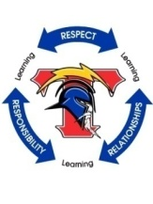
Relationships

GUIDANCE AND COUNSELING

School counseling offices are in B-Hall and counselors are available from 8:00 a.m. to 3:10 p.m. Students should sign up for an appointment or have a pass to see their counselor:

9th grade Room B1 Cody Dickman
10th grade Room B5 Ashley Lyons
11th grade Room B5 LaSharn Bell
12th grade Room B1 Angie Gifford

Registrar- oversees school records and works with those requesting school transcripts. (Located in B2 Main Office)

Future Ready Success Center–supports and guides students as they fill out college applications, apply for college testing or write a résumé to find a job. (Located in B6)

Psychologist–assesses students through testing, observation, & other means to help determine proper educational and mental health supports. (Located in B2)

Social Worker-assists students, families, and staff to identify needs that interfere with learning, and provides information on available community resources. (Located in B2)

Titan Time

Achieving academic success is an attainable goal for every student at Wichita High School South. As part of our class schedule, we provide an academic tutorial period known as Titan Time. This period lasts for 38 minutes each day, except for Wednesdays. Titan Time provides students with the opportunity to collaborate with teachers and receive additional support to enhance their academic performance.

TITAN TIME GUIDELINES

- Students must check on the availability of their teacher ahead of time to attend tutorial sessions during Titan Time on Tuesdays, Thursdays, and Fridays. Teachers should not admit students who are not on their pre-approval list.
- Advocacy will be on Mondays during Titan Time. Students may not pass to receive tutorial help on Advocacy days.
- If the student does not plan to attend a tutorial session, he/she must bring work to Titan Time that will enhance his/her academic skills.
- Students may not attend tutorial sessions without a reservation with their respective teacher. Be prepared to show your signed agenda to your Titan Time teacher.
- Students can only move to a teacher's classroom who appears on that student’s schedule. The exceptions are for students who need to use the computer labs/library during Titan Time or visit with college representatives.
- Seniors are expected to be enrolled in a Titan Time class for both semesters.
- Passing time is only for those students who are taking advantage of a tutorial session, not for bathroom or drink breaks. Students should remain in their designated area for the duration of Titan Time.
- Passing for tutorial sessions will take place on select Tuesdays, Thursdays, and Fridays. Passing times are from 2:37 to 2:42 p.m. Hallways should be cleared from 2:42 to 3:10 p.m.
- Students are expected to follow all Titan Time procedures. Failure to do so may result in the suspension of tutorial passing privileges.
- The success of Titan Time depends on both students and staff consistently following established procedures. Staff are expected to actively supervise, honor passing expectations, and ensure students are attending approved tutorial sessions so that Titan Time remains a productive and effective learning opportunity for all.

TITAN TIME GRADING

Titan Time grading is consistent among teachers. Students earn up to 10 points per day (Monday, Tuesday, Thursday, and Friday) for participation in advocacy and tutorials.

Athletics & Activities

South High Athletics Social Media:
South High Athletics BOUND Webpage
X, formerly known as Twitter ‐ @southtitans
Instagram - @wstitanathletics
Facebook - @WSouthtitans

COMPETITIVE ATHLETICS
Athletics on the interscholastic level are a part of the total educational program at Wichita High School South. South is a member of the Greater Wichita Athletic League and a member of the Kansas State High School Activities Association (KSHSAA). Johnny Martin is the Athletic Director for Wichita South and can be reached at 973-5506 if you need additional information regarding athletics or clubs.
Eligibility -To be eligible to participate in the sports program, an athlete must have passed five (5) subjects the previous semester and be currently enrolled in five (5) subjects.

Physical - A physical examination with the appropriate KSHSAA paperwork completed must be on file in the athletic office before a student may participate in any part of a sports program. Pre-Participation Physical Exam AND the updated Parent/Student Concussion Information Release forms are available for download on the KSHSAA website. Both annual forms are required to be on file at your school for every student-athlete and cheerleader, prior to participation in a first practice.

BEHAVIORAL EXPECTATIONS FOR STUDENT PARTICIPANTS
Participation in activities is a privilege and an honor to represent his/her school. It teaches self-confidence, poise, respect for the rules and good sportsmanship. South High and the Kansas State High School Activities Association believe this to be an important part of the total educational process.

TITAN CODE OF CONDUCT
A student who is a member of a Wichita South High School athletic team or organization in any capacity (athlete, cheerleader, student manager, or statistician) must be willing to assume the responsibilities that go along with being a member of a team at Wichita South. The student body, the community and others often judge our school by our student-participants’ conduct and attitude on and off the field, in season and out of season. Student-athletes are role models; therefore, they are expected to be positive examples in school and out of school.
Participation in athletics or organizations is a privilege requiring that a student makes a commitment to practice with perfect or near perfect attendance, to work hard to excel, to learn cooperation and display team effort and to exemplify good behavior both at school and away from school.

Titan participants will be respectful, responsible, and always display good citizenship.

Respectful: Treat others with respect -- Be tolerant and accepting of differences -- Understand not all things go your way and deal with those issues in a positive manner – Everyone deserves respect and to be talked to in a respectful manner!

Responsible: Do what you are supposed to do -- Plan accordingly – Persevere – Use self-control – Show self-discipline – Consider your consequences before you act or speak – Be accountable to self, family, team and school – Be a good example!

Citizenship: Make your school and community better – Cooperate – Be helpful – Obey rules and laws – Respect authority – Volunteer – Be a leader!

Academics: Be the best you can be! Academics First Policy is in place to assist you in a positive manner --- use it to your advantage!

ACADEMICS FIRST

Academics First is designed to prioritize academic achievement. Each Monday, a list of students with grades of D or F is generated. The Academic Probation list is updated weekly, allowing students to focus on their academic work and remove their names from the list. At South High School, academics are prioritized as indicated by this policy.

ELECTRONIC COMMUNICATION POLICY

Texting, tweeting, and other uses of other social media networks to disparage or criticize the team, other students, opponents, coaches, or other school personnel is inappropriate behavior and unbecoming of a Wichita South High School student-participant. Any individual identified on a social networking site which depicts illegal or inappropriate behavior, fighting or illegal activity will be disciplined accordingly.

ALCOHOL AND DRUG POLICY

Students are subject to administrative action if an administrator or law enforcement officer’s investigation results in information that students have been involved in an illegal activity or any violation of a state statute. A student who uses any form of tobacco, illegal drugs, alcoholic beverages, or any illegal substances at school, at a school event, or traveling to and from a school activity/event is not in good standing and is subject to disciplinary action as determined by the Principal and Athletic Director.

BOE POLICY 1465

IN-SCHOOL AND OUT-OF-SCHOOL SUSPENSION

Any suspension from school may result in suspension from extracurricular activities. Students may not be present at extracurricular events during the suspension time for any reason.
Excessive disciplinary issues during the school day (i.e.- fights, intolerable behavior, and defiance) will result in consequences that could result in missing games and removal from the team.

In-School Suspension (Titan Up) – Any student in Titan Up on a game day may not be permitted to attend the game in any capacity (Administrative Discretion). Excessive Titan Up room attendance may result in missing game time and possible removal from team.

CLUBS/ORGANIZATIONS

In addition to athletics and other activities which are governed by the KSHSAA, South High offers a variety of clubs and other organized activities. Students are encouraged to participate in extracurricular activities. Joining a club/organization or participating in athletics gives students the opportunity to meet new people, improve skills, contribute to South High and the community, and have a good time in the process. A list of clubs with sponsors will be generated each August.

POST SECONDARY ASSETS

Post-secondary assets are defined as experiences, achievements, or credentials that prepare students for success after high school—whether in college, in the workforce, or the military. USD 259 has embedded PSA tracking into its strategic plan and graduation requirements for the Class of 2028 and beyond requiring students to earn at least two PSAs to graduate

SOUTH HIGH TRADITIONS

- Wichita High School South became the fifth public secondary school in the city when its doors were opened to 1502 students in three grades Sept. 4, 1959. The 328 graduates from the Class of 1960 went through ceremonies in the courtyard June 1.
- The original cost of the building was $3.9 million; it was designed by Fosbeam and Parks with construction by the Clarence Vollmer Construction Company. Situated on a 40-acre tract and modeled after West and Southeast, the original building comprised 226,000 square feet. With several additions, and considering inflation, the total value of the complex exceeded $12 million in 1982. A courtyard between C and D halls became a new library media center in the mid 1970’s and the area was air conditioned.
- The ninth-grade class was added in the fall of 1988. Sim Elementary School became part of the complex and a variety of classes met there. The Language Arts Department was moved to Sim in the fall of 1989.
- When South opened, its teams were “Colonels,” its yearbook was the Sabre, its newspaper was the Southerner and the school song was “Dixie.” It was that way for 12 years. In June of 1971, the Board of Education ruled that themes must “continually unify and develop a feeling of togetherness” and a committee was formed to come up with a new theme. After analyzing several ideas and possible choices, members of the committee decided that the name “Titan” was not offensive to any group and that the mythical figure would enhance the school’s image. The original Titan was designed by Don Alexander, a 1970 graduate. Through a system of voting by the student body and faculty, Torch and Sceptre were chosen for the newspaper and yearbook.
- C. Elmer Carpenter Memorial Stadium was designated in the 1980-81 school year after a petition to name it after the former athletic director was signed by students and citizens and presented to the Board of Education. Carpenter was the athletic director at South for 15 years and died in 1980. Even though it is on the South site, the stadium is a facility used by all the Wichita high schools. It has also been used for the Special Olympics and other special events.
- The courtyard opposite the main office has become a place for student memorials. New to the courtyard in 1994 was the addition of an alumni walk. The walk will be made with imprinted bricks with the name and “Class of __” for each alum who chooses to donate. Also new to South High in 1994 was an 8’6” steel Titan. Sculpted by retired public school English teacher, Frank Jensen, the Titan was donated to the school by the South High Activity Booster and the graduating class of 1994.
- The school district passed a comprehensive bond issue in April 2000 for $284.5 million of improvements. The South High construction began in November 2003 and concluded in 2007. South High’s 10.1 million dollars of renovations included: 27 new classrooms, expansion of a major hallway intersection and relocation of support administration/staff to a common area. All the portable classroom buildings were removed, and all classroom spaces are now air-conditioned.
- With the passage of the bond issue in November of 2008, Wichita South received improvements totaling more than twelve million dollars. The turf was replaced on the football field, new windows were installed, and the auditorium renovation was completed.
- Construction began in October 2011 and was completed in August 2013 for the following improvements: a 2,000-seat gym with locker rooms, a swimming pool, and a multi-purpose room which serves as one of two FEMA shelters, the small gym was converted into a weight room, a new music wing was built which also serves as a FEMA shelter, art and technical education classrooms were remodeled and expanded.
- In the Spring of 2015, a renovation of the cafeteria was completed.
- In the Winter of 2018, we celebrated our first Hall of Fame. Those that have been inducted into the South High Hall of Fame are Klaus Kolmai, Steve Eck, Ricki Williams-Ellison, Ted Gilmore
- In the Winter of 2019, we inducted Class of 1968 Baseball Team, Lawrence Pete, Sam and Marlene Campbell, Tony Dykstra, Bill Oswald, Lisa Adams, Tim Millsap, Elmer Carpenter, Laura Gale-McNaught, Kari Bitler-Nett, Mike Schmidt.

State Championships

- Boys Baseball: 1968, 1980
  - Boys Basketball 1978, 1979, 1980, 1981, 1988, 1989, 1991, 1993, 1994, 1996
  - Boys Bowling 2006
  - Boys Gymnastics 1982-83
  - Boys Track 1986
  - Boys Wrestling 1975, 1978
  - Girls Basketball 1974,1978, 2013, 2014, 2015, 2016
  - Girls Gymnastics 1973-74, 74-75, 76-77, 77-78, 88-89

Greater Wichita Athletic League Champions

  - Boys Baseball 1968, 1981, 1982, 1985, 1987, 1990, 1991
  - Boys Basketball 1978, 1981, 1987, 1988, 1989, 1990, 1991, 1992, 1993, 1994, 1995, 1996
  - Boys Bowling 2000, 2002
  - Boys Cross Country 1969, 1978, 1999
  - Boys Football 1971, 1987, 1991
  - Boys Gymnastics 1966-67, 67-68, 68-69, 69-70, 70-71, 71-72, 72-73, 73-74, 75-76, 76-77, 77-78, 79-80, 80-81
  - Boys Soccer 1980, 1981, 1982, 1984, 1994
  - Boys Swimming 1978-79
  - Boys Track 1973, 1974, 1975, 1976, 1977, 1978, 1979,1985, 1986
  - Boys Wrestling 1971, 1988, 1994, 1995, 1996, 1998, 1999, 2018
  - Girls Basketball 1973, 1974, 1975, 1978, 2013, 2014, 2015, 2016, 2017, 2018
  - Girls Bowling 2004
  - Girls Cross Country 1988
  - Girls Gymnastics 1974-75t, 75-76, 76-77, 77-78, 85-86t, 86-87, 87-88, 88-89, 89-90, 90-91, 91-92t
  - Girls Softball 1990, 1991
  - Girls Track 1973, 1974, 1975, 1978, 1988
  - Girls Volleyball 1974, 1977, 1978, 1979, 1985, 1986, 1989, 1991, 1993

