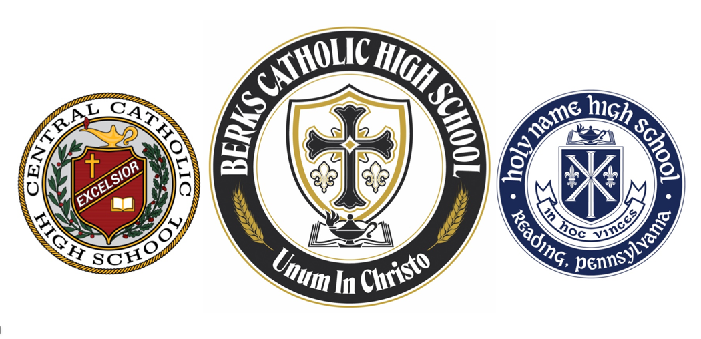
Attention All Berks Catholic, Central Catholic, and Holy Name Grads.
Berks Catholic can help you plan your next reunion!
Contact Sarah Hess, Director of Alumni Relations, at shess@berkscatholic.org.

Checklist:

Form a class reunion committee and solicit volunteers to help.
Request class list from Berks Catholic.
Create a Facebook page for your class to help spread the word and locate lost class members.
Create a class reunion budget. Decide how much each attendee will pay and whether drinks will be included.
Choose a venue that meets your budget and pay deposit. The McGlinn Commons in the John R. Post Learning Center
at Berks Catholic is a good option with no rental fee.
Set up pay site such as PayPal or Venmo and designate a volunteer to collect money.
Share reunion information with Berks Catholic, and we will post on our website.
Send “Save The Date” postcards or e-mails at least 6 months prior.
Print and mail formal invitations or flyers.
Collect any class reunion memorabilia and yearbooks for display.
Research and develop deceased classmate tribute.
Create nametags (Yearbook pictures are a fun addition to nametags).
Decide on decorations/flowers.
Create photo slide show.
Finalize agenda with a set schedule (when food will be served/when bar will be open/will anyone speak?).
Finalize headcount and report to venue or caterer.
Collect contact information from attendees as well as classmates that can’t attend.
Designate someone to take photographs and please share with Berks Catholic for newsletter and website.
Finalize class reunion budget/Consider a class gift with any surplus.
Update alumni office on any new contact information for your classmates and return borrowed items.

What Berks Catholic can provide for you:
- Class list
- Plastic BC, CC, or HN cups, magnets, and other giveaways for your attendees
- Memorabilia or yearbooks for display (must be returned)
- Suggestions for venues and caterers for your reunion

