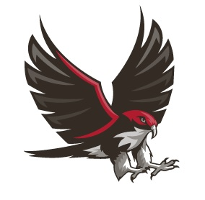
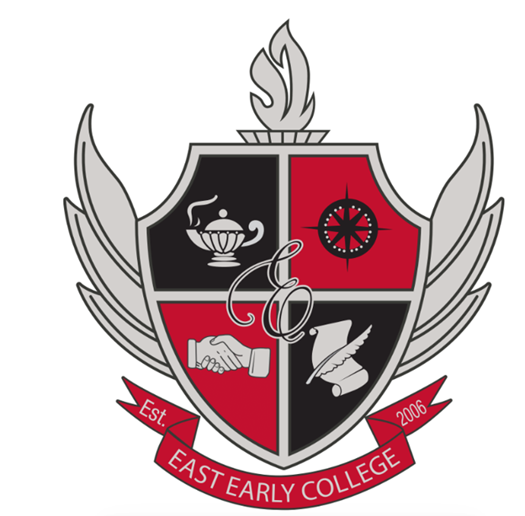

EAST EARLY COLLEGE HIGH SCHOOL

2026-2027 Café con la Directora.
Familias de East Early, los invitamos a acompañarnos cada mes en Café con la Directora. Compartiremos actualizaciones importantes, celebraciones y estrategias para apoyarlos en el acompañamiento académico de sus hijos.
Todas las reuniones se llevarán a cabo en la biblioteca y contarán con una opción virtual. (Los enlaces virtuales se compartirán durante la semana de la reunión).

Juntas los Viernes a las 9:00am
September 4, 2026
October 2, 2026
November 13, 2026
December 4, 2026

Juntas los Jueves a las 4:00pm
January 14, 2026
February 4, 2026
March 4, 2026
April 8, 2026
May 6, 2026




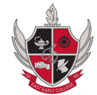

EAST EARLY COLLEGE HIGH SCHOOL

2026-2027 Coffee with the Principal

We invite you to join us each month for Coffee with the Principal. During these meetings, we will share important updates, celebrate our successes, and provide strategies to help you support your child's academic success.
All meetings will be held in the library and will also be available virtually.
(Virtual meeting links will be shared during the week of each meeting.)
9:00am Friday Meetings
September 4, 2026
October 2, 2026
November 13, 2026
December 4, 2026

4:00pm Thursday Meetings
January 14, 2026
February 4, 2026
March 4, 2026
April 8, 2026
May 6, 2026


