Summer Mission Trip

Manila, Philippines
May 29th-June 12th, 2027

(boys only-graduating seniors or non-CVCS basketball players)
-Boys basketball camp
-Food ministry & evangelistic outreach
-Partner with Lord of the Harvest Church
-Approx Cost: $5000 (Application and $100 deposit due Oct 30)

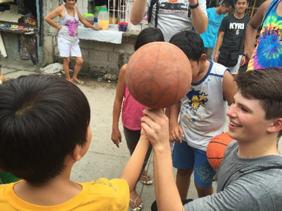

CONTACT: MR. KOCH for more information Bkoch@cvcsonline.org

