Summer Mission Trip

Ensenada, Mexico

May 29th-June 4th, 2027

-Build a house
-Participate in Children’s Ministry
-Approx Cost: $1800(Application & $100 deposit to CVCS due by Oct 30)
-Led by John Thompson
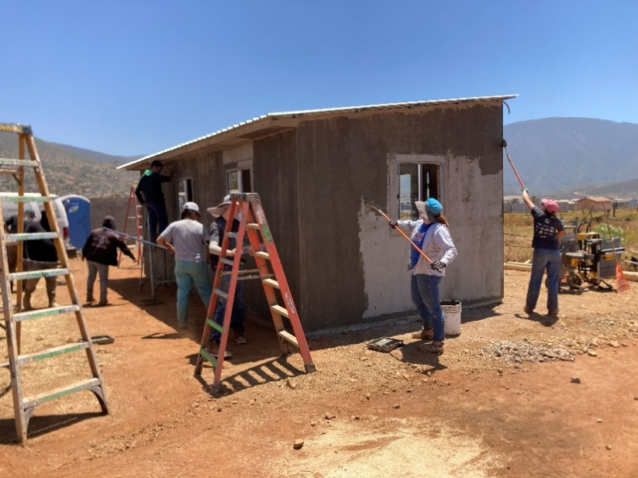

Pick up an application for the Mexico Mission Trip from Mrs. Moehlmann a.s.a.p. Spots are limited.

