Access Destiny
Students come to library without knowing how many books they have borrowed. It’s a normal worry, but students and families can access the book information on their Classlink account. All you need to get started is the students’ login information. Some students may not remember their login information. You can request the information from their teacher; however most students will know it.
Step 1: Open Classlink on your desktop.
Step 2: Click on Library resources. 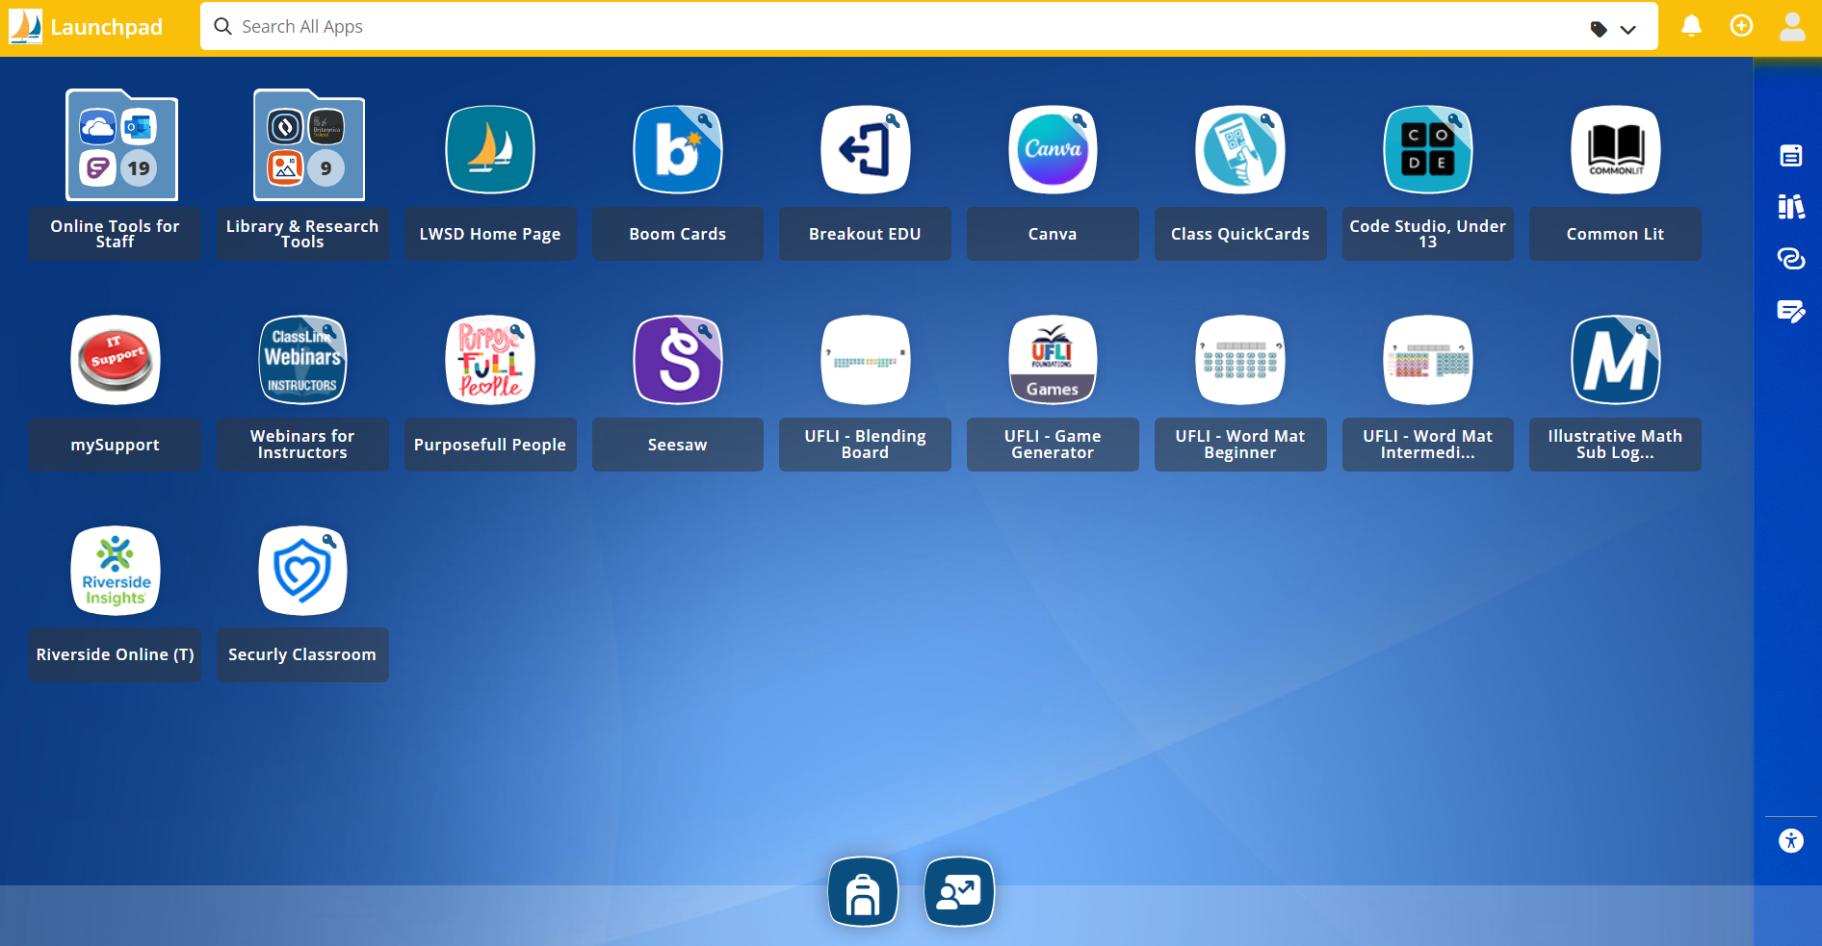Step 3: Open the Destiny App. *Destiny needs to be opened through Classlink not the Destiny Icon on the desktop. 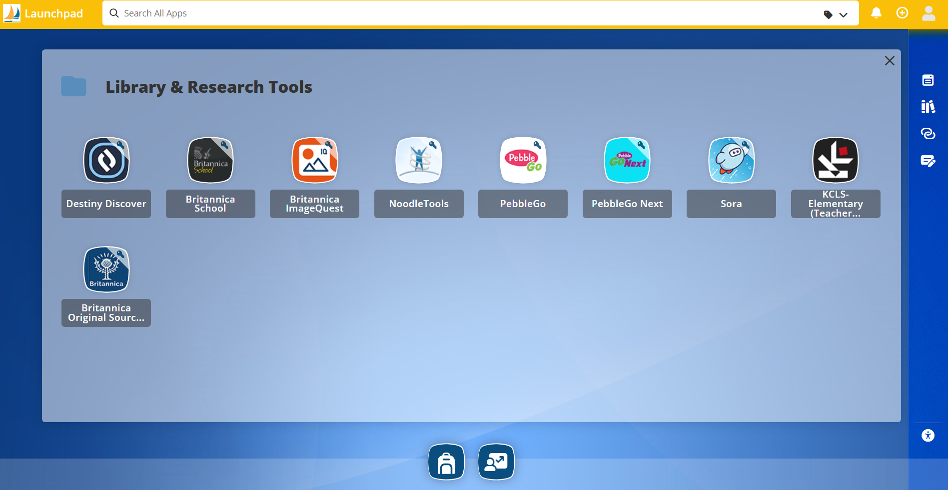
Step 4: Click on My Info tab. Your name should be in the top right corner to show you are logged into your Destiny Account. 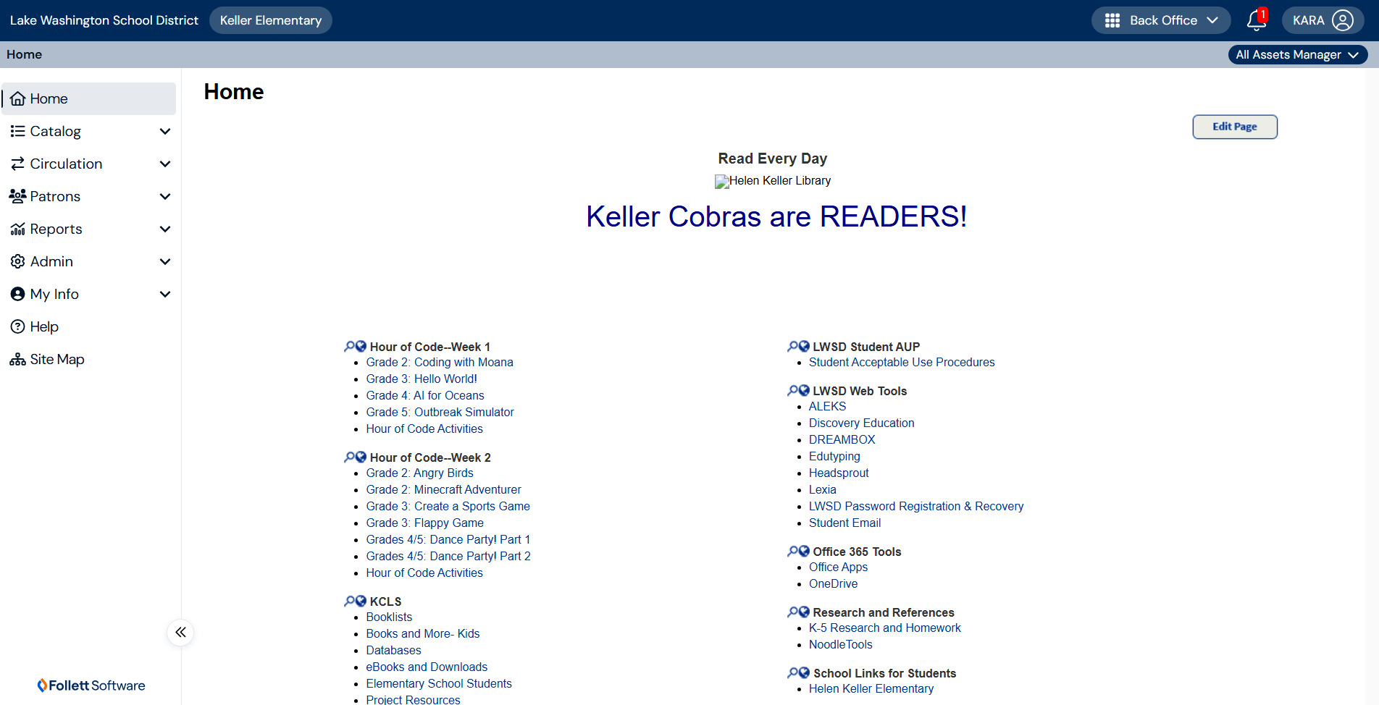

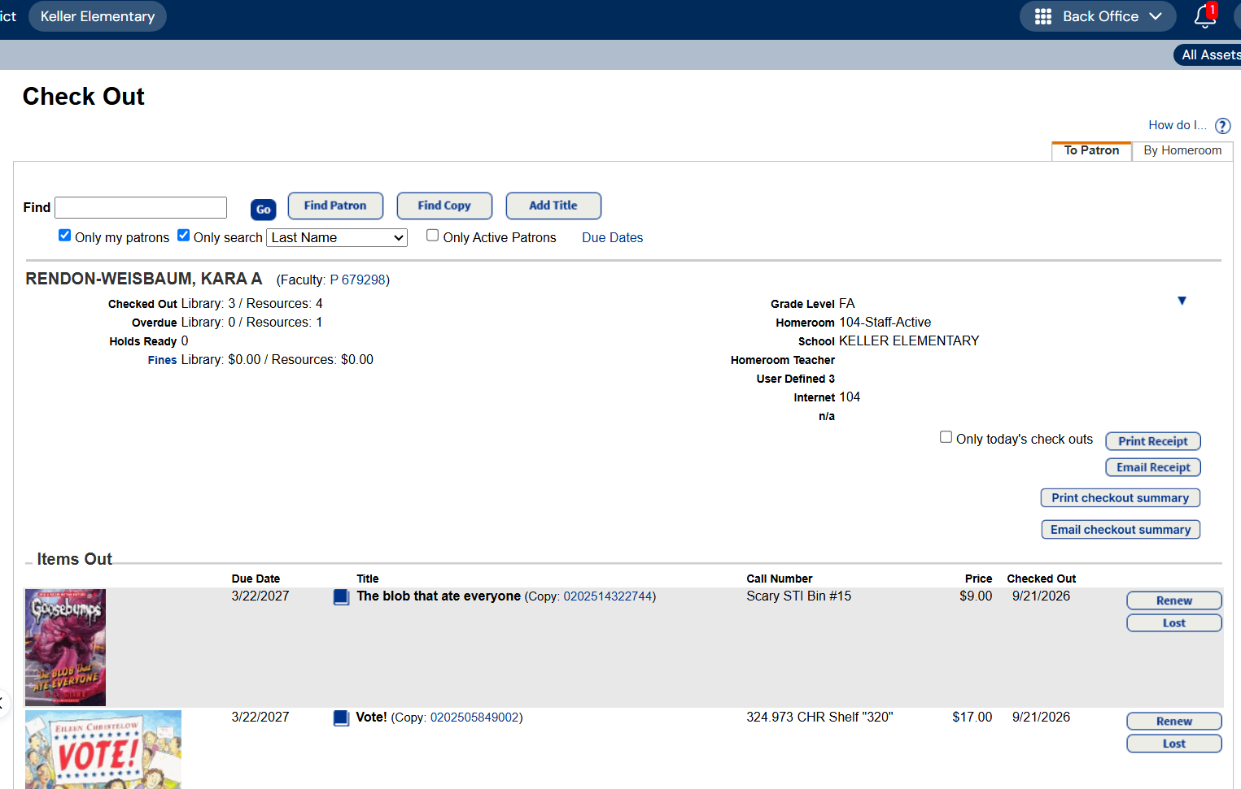
This information is available at home and at school. Please contact me for assistance.

Works Cited Guidelines
LWSD provides elementary students with access to creating Modern Language Association (MLA) format preparing students for middle school and beyond. Students can access the Noodletools app in their student accounts. During the late winter months, students in 4th and 5th grades will learn to create citations for books and databases when they are in the library. This will also be reinforced in their classroom.
Step 1: Continue as above with steps 1 and 2 to access student Classlink.
Step 2: Click on Noodletools. 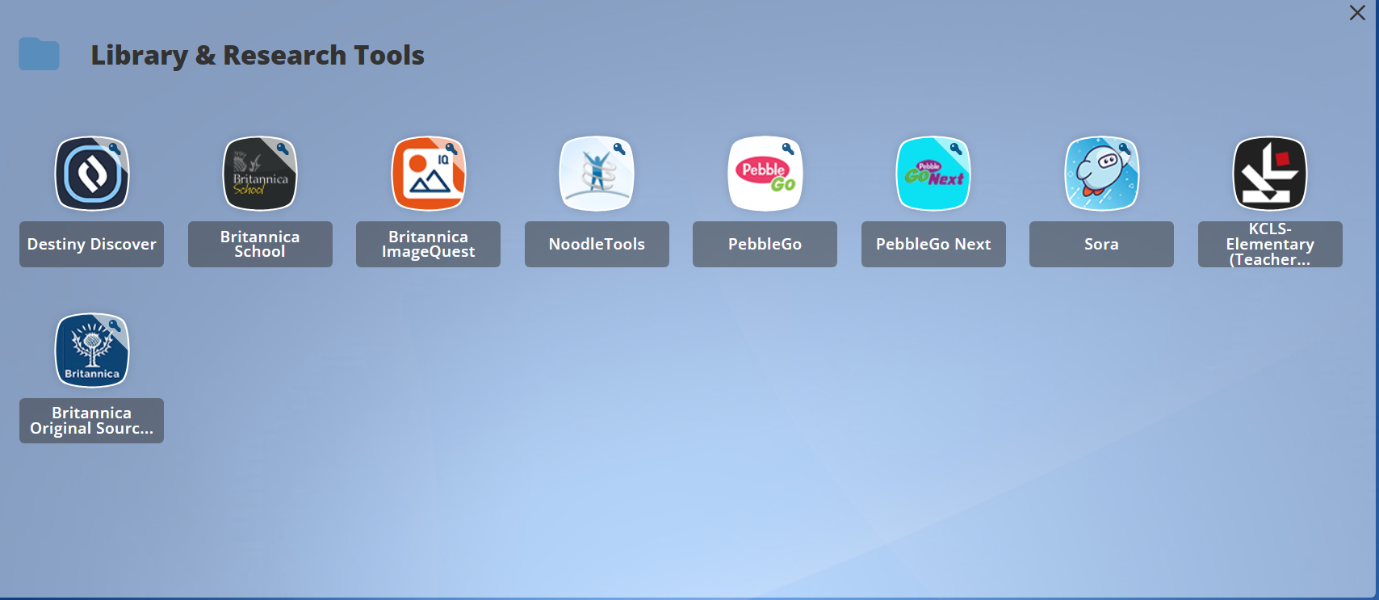
You may need to update student information before you begin. Students will be provided with time to do this during school hours but may miss it due to sickness or absence. Once students have updated their information, they practice in their homes or classrooms.
Helpful Library Links
Keller Library Catalog
Search for books and databases on the Keller library catalog.

