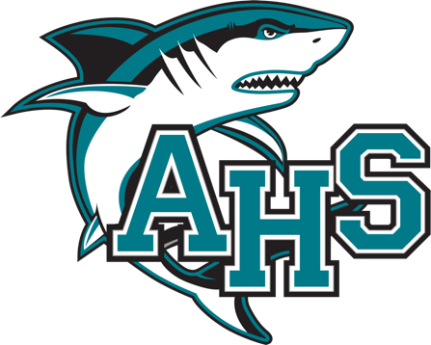

SENIOR SCHOLARSHIP OPPORTUNITIES
****See your School Counselor in the counseling office if you have any questions****
***Students should download the document and then open it up in the desktop Word app for PDFs to be displayed properly ***
Deadline DATE | SCHOLARSHIP | REQUIREMENTS | AMOUNT $
Varies | Big Future Scholarship | https://bigfuture.collegeboard.org/pay-for-college/bigfuture-scholarships | varies
Varies | Student Scholarships | https://studentscholarships.org/ | varies
Varies | Scholarships | https://www.scholarships.com/ | varies
Varies | Fastweb | https://www.fastweb.com/ | varies
Varies | Unigo | www.unigo.com | varies
Varies | Cappex | www.cappex.com | varies
Varies | College Scholarships | www.collegescholarships.com | varies
Varies | Gates Millennium Scholars Program | www.gmsp.org | varies
Varies | Collegiate Funding | www.collegiatefunding.com | varies
Varies | Horatio Alger Scholarships | https://horatioalger.org/scholarships-and-services/undergraduate-scholarships | varies
Varies | Going Merry Scholarships | www.goingmerry.com | varies
Varies | Raise Me | https://www.raise.me/ | varies
Varies | Florida Trend’s NEXT | https://floridanext.com/scholarships-free-money-for-college/ | varies
Varies | National Center of Learning Disabilities | https://ncld.org/scholarships-awards/ | varies
Varies | United Negro College Fund (UNCF) | https://scholarships.uncf.org/s/pre-login-welcome-page | varies
Varies | Bold Scholarships | https://bold.org/scholarships/ | varies
Varies | Career One Stop | https://www.careeronestop.org/toolkit/training/find-scholarships.aspx | varies
Varies | Scholar’s App | https://scholarsapp.com/ | varies
Varies | Cirkled In Scholarships | https://www.cirkledin.com/scholarships/search/ | varies
Varies | Kantner Foundation | https://kantnerfoundation.org/ | varies
10/31/26 | VFW-Voice of Democracy | Complete an audio essay on the theme “What a Veteran taught Me about America.”  https://vfwfl.org/di/vfw/v2/default.asp?pid=6214 | Up to $35,000
11/12/26 | Elks Most Valuable Scholarship | https://www.elks.org/scholars/default.cfm?m=programs  This scholarship is open to any high school senior who is a US Citizen. Applicants will be judged on scholarship, leadership, and financial need. The Elks National Foundation will award the Elks Most Valuable Student Scholarship to 500 of the highest-rated applicants. Please list Port Orange Elks on application. | $1,000 to $7,500 per year
11/13/2026 | Dr. Martin Luther King Jr. Scholarship | Minimum GPA of 3.0  | $2,000
11/13/2026 | Trayvon Martin Scholarship | GPA 2.5-2.9 | $2,000
12/1/2026 | The Hagan Scholarship | Must have 3.5 CGPA  https://haganscholarships.org/ | Up to $60,000
12/1/2026 | WebstaurantStore Diversity Scholarship | Must be American Indian/Alaska Native, Asian, Black/African American, Hispanic/Latino or Native Hawaiian/Other Pacific Islander.  Must be majoring in Culinary/Hospitality Management.  GPA of 2.5 or higher or 2 years of work experience in the restaurant/hospitality industry.  https://www.webstaurantstore.com/scholarship/diversity-scholarship/ | $5,000
01/14/2027 | The Jackie Robinson Foundation (JRF) | https://jackierobinson.org/apply/ | varies
01/19/2027 | Spectrum News 13 | GPA of 3.5 or higher  www.mynews13.com/projectweather | $1,000
2/5/2027 | Lions Club District 35-0 Youth Exchange Scholarship |  | $1,500
3/1/2027 | The American Legion | Varies scholarships available.  https://www.floridalegion.org/programs-services/scholarships/ | varies
3/31/2027 | Matt Buth Foundation | mattbuthfoundation.org  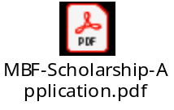 | $2,500
4/16/2027 | Pat Miller Volunteer Scholarship Award | Must had graduated from Sweetwater Elementary.  GPA 3.0  Minimum of 25 volunteer hours at Sweetwater Elementary.  Complete attached document and essay.   | $1,000

