Lynchburg-Clay Elementary

News
We offer fat free 1% flavored milk with a choice of chocolate or white and whole grain bread products

Alternate Meals
Monday: Pizza Lunch Kit
Tuesday: Chicken Nuggets
Wednesday: PB&J Kit
Thursday: Chicken Nuggets
Friday: Corn Dog

PB&J Kit Includes: Uncrustable, Cheese Stick and Crackers
Pizza Lunch Kit Includes: Cheese, Pizza Sauce, Pizza Crusts

EVERY CHILD EATS FREE BREAKFAST AND LUNCH!!
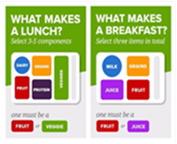
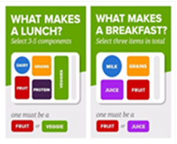
Cinni Mini

Bosco Sticks
Green Beans
Assorted Fruit
Pop Tart

Pizza Rippers
Cooked Carrots
Assorted Fruit
Apple Cider Donut

The Max Sticks
Corn
Assorted Fruit
Chocolate Muffin

Soft Taco
Texas Ranchero Beans
Veggie Bar
Assorted Fruit
Cinnamon Roll

Chicken Strips
French Fries
Assorted Fruit
Pumpkin Bread

Ravioli
Breadstick
Veggie Bag
Assorted Fruit

Cereal Kit

French Bread Pizza
Salad Bar
Assorted Fruit

Pumpkin Donut Holes

Chicken Sandwich
French Fries
Assorted Fruit
Apple Cinnamon Muffin

Doritos Walking Taco
Veggie Bar
Assorted Fruit
Churros

Cinnamon Roll

Bat Chicken Nuggets
Mashed Potatoes & Gravy
Dinner Roll
Assorted Fruit
Fruit Frudel

Corndog
Baked Beans
Assorted Fruit
Soft Pretzel
Cinnamon Toast Crunch Filled Bar
Little Caesar’s Pizza
Corn
Assorted Fruit
Candy Cookie
Super Donut

Tomato Soup
Grilled Cheese
Veggie Bag
Assorted Fruit
Chocolate Muffin

Taco Bites
Taco Fiesta Beans
Assorted Fruit

Cinnamon Roll

Popcorn Chicken
Mac & Cheese
Celery & Peanut Butter
Assorted Fruit

Mini Waffles

Alfredo Pasta
Breadstick
Veggie Bag
Assorted Fruit

Cereal Bar

Tony’s Pizza
Salad Bar
Assorted Fruit
Pull Apart Donut

Meatball Sub
Tater Tots
Assorted Fruit
Chocolate Muffin

Walking Taco
Texas Ranchero Beans
Veggie Bar
Assorted Fruit

Cinnamon Roll

Cheeseburger
Onion Rings
Assorted Fruit
Halloween Donut

Big Daddy’s Pizza
Corn
Cookie
Assorted Fruit

NO SCHOOL
USDA is an equal opportunity provider, employer, and lender. *Menu is subject to change due to availability

EVERY STUDENT EATS FREE FOR THE 2026-2027 SCHOOL YEAR!!
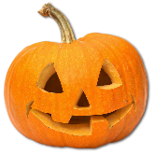
National School Lunch Week

