STUDENT ASSIGNMENT PROJECT
Engagement Session #2 Online Survey Results
September 21–October 6, 2026
2,042  respondents | 73.8%  parents/guardians | 54.7%  prioritize intact neighborhoods | 31.5%  favor a case-by-case balance

Executive read
Session #2 shows a community that is still strongly engaged, but whose response pool is somewhat broader than Session #1. The clearest signal is that respondents want neighborhood and community considerations to carry significant weight, while a substantial group supports balancing those interests with district-wide capacity and equity.
- Neighborhood and community integrity remains the dominant preference: 1,117 respondents (54.7%) said the District should prioritize keeping neighborhoods and communities intact, even if that limits district-wide efficiency.
- A sizeable 644 respondents (31.5%) prefer a case-by-case approach that weighs neighborhood interests and district-wide needs equally.
- Only 157 respondents (7.7%) chose district-wide capacity and equity as the priority when the two are in tension.
- Parents/guardians remain the largest audience at 73.8%, but community partners (10.4%) and school staff (10.1%) are more represented than in Session #1.
- School-support selections remain concentrated in Chamblee and Lakeside, with Chamblee accounting for 32.9% of the six-cluster selections and Lakeside 28.7%.

Who participated?
Parents and guardians continue to drive the response pool, but Session #2 includes a noticeably larger share of community partners and school staff than Session #1. This matters when interpreting shifts in the feedback.
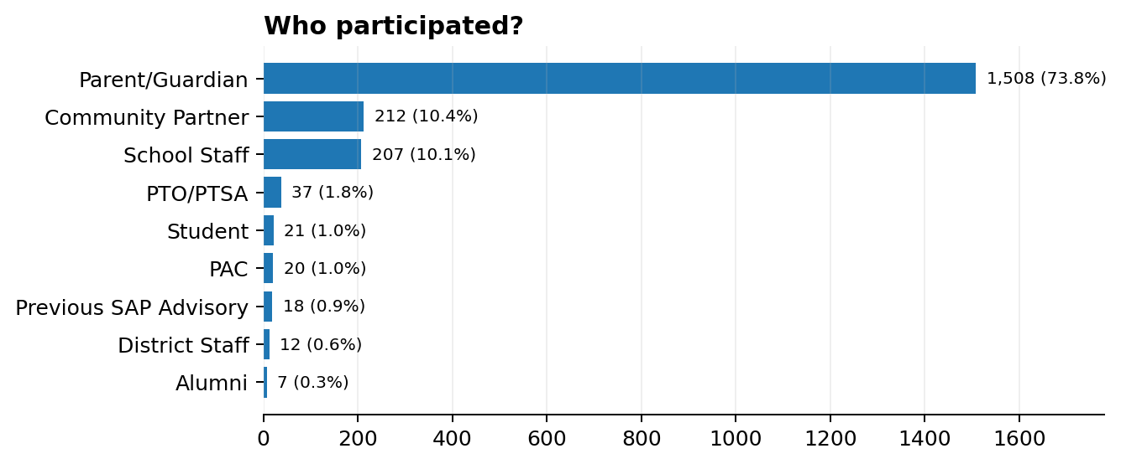

Where respondents are connected
The school-support question allowed respondents to select more than one school. The six focus clusters account for 2,922 school-support selections, so these figures represent selections, not unique respondents.
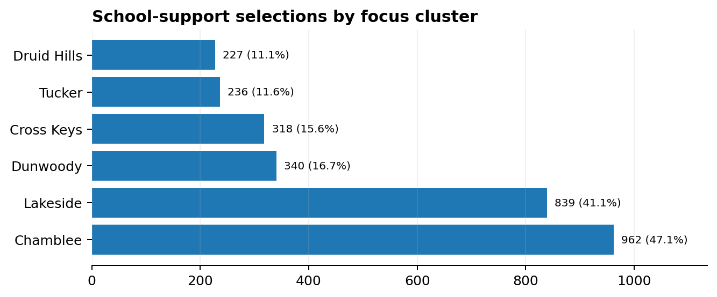

What respondents say matters most
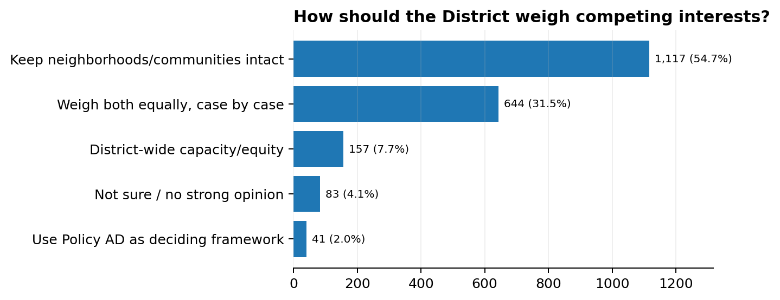
The central tension is clear: most respondents want the District to protect neighborhood and community connections, but nearly one-third want those interests weighed equally with district-wide needs on a case-by-case basis. The results do not support a simple “local versus district” split.

Themes reflected in Session #2
- Neighborhoods and community: The strongest theme, reflected directly in the leading response option.
- Balance and case-by-case judgment: Nearly one-third of respondents want the District to weigh local and district-wide interests together rather than apply one rule to every situation.
- Capacity and equity: A smaller group explicitly prioritizes district-wide capacity and equity, showing that some respondents place system-level considerations first.
- Policy and consistency: A small but clear group wants Board Policy AD itself to serve as the deciding framework.

Top schools selected for support
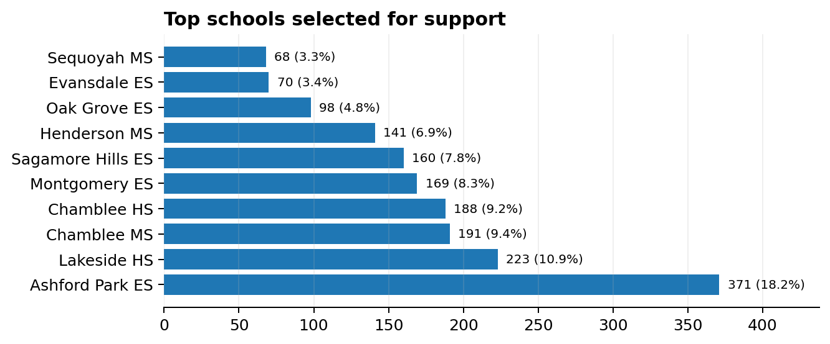

Notable and surprising patterns
- The respondent pool broadened. Parents/guardians fell from 81.2% in Session #1 to 73.8% in Session #2, while community partners rose from 5.4% to 10.4% and school staff from 7.4% to 10.1%.
- The neighborhood preference remains strong, but it is not absolute. More than three in 10 respondents prefer a case-by-case balance, which gives the District room to present tradeoffs rather than frame the discussion as neighborhood protection versus district needs.
- Chamblee and Lakeside continue to dominate school-support selections. Together they represent 61.6% of the six-focus-cluster selections.
- Ashford Park remains the single most-selected school, with 371 selections. Chamblee Middle and Chamblee High also remain among the most frequently selected schools.
- Sequoyah MS drew 68 selections. Because it is part of the Cross Keys school-support list in this export, it materially increases the Cross Keys cluster's selection count compared with Session #1. This should be considered when comparing cluster totals across sessions.

Implications for Engagement Session #3
- Show the tradeoffs. Participants are giving the District permission to weigh competing considerations, but they want to understand why a particular option is the better choice.
- Make the decision framework visible. For each proposed zone change, show neighborhood continuity, capacity impact, feeder implications, transportation and student impact together.
- Avoid treating every neighborhood preference as an absolute. The 31.5% case-by-case response suggests an opportunity to explain where district-wide needs may reasonably outweigh local preferences.
- Continue broad outreach. The larger community-partner and staff presence in Session #2 suggests value in maintaining multiple engagement pathways, not only parent-focused communication.
- Be precise about what the survey can and cannot tell us. This export does not include individual written comments, so qualitative conclusions should remain limited to the closed-ended responses and school-selection patterns.

