MEDIA RELEASE
Click here, delete this text, and insert organization/agency logo

[Organization/Agency Name]
[Contact First and Last Name]
[Contact Phone Number]
[Contact Email Address]

[Release Date]

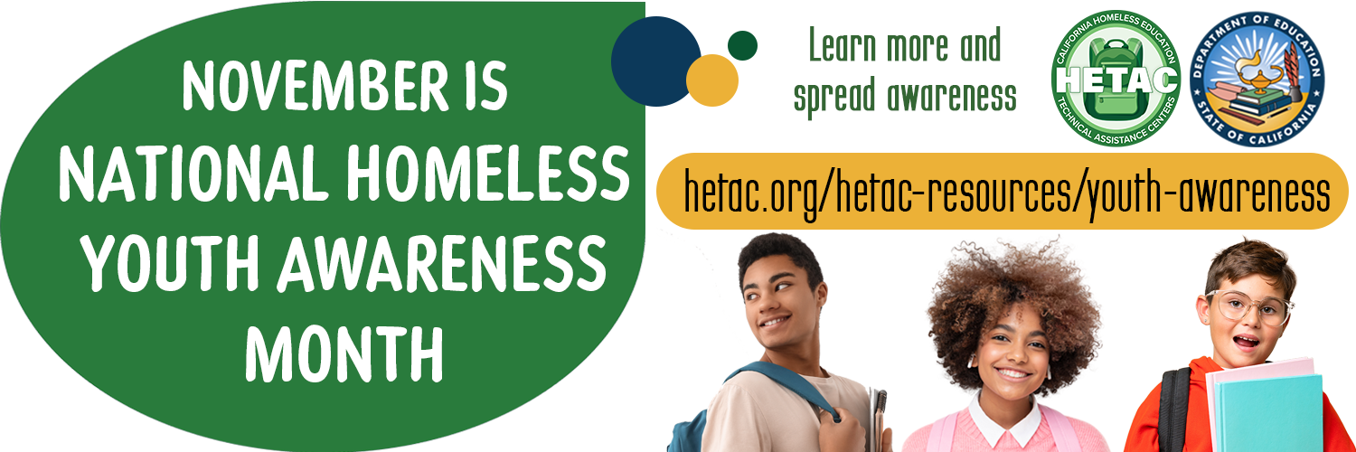

NOVEMBER IS NATIONAL HOMELESS YOUTH AWARENESS MONTH (NHYAM)

[Organization/Agency Name] Observes NHYAM in Recognition of the [state or local data] Youth who Experience Homelessness in [Name of State or Community]

[City, State] — Each year since 2007, Congress has passed a resolution recognizing November as National Homeless Youth Awareness Month (NHYAM) to build awareness of the issue of youth homelessness, including its causes and potential solutions, and highlight the need to work to prevent homelessness among children and teens. [Organization/Agency Name] joins with Congress and other national, state, and local partners in elevating the issue of youth homelessness and applauding existing collective efforts to address the issue while also calling for a stronger and more coordinated focus on preventing and ending homelessness among young people in [name of state or community].

[“Compelling quote from organizational, community, or national leader on the effects of homelessness on young people, the importance of a safe and stable home for youth development and thriving in adulthood, the importance of addressing the issue of youth homelessness, and/or a call to action for responding to the issue of youth homelessness”]

Research shows that youth of color, youth identifying as LGBTQ+, and youth with low levels of education are among those at greatest risk for experiencing homelessness. Public systems—including schools, higher education, workforce development, housing and homeless response, child welfare, juvenile justice, and others—and private stakeholders—including philanthropy, non-profit organizations, and individual citizens—can commit to helping grow and share awareness of the issue of homelessness and contributing their resources to efforts to prevent and end homelessness for all young people in [name of state or community].

[Organization/agency may wish to add more information related to their particular involvement with the issue of youth homelessness, including key talking and data points and/or a quote targeted to their specific focus or area of work.]

Learn more about NHYAM and access resources such as awareness videos, social media graphics and messages, and sample activities from the California Homeless Education Technical Assistance Center’s NHYAM Toolkit. Be a part of ensuring youth have a place to call home as they seek the education and personal development they desire as a foundation for their future.

###

This sample media release is provided by the California Homeless Education Technical Assistance Center (HETAC) as part of its National Homeless Youth Awareness Month (NHYAM) Toolkit.

