Sample National Homeless Youth Awareness Month Board Resolution
This resource
- is part of the California Homeless Education Technical Assistance Center’s suite of resources in recognition of November as National Homeless Youth Awareness Month (NHYAM), and
- provides a sample board resolution policy that can be used as a starting place for school boards or other organizations to develop their own board policy in recognition of November as NHYAM.

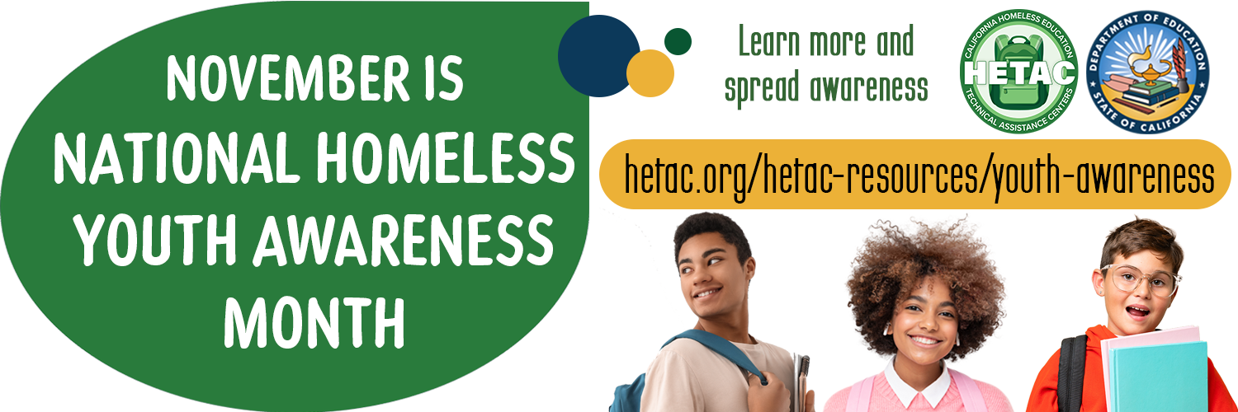

Context
In 2007, Congress passed its first resolution recognizing November as NHYAM to build awareness of the issue of youth homelessness, including its causes and potential solutions, and work to prevent homelessness among children and teens. Since then, November has been a time to bring greater awareness to the issue of youth homelessness; applaud the efforts of businesses, organizations, and volunteers dedicated to meeting the needs of children and youth experiencing homelessness; and grow the commitment to intensify efforts to prevent and end homelessness among young people in the United States.
The California Homeless Education Technical Assistance Center (HETAC) and the California Department of Education (CDE) join with others in recognizing November as NHYAM. The HETAC and CDE, in particular, wish to acknowledge the important role education can play in preventing and ending homelessness among young people, and provide the sample board resolution below as a starting place for school boards or other organizations that wish to pass a board resolution. This resolution can serve as a formal record of a board of directors’ recognition of November as NHYAM and any related steps the board has agreed to take or asks that others take in response.
Text highlighted in yellow and enclosed by << >> indicates areas school boards or other organizations should customize when developing their own board resolution. School boards or other organizations can copy and paste the sample board resolution into another document and edit it, as desired.

<<Name of Local Educational Agency [LEA] or Organization>> Board Resolution
WHEREAS it is estimated that 1 in 30 youth ages 13 to 24 and 1 in 10 young adults ages 18 to 25 in the United States experience some form of homelessness over the course of a year; and
WHEREAS U.S. public schools enroll more 1.5 million children and youth experiencing homelessness each school year; and
WHEREAS an estimated <<number>> of children and youth experienced homelessness in <<name of community/county/state>> in << timeframe>>; and
WHEREAS a disproportionate number of youth experiencing homelessness are members of historically underserved populations, including youth of color and LGBTQIA+ youth; and
WHEREAS youth experiencing homelessness on their own are more likely to be victims of physical and sexual abuse, labor or sex trafficking, and other forms of exploitation; and
WHEREAS students experiencing homelessness continue to face challenges due to high levels of school mobility, residential mobility, educational disruption, unmet basic needs, and homelessness-related trauma and stress; and
WHEREAS youth without a high school credential are 346% more likely to experience homelessness than their peers who complete high school; and
WHEREAS <<name of LEA, LEA program, or organization>> provides assistance to children, youth, and families experiencing homelessness – including <<summary of services provided>> - focused on <<focus and goals of services provided>>; and
WHEREAS <<name of LEA, LEA program, or organization>> aims to bring greater awareness of the challenges and needs experienced by children, youth, and families experiencing homelessness and the resources available to address those challenges and needs; and
WHEREAS in 2007 Congress passed its first resolution (original House resolution | original Senate resolution) recognizing November as National Homeless Youth Awareness Month to build awareness of the issue of youth homelessness, including its causes and potential solutions, and highlight the need to work to prevent homelessness among children and teens; and
WHEREAS schools and organizations across the country have continued to recognize November as National Homeless Youth Awareness Month each year to bring greater awareness to the issue of youth homelessness; applaud the efforts of businesses, organizations, and volunteers dedicated to meeting the needs of children, youth, and families experiencing homelessness; and grow the commitment to intensify efforts to prevent and end homelessness among young people in the United States; and
WHEREAS <<name of LEA or organization>> will demonstrate its commitment to improving the <<area of focus e.g. educational, housing, well-being, etc.>> outcomes of children and youth experiencing homelessness by bringing attention to and supporting National Homeless Youth Awareness Month events and initiatives throughout <<name of community/county/state>> during the month of November in <<year>> ;
NOW, THEREFORE, BE IT RESOLVED that <<name of LEA or organization>> hereby recognizes November as National Homeless Youth Awareness Month and hereby requests that <<party/ies e.g. elected officials in name of community/county/state>> and citizens of <<name of community/county/state>> recognize the unique challenges and needs of children, youth, and families experiencing homelessness and commit to increasing both awareness of the issues impacting these children, youth, and families and their commitment to helping these children, youth, and families succeed.
ADOPTED this <<date>> day of <<month>> <<year>> by the <<name of LEA or organization>> in <<city, state>>.

<<NAME OF LEA OR ORGANIZATION>>

________<<signature of authorized LEA or organizational representative>>________
<<name and title of signatory>>
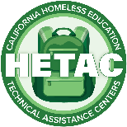

A California Homeless Education Technical Assistance Center (HETAC) NHYAM Resource
Funded by the California Department of Education
Hetac.org

