Student Voice Protocol: Grading and Homework WORKING DRAFT
Fall 2026

Formats
- Admin / GPAC team interviews: using protocol interview students 1:1
- Focus groups: District leaders working with equity teams to conduct focus group conversations using a modified protocol, may include community committee members
- Committee Teacher class conversations – using a modified protocol will conduct focus group conversations with their classes
- Student to student: committee member students may also use the protocol to conduct 1:1 interviews

Framework for Interviews
Questions | Goals & Conditions
How are we doing to make sure that your grade reflects how well you learned the essential learnings of the class, and are not overly impacted by the process of learning such as early stumbles? | - Clarity: Students know in advance the quality and quantity of work expected in the class to achieve their desired grade  - Opportunity & Support: Students get the support and guidance they need to a have the opportunity to earn their desired grade  - Fairness: Students understand how their grade reflects their learning  Conditions:  We want to create conditions where the focus is on learning, not accrual of points, and both effort and outcome are rewarded
How are we doing in making sure students have the chance to try new learning, and get feedback so that they can learn from their mistakes before major graded tasks and tests? | - Resilience: Students have room to try, make mistakes, and learn  - In the Zone: Students are challenged but not overwhelmed (sometimes called the zone of proximal development)  - Ownership: Learning is a partnership that goes back and forth as teacher provide guidance, students try out the learning, and teachers provide feedback …; both take responsibility for outcomes and growth  Conditions:  - For this to work, student must keep up with the work so the teacher has the opportunity to provide feedback, and teachers need to provide timely feedback
How are we doing in making sure student workload is appropriate for their goals and allows time for healthy life choices such as clubs, sports, community activities? | - Student Choice: Students intentionally select courses knowing how much work will be involved  - Reasonable: A reasonable schedule results in reasonable workload  - Opportunity for Rigor: Rigor focuses on quality over quantity, students make informed choice on courses and programs based on their goals  Conditions:  - Work habits in class and out of class make work load variable across students  - Students who select multiple courses with advanced frameworks (AP/IB/CHS) may end up with more workload
How are we doing in making sure students see the learning as personally meaningful, enjoyable, and/or supportive of their life and learning goals? | - Joy: Students find the content and/or process of learning in their classes to be positive.  - Relevant: Students find the learning to be personally relevant to their current life and/or goals.  - Representative: Students seek themselves in the learning through how they express themselves and/or in the content of the learning.

Protocol

General Directions
Our goal is to get broad student voice, capture their experiences in our classes; aiming for 40+ students from each school, with range of backgrounds (race, grade level, types of courses, levels of achievement…). There are 4 topics. The protocol suggests students decide which topic(s) they want to discuss.
Time: How long each interview goes is up to the interviewer and student. Giving 5-10 minutes should allow the student to speak to at least one topic. It is okay to go longer if you feel you have and the student has things to say.
Individual vs groups: Use your judgement. Groups are okay, making sure all give consent to record. Be conscious that the audio file won’t pick up non-verbal cues and agreement. In groups, skip asking about IEP/504 or support classes.

Outline
Introduction
- Introduce self
- Allow student(s) to introduce themselves (name, grade)
- Introduce the process (slide or handout)
Background (not recorded)
Permission to record / establish ground-rules
Recorded interview / listening session
Stop recording
Thank-you and next steps reminder

Recording Interviews and saving files
Recommendation: Use Sound Recorder app on your laptop to record the interview. After recording if you right-click on the file, you can choose to see file location to access the audio file
Use this Interview Register to submit the file.
Click here to see demo.

Facilitator Script
Introduction
Hello, [introduce your self and your role if the student doesn’t know you]
Ask a welcoming question or two such as, "How is your day going?"
Thank you for being willing to talk today. Let me tell you what this is all about. We have a group of teachers, students and parents who are meeting to talk about how grading and homework is going in high schools and to make recommendations for making grading and homework a better experience for students. So we want to hear from students how it is going now. What about grading and homework is working well and what about grading and homework is not working well for students.
Any questions about the goal?

Background
First, we want to make sure we talk to all types of students so we get a lot of different perspectives. Everything you share today is private and we will not put your name down. So if you don't mind, can you share...
- What grade are you in?
- How would you describe your race?
- Are you taking any advanced classes? How many?
- Are you taking any support classes or receiving support services such as lab classes, guided studies...
- Do you have a 504 plan or IEP?

Ground Rules
We want to collect stories but protect both you and others, so if you allow me to record this interview can we set a few simple ground rules:
- We want you to feel free to share your experience and your experience.
- We want to know both the good and the not-so-good experiences you have had.
- We want to stay anonymous, so I won’t use your name and I ask that you not use anybody elses name. So if you have a specific teacher in mind you can say something like, “I had this one teacher...” or “I had a math teacher that...” but don’t say their name.
Is that all okay?
Permission to record
I need your permission to record this, and then at the end, I am going to ask your permission to keep and submit the recording. If either time you say no, there will be no recording. Do you mind if I record this interview?
Start Recording
Now I have to ask again while I am recording, are you okay with me recording this?
Great, thanks.
I basically have 4 questions we can discuss, and you get to pick which topic and/or which order. Here are the main topics (show page 1). Which one would you like to start with?
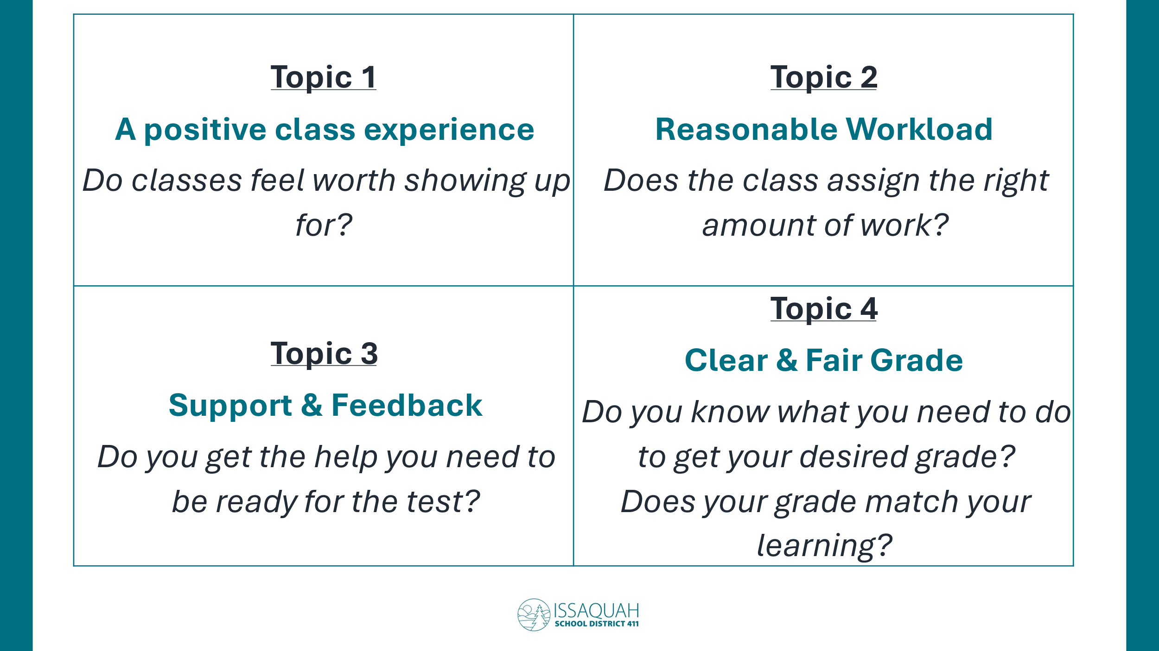

Topic 1 Questions
For this topic, our hope is that students find their classes worth showing up for! We want students to find classes enjoyable, meaning they are interesting or fun or feel important. We want students to see how their class is connected to real life or prepares them for their future. You know, even if the class is hard or not your favorite topic, we want you to feel a sense of pride, accomplishment and even a little joyfulness in the class.
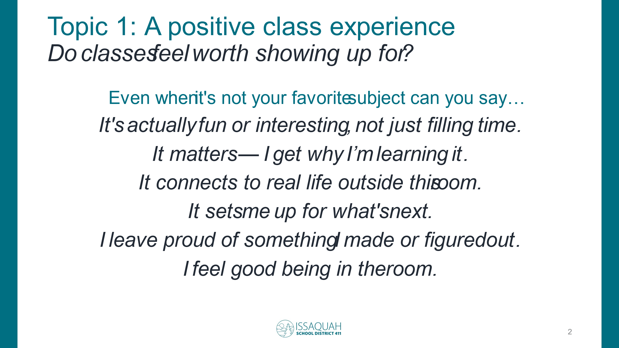
How many of your current classes are either joyful, fun, interesting, or feel important and relevant?
- In those classes what does the teacher do to make the classes that way?
- How many of your classes don’t feel joyful, fun, interesting or important?
- What is happening that makes those classes feel that way?
- What could the teacher in those classes do differently so the class feels better to you?

Topic 2 Questions
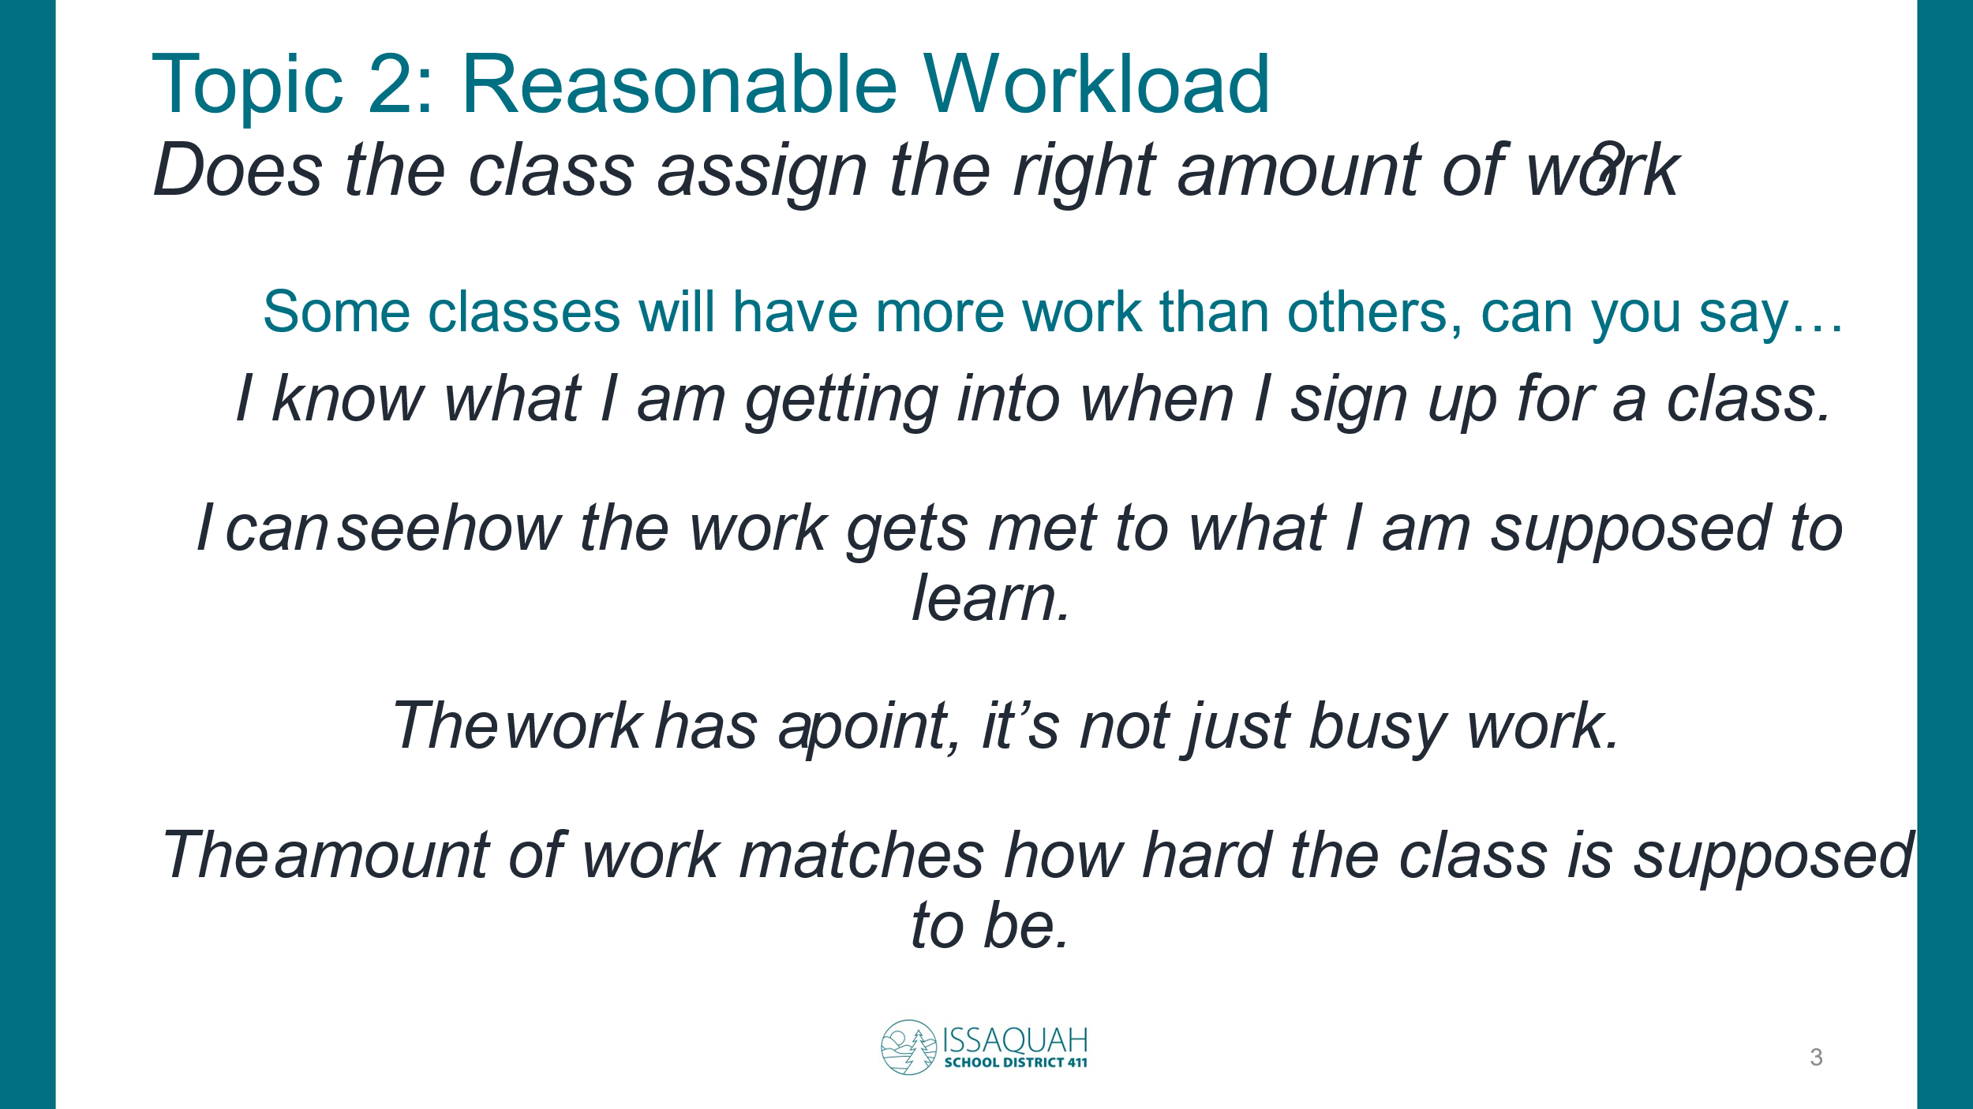
For this topic, we know that every class will ask students to do work in class, and may require work outside of class. Our goal is that you can manage your own workload reasonably and the work is meaningful. In other words, you can pick classes knowing how much work is involved, that when you pick a reasonable schedule, there is a reasonable amount of work expected, and that if you work hard in class there is a reasonable amount of homework based on the type of class – knowing that some advanced classes may require more work. And most important, we want the work to feel purposeful, work that helps you learn the required content, not “busy work”.
- In how many of your current classes do you feel the workload expectations are reasonable for the class?
- What does the teacher do to make sure the work is reasonable and meaningful?
- How many of your classes do you feel the workload is not reasonable or not meaningful?
- What is happening that makes those classes feel that way?
- What could the teacher in those classes do differently?

Topic 3 Questions
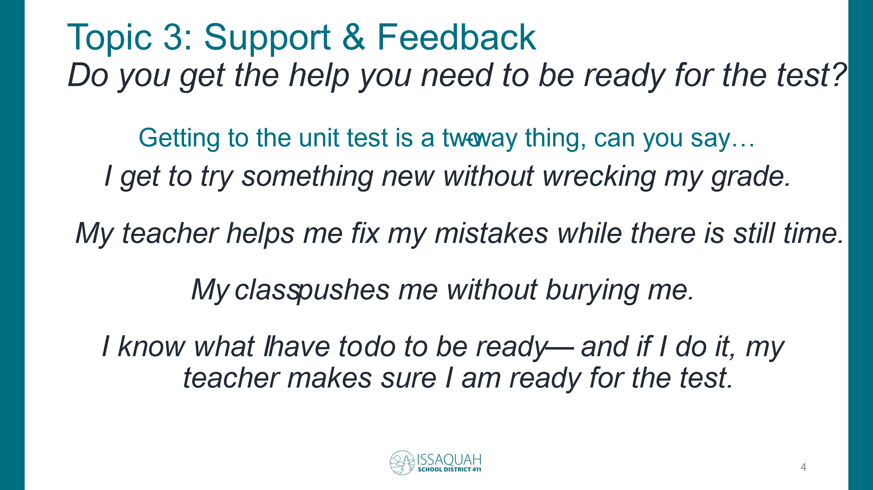
For this topic, we want to ask about how well prepared you are for tests, projects, papers, or big graded tasks. Our goal is that leading up to those big graded moments you have had the opportunity to practice the skills and get feedback so you know what you are doing well and can learn from your mistakes before it counts for a lot of your grade.
- In how many of your current classes do you feel your teacher provides you feedback so you are ready for heavily graded tests and other tasks?
- What does the teacher do to make sure your are prepared?
- How many of your classes do you feel you are often not given the feedback you need to be ready for tests?
- What could the teacher in those classes do differently?

Topic 4 Questions
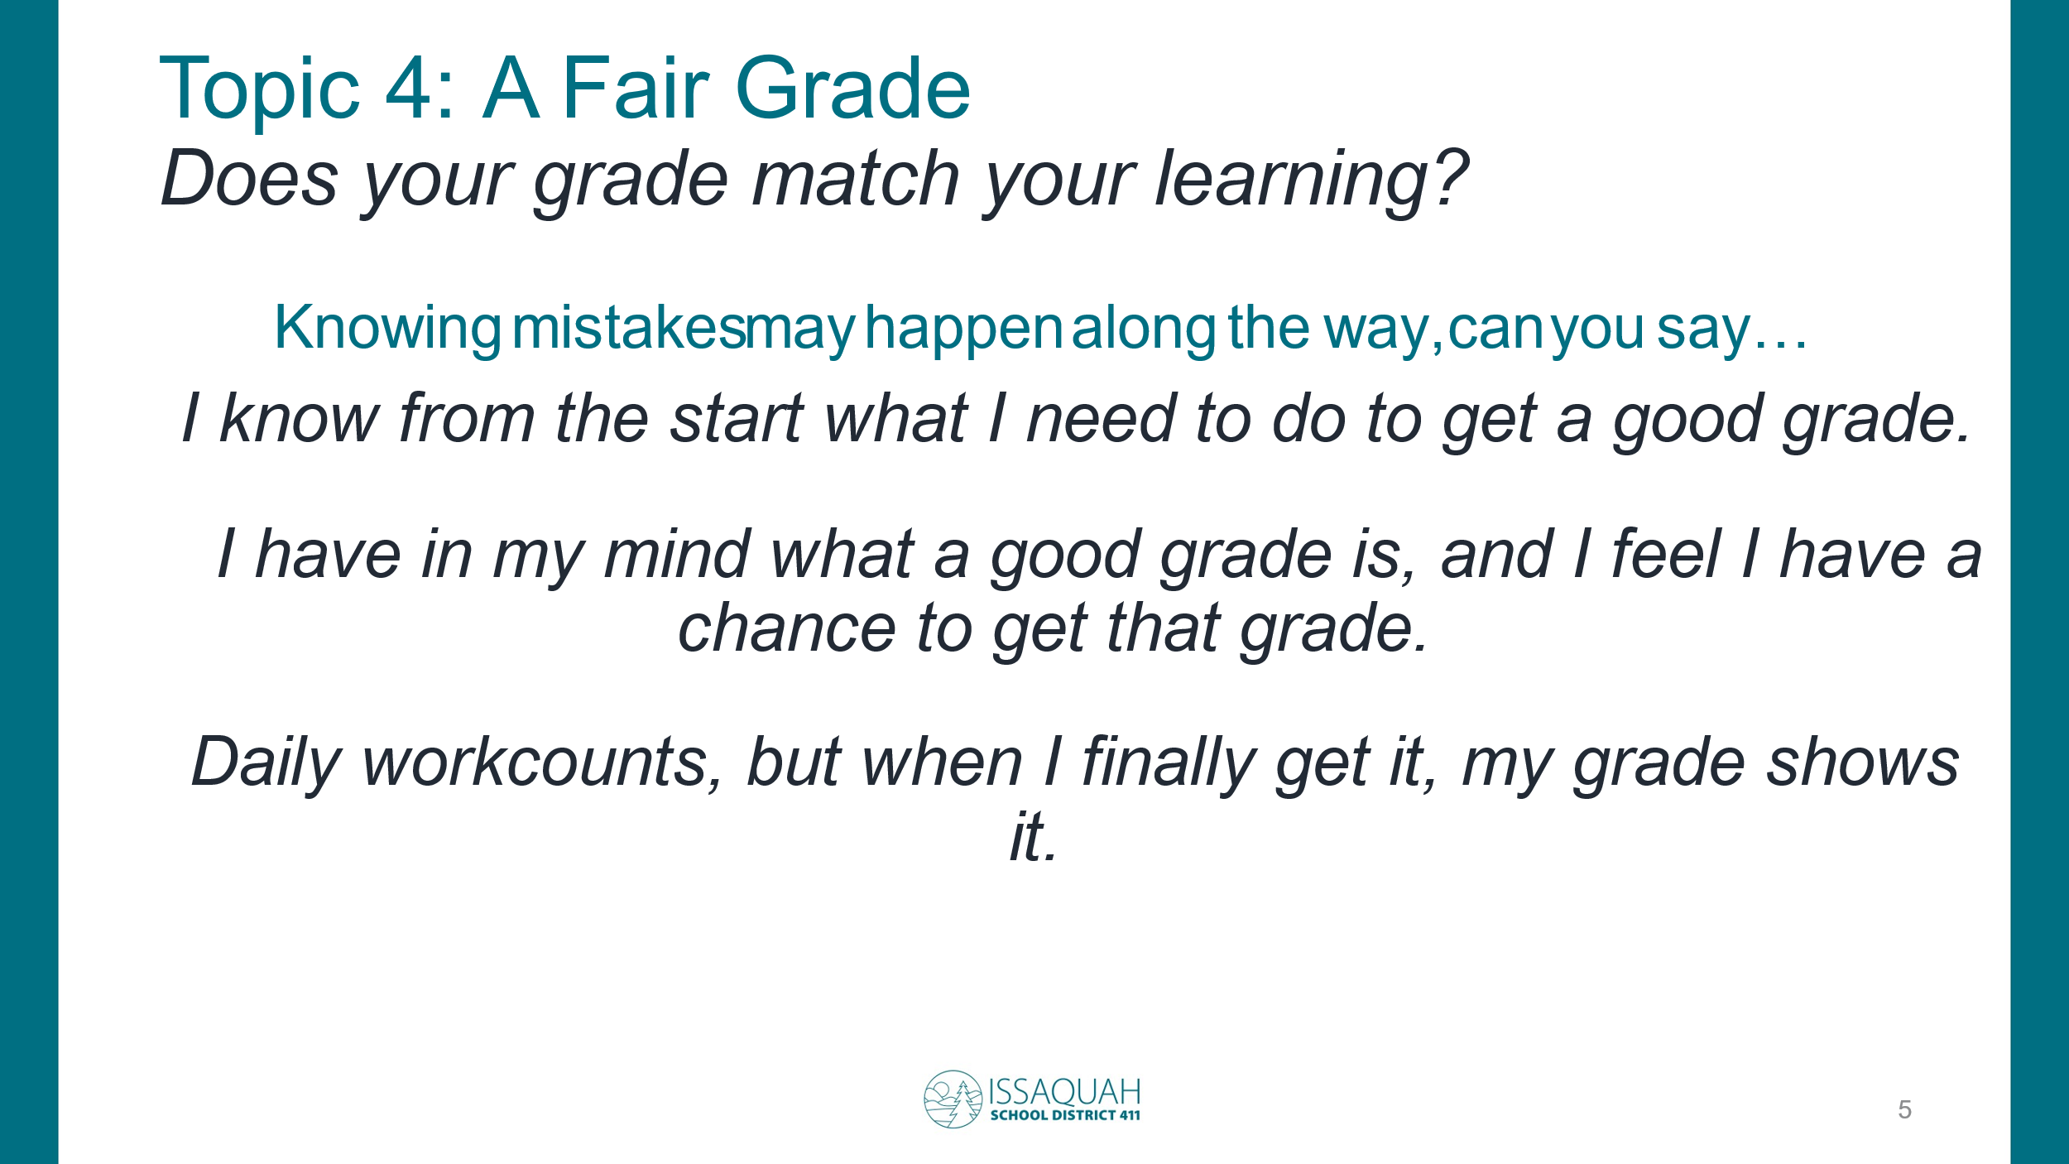
For this topic, we want to ask about how well you feel your grades match how well you learned the most important learning in the class. The goal is that you know what is expected ahead of time, and that you have a fair opportunity to reach the grade you want to get, and that at the end of each unit, you feel your grade fairly matches how well you learned.
- In how many of your current classes do you feel you know what you need to do, have a fair chance to learn, and get a grade that reflects the level of your learning?
- What does the teacher do to make sure you feel you got a fair grade?
- How many of your classes do you feel you are often not given a fair chance at a fair grade?
- What could the teacher in those classes do differently?

Closing Questions
- Okay, we have asked a lot of questions, is there anything else you would like to share about homework or grading that either bothers you, or that works really well, or that the community committee should know to help improve the experience of students?

- And finally, do I have your permission to use this recording to share your input with the committee? If you say no, I will delete it.

- Thank you so much. We plan on sharing out to students and families, how the committee uses these interviews to help improve how students experience homework and grading.

