A Peek at our Week
Mrs. Bird
Monday, October 12 – Friday, October 16, 2026
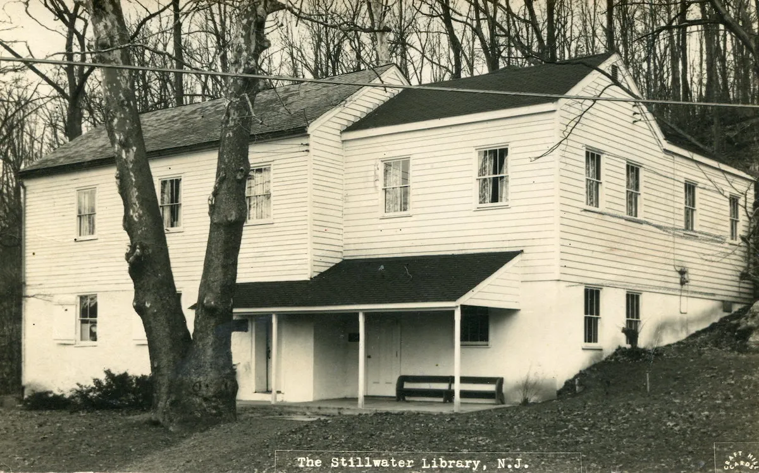
Second graders will visit the Stillwater Historical Society this Thursday for our walking field trip! Please dress accordingly!
WORD WALL WORDS: thicker, softest, again, please, animal
Please practice reading and spelling these words each night!
Homework Schedule
Monday  *Spanish & Gym/Health* | Tuesday  *STEAM& Gym/Health* | Wednesday  *Art* | Thursday  *Gym/Health* | Friday  *Music & Gym/Health*  Library Visit Biweekly
No School  Columbus Day | Math: Additional Practice 3.3  Reading: Log | Math: Additional Practice 3.4  Reading: Log | Math: Additional Practice 3.5  Reading: Log | Have a wonderful weekend!
Taking a Closer Look…
- Math: We will continue Topic 3 on various strategies to add within 100.
- Social Studies: We will be wrapping up our unit on communities. We will have a community quiz on Wednesday, focusing on rural, suburban, and urban communities and their characteristics.
- Reader’s Workshop: We will continue our first unit, Becoming a Big Kid Reader. Students will participate in Book Clubs. Each student in each club will read a different book from the same series. Then groups will meet to discuss the characters, setting, problems, and solutions within the books in their assigned series. We will practice retelling key details.
- Writer’s Workshop: Students will continue the process of writing small moment stories. We will focus on telling details bit by bit and writing strong beginning and endings.
- Fundations: We will begin Unit 4 in our Fundations program. We will learn the following suffixes: -S, -ES, -ED, -ING, -ER, and -EST. One way to support your child at home is to practice reading and spelling various words with these suffixes! Some examples are: jumps, brushes, talked, ringing, taller, smallest.

**Remember to have sneakers for gym class!**

