NEFF ECC SCHOOL-PARENT COMPACT • 2026-2027
AT SCHOOL: As a student, I will:  • Be in dress code and ON TIME BY 7:30, PREPARED, and READY to learn EVERY day.  • Bring the materials I need and take care of my belongings.  • Do my best in my learning, behavior, and classroom routines.  • Read, look at books, or listen to stories every day.  • Follow classroom, school, and bus safety rules and treat others with respect.  • Use classroom technology safely, responsibly, and only for learning.  • Show kindness, include others, and be a caring friend.  • Take care of school materials and clean up my learning space.  • Tell a trusted adult when I feel unsafe, see unkind behavior, or need help.  • Respect and celebrate the cultures, languages, and differences of others.  Student Signature: ______________________________  Parent/Guardian Signature: ______________________  COMMUNICATION ABOUT LEARNING  Neff ECC values consistent, two-way communication with families about each child’s learning and development. Communication may include:  • Classroom folders or take-home materials  • Phone calls, messages, or teacher check-ins  • ParentSquare and school announcements  • Progress updates and student learning information  • Parent-teacher conferences and family meetings | IN THE CLASSROOM: As a teacher, I will:  • Be prepared, on time, and ready to provide purposeful learning every day.  • Maintain high expectations and believe every child can grow and succeed.  • Use student data and observation to respond to individual learning needs.  • Collaborate with colleagues and support staff to provide appropriate services and supports.  • Model professionalism, patience, kindness, and respect.  • Create a safe, welcoming, engaging, and developmentally appropriate learning environment.  • Partner with families in decisions that support their child’s education.  • Offer reasonable opportunities for conferences and family communication.  • Apply classroom and school expectations fairly and consistently.  • Share student progress regularly and maintain open communication with families.  • Provide meaningful practice and learning opportunities that reinforce classroom instruction.  • Honor and celebrate the cultural and linguistic diversity of every child and family.  Teacher Signature: ______________________________  AT HOME: As a parent/guardian, I will:  • Help my child arrive at school on time, appropriately dressed, prepared, and ready to learn.  • Support school expectations for personal electronic devices during the instructional day.  • Monitor my child’s health and communicate important needs to the school.  • Recognize that I am my child’s first teacher and build learning into daily routines.  • Read, talk, sing, count, and explore with my child regularly.  • Stay in communication with my child’s teacher and work together to support progress.  • Model respectful, positive interactions with school staff, families, and community members.  • Review progress information and respond when signatures or feedback are requested.  • Participate in conferences, family events, workshops, and school activities whenever possible. | OUR GOALS FOR STUDENT ACHIEVEMENT  DISTRICT PARTNERSHIP GOALS  • Increase meaningful family engagement across the district.  • Strengthen timely, accessible communication with parents and guardians.  • Build collaborative partnerships between families, schools, and the district.  • Provide family learning opportunities, resources, and support.  • Promote safe, welcoming learning environments for every student.  NEFF ECC SCHOOL GOALS  • Increase family participation in children’s early learning and school experiences.  • Maintain clear, consistent, two-way communication between school and home.  • Strengthen shared responsibility for student growth through family-school partnerships.  • Equip families with strategies and resources to support learning at home.  • Provide a safe, nurturing, inclusive environment where young learners can thrive.  Together, we build strong foundations for lifelong learning.

NEFF ECC SCHOOL-PARENT COMPACT • 2026-2027
WHAT IS A SCHOOL-PARENT COMPACT?  A School-Parent Compact is a shared agreement created by families, students, and school staff. It describes how we will work together to help children meet or exceed learning expectations. The compact connects family partnership, high-quality instruction, student learning skills, and the school’s improvement priorities.  JOINTLY DEVELOPED WITH PARENTS/GUARDIANS  Neff ECC families, staff, and students have opportunities each year to review student learning needs and discuss ways to strengthen the partnership between home and school. Staff share learning strategies, families contribute ideas that make support practical and meaningful, and students are encouraged to take age-appropriate ownership of their learning. Family feedback is welcomed throughout the year.  Families who would like to volunteer, participate in school activities, or provide feedback are encouraged to contact Neff ECC or their child’s teacher.  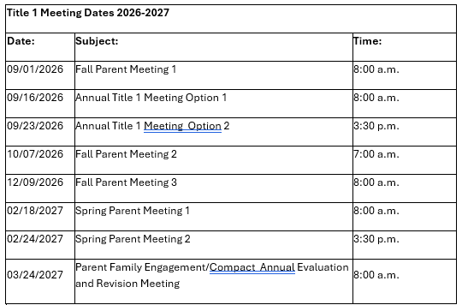 | ACTIVITIES TO BUILD PARTNERSHIPS  • Meet the Teacher and beginning-of-year family events  • Open House and parent-teacher conferences  • Family literacy, math, science, and early-learning events  • Coffee with the Principal and family information sessions  • Parent education workshops and Parent University opportunities  • Student celebrations, performances, and recognition events  • Opportunities to volunteer and participate in campus activities  • Community and district partnership events that support young children and families  STUDENT LEARNING GOALS  At Neff ECC, we help young learners build the habits and foundational skills they need for success. Students, families, and teachers work together to:  • Build a daily habit of reading, listening to stories, and talking about books.  • Celebrate growth from beginning-, middle-, and end-of-year assessments and classroom learning evidence.  • Practice early literacy, language, math, social-emotional, and problem-solving skills at school and at home.  • Use developmentally appropriate digital learning resources when assigned by the teacher.  My child’s learning goal this year:  __________________________________________________  To help achieve this goal, we will:  __________________________________________________  __________________________________________________ | SCHOOL-PARENT COMPACT  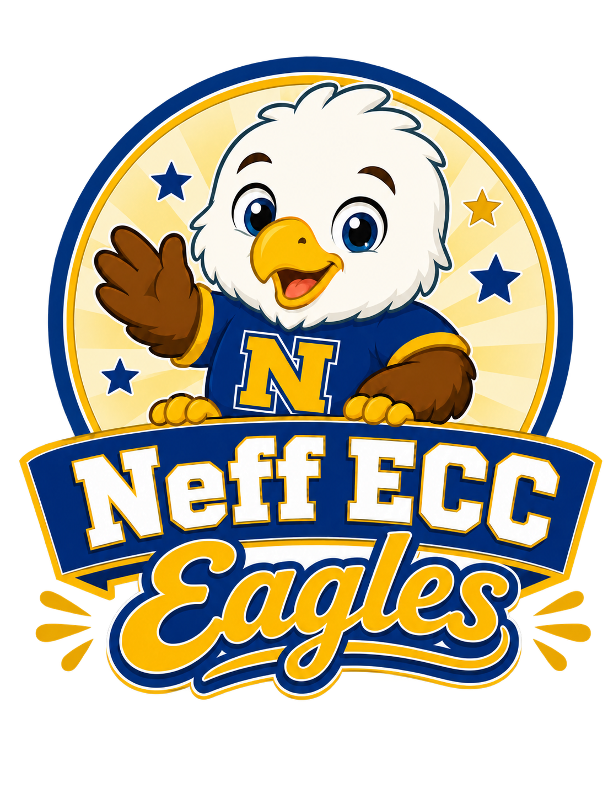  Neff Early Childhood Center  Houston Independent School District  2026-2027 School Year  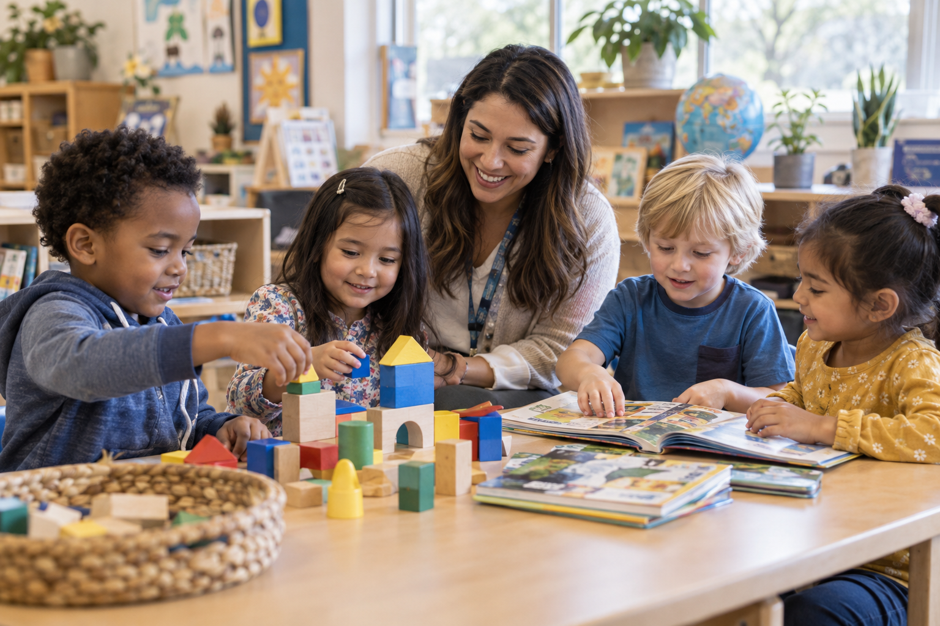  OUR SHARED COMMITMENT  School + Family + Student  Working together for every child  Address: 8200 Carvel Ln, Houston, TX 77036  Telephone: (713) 778-3470  SWebsite: neffecc.houstonisd.org/our-school  Principal: Carlos Rodriguez  Please keep this compact as a reminder of our shared responsibility for student success.
  NEFF ECC
  Growing, Learning, and Thriving Together

