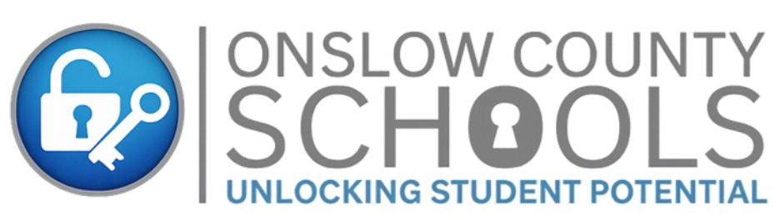

Title I Parent Right to Know Notification

Dear Parent/Guardian,
As a Title I school district, we are committed to keeping families informed about important rights and information available to parents and guardians under Title I, Part A of the Elementary and Secondary Education Act, as amended by the Every Student Succeeds Act. Federal law and North Carolina guidance require schools receiving Title I funds to notify families of their right to request information about teacher qualifications, student assessment participation and their student’s level of achievement and growth, English learner identification protocols, and school performance information.
The information below explains your rights and where you may request or access additional information.

Testing Transparency
Parents and guardians have the right to request information about state and local policies regarding student participation in required assessments. This includes information about assessments required by federal, state, or local law and any applicable procedures or parental rights related to assessment participation.
North Carolina administers required state assessments to measure student progress toward state academic standards and to provide families, schools, and communities with information about student achievement and academic growth. Families may request information about the purpose of required assessments, the content areas assessed, the grade levels tested, the format and timing of assessments, and how assessment results are used.
Schools will also provide each parent or guardian with information about their child’s level of achievement and academic growth, if applicable and available, on each required state academic assessment. This information may include assessment results, achievement levels, growth measures, and other available data that help families understand how their child is progressing toward North Carolina academic standards.

Federal School Report Card
Each year, state and local education agencies receiving Title I funds are required to make school report card information available to the public. The North Carolina School Report Cards provide families with important information about schools and districts, including student performance, academic growth, school characteristics, educator qualifications, school accountability results, and other data required under federal and state reporting requirements.
The School Report Card is intended to help families better understand school performance and progress. While the report card provides important data, it does not reflect every aspect of a school community, such as family engagement, student leadership, extracurricular opportunities, or the many ways staff support students each day.
Families may contact the school or district office for assistance accessing or understanding school report card information.

English Learner Identification, Placement, and Services
Parents and guardians of students who may be identified as English Learners have the right to receive information about the district’s English Learner identification protocols and language instruction services. This includes how students are identified, how placement decisions are made, the English language proficiency levels used, the assessments administered, and the results of those assessments.
In North Carolina, all students are provided with a Home Language Survey upon initial enrollment. When the survey indicates that a language other than English may be present in the student’s background, the student may be assessed using the appropriate state-adopted English language identification assessment, such as the WIDA Screener for Kindergarten, WIDA Screener, or WIDA Alternate Screener. These assessments help determine whether a student qualifies for English Learner services and supports.
Students identified as English Learners participate in annual English language proficiency assessments, such as WIDA ACCESS for Kindergarten, WIDA ACCESS, or WIDA Alternate ACCESS, as applicable. These assessments measure progress in listening, speaking, reading, and writing and help schools determine the student’s current English language proficiency level, progress toward proficiency, instructional needs, and eligibility for continued services or exit from English Learner status.
Parents and guardians will receive information about assessment results and the meaning of their child’s proficiency level. Schools will also share information about the methods of instruction, language development services, and programming used to support the student’s access to grade-level instruction and progress toward meeting North Carolina academic standards.
English Learner services are designed to support students in developing academic English while continuing to participate meaningfully in grade-level content. Supports may include direct English language development instruction, classroom-based language supports, accommodations when appropriate, progress monitoring, collaboration among teachers and support staff, and other services aligned to the student’s identified needs.
Families may also request information about how English Learner identification, placement, language instruction services, and assessment results may relate to grade-level promotion, access to academic programming, and graduation requirements, as applicable to the student’s grade level. Schools will work with families to explain available supports and how the student will be supported in meeting academic standards, promotion criteria, and graduation expectations.

How to Request Information
If you would like to request information about teacher or paraprofessional qualifications, assessment participation policies, your child’s assessment results, school report card information, or English Learner identification, placement, assessments, services, and programming, please contact your child’s school office or the district Title I office.
We value our partnership with families and remain committed to providing clear, timely, and accessible information to support your child’s academic success.

Sincerely,
Dee Owens
Director of Title I & K-8 Literacy
Onslow County Schools
dee.owens@onslow.k12.nc.us 910.455.2211 ext. 71273

Title I 6.0 - updated 6/18/2026

