STUDENTS WILL…
• Be Reliable by coming to school and class prepared, ready to learn, and with all necessary materials and assignments.
• Be On Time & On Task by arriving on time, following directions, staying focused, and making the most of every learning opportunity.
• Accept Responsibility by making positive choices, demonstrating respectful behavior, and taking ownership of their actions and learning.
• Be Relentless by working hard, persevering through challenges, using positive character traits, and always striving to Dream Big and Do It Bigger!

STUDENTS

COMMMUNICATION ABOUT LEARNING

Students, Teachers, Parents/Guardians – Working Together for Success!

IN THE CLASSROOM

AT HOME

OUR GOALS FOR STUDENT ACHIEVEMENT

DISTRICT GOALS

SCHOOL GOALS

SCHOOL STAFF WILL…
• Provide engaging, high-quality instruction aligned with state, district, and campus goals to maximize learning and help every Cub grow.
• Use student data to differentiate instruction, provide targeted interventions, and respond to the individual academic and social-emotional needs of every student.
• Create a safe, supportive, and welcoming learning environment that encourages students to demonstrate ROAR: Reliable, On Time & On Task, Accept Responsibility, and Relentless.
• Build strong partnerships with families through consistent communication using ParentSquare, phone calls, emails, folders, campus platforms, and other school communications.

- Every campus achieves an A or B rating by August 2027

- Improve Instruction in Every Classroom

- Raise Reading Achievement

- Invest in Teachers and Leaders

- Support Students with Special Needs

Blackshear Elementary believes strong school-family partnerships are essential to helping every Cub learn, grow, and succeed. We are committed to maintaining open, meaningful, and two-way communication with families about student learning, academic progress, and areas of growth.
Throughout the school year, families, teachers, and staff will stay connected through a variety of communication methods, including:
- ParentSquare, emails, and phone calls
- Thursday Folders and campus communications
- Progress Reports and Report Cards
- Parent-teacher conferences and individual student check-ins

- Achieve a B rating by August 2027

- Strengthening Family Engagement

- Promote consistent, two-way communication

- Build meaningful family-school partnerships

- Empower families through education, resources, and support
PARENTS WILL…
• Stay Connected & Engaged by participating in parent meetings, family nights, school events, conferences, and other opportunities to be part of the Blackshear community.
• Support Strong Attendance by ensuring students arrive at school on time, every day, ready to learn.
• Make Learning a Priority at Home by encouraging daily reading, supporting homework and practice, and providing consistent time and space for learning.
• Encourage ROAR at Home by reinforcing responsibility, positive choices, perseverance, and healthy routines—including appropriate limits on recreational screen time.

WHAT IS A SCHOOL-PARENT COMPACT?

JOINTLY DEVELOPED WITH PARENTS/GUARDIANS

ACTIVITIES TO BUILD PARTNERSHIPS

Student Goals:

SCHOOL PARENT COMPACT

2026-2027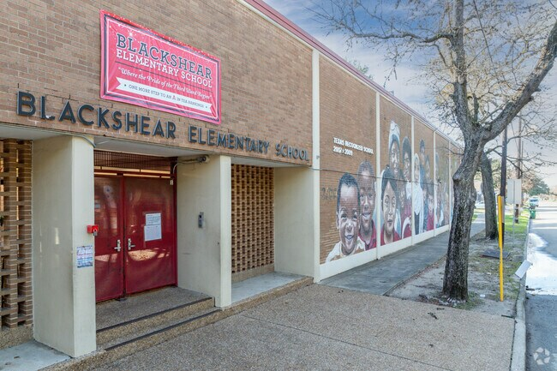

School Website:

School Telephone:

School Email:

Meet The Teacher – August 2026
Open House- September 2026
Grandparents Day – September 2026
Literacy Night – Fall 2026
Title I Parent Meetings – Fall 2026/Spring 2027
Math/Science Night – Fall 2026/Spring 2027
GT Expo – Spring 2027
PTO Meetings – Monthly
Coffee With the Counselor- Monthly
Blackshear Elementary
Jesseye Brown, Principal
Houston Independent School District 2900 Holman
Houston TX, 77004
A School-Parent Compact is a shared commitment among Blackshear Elementary, our families, and our students that outlines how we will work together to support student learning, growth, and academic success.
At Blackshear, we believe every Cub’s success is a shared responsibility. By working together as one Blackshear family, we strengthen the connection between home and school and ensure every Cub has the support and encouragement needed to Dream Big and Do It Bigger!
As a Blackshear Cub, I will ROAR by:
Being Reliable by coming to school every day, prepared and ready to learn.
Being On Time & On Task by arriving on time, staying focused, completing my work, and always giving my best effort.
Accepting Responsibility for my learning by setting academic goals, reading daily, completing assignments, and making choices that help me grow.
Being Relentless by working toward my goals, tracking my progress, learning from challenges, and never giving up.
I will take pride in my learning, celebrate my growth, and challenge myself to Dream Big and Do It Bigger!
www.BlackshearES@houstonisd.org

https://blackshear.houstonisd.org/

713-942-1481
The Blackshear Elementary School-Parent Compact is created through the shared voices and partnership of our families, students, teachers, and staff. Each year, our Blackshear community reviews student achievement data, campus goals, and student needs to identify how we can work together to help every Cub learn, grow, and succeed.
Teachers commit to providing engaging, high-quality learning experiences; families partner with the school to support learning and growth at home; and students take ownership of their learning by working hard and demonstrating our ROAR expectations by being Reliable, On Time & On Task, Accepting Responsibility, and being Relentless.

