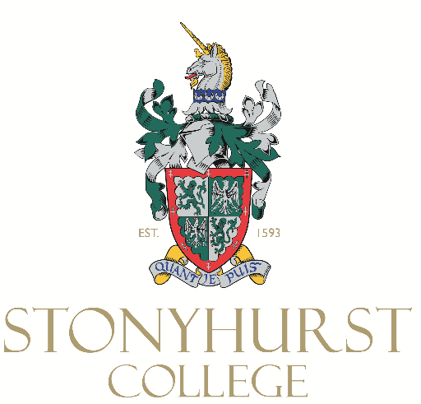

Job Description

Job Title: Domestic Assistant Cleaner

Line Manager: Head Housekeeper

The Domestic Team at Stonyhurst take pride in creating a ‘home from home’ for our Boarding pupils as well as looking after the magnificent buildings within the grounds.
Stonyhurst is next to the picturesque village of Hurst Green, we offer a unique working environment with excellent benefits such as complimentary access to the Swimming pool and gym facilities.
Uniform and safety shoes are provided, discounted access to the Golf club, fee remission, cycle to work scheme and an Employee Benefits package which includes pension scheme, retail discounts and well-being services are all inclusive to the role.
Applicants should be enthusiastic, possess a “can-do” attitude and enjoy working as part of a supportive and dedicated team.
Key responsibilities
- To ensure the effective cleaning and domestic maintenance of any/all areas of the campus.
- To comply with all health and safety requirements of the campus as outlined in departmental procedure manuals.
- To undertake any other duties, commensurate with role, as directed by the Head Housekeeper.
Professional and Personal Qualities
- Experience of, or a genuine interest in, working within an educational setting.
- Comfortable working with and liaising with a wide range of colleagues.
- Ability to develop positive professional relationships.
- Ability to prioritise tasks and manage time effectively.
- A willingness to respond to the operational needs of the school and have a flexible approach to the role.
- An awareness and appreciation of the importance of all College policies and procedures including Safeguarding and Health & Safety.

