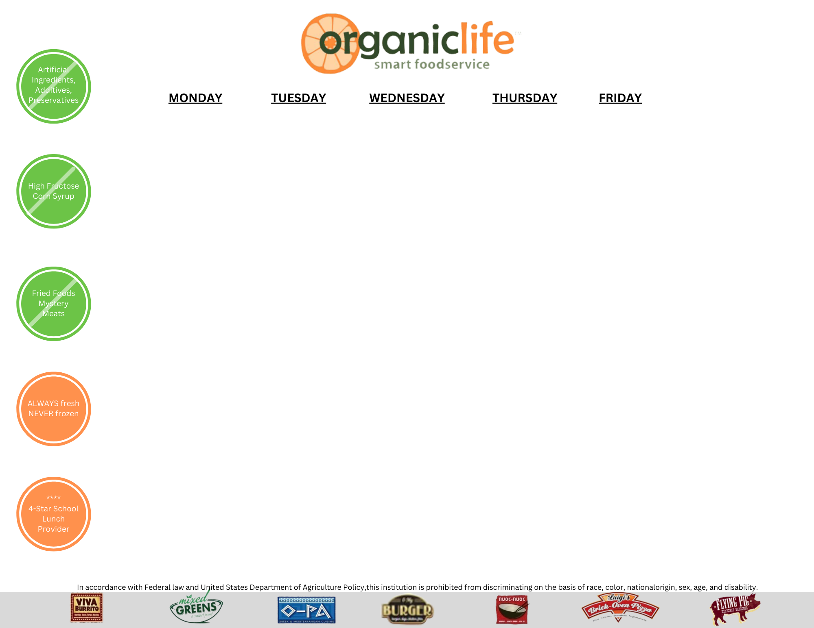
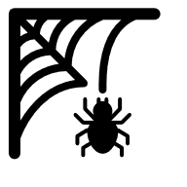  Waffles  Cold Breakfast Bar  Assorted Cereals  Assorted Muffins  Pop Tart  String Cheese |  |  | 1  Sausage Biscuit  Cold Breakfast Bar  Assorted Cereals  Assorted Muffins  Pop Tart  String Cheese | 2  Waffles  Cold Breakfast Bar  Assorted Cereals  Assorted Muffins  Pop Tart  String Cheese
5  French Toast Sticks  Cold Breakfast Bar  Assorted Cereals  Assorted Muffins  Pop Tart  String Cheese | 6  Egg Cheese Muffins  Cold Breakfast  Assorted Cereals  Assorted Muffins  Pop Tarts  String Cheese | 7  Pancakes Nuggets  Cold Breakfast  Assorted Cereals  Assorted Muffins  Pop Tarts  String Cheese | 8  Biscuit w/ Sausage Gravy  Cold Breakfast  Assorted Cereals  Assorted Muffins  Pop Tarts  String Cheese | 9  No  School
12  No School  Columbus Day | 13  Breakfast Pizza  Cold Breakfast Bar  Assorted Cereals  Assorted Muffins  Pop Tart  String Cheese | 14  Sausage Biscuit  Cold Breakfast Bar  Assorted Cereals  Assorted Muffins  Pop Tart  String Cheese | 15  French Toast Sticks  Cold Breakfast Bar  Assorted Cereals  Assorted Muffins  Pop Tart  String Cheese | 16  Waffles  Cold Breakfast Bar  Assorted Cereals  Assorted Muffins  Pop Tart  String Cheese
19  Cinamon Roll  Cold Breakfast Bar  Assorted Cereals  Assorted Muffins  Pop Tart  String Cheese | 20  Cheese Omelet  Toast  Cold Breakfast Bar  Assorted Cereals  Assorted Muffins  Pop Tart  String Cheese | 21  Egg Cheese Muffins  Cold Breakfast Bar  Assorted Cereals  Assorted Muffins  Pop Tart  String Cheese | 22  Donut  Cold Breakfast Bar  Assorted Cereals  Assorted Muffins  Pop Tart  String Cheese | 23  No School  Parent Teacher  Conferences
26  Pancakes Nuggets  Cold Breakfast Bar  Assorted Cereals  Assorted Muffins  Pop Tart  String Cheese | 27  Breakfast Burrito  Cold Breakfast  Assorted Cereals  Assorted Muffins  Pop Tarts  String Cheese | 28  Eggs, Toast and Hash Brown  Cold Breakfast  Assorted Cereals  Assorted Muffins  Pop Tarts  String Cheese | 29  Sausage Biscuit  Cold Breakfast Bar  Assorted Cereals  Assorted Muffins  Pop Tart  String Cheese | 30  French Toast Sticks  Cold Breakfast Bar  Assorted Cereals  Assorted Muffins  Pop Tart  String Cheese

October 2026 Breakfast Menu

Daily All Grades
Breakfast Choices:

~ Daily Special 1
~ Daily Special 2

Farmers Market
Daily
Fresh Fruit
Canned Fruit
100% Juice

Milk Choices:

1% White
Or
Fat Free Chocolate

