A Parent’s Guide to…

Fox Chapel Area Online
FCAO



8/2026

Welcome to FCAO
This booklet is designed to answer the questions parents and guardians may have about their child’s online classes. FCAO has been in existence for nearly a decade and offers Fox Chapel Area students a unique opportunity to customize their educational path to best suit their schedules. I hope this guide helps to give you the information you need, and please reach out with any further questions! Stephanie Reilly
FCASD Online Learning Coordinator
412-967-4417 stephanie_reilly@fcasd.edu

Courses Overview
The FCAO classes run on several platforms, as listed below.
- Schoology: College & Financial Essentials, Investing, Health, Psychology, History of Rock & Roll
- Other: SAT Prep
- Edgenuity: All other classes

Each platform is slightly different and it’s important to know and understand the platform that your child’s classes are on.

Recommendation
Learning how to navigate and succeed in an online class is a valuable skill to learn in HS, but your child may need some support as they get started. Sign up for the daily or weekly progress reports (discussed below) and stay on top of your student, particularly in the beginning of the semester. It’s very difficult to get caught up once a student gets behind in an online class.

FCAO FAQ
Who grades my child’s work?
FCAO teachers are fully-certified Fox Chapel Area teachers, who teach both online and in the classroom. The FCAO teachers grade the written work (essays, short answers, projects, etc.) and speaking assessments in world language classes.

What’s the best way to reach the teacher?
Email is the easiest way to reach the teacher. Through email, you or your child can set up a phone call, video chat, or in-person meeting.

Edgenuity Grading
- Edgenuity calculates a target completion each day and compares your child’s progress with the target.
- FCAO expects your child to stay within 5% of the target completion at all times. The reason for this is that it is very difficult to get caught up when a student gets behind in an online class. The FCAO teachers look at your child’s grades and progress and will reach out to your student if they are at risk.
- Progress grades are entered into Powerschool every three weeks. These progress grades are just for information, they are not calculated into the course final grade.
- The overall course grade is calculated as follows:
  - 40% Q1 grade (average of Week 3 + Week 6 + Week 9 grades)
  - 40% Q2 grade (average of Week 3 + Week 6 + Week 9 grades)
  - 20% Final
  - Exceptions: year-long courses such as Bio Acc.

- Edgenuity calculates 3 different grades, each of which serve a different and valuable purpose.
  - Overall grade = the grade on the work the student has submitted
  - Actual grade = the overall grade adjusted down if the student is behind in progress. If the student is on pace (or ahead), the actual grade is the same as the overall grade
  - Relative grade = the grade the student has if all unfinished assignments (whether they are late or not yet due) are set to zero. This grade is meaningless until the end of the semester.

Edgenuity FAQs
What does it mean if my child is “out of retakes”?
FCAO has set up the classes so that if students don’t pass a quiz, their class is locked and they need to reach out to the FCAO teacher. This is to avoid the student marching through the class unsuccessfully, and serves as another touch point between teacher and student. The FCAO teachers are very helpful and a great resource for your student.

Edgenuity Progress Reports
As the parent/guardian of an FCAO student in an Edgenuity class, you can receive daily or weekly emails with up-to-date grading and progress information. Example progress report:

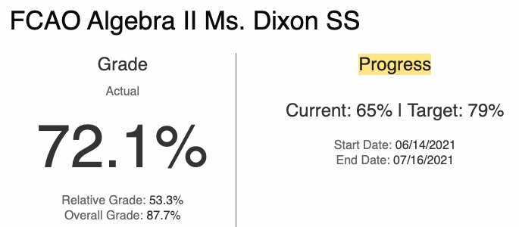

Explanation:
- This student is 65% done with the class, but her target completion is 79%. Since she is not within 5% of the target, she is considered behind.
- The grade for the work submitted thus far has earned her a 87.7%. This is her “overall grade”.
- Her “actual grade” is 72.1% because she is slightly behind.
- Her “relative grade” is 53%, which means that if the class ended today and all unfinished assignments were given a zero, she would have a grade of 53%.

Edgenuity Daily or Weekly Progress Reports
To receive this report, email the Online Learning Coordinator (stephanie_reilly@fcasd.edu) and your email(s) will be added to the system to receive the automatically-generated report.

Schoology Grading
- Schoology classes have been entirely created by Fox Chapel Area High School teachers.
- Schoology classes are not self-paced. Typically, Schoology classes have assignments due weekly.
- Depending on the teacher, late assignments do not receive full credit. Very late assignments may not be accepted for any credit.
- The teacher will post their syllabus that includes their policy for late work on Schoology.
- Any questions on grading can be directed to the teacher.
- Grades for Schoology online classes are available in Powerschool, just like our in-school classes:
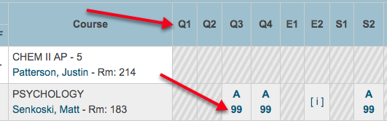
- Clicking on the numerical grade will bring up the list of assignments and their individual grades. Note along the top is the grading period (1st quarter, 1st semester, etc.).

“Other” Platforms
- SAT Prep is a combination of content on Khan Academy plus content on Schoology. The grades for SAT Prep are available on Powerschool.
- PE consists of two parts: online content from Edgenuity and a Fitness Log. Students enter their fitness activities into the Fitness Log within Edgenuity. The PE teacher grades the logs and enters the grades into Edgenuity, so Edgenuity does report the complete grade for the class. Feedback for the log is provided via email to the student weekly.

Additional Information
- FCAO AP courses are limited to full-time online students.
- AP and Keystone online courses have an end date of the exam. This allows the online student the opportunity to complete all of the content for the exam.
- Prep work for AP/Keystone exams is included in the online course content, to afford the online student the same preparation as our in-school students.
- Students will be asked to come into the school for benchmarking for Keystone and Keystone-related courses.

FCAO Attendance Policy (Fully Online Students)
The attendance policy is outlined fully in the FCAO Program Guide, available at fcaonline/fcasd.edu.

FCAO Attendance Process
“1st Period Flex” students
- Students without a 1st period class because of their FCAO class(es) are called first-period flex students.
- First-period flex students must sign in on the iPad in the vestibule outside the main office.
- If a flex student arrives before their first in-person class, they need to check in with the Online Learning Coordinator.
- Any attendance questions can be directed to the Online Learning Coordinator or FCAHS Attendance Officer.
- 1st period flex students must arrive in time to sign in, get to the locker, and get to their 2nd period class before class begins.
- Per the student handbook, a student who is tardy more than six times can have their parking pass revoked.
“4th Period Flex” students
- Students without a 4th period class in school because of their FCAO class are called 4th-period flex students.
- Daily attendance taken by the student’s QRT teacher.
- Student must sign out using the iPad near the FCAO office (Room 115).
- If a flex student stays after their last in-person class, they need to check in with the Online Learning Coordinator.
Full-time online students
- If a full-time FCAO student needs to be in the building, please coordinate with the Online Learning Coordinator.

Contacts
FCAO Online Learning Coordinator
Stephanie Reilly
412-967-4417
stephanie_reilly@fcasd.edu

FCAHS Attendance Officer
Roger Sullenberger
412-967-4415
roger_sullenberger@fcasd.edu

HS Guidance Office 412-967-2437
Mr. McLister (A-C)
412-967-2439
timothy_mclister@fcasd.edu

Mr. Baxter (D-G)
412-967-2441
john_baxter@fcasd.edu

Ms. Papalia (H-K)
412-967-2444
dana_papalia@fcasd.edu

Ms. Crissman (L-O)
412-967-2445
tina_crissman@fcasd.edu

Mr. O’Connor (P-S)
412-967-2442
ben_o’connor@fcasd.edu

Ms. DeComo (T-Z)
412-967-2440
tara_decomo@fcasd.edu

HS Main Office 412-967-2433 Fax 412-967-2458

