Penn Hills High School • Fall Play • 2026
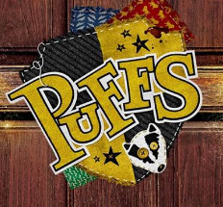
Sponsorship (NO AD)

Name___________________________________________________________
Telephone Number_______________________________________________
CHOOSE YOUR LEVEL OF SPONSORSHIP:
o Platinum Level @ $300.00 o Gold Level @ $100.00
(includes 4 show tix) (includes 2 show tix)
o Silver Level @ $50.00 o Bronze Level @ $25.00
Includes: (optional)
o Add this line to program for me: “... is a proud sponsor of (Cast/Crew Name)”
PAYMENT TYPE:
o Check – payments can be mailed to: Penn Hills High School, 309 Collins Dr.
Pittsburgh, PA 15235 – Attn. Josette Pickens, Producer
Make checks payable to: “PHHS Activity Fund”
o Cash
• Payments due October 10.
Cast/Crew Member Name:________________________________________________
Contact Phone:_________________________________________________
This is important so we know who to give ad credit to!

