A Peek at our Week
Mrs. Bird
Monday, October 5 – Friday, October 9, 2026
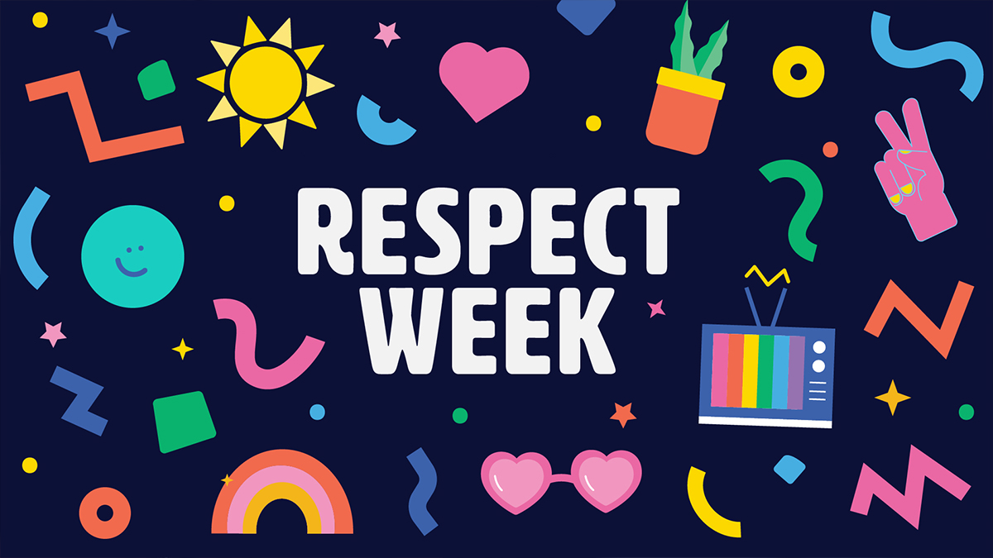
WORD WALL WORDS: mind, lost, done, goes, pretty
Please practice reading and spelling these words each night!
Homework Schedule
Monday  Wear your favorite hat!  *Spanish & Gym/Health* | Tuesday  Wear sports themed clothing!  *STEAM& Gym/Health* | Wednesday  Wear PJs or spaced themed clothing!  *Art* | Thursday  Wear school colors or mismatch!  *Gym/Health* | Friday  Wear blue or gold!  *Music & Gym/Health*  Library Visit Biweekly
Math: Worksheet  Reading: Log | Math: Worksheet  Reading: Log | Math: None  Reading: Log | Math: Additional Practice 3.1  Reading: Log | Have a wonderful weekend!
Taking a Closer Look…
- Math: We will complete Topic 2 on even numbers, odd numbers, and arrays. Our test is scheduled for Wednesday! Then, we will begin Topic 3 on various strategies to add within 100.
- Social Studies: We will continue our unit on communities. We will learn about the history of Stillwater while creating a timeline brochure.
- Reader’s Workshop: We will spend this time focusing on the Week of Respect. We will read the story, Spookley the Square Pumpkin, we will discuss the lesson from this special story, and create our very own unique pumpkins.
- Writer’s Workshop: Students will continue the process of writing small moment stories. We will focus on applying new skills as we continue to write more stories. Students will practice writing specific feeling words and remembering how to spell common sight words correctly in their writing.
- Fundations: We will begin Unit 3 in our Fundations program. We will learn the following closed syllable exception sounds: ind, ild, old, olt, ost. This unit is only one week long. Our test is scheduled for Friday!

**Remember to have sneakers for gym class!**

