Mrs. Jesseye Brown
Proud Principal
sCHOOL ACTION PLAN 2026-2027
Blackshear Elementary School | 110
School Action Plan – Needs Assessment

District philosophy and guiding framework:
Theory of Action
Vision
Core Beliefs

Needs related to student achievement data
- The data used for this needs assessment is derived from the results of the 2025-2026 STAAR tests.
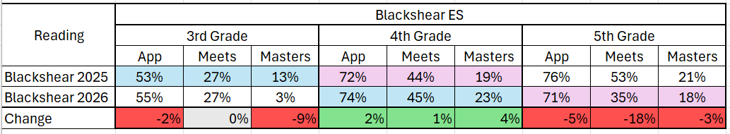
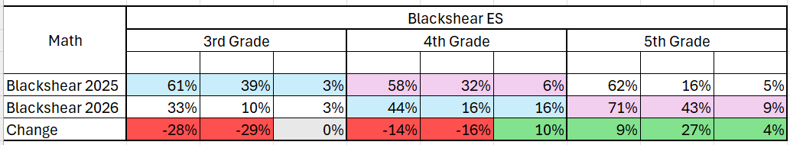
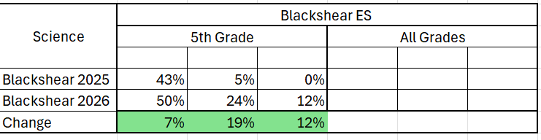
NWEA Scores
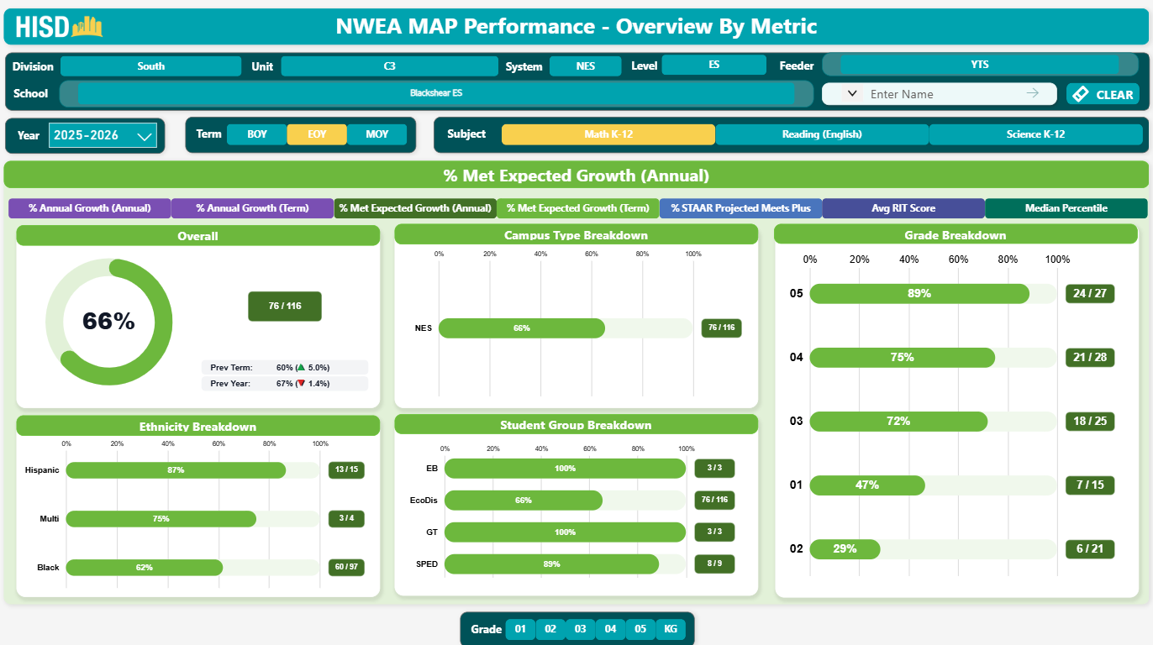
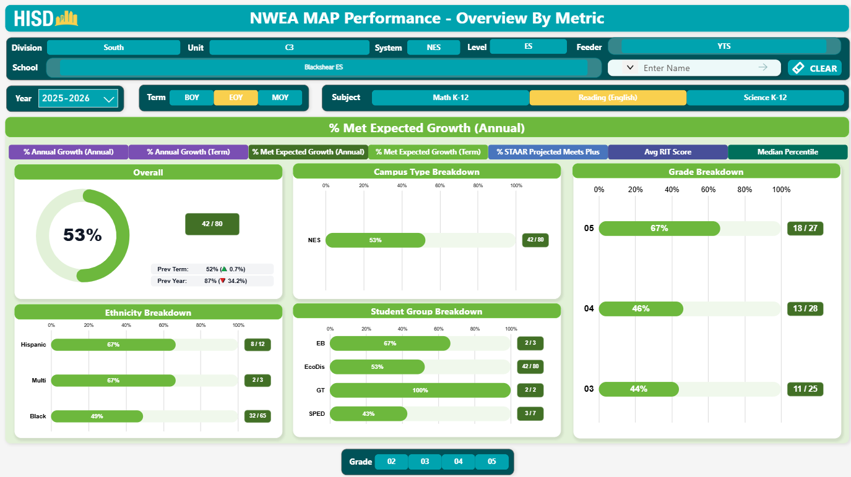
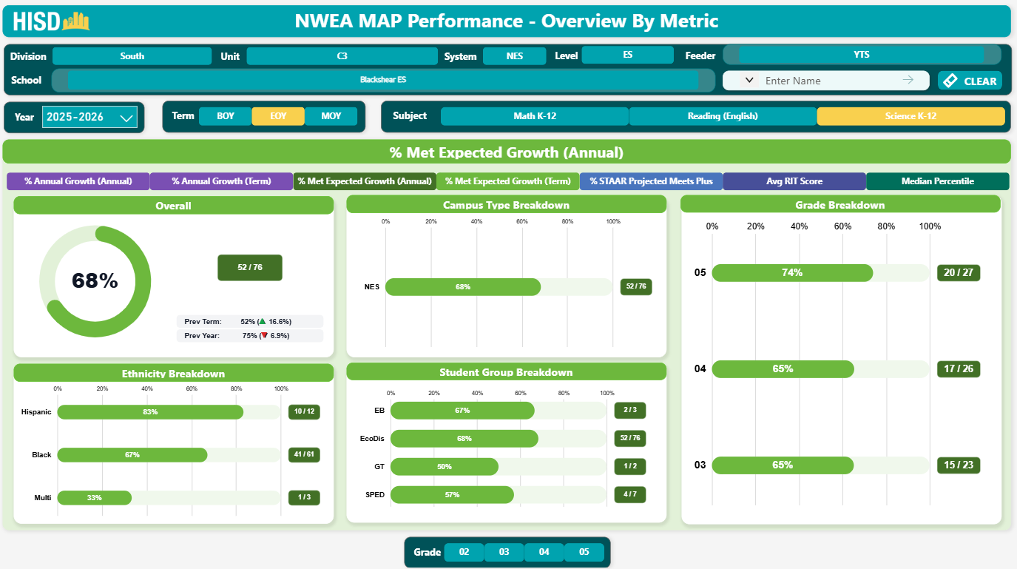
IRT Scores
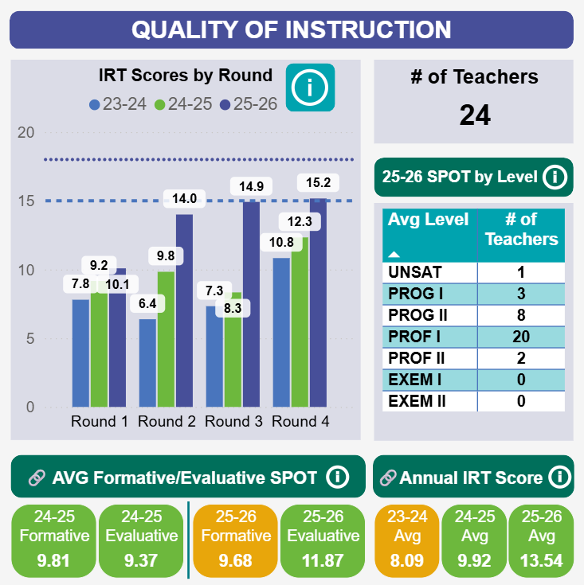
DIBELS
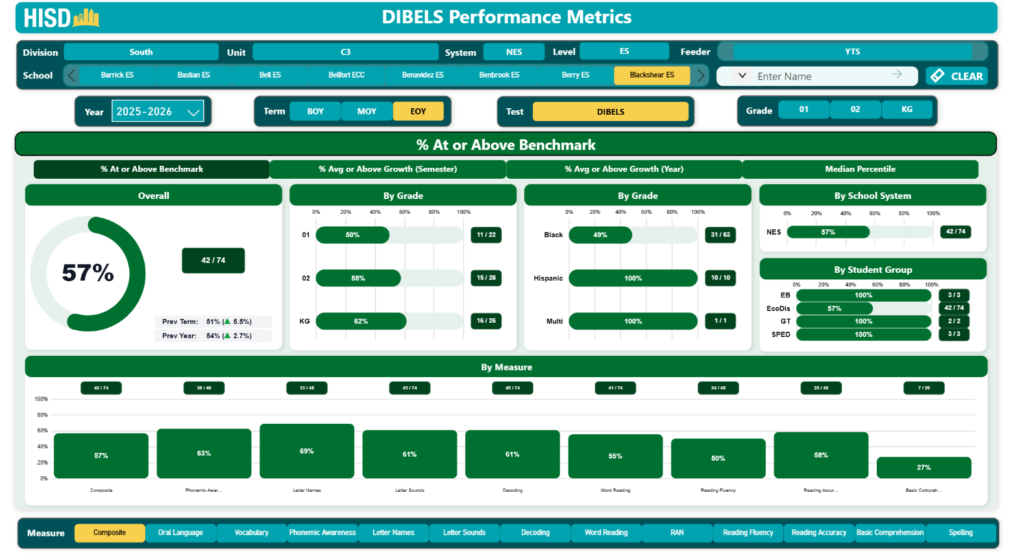
CIRCLE
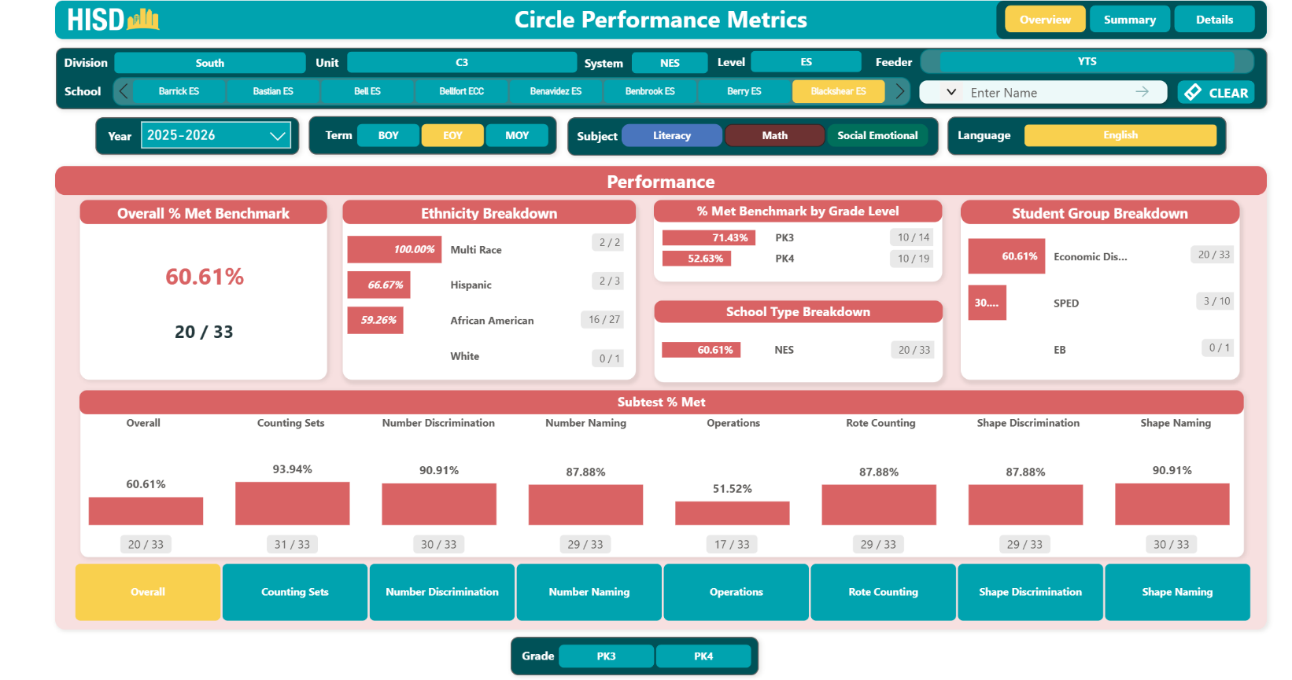
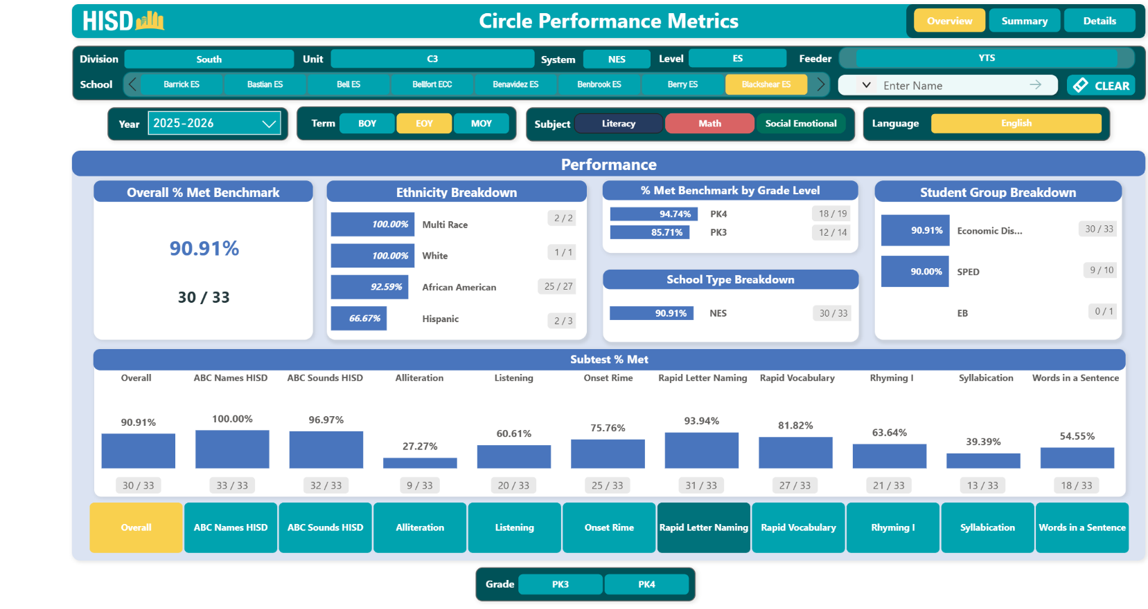
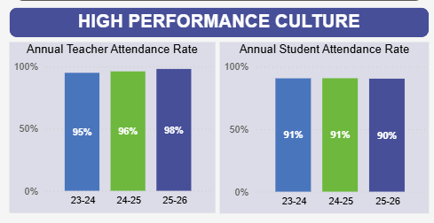

Needs related to improving the quality of instruction
ROOT CAUSE
The data used for quality of instruction needs assessment is derived from progress monitoring data that analyzes instructional deficiencies using multiple sources of data, including IRT results which grew from 10.08 – BOY IRT 1 to 15.166 EOY IRT 4, the AIM platform (Lead Rating: Proficient II), and the HISD Spot App. The data derived from the quality of instruction indicates a need for professional development centered on providing effective support to our students in special populations, such as special education and emergent bilingual students. Additionally, our data indicates a need for professional development on how to effectively engage students through multiple response strategies to engage all students’ responses, exemplars to ensure students understand the expected outcome of success and active monitoring to collect data on student progress and implement data-driven instruction. Blackshear students walk and are more independent with limited parental involvement. The average education level of parents is 10th Grade. When the weather is poor, students will stay at home due to lack of transportation. Student uniform and cleanliness is also a barrier for attending school. The campus has provided free uniforms, laundry services and transportation for families to attend school daily. Lower Elementary (PK-1) focus heavily on students achieving reading mastery. Math mastery is further delayed and creates deficits as students’ progress to the next level grade level.

System evaluation (philosophy, processes, implementation, capacity)
The following processes are present in the action plan and help ensure accountability and drive data-driven decisions to support rapid improvement at Blackshear ES.
- Identifying Baseline Data: By understanding the school’s current performance, leaders can pinpoint specific areas that need improvement, such as low-test scores or poor attendance, directly aligning efforts with state standards the school needs to meet.
- Setting Measurable Goals: Clear, measurable goals focus the school’s efforts on areas that directly affect meeting academic and operational standards, ensuring that every action taken contributes to progress.
- Monitoring Implementation: Regular monitoring ensures that turnaround strategies, like curriculum adjustments or training, are properly executed. This prevents wasted time and resources, keeping the school on track to meet standards.
- Measuring Progress: By continually assessing student performance and teacher effectiveness, schools can track whether they are closing the gap between current performance and required standards.
- Making Adjustments: When evaluations show that strategies are not working as expected, adjustments are made. This flexibility allows schools to refine their approach, improving their chances of meeting or exceeding standards over time.
Key Actions (Focus Areas)
/● Improve math proficiency for identified at-risk population of Tier 2 & Tier 3 PK-5th Grades
● Improve reading proficiency in kinder-5th grade, including at-risk population of students who failed readiness K-3rd and state assessment (STAAR) 3rd – 5th
● Improve SPED instruction, service delivery, and outcomes
● Improve student enrollment and daily attendance

KEY ACTION ONE | Key Action (Briefly state the specific goal or objective.)
KEY ACTION ONE | Improve math proficiency for identified at-risk population of Tier 2 & Tier 3 PK-5th Grades
KEY ACTION ONE | Indicators of success (Measurable results that describe success.)
KEY ACTION ONE | ● By January 2027, 60% of Tier 2 & Tier 3 students will meet their individual growth target on K-5 NWEA MAP Math.  ● By January 2027, 90% of Tier 2 & Tier 3 students will reach or exceed their Domain 2 growth target on math unit assessments (70% Mastery) of the time. By June 2027, this rate will increase to (80% Mastery) of the time.  ● 80% of Tier 2 & Tier 3 students will reach or exceed their growth target for Spring 2027 NWEA EOY Math.  ● By January 2027, 70% of PK4 students will score On Target for Math CIRCLE Subtests at MOY.
KEY ACTION ONE | Specific actions – school leaders (What specific action steps will the building leaders take to accomplish the objective?)
KEY ACTION ONE | ● Leaders will coach teachers on effectively implementing MRS to provide various opportunities for scholars to increase their ability to read, write, and speak in math computations scoring average of 80% on IRT 1-4.  ● Leaders will track, reflect on, and respond to the Tier 2 & Tier 3 students achievement outcomes aligned to reading and/or Math DOLs and unit assessments through block-to-block coaching and weekly leadership team meetings.  ● Leaders will coach teachers to mastery (80% of students push out to Teams Center and teachers average Proficient II on SPOT), make the needed instructional adjustments and provide feedback to Tier 2 & Tier 3 students.  ● Leaders will train teachers on using the campus Lesson Internalization framework with a focus on differentiating and scaffolding their lessons to meet the needs of Tier 2 & Tier 3 scholars during preservice in August 2026 and as needed throughout the school year that can demonstrate over 80% of students score 80% on their unit assessments.  ● Leaders will coach and monitor the implementation of SCR and ECR across contents and provide on-going professional development refreshers monthly to ensure mastery in these areas for teacher and scholars.
KEY ACTION ONE | Specific actions – staff (What specific action steps will the staff take to accomplish the objective?)
KEY ACTION ONE | ● Execute HISD specific engagement strategies (MRS) daily & consistently throughout the instructional block to provide scholars various opportunities to listen to, read, write and speak in English. Teachers must have minimum 4 at bats with MRS in each section of lesson cycle.  ● Intentionally adjust instructional practices to reflect targeted, differentiated, support for all Tier 2 & Tier 3 students in all instructional spaces, on a block-to-block daily basis.  ● Execute daily monitoring to prioritize Tier 2 & Tier 3 students’ quality of student work and overall English language proficiency.  ● Implement instructional best practices focused on the “Sweet 16” provided during PD sessions utilizing the campus lesson internalization framework with a focus on differentiating and scaffolding.

Key Action One: Staff Development
Who: Instructional Leaders
What: Provide quality PD sessions, on the spot coaching, daily planning, PLCs, and Demo days.
When: Daily & Weekly
Where: Campus & District Sites
Key Action One: Budget
Proposed item | Description | Amount
Staff development | Teachers will participate in targeted PD focused on using the campus Lesson Internalization framework with a focus on differentiating and scaffolding their lessons to meet the needs of EB students and to ensure a well-rounded education. | 0
Materials/resources | Curriculum documents Lead4ward documents Ontrack reports SPOT form Lesson internalization document | 0
Purchased services | NA
Other
TOTAL |  | 0
Funding sources:

KEY ACTION TWO | Key Action (Briefly state the specific goal or objective.)
KEY ACTION TWO | Improve reading proficiency in for all students in kinder – 5th grade, particularly those who failed readiness and state assessment.
KEY ACTION TWO | Indicators of success (Measurable results that describe success.)
KEY ACTION TWO | ● By MOY 2027, 60% of teachers will achieve the 61st growth percentile, or higher on the Reading M.A.P. tests. By June 2027 this rate will increase to 70%.  ● By MOY 2027, 60% of teachers will achieve the 50th achievement percentile, or higher on the Reading M.A.P. tests. By June 2027 this rate will increase to 70%.  ● Campus average engagement on Amira will be at 80% of students have read 40 stories by January MOY, this will increase to 95% by EOY.  ● By March 2027, 70% of students will score 4 on ECR Ontrack reporting data.
KEY ACTION TWO | Specific actions – school leaders (What specific action steps will the building leaders take to accomplish the objective?)
KEY ACTION TWO | ● Leadership team will explain the rationale and philosophy of systems thinking that will support improving student achievement during planning sessions, Demo Day and PLCs.  ● Lead teachers in block to block, and unit Student Work Analysis Protocol to determine highest leverage gaps in the quality of student work, as aligned to the lesson objectives, and the highest leverage next step(s) to address gaps in student mastery during PLC, Demo Day and PD Days.  ● Partner with high performing ELA teachers on campus to leverage non-ELA teachers in writing across the curriculum with Short Constructed Responses (SCR) in all core contents and Extended Constructed Response (ECR) in ELAR & AOT classrooms.  ● Track, reflect on, and create key next steps to respond to the reading demonstration of learning (DOL) and unit assessment, ‘meets’ and ‘masters’, outcomes during our weekly leadership team meeting.  ● Coach teachers to proficiency in the lesson internalization protocol for (1st & 2nd teach) reading, where the top priority is customizing the provided curriculum slides to reflect the rigor of the standards, providing clear thinking steps to mastery, and student engagement.  ● Provide professional development weekly through PLCs and Demo days utilizing our campus lesson customization framework and by modeling best practices aligned to high quality instruction.
KEY ACTION TWO | Specific actions – staff (What specific action steps will the staff take to accomplish the objective?)
KEY ACTION TWO | ● Plan and execute a daily SCR in all core content classrooms from September 2026 to May 2027, and monthly ECR in ELAR  ● Analyze the quality of student work by identifying trends in gaps of work samples pulled from 4 low, 4 medium, and 4 high performing student work samples during tier 1 instruction, both on a block to block and daily basis. (this includes when unit assessments occur)  ● Intentionally plan 2nd and 3rd teach lessons focused on closing weekly gaps identified in the digital DOL outcomes and district unit assessments  ● Ensure all student-facing materials for 1st and 2nd teach are customized, prior to first instruction, to fully and directly align to the rigor of the state standards, include a clear roadmap to mastery, and authentic engagement with content  ● Engage in PLCs and Demo Days weekly to receive data driven professional development, practice upcoming lessons, give and receive peer feedback, reflect on practices, and improve the delivery of instruction to ensure scholars master LOs

Key Action TWO: Staff Development
Who: District Leadership Development Team (Curriculum) & Campus Leaders
What: Provide professional development sessions: On the spot coaching, daily planning, PLCs, and Demo Days
When: Daily & Weekly
Where: Campus and District locations
Key Action TWO: Budget
Proposed item | Description | Amount
Staff development | Teachers will participate in targeted PD sessions that focus on improving high-quality instruction to meet the needs of students with a focus on PLCs, Demo Days and on the spot coaching. | 0
Materials/resources | District curriculum, Great 8 PD, district PD resources, Spot Form | 0
Purchased services | NA
Other
TOTAL |  | 0
Funding sources:

KEY ACTION THREE | Key Action (Briefly state the specific goal or objective.)
KEY ACTION THREE | Improve SPED instruction, service delivery, and outcomes
KEY ACTION THREE | Indicators of success (Measurable results that describe success.)
KEY ACTION THREE | ● The percentage of “instructionally proficient” special education student folder compliance, as measured by a rubric and reviewed by an independent team from the Special Education Department, will be at 70% or higher at MOY and increase to at least 90% by May 2027.  ● By January 2027, 60% of special education and general education teachers will score a 13 or higher in on the inclusion SPOT observation conducted by the campus leadership team. The percentage of special education & general education teachers scoring 13 or higher will increase to 80% (4 out of 5) by June 2027.  ● By the end of the first semester 100% of campus ARDS will be held on or before the TEA deadline. This percentage will remain constant at 100% by EOY June 2027.  ● By January 2027, the percentage of SpEd scholars scoring in the 61st percentile growth (or higher) on NWEA MAP.
KEY ACTION THREE | Specific actions – school leaders (What specific action steps will the building leaders take to accomplish the objective?)
KEY ACTION THREE | ● Perform campus based monthly SpEd folder audits, reviewing 20% of all SpEd folders each time, with a focus on Quality of IEPs using the Office of Special Education Services Folder Audit Rubric.  ● Meet with SpEd Department Chair and SpEd support weekly to review multiple layers of SpEd compliance: ARDS, IEPs, Accommodations, Progress Monitoring, 504, Dyslexia, and Documentation.  ● Coach staff on high quality instruction/support during 1st and 2nd teach, with a focus on differentiation and scaffolding to meet the needs of Tier 2/3 and SpEd scholars.  ● Engage in block to block, and daily data sorts to urgently close instructional gaps around SpEd scholar outcomes in 1st and 2nd teach.  ● Coach staff on high quality instructional look fors, based on the specialty guidance for SpEd spaces according to the district SPOT form, with a targeted focus on Domain 2 Instruction.
KEY ACTION THREE | Specific actions – staff (What specific action steps will the staff take to accomplish the objective?)
KEY ACTION THREE | ● Co-Teachers and Teachers will document all SpEd. scholar accommodations and/or modifications in PowerSchool, as reflected by the 3 week grading benchmarks.  ● Complete all required paperwork for ARD meetings and documentation of IEP implementation.  ● Implement instructional best practices providing during professional development sessions and on the spot coaching to ensure high quality differentiated and scaffolded instruction, daily, to scholars.  ● Conduct block to block and daily data sorts to determine trends and the highest leverage gap in special education student performance (1st and 2nd teach).  ● Implement high quality instructional look fors based on the district specialty guidance for Special Educations teachers, with a targeted focus on Domain 2 Instruction.
Key Action THREE: Staff Development
Who: Instructional leaders and Special Education Department Chair
What: Accurately identify and create a plan to implement special education student needs, based
on students’ IEPs. Additionally, Provide professional development session on the following: On the
spot coaching, daily planning, PLCs, and Demo days.
When: Daily and Weekly
Where: District and campus locations
Key Action THREE: Budget
Proposed item |  | Description | Amount
Staff development |  | Teachers will participate in professional development focused on increasing instructional rigor while incorporating effective scaffolds to ensure special education students can access grade-level content and apply higher order thinking skills. | 0
Materials/resources |  | Curriculum documents, IEPs, OnTrack data reports | 0
Purchased services |  | NA
Other
Other
TOTAL |  |  | 0
Funding sources:

KEY ACTION FOUR | Key Action (Briefly state the specific goal or objective.)
KEY ACTION FOUR | Improve student attendance
KEY ACTION FOUR | Indicators of success (Measurable results that describe success.)
KEY ACTION FOUR | ● By the MOY, 80% of all campus homeroom will maintain attendance at 95%  ● By the MOY campus culture survey, 78% of teachers will agree or strongly agree to the following statement, “My school has an effective instructional team”. This percent will increase to 85% by the EOY campus culture survey.  ● By January (MOY) 2026, staff attendance will be at 96% or higher. This percentage will be at 98% or higher by EOY June 2026.  ● By January (MOY) 2027, an average of 75% of families will answer Yes to being ‘Happy’ or ‘Mostly Happy’ with their child’s campus experience, based on the Parent ‘Possip’ sentiment report. By May (EOY) 2027 this average will increase to 90% of families.
KEY ACTION FOUR | Specific actions – school leaders (What specific action steps will the building leaders take to accomplish the objective?)
KEY ACTION FOUR | ● Conduct daily attendance rounds to ensure 100% fidelity to increasing attendance.  ● Plan and execute at least seven parent engagement events by EOY.  ● Provide daily on-the-job coaching that aligns with written feedback, shared at least bi-weekly using the Spot Observation form.  ● Weekly PLC Training: During weekly PLCs, train teachers on customizing lessons so they reflect both the rigor of the TEKS and unique needs of our students, and effectively improve student outcomes and thus teacher effectiveness.  ● Conduct at least 9-week cycles (4) of campus listening tours to effectively collect and respond to qualitative feedback on campus culture data.  ● Conduct outcomes, causes, and solutions round with campus grade team leaders, around the MOY campus culture data.  ● Execute monthly campus team(s) gratitude moments/notes. (leaders will rotate teams to ensure equity in the moments of gratitude)  ● Set up and monitor parent connections on Parent Square, ensuring 100% of families are connected by October of the new school year. (and ongoing as new families enroll)
KEY ACTION FOUR | Specific actions – staff (What specific action steps will the staff take to accomplish the objective?)
KEY ACTION FOUR | ● Engage scholars in community circles, daily- from 7:45am-7:55am.  ● Partake in the planning and execution of at least seven campus events centered on family engagement.  ● Reflect on instructional feedback and improve the delivery of instruction as appropriate.  ● Engage in daily structured planning that is both leader and teacher led, to effectively customize lessons to reflect the rigor of the TEKS and unique needs of all students.  ● Engage in at least (4) listening tours and an round to share qualitative feedback on campus experience, as it relates to campus culture.  ● Experience and receive moments of gratitude from leaders.  ● Ensure 100% of families are connected to Parent Square and positively communicate at least weekly with families on the Parent Square application.

Key Action FOUR: Staff Development
Who: Campus leadership team and staff
What: Professional Development: Set Up and Follow up Parents Connecting on Parent Square, High Quality Instruction, and Community Circles
When: Daily, Weekly and during monthly campus PD days
Where: District and campus locations
Key Action FOUR: Budget
Proposed item | Description | Amount
Staff development |  | 0
Materials/resources |  | 0
Purchased services | NA
Other
Other
TOTAL |  | 0
Funding sources:

