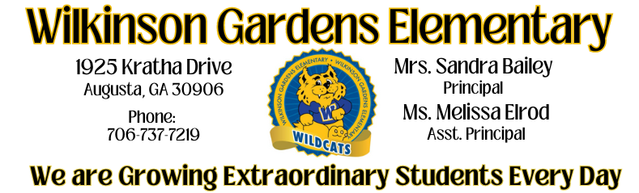

School Council Members
Name | Role
Sandra Bailey | Principal
Melissa Elrod | Assistant Principal
Shanice Williams | Parent
Shaquisha Holliman | Parent
Raven Allison | Parent
LaQuandra Fedrick | Parent
Ashley Crawford | Parent
Kerri Wesby | Teacher
Marnetta Lee | Teacher/Parent
Nicole Jones | Instructional Specialist/Staff

