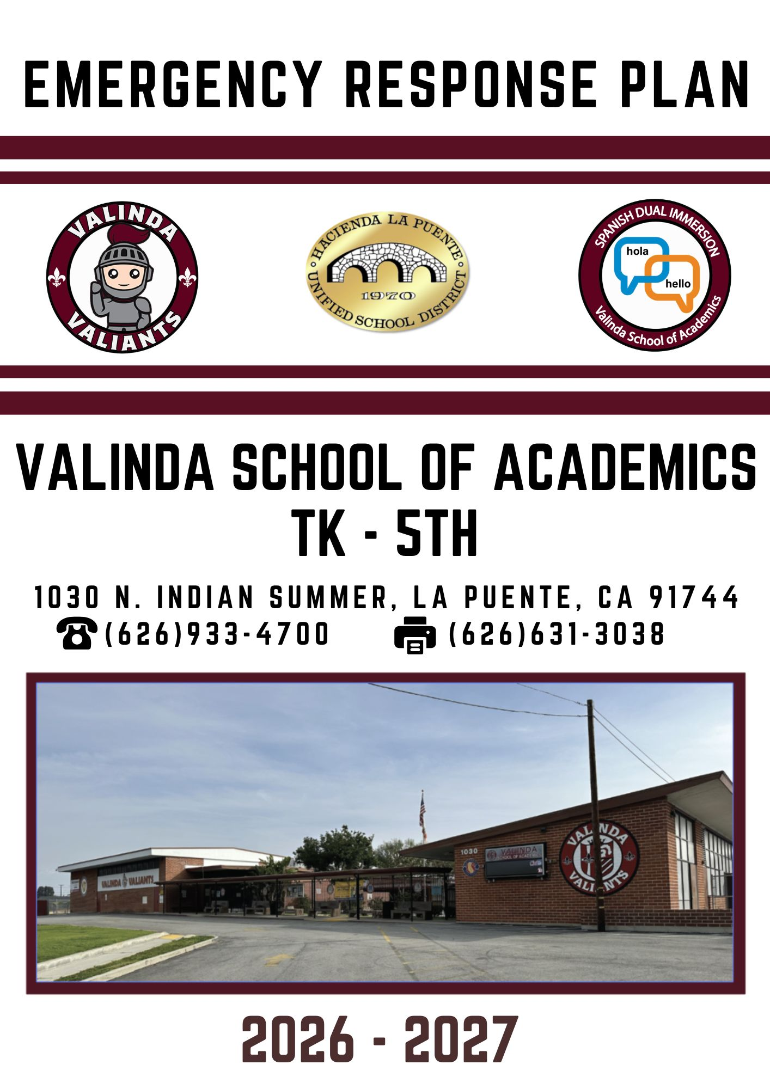
Contents
INTRODUCTION Error! Bookmark not defined.Approval Statement 5BASIC PLAN 6Emergency Contact Numbers 6SITE ASSIGNMENTS AND STAGING AREAS 7ICS ASSIGNMENTS 9
Disaster Buddy Teacher Assignments 10
EVACUATION CHECKLIST 10REVERSE EVACUATION 12
SCHOOL MAPS 13
RESOURCE INVENTOR 14
ANIMALS 15
ASSAULT/FIGHTS Error! Bookmark not defined.BOMB THREAT Error! Bookmark not defined.BUS INCIDENT Error! Bookmark not defined.EARTHQUAKE 22FIRE 24GAS LEAK 26GENERAL EMERGENCY 28HAZARDOUS MATERIALS EVENT 29INTRUDER/HOSTAGE 30MEDIA Error! Bookmark not defined.SERIOUS INJURY/DEATH 34SHELTERING PROCEDURES 35STAFF RESPONSIBILITIES 36STUDENT UNREST 37SUICIDE 38TERRORIST EVENT 38WEAPONS 41WEATHER 42APPENDIXES 43Appendix A: Bomb Threat Checklist 43Appendix B: Notice of First Aid Care 45Appendix C: Plan Compliance Checklist 46Appendix D: Pandemics 51Appendix E: Public Information Release 53Appendix F: Sample School-Parent Letter 55Appendix G: Search and Rescue Teams List 56Appendix H: Site Status Report 59Appendix I: Staff Skills Survey & Inventory 60Appendix J: Student Accounting Form 61Appendix K: Student Release Form 63Appendix L: Incident Response Job Descriptions 55
Mock Disaster Drill Sequence of Events 80
Mock Disaster Drill Exercise Notes 82
Supplies needed for First-Aid Kit 83

INTRODUCTION

What is an Emergency?

An emergency is a duly proclaimed existence of conditions of disaster or extreme peril to the safety of persons or property caused by air pollution, fire, flood or floodwater, storm, epidemic, riot, earthquake, intruder, or other causes. Such an event may be beyond the control of the services, personnel, equipment and facilities of the site and/or district and require the combined efforts of the County or other political subdivisions. School district facilities must be prepared to respond to an emergency or traumatic event in an organized and timely manner so that students and staff can continue to function effectively without additional trauma or the development of additional emergencies.

School emergencies can be small and easily managed, or they can be large and difficult to manage. Every school district emergency must be managed in a way that ensures the safety of all personnel involved. In order to provide a safe and secure teaching and learning environment, personnel must plan for the management of emergency events that cannot be predicted or prevented. This plan is designed to help you do that.

Purpose:

To effectively handle an emergency, a comprehensive Emergency Operations Site Plan must be developed and a Site Emergency Response Team must be organized before an emergency occurs. Our school’s Emergency Operations Plan must be organized and all staff members trained in order to effectively prepare for maximum safety, efficiency and communication in the event of an emergency.

The Incident Command System (ICS) will be used to manage all emergencies that occur within the district. We encourage the use of ICS to perform non-emergency tasks to promote familiarity with the system. All district and site personnel complete mandatory training.

Students and parents must also understand that contingency preparation and procedures are necessary and are conducted for their safety and well-being. An overview of the plan will be explained and distributed to parents.

Planning, preparation, and training will help staff personnel learn the proper course of action in an emergency. This manual will provide step-by-step guidelines to help deal with emergencies that may occur. This manual cannot foresee all possible circumstances of an emergency. Staff must be prepared to evaluate all the circumstances and make sound judgments based on the situation. Staff will receive annual training in the emergency response plan.

A committee will be established consisting of local law enforcement, fire/EMS, emergency management, county health department and site personnel to develop the Emergency Operations Plan. The committee should consist of site staff from the following disciplines at a minimum:
- Administrator (Principal or Assistant)
- Office staff
- Maintenance
- Food Service staff
- Safety/Security personnel
- Teacher
- Para educators
- Certificated Staff

Procedures will be developed to provide for disabled and non- or limited-English speaking students and staff.

This plan shall be reviewed annually by the above committee and updated to maintain current procedures.

Drills will be conducted periodically to test the effectiveness of the plan. A debriefing shall be conducted after each drill to receive feedback from all participants on the effectiveness of the plan. Identified weaknesses will be addressed to strengthen the plan.

Each classroom will be supplied with a Classroom Emergency Response Guide that provides instructions on how to respond to specific events as determined by site emergency planning committee.

An NOAA capable radio with battery power back-up will be placed in the office where it can be monitored for emergency messages during school hours.

Provisions for off campus emergencies (e.g. bus accidents, field trips, off campus school activities) will be addressed in this plan.

A copy of this plan will be filed with the district office.

During a Disaster: Step by Step is Right Here

The greatest mistake principals, teachers and staff make in a crisis situation comes from not knowing what steps to take and in what order in a given situation. Planning, training and drills will help prevent those mistakes. In a crisis it helps to know where to turn for help. This manual provides specific sequential steps to take. These steps are guidelines to inform you of the most likely steps to take. It is critical to evaluate the circumstances of the actual event and determine the most appropriate course of action. Some common incidents have been addressed to help you in an emergency. Each site must conduct a hazard assessment to identify all hazards that pose a risk to the school.

Approval Statement

The School Safety Plan for Valinda School of Academics has been reviewed and found to comply with the Los Angeles County Emergency Response Plan minimum and/or recommended requirements.

Elizabeth Bermejo
Site Administrator (required) | Date |  | District Representative (required) | Date
Law Enforcement (recommended) | Date |  | Fire/EMS  (recommended) | Date
Los Angeles County Emergency Management (recommended) | Date |  | Los Angeles County Public Health  (recommended) | Date

BASIC PLAN

SITUATION AND ASSUMPTIONS

Situation

The school site is located at 1030 N. Indian Summer Ave. The site consists of 36 classrooms. There is an Average Daily Attendance 310 students and 47 staff members.

The principal has the primary responsibility for developing and implementing the site Emergency Operations Plan. The principal has the responsibility of executing the policies developed by the district.

Site personnel and/or local fire and law enforcement agencies handle most emergencies on site.

Assumptions

During an emergency, centralized direction and control (i.e., activation of the Command Post) is the most effective approach to management of emergency operations.

In case of an emergency that is beyond the capabilities of the site to handle, site personnel will coordinate with local emergency response agencies. This may include having a member or members act as liaison with responding agencies.

COMMUNICATIONS

Emergency Communications

When an emergency condition exists, the Incident Commander will notify the necessary personnel to respond to their area of assignment. The methods of communication listed below in descending order will be used (a being the primary mode of communication followed by alternative modes). Notifications will be given in plain language. Code words shall not be used.

- Intercom
- Telephone
- Two-way radios
- Runners
- Cell Phones when appropriate

Media Relations

The site Information Officer will be prepared to deal with the media prior to the arrival of the district Information Officer. A separate staging location will be pre-identified for media briefings.

Emergency Contact Numbers

Public Agencies | Number
General Emergency/Fire | 9-911
California Highway Patrol (CHP) | (626) 338-1164
La Puente City Hall | (626) 855-1500
Local Hospital – Pomona Valley | (909) 865-9500
Local Hospital - Queen of the Valley | (626) 962-4011
Los Angeles County Department of Mental Health (24 hour team) | (800) 854-7771
Los Angeles County Department of Public Health | (626) 968-3711
Los Angeles County Sheriff | (626) 330-3322
Poison Control | (800) 222-1222
U.S. Health Works (Contract Physician) | (626) 961-1152
Universal Health Care (Contract Physician) | (626) 336-6652
District Contacts | Number
Chief of Police and Safety | (626) 933-3898/99
District Facilities Failures – 24 hours | (626) 933-4357
Food Services | (626) 933-3900
Health Services | (626) 933-3899
Information Services | (626) 934-4800
Maintenance | (626) 933-8703
Operations | (626) 933-8712
Suicide Prevention Hotline (24 hours, not toll-free) | (310) 391-1253
Superintendent | (626) 933-3801
Transportation | (626) 933-3826
Utilities | Number
Electrical Emergency | (800) 655-4555
Natural Gas Emergency | (800) 427-2200
Water Emergency | (626) 858-7246

* Determine the appropriate sequence required to dial 911 from your site’s phone system.

SITE ASSIGNMENTS AND STAGING AREAS
On Site Locations and Staging Areas
 | Primary | Alternate | Alternate
On Site Command Post | Center  Upper Grade Field | Elementary Field | Grandview School  Workman High School
Student Care | Right  Upper Grade Field | Elementary Field | Grandview School  Workman High School
First Aid | Right  Upper Grade Field | Elementary Field | Grandview School  Workman High School
Student Request | Elementary Field Parking Lot Gates | Kindergarten Street Gates | Grandview School  Workman High School
Student Release | Elementary Field Parking Lot Gates | Kindergarten Street Gates | Grandview School  Workman High School
Media Staging | Far Corner Street (Away from school)  Elementary Playground | Far Corner Street (Away from school)  Upper Grade Playground | Grandview School  Workman High School
Law Enforcement Staging | Left Blacktop  Upper Grade Field | Elementary Field | Grandview School  Workman High School
Fire Staging | Left Lower Blacktop  Upper Grade Field | Elementary Field | Grandview School  Workman High School
Public Works Staging | Left Lower Blacktop  Upper Grade Field | Elementary Field | Grandview School  Workman High School
Utilities Staging | Left Lower Blacktop  Upper Grade Field | Elementary Field | Grandview School  Workman High School
Student Relocation Center | Upper Grade Field | Elementary Field | Grandview School  Workman High School
District Staging | Right Lower Blacktop  Upper Grade Field | Elementary Field | Grandview School  Workman High School

ICS ASSIGNMENTS
POSITION | 1ST (Primary) | 2ND (Alt) | 3rd (Alt)
Incident Commander | Elizabeth Bermejo | CC Schools Coordinator- Mia Reyes | TOSA  Tanya Aguilera
Safety | Omar Olid | Olga Amaya | Mariela Garcia
Liaison | CC Schools Coordinator-  Mia Reyes/Staci Henderson | Alisson Morales | Dennis Hisamoto
Information Officer | District PIO/Tanya Aguilera | District PIO/Jennifer Valencia | District PIO/Fany Melendez
Operations | Maria Mendez de Magana | Tanya Aguilera | CC Schools Coordinator-Mia Reyes
Communications | Hector Luken | Dennis Hisamoto | Mariela Garcia
Recorder | Team  Brenda Soto, Ruth Gutierrez | Team  Paloma Ortiz Rojas, Guadalupe Naranjo, Silvia Corona | Team  Lesley Chavez, Nora Pinedo-Ku
Security | Mariela García  Dennis Hisamoto | Hector Luken, Custodial Staff, ASES Staff | Omar Olid, Hector Luken, Custodial Staff, ASES Staff
Search & Rescue | Team  Jennifer Valencia  Corry Castillo  Olga Amaya  Miriam Preciado  Kitchen STAFF (4) | Team  Lorena Gonzalez  Fanny Melendez  Staci Henderson  Maria Carlos  Silvia Corona | Team  Rosalba Torrez  Allison Morales  Martha Zamora  Debra Piggee  Nancy Rosales
Safety/Damage | Omar Olid | Hector Luken
Medical/First Aid | Team  Adriana Amaya  Fanny Meléndez  Lorena Gonzalez  Rebecca Pérez  Shaylyn Rodríguez  Betty Pham- Nurse | Team  Rosalba Torrez  Allison Morales  Martha Zamora  Rebecca Pérez  Debra Piggee | Team  Lesley Chavez  Jodie Doyle  Elizabeth Catan  Gabriela Castellanos  Paloma Ortiz Rojas
Student Supervision | Team  Jodie Doyle, Lisa Gonzalez, Allison Morales, Debra Piggee, Silvia Corona, Anna Addenbrooke, Rosalba Torrez, Lesley Chavez Head Start Team, Instructional Aides (6) | Team  Jodie Doyle, Lisa Gonzalez, Allison Morales, Debra Piggee, Anna Addenbrooke, Rosalba Torrez, , Kitchen Staff, Instructional Aides (6) Headstart Team | Team  Jodie Doyle, Lisa Gonzalez, Allison Morales, Joana McKay, Anna Addenbrooke, Rosalba Torrez, Kitchen Staff, Instructional Aides (6) Head start Team
Student Request/ Release | Desirée Rubio  Paloma Ortiz Rojas | Rebecca Perez  Tanya Aguilera | Nora Pinedo-Ku  Maria Carlos
Runners | Rosalba Torrez  Maria Carlos | Irma Andrade  Guadalupe Naranjo | Rebecca Pérez  Maria Carlos

- Any additional adult employee on campus will be asked to assist as needed.

DISASTER BUDDY TEACHER ASSIGNMENTS

Your buddy Teacher is listed below. This is the classroom you must check on during the drill and/or in a real emergency situation. You may be responsible for supervising your buddy teacher’s class once on the grass area. If your buddy teacher is injured you will need to escort his/her class out to their section. If your buddy’s class is blocked or damaged so that they are trapped make sure you report this immediately to the Command Center once your own class is safely in place.

K1: Lorena Gonzalez  K2: Lisa Gonzalez  Preschool/Head Start | K3: Lesley Chavez  11: Resource Room  12: Paloma Ortiz-Rojas/Parent Room  13: Mia Reyes
21. Rosalba Torrez  22: Silvia Corona | 31: Debra Piggee  32: Jodie Doyle
23: Fanny Melendez  24: Anna Addenbrooke | 33: Adriana Amaya  34. Hector Luken
41: Corry-Grant-Castillo
42: Jennifer Valencia

43: Shalyn Rodriguez  44: Miriam Preciado | 51: Mariela Garcia/Dennis Hisamoto  52: Allison Morales  53: PD Room  54: Staci Henderson/Interventionists
61/62: Ruth Gutierrez/Library  64: Jessica Marin/VAPA Dance-Thursday  65: Neda Badiei/VAPA Art-Thursday  66: Storage  67: John Zavala/Band | 71: ASES  72: ASES  73: ASES  74: Cole Bacani  75: ASES  76: ASES  77: Mary Griswold/VAPA Violin-Thursday
Cafeteria STAFF
Office STAFF

EVACUATION CHECKLIST

Evacuation:

- Incident Commander (IC) initiates evacuation procedures.
- IC determines if students and staff should be evacuated outside of building or to Assembly Area relocation center. Elizabeth Bermejo contacts the Transportation Coordinator and informs them that the evacuation is taking place.
- Incident Commander notifies relocation center.
- Direct students and staff to follow evacuation drill procedures and route. Follow alternate route if normal route is too dangerous.
- Close all windows.
- Turn off lights, electrical equipment, gas, water faucets, air conditioning and heating system.
- Describe how disabled and limited-English speaking students and staff will be provided for.
- Lock doors.

Teachers:

- Direct students to follow normal evacuation drill procedures unless IC alters route.
- Take classroom roster and emergency kit.
- Close classroom doors and turn out lights.
- When outside building, account for all students. Inform principal or Incident Commander immediately of missing student(s).
- If students are evacuated, stay with class unless relieved by buddy teacher. Take roll again when you arrive at the relocation center.
- Relocation Centers

- List primary and secondary student relocation centers:

Primary Relocation Center Secondary Relocation Center
Grandview School William Workman High School

Address/Phone No.: Address/Phone No.:
795 Grandview Lane South 16303 East Temple Avenue
La Puente, CA 91744 La Puente, CA 91744

LOCKDOWN

Teacher responsibilities
- Quickly survey the hallway (if safe to do so).
- Bring any student or staff inside the room.
- Inform the principal of any missing students or students in your room not assigned to your classroom.
- Lock doors, turn off the lights, keep students away from windows and/or open areas.
- Keep students calm and quiet.
- No cell phone activity.
- No talking.
- Do not open the door.
  - Proper authorities will have keys.
- Only open the doors after “all clear” signal is given.
- Slide Red or Green status card under the door (if safe to do so).
  - Green card - Okay
  - Red Card - Emergency, non-medical
  - Red and white cross - Medical emergency
- If evacuated, take the roll book.

Soft lockdown is a lockdown where instruction/business can still take place. Doors are locked and possibly barricaded.
- All students move to their designated classrooms, behind locked doors
- Staff move indoors, behind locked doors, unless it necessary to be outside
- - student escorts
- - meet with first responders
- - do safety assessments of site
- All visitors report to office

Reasons:
- Police helicopter orbiting over school
- Police or Fire Activity near school
- Smoke or chemicals near school
- Activity at a neighboring, or non-neighboring, school
- - possible shooting at a school in a nearby district
- National or regional incident
- - example 9-11
- Principal’s discretion

If I repeat Valinda Valiants, Valinda Valiants, Valinda Valiants that means I am forced to act against my will. Do not open the doors.

REVERSE EVACUATION

Reverse Evacuation/Shelter-in-place provides refuge for students, staff and the public within school buildings during an emergency. Shelters are located in areas that maximize the safety of inhabitants. Safe areas may change depending on the emergency. Be prepared to go into lockdown/shelter-in-place once inside.

Identify safe areas in each school building.

- Incident Commander warns students and staff to assemble in safe areas. Bring all persons inside building(s).

- Teachers take class roster.

- Close all exterior doors and windows.

- Turn off any ventilation leading outdoors.

- Cover up food not in containers or put it in the refrigerator.

- If advised, cover mouth and nose with a handkerchief, cloth, paper towels or tissues.

- Teachers should account for all students after arriving in the safe area.

- Office personnel must contact each teacher/classroom for a headcount.

- All persons must remain in safe areas until notified by Incident Commander or emergency responders.
Sheltering Procedures

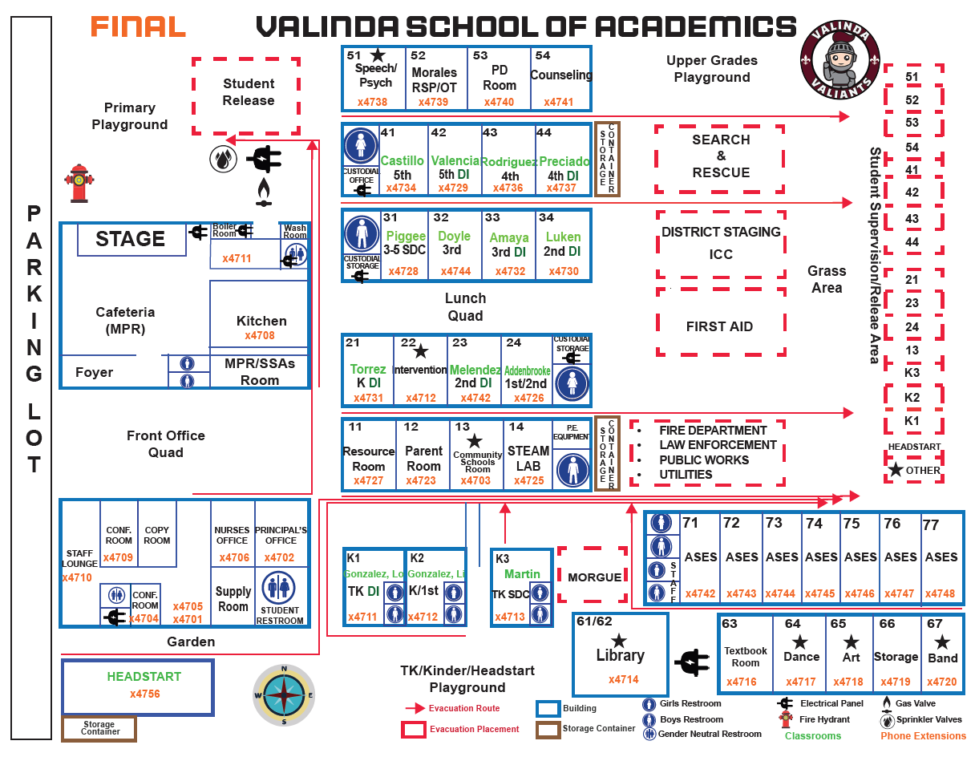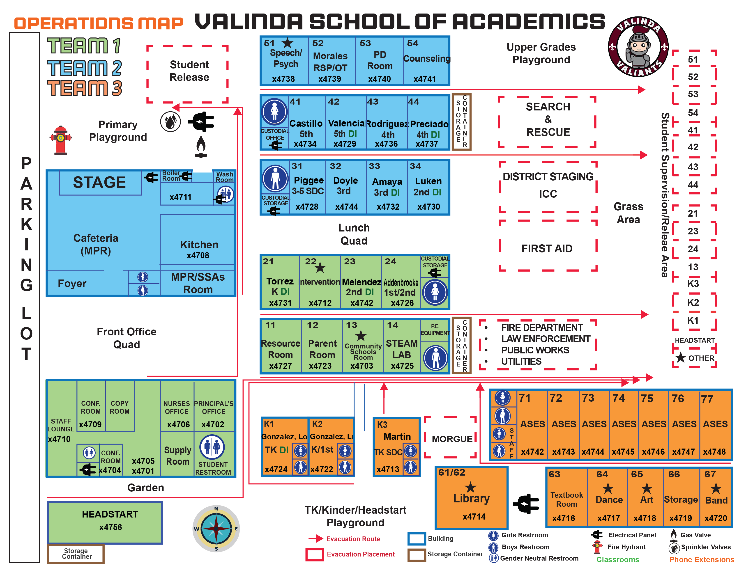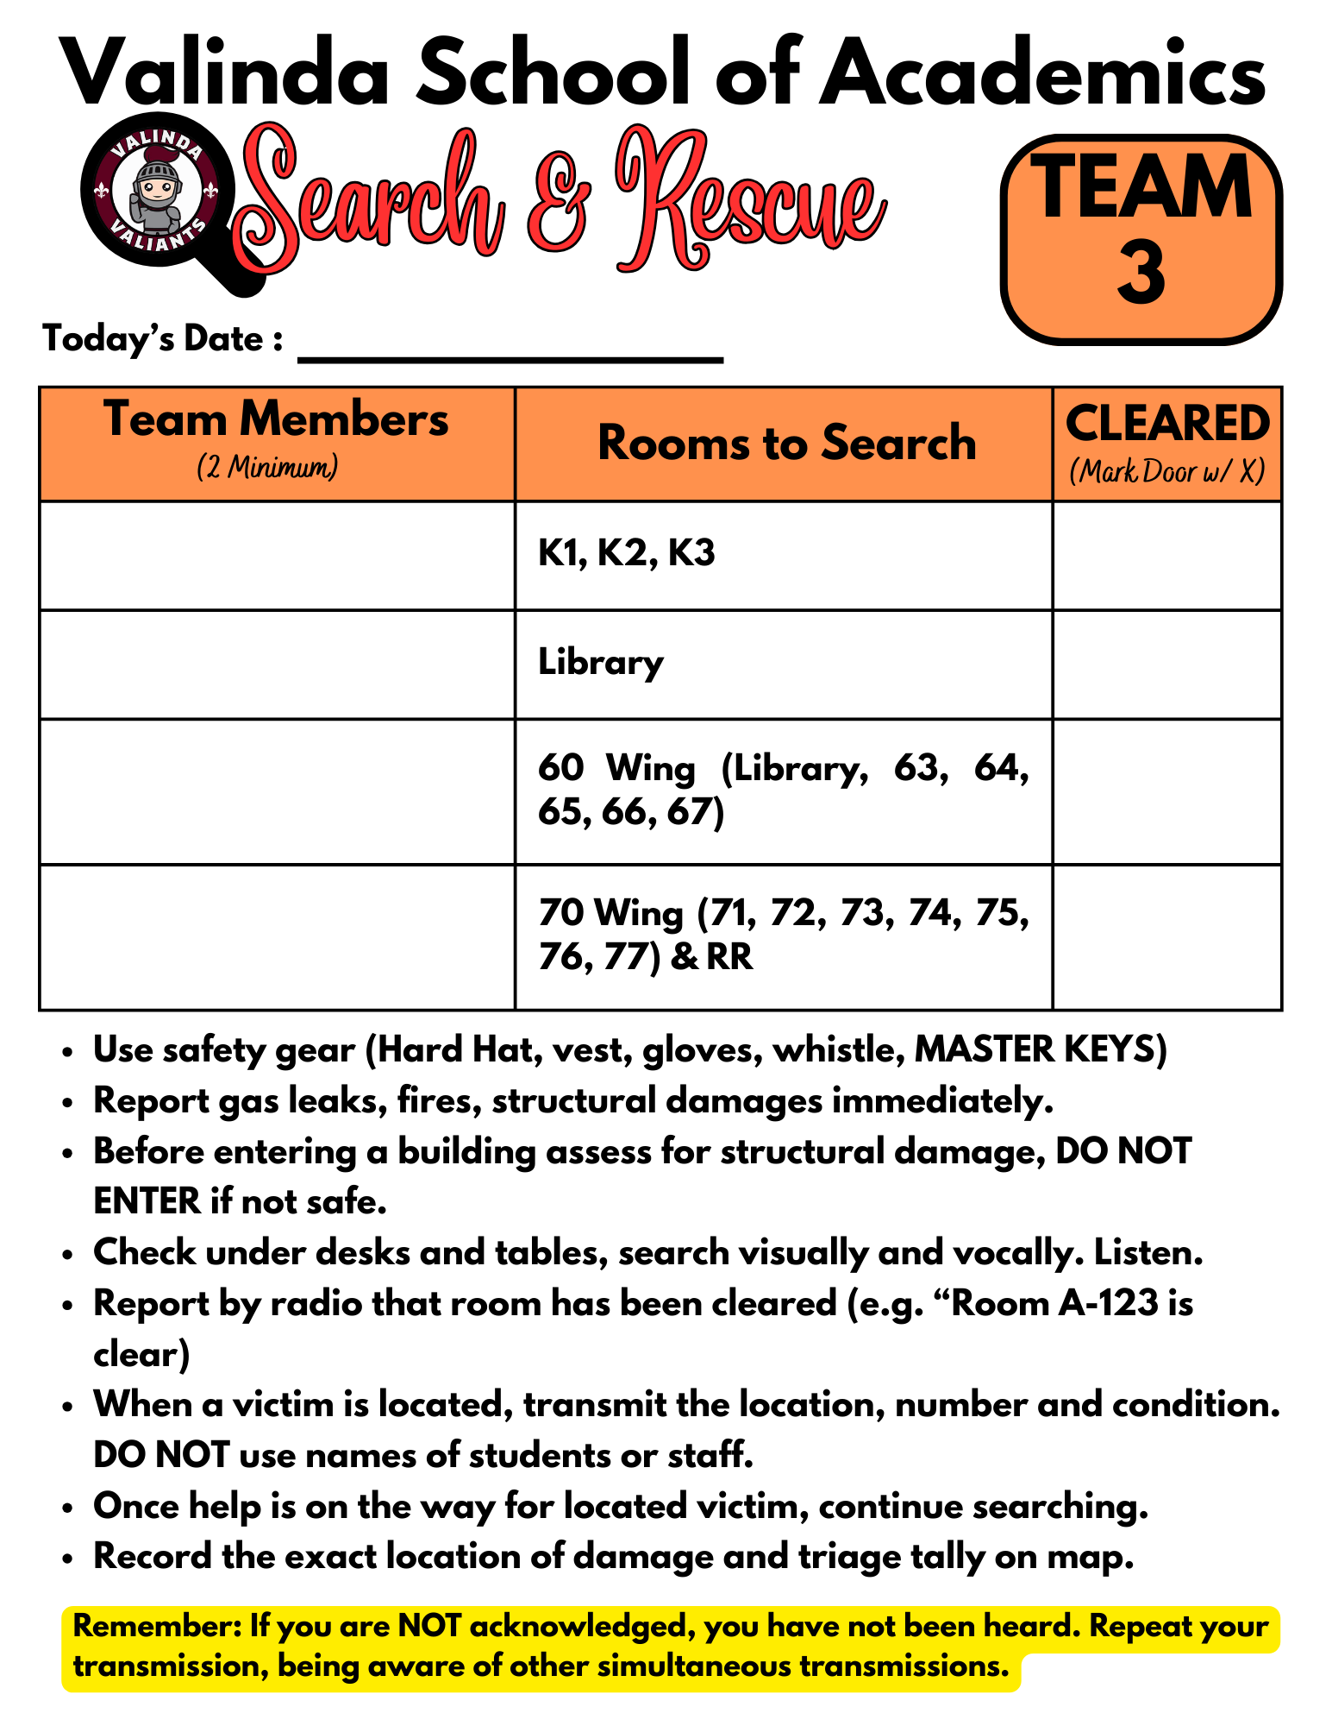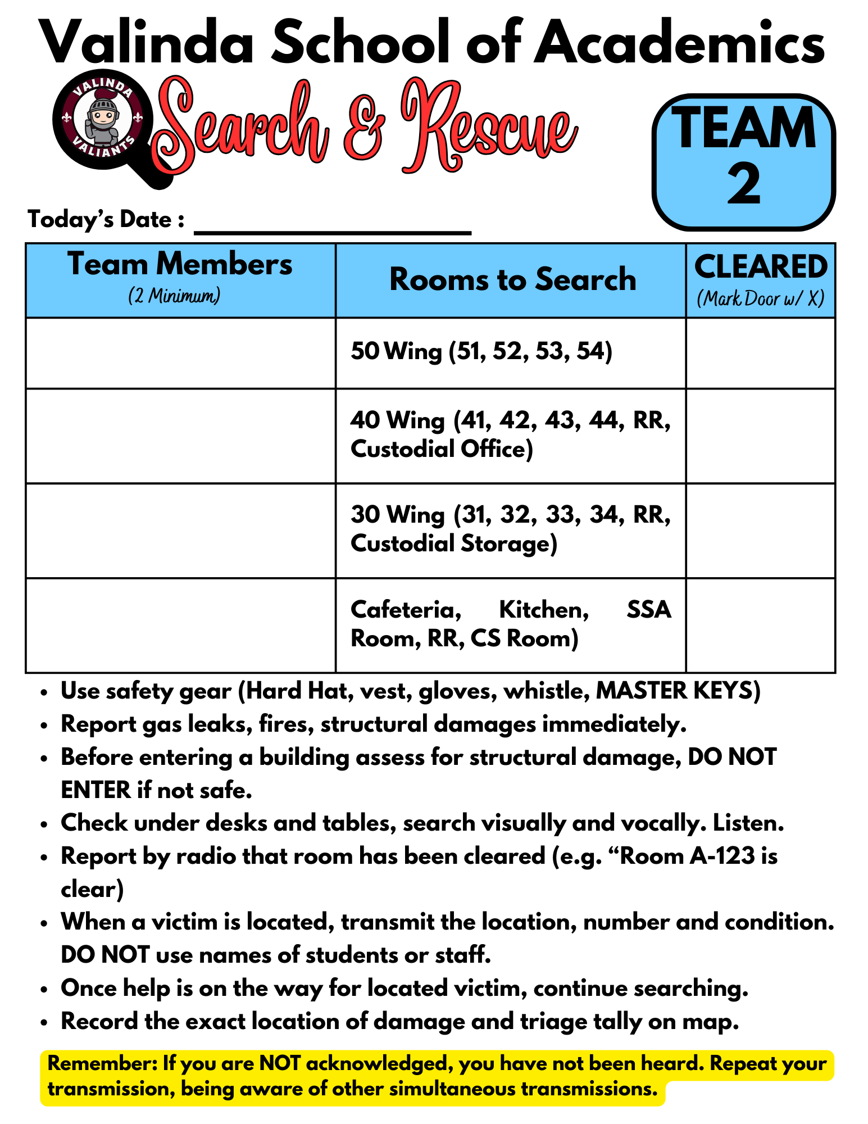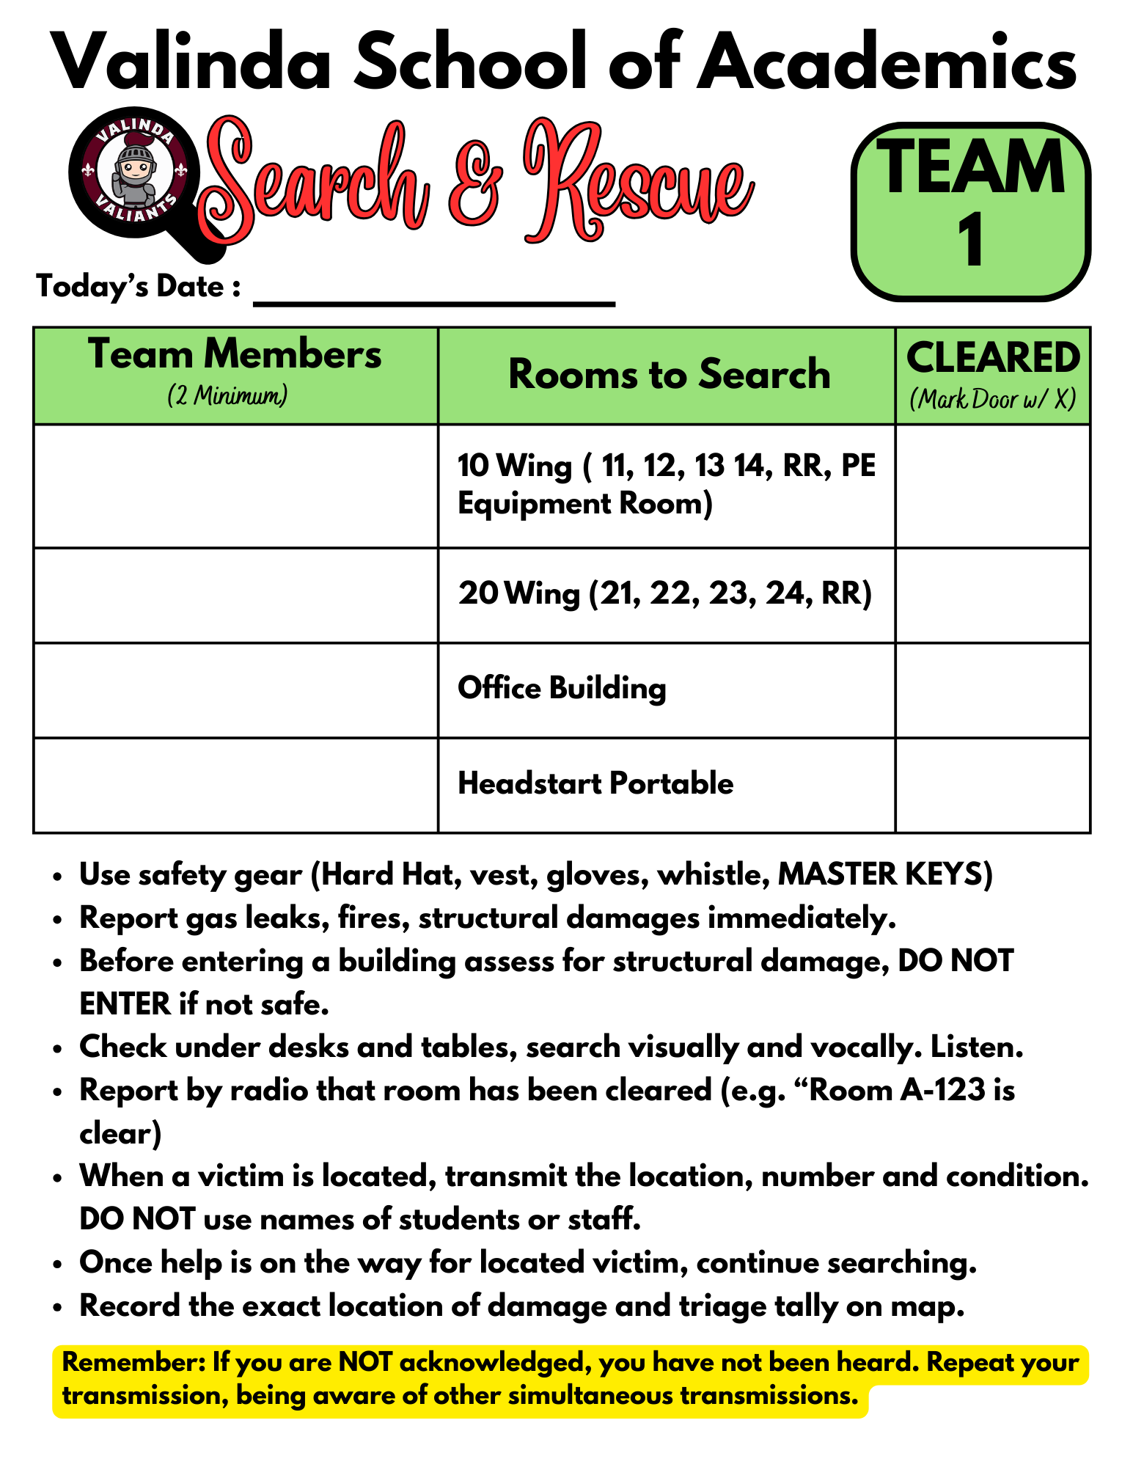
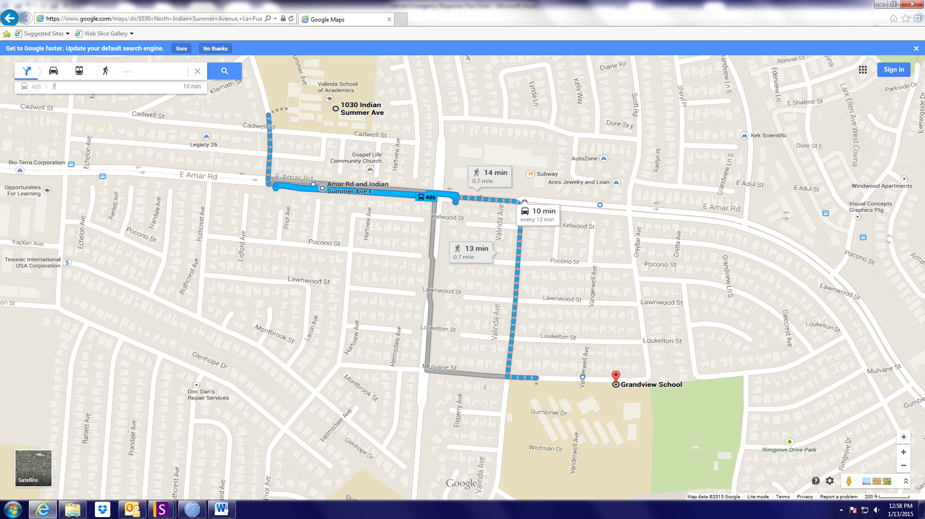

Note: Valinda to and from Grandview Middle School

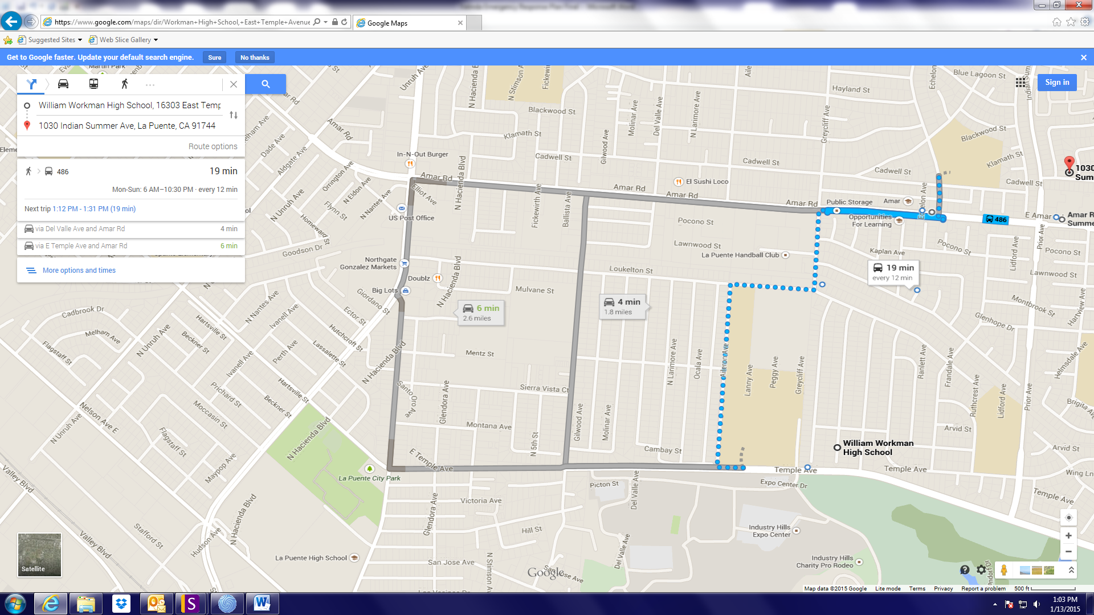

Note: Valinda to and from Workman High School

BOMB THREAT

Upon receiving a message that a bomb has been planted in school:

- Use bomb threat checklist. (Page 36 of Emergency Response Plan)

- Ask where the bomb is located, when will the bomb go off, what materials are in the bomb, who is calling, why is caller doing this.

- Listen closely to caller’s voice and speech patterns and to noises in background.

- After hanging up phone, immediately dial to trace call or record number off of phone.

- Notify Incident Commander or designee.

- Incident Commander orders evacuation of all persons inside school building(s).

- Incident Commander notifies police (call 911) and Superintendent. Incident Commander or Superintendent must report incident to police. 9-911

Evacuation procedures:

- Incident Commander warns students and staff. Do not mention “Bomb Threat”. Use standard fire drill procedures.

- Direct students to take their belongings.

- Students and staff must be evacuated to a safe distance outside of school building(s).

- After consulting with Superintendent, Incident Commander may move students to Center Field if weather is inclement or building is damaged.

- Primary relocation Center Field

- Teachers take roll after being evacuated.

- No one may re-enter the building(s) until fire or police personnel declare them safe.

- Incident Commander notifies students and staff of termination of emergency.

- Resume normal operations.

Bus Driver/Monitor

- Ensure the safety of students and staff first.

- Call 911, if necessary. 9-911

- Notify the district transportation office.

- Notify Incident Commander.

- Incident Commander assembles Emergency Response Team Members.

Site Personnel

- Notify CPR/first aid certified persons in school building of medical emergencies (names of CPR/first aid certified persons are listed in Emergency Response Team Members section).

- Assess counseling needs of victim(s) or witness(s).

- Implement post-crisis procedures.

- Incident Commander notifies Superintendent and parents of students involved.

- Identify location(s) where injured are taken.

EARTHQUAKE

In the event of an earthquake:

Give DROP AND COVER command.

After shaking stops, check for injuries, and render first aid

If ordered by Site Coordinator, evacuate.

DO NOT return to building.

DO NOT light any fires.

Keep a safe distance from any downed power lines.

Check attendance whether or not evacuation takes place. Report any missing students to Site Incident Commander.

Stay alert for aftershocks

Site Incident Commander will issue further instructions.

Inside Building:

Get under desk or table or other sturdy furniture with back to windows.

If not near any furniture, sit in a corner or with back against a wall with back to windows.

Drop to knees, clasp both hands behind neck, bury face in arms, make body as small as possible, close eyes, and cover ears with forearms.

If notebooks or jackets are handy, hold over head for added protection.

Stay away from windows, bookcases, or other heavy objects.

Maintain position until shaking stops.

Outside Building:

Assume DROP AND COVER position in an open space.

Maintain position until shaking stops.

Move away from buildings, trees, overhead wires, and poles.

Do NOT enter building until it is determined to be safe.
Students using wheelchairs:
- Leave the student in the wheelchair (unless a dangerous situation would mandate removing the student from the wheelchair in order to move the student to a safe place).
- Lock the wheels on the wheelchair.
- Cover the student’s head to prevent injury from falling objects.

FIRE
In the event a fire or smoke from a fire has been detected:

- Activate fire alarm.

- Evacuate students and staff to a safe distance outside of building.

- Follow normal fire drill route. Follow alternate route if normal route is too dangerous.

- Teachers take class roster.

- Incident Commander notifies police (call 911) and Superintendent Incident Commander or Superintendent must report incident to Fire Marshal. 9-911

- Teachers take roll after being evacuated.

- After consulting with Superintendent, Incident Commander may moves students to cafeteria if building is damaged or inclement weather.
Primary relocation is Grandview Middle.

- No one may re-enter building(s) until entire building(s) is declared safe by fire or police personnel.

- Incident Commander notifies students and staff of termination of emergency. Resume normal operations.

GAS LEAK

If gas odor has been detected in the building:

- Evacuate students and staff to a safe distance outside of building.

- Follow normal fire drill route. Follow alternate route if normal route is too dangerous.

- Teachers take class roster.

- Incident Commander notifies police and fire (call 911) and Superintendent. 9-911

- Teachers take roll after being evacuated.

- After consulting with Superintendent, Incident Commander may move students to cafeteria, if weather is inclement or building is damaged.
Primary relocation center Workman High School.

- No one may re-enter building(s) until fire or police personnel declare entire building(s) safe.

- Incident Commander notifies students and staff of termination of emergency. Resume normal operations.

If gas odor has been detected outside the building:

- Incident Commander notifies police and fire department (call 911) and Superintendent. Incident Commander or Superintendent must report incident to Fire Marshal.

- Incident Commander determines whether to shelter in place or evacuate. Fire personnel will assist with decision.

- After consulting with Superintendent, Incident Commander may move students to Grandview Middle School, if weather is inclement or building is damaged.
Primary relocation center Workman high School.

- No one may re-enter building(s) until fire or police personnel declare entire building(s) safe.

- Incident Commander notifies students and staff of termination of emergency. Resume normal operations.

GENERAL EMERGENCY
- Notify 9-911 (if necessary) and the Incident Commander. Incident Commander notifies Superintendent. (Insert the actual sequence to dial 911 from your phone system)

- Notify CPR/first aid certified persons in school building of medical emergencies, if necessary. Names of CPR/first aid certified persons are listed in Emergency Response Team Members section.

- Seal off high-risk area.

- Take charge of area until incident is contained or relieved.

- Assemble Emergency Response Team.

- Preserve evidence. Keep detailed notes of incident.

- Refer media to Superintendent of Schools 626-933-1000
District Spokesperson Telephone Numbers

HAZARDOUS MATERIALS EVENT

Incident occurred in school:

- Call 9-911. (Insert the actual sequence to dial 911 from your phone system)

- Notify Incident Commander.

- Incident Commander notifies Superintendent.

- Seal off area of leak/spill.

- Take charge of area until fire personnel contain incident.

- Fire officer in charge will recommend shelter or evacuation actions.

- Follow procedures for sheltering or evacuation.

- Notify parents if students are evacuated.

- Resume normal operations after consulting with fire officials.

Incident occurred near school property:

- Fire or police will notify Superintendent.

- Fire officer in charge of scene will recommend shelter or evacuation actions.

- Follow procedures for sheltering or evacuation.

- Notify parents if students are evacuated.

- Resume normal operations after consulting with fire officials.

INTRUDER/HOSTAGE  Intruder- An unauthorized person who enters school property:  - Notify Incident Commander.  - Ask another staff person to accompany you before approaching guest/intruder.  - Politely greet guest/intruder and identify yourself.  - Ask guest/intruder the purpose of his/her visit.  - Inform guest/intruder that all visitors must register at the main office.  - If intruder’s purpose is not legitimate, ask him/her to leave. Accompany intruder to exit.  If intruder refuses to leave:  - Warn intruder of consequences for staying on school property.  - Notify security or police and Incident Commander if intruder still refuses to leave. Give police full description of intruder. (Keep intruder unaware of call for help if possible)  - Walk away from intruder if he/she indicates a potential for violence. Be aware of intruder’s actions at this time (where he/she is located in school, whether he/she is carrying a weapon or package, etc.).  - Maintain visual contact with intruder from a safe distance.  - Incident Commander notifies Superintendent and may issue lock-down procedures (see Lock-Down Procedures section). | Hostage:  - If hostage taker is unaware of your presence, do not intervene.  - Call 911 immediately. Give dispatcher details of situation; ask for assistance from hostage negotiation team. (Insert the actual sequence to dial 911 from your phone system)  - Seal off area near hostage scene.  - Notify Incident Commander.  - Incident Commander notifies Superintendent.  - Give control of scene to police and hostage negotiation team.  - Keep detailed notes of events.  If taken hostage:  - Follow instructions of hostage taker.  - Try not to panic. Calm students if they are present.  - Treat the hostage taker as normally as possible.  - Be respectful to hostage taker.  - Ask permission to speak and do not argue or make suggestions.

MEDIA

- All staff must refer media to site or district spokesperson.

- The School District, Law Enforcement and Fire assume responsibility for issuing public statements during an emergency. (This responsibility shall be pre-determined during the planning process)

- Superintendent serves as district spokesperson unless he/she designates a spokesperson. If spokesperson is unavailable, an alternate assumes responsibilities.

 | Name | Telephone Numbers (home, work, mobile)
District spokesperson | Superintendent of Schools Dr. Kimberly | 626-933-1000
Alternate spokesperson | Assistant Superintendent of Schools - Dr. Angela Lin | 626-933-3815

School Public Information person acts as contact for emergency responders and assists district spokesperson with coordinating media communications. If Public Information person is unavailable, an alternate assumes responsibilities.

 | Name | Telephone Numbers (home, work, mobile)
School Public Information person | Elizabeth Bermejo | 626-933-4702
Alternate Public Information person | Community Schools Coordinator – Mia Reyes | 626-933-4703

During an emergency, adhere to the following procedures:

- Incident Commander or designee relays all factual information to Superintendent.

- Superintendent notifies other schools in district and may ask school Public Information designee to prepare a written statement to media.

- Establish a media information center away from school.

- Update media regularly. Do not say “No comment”.

- Do not argue with media.

- Maintain log of all telephone inquiries. Use scripted response to respond to inquiries.

Media statement:

- Create a general statement before an incident occurs. Adapt statement during crisis.

- Emphasize safety of students and staff first.

- Briefly describe school’s plan for responding to emergency.

- Issue brief statement consisting only of the facts.

- Respect privacy of victim(s) and family of victim(s). Do not release names to media.

- Refrain from exaggerating or sensationalizing crisis.
SERIOUS INJURY/DEATH

If incident occurred in school:

- Call 911. (Insert the actual sequence to dial 911 from your phone system)
- Notify CPR/first aid certified persons in school building of medical emergencies (names of CPR/first aid certified persons are listed in Emergency Response Team Members section).
- If possible, isolate affected student/staff member.
- Notify Incident Commander.
- Incident Commander notifies Superintendent.
- Activate school Emergency Response Team. Designate staff person to accompany injured/ill person to hospital.
- Incident Commander notifies parent(s) or guardian(s) of affected student.
- Direct witness(es) to school psychologist/counselor. Contact parents if students are sent to psychologist/counselor.
- Determine method of notifying students, staff and parents.
- Refer media to Superintendent of Schools 626-933-1000

If incident occurred outside of school:

- Activate school emergency response team.
- Notify staff before normal operating hours.
- Determine method of notifying students and parents. Announce availability of counseling services for those who need assistance.
- Refer media to Superintendent of Schools 626-933-1000

Post-crisis intervention:

- Meet with school counseling staff and County Mental Health and or other related agencies to determine level of intervention for staff and students.

- Designate rooms as private counseling areas.
- Escort affected students, siblings, close friends, and other “highly stressed” students to counselors.
- Debrief all students and staff.
- Assess stress level of all students and staff.
- Recommend counseling to overly stressed students and staff.
- Follow-up with students and staff who received counseling.
- Designate staff person(s) to attend funeral.
- Allow for changes in normal routines or test schedules to address injury or death.

SHELTERING PROCEDURES
Sheltering provides refuge for students, staff and public within school building during an emergency. Shelters are located in areas that maximize the safety of inhabitants. Safe areas may change depending on the emergency.

- Identify safe areas in each school building.

- Incident Commander warns students and staff to assemble in safe areas. Bring all persons inside building(s).

- Teachers take class roster.

- Close all exterior doors and windows.

- Turn off any ventilation leading outdoors.

- Seal doors, windows, and vents with plastic sheets and duct tape.

- Cover up food not in containers or put it in the refrigerator.

- If advised, cover mouth and nose with handkerchief, cloth, paper towels or tissues.

- Teachers should account for all students after arriving in safe area.

- All persons must remain in safe areas until notified by Incident Commander or emergency responders.

STAFF RESPONSIBILITIES
Incident Commander or designee:

- Verify information.
- Identify Command Post.
- Call 911 (if necessary). (Insert the actual sequence to dial 911 from your phone system)
- Seal off high-risk area.
- Convene Emergency Response Team and implement emergency response procedures.
- Notify Superintendent.
- Notify students and staff (depending on emergency; students may be notified by teachers).
- Evacuate students and staff if necessary.
- Refer media to district spokesperson (or designee).
- Notify community agencies (if necessary).
- Implement post-crisis procedures.
- Keep detailed notes of crisis event.

Teachers:

- Verify information.
- Lock classroom doors, unless evacuation orders are issued.
- Warn students, if advised.
- Account for all students.
- Stay with students during an evacuation. Take class roster.
- Refer media to district spokesperson (or designee).
- Keep detailed notes of crisis event.

STUDENT UNREST
- Notify police, if necessary. (Insert the actual sequence to dial 911 from your phone system)

- Ensure the safety of students and staff first.

- Contain unrest. Seal off area of disturbance.

- Notify Incident Commander.

- Incident Commander notifies Superintendent.

- Warn staff. Incident Commander may issue lock-down (see Lock-Down Procedures section).

- Shut off bells.

- Move students involved in disturbance to an isolated area.

- Meet with student representatives to address issues.

- Document incidents with cassette recorder or take detailed notes.

- Teachers:

- Keep students calm.

- Lock classroom doors.

- Do not allow students to leave the classroom until you receive an all-clear signal from Incident Commander.

- Make a list of students that are absent from classroom. Document all incidents.

SUICIDE
Suicide Attempt in School:

- Verify information.
- Call 9-911. (Insert the actual sequence to dial 911 from your phone system)
- Notify school psychologist/counselor, Incident Commander and Los Angeles Child Mental Health Services (students under 18). See telephone number on page 7.
- Incident Commander notifies Superintendent and parent(s) or guardian(s) if suicidal person is student. Incident Commander may schedule meeting with parents and school psychologist/counselor to determine course of action.
- Calm suicidal person.
- Try to isolate suicidal person from other students.
- Stay with person until counselor/suicide intervention arrives. Do not leave suicidal person alone.
- Determine method of notifying staff, students and parents.
- Hold daily staff debriefings before and after normal operating hours as needed.
- Activate school Emergency Response Team to implement post-crisis intervention. Determine level of intervention.

Suicidal Death/Serious Injury:

- Verify information.
- Activate school emergency response team.
- Incident Commander notifies Superintendent.
- Notify staff in advance of next school day following suicide or attempted suicide.
- Determine method of notifying students and parents. Do not mention “suicide” or details about death in notification. Do not hold memorials or make death appear heroic. Protect privacy of family.
- Implement post-crisis intervention.

Post-crisis Intervention:

- Meet with school counseling staff and Mental Health or other mental health workers to determine level of intervention for staff and students.
- Designate rooms as private counseling areas.
- Escort siblings, close friends, and other “highly stressed” students to counselors.
- Assess stress level of staff. Recommend counseling to overly stressed staff.
- Refer media to Superintendent of Schools 626-933-1000. Do not let media question students or staff.
- Follow-up with students and staff who received counseling. Resume normal routines as soon as possible.

TERRORIST EVENT

Weapons of mass destruction likely to be employed by terrorists fall into four basic categories: Nuclear, Biological, Chemical, and Conventional. The below outlined procedures will protect students and staff should such attacks occur.

Nuclear:
Defense against nuclear weapons depends primarily on distance from the point of detonation. If time permits:
- Move students and staff to specifically identified basement or lower level rooms. Interior hallways may be used as an alternate.
- Close all doors leading into hallways to minimize flying glass.
- All people assume the duck, cover and hold position on the ground.
- Shut down all utility systems to the building. (Gas and electricity are the priorities)
- Shelter in place to protect from fall out if attack is far enough away.
- Keep students and staff inside buildings. Allow parents to pick up their children at their own discretion once cleared to do so by public safety, emergency management, or military authorities
Biological:
Defense against biological attacks is difficult. Awareness of an attack is usually not possible for days or weeks. The first signs may emerge as personnel notice a higher than usual incidence of various symptoms. Should an attack be discovered while in progress the school should:
- Reverse-evacuate all people into school buildings.
- Shelter in place. (Do not use basements or low lying areas)
- Close all doors and windows.
- Shut down the HVAC system. (Limit airflow from outside)
- Seal doors, windows, and vents with plastic and duct tape.
- Keep students and staff inside buildings. Allow parents to pick up their children at their own discretion once cleared to do so by public safety, emergency management, or military authorities.
Chemical:
- Reverse-evacuate all people into school buildings.
- Shelter in place. (Do not use basements or low lying areas)
- Close all doors and windows.
- Shut down the HVAC system. (Limit airflow from outside)
- Seal doors, windows, and vents with plastic and duct tape.
- Be prepared to treat students and staff who experience a reaction to the chemical agent.
- The decision to evacuate should be made after consulting with public safety, emergency management, or military authorities.
Conventional:
The danger from the blast effect of conventional explosive devices is similar to nuclear devices with a higher rate of survivability. If responding to the threat of an imminent blast nearby:
- Move students and staff to specifically identified basement or lower level rooms. Interior hallways may be used as an alternate.
- Close all doors leading into hallways to minimize flying glass.
- All people assume the duck, cover, and hold position on the ground.
- Shut down all utility systems to the building. (Gas and electricity are the priorities)
- Shelter in place to protect from fall out if attack is far enough away.
- Keep students and staff inside buildings. Allow parents to pick up their children at their own discretion once cleared to do so by public safety, emergency management or military authorities
- If the school is the target:
- Evacuate to pre designated off site location(s)

WEAPONS
- Call police if a weapon is suspected to be in school. (Insert the actual sequence to dial 911 from your phone system)

- Ask another administrator or SRO to join you in questioning suspected student or staff member.

- Accompany suspect to private office to wait for police.

- Conduct search with police or SRO.

- Inform suspect of his/her rights and why you are conducting search.

- Keep detailed notes of all events and why search was conducted.

- Notify parent(s) or guardian(s) if suspect is a student. Explain why search was conducted and results of the search.

- If suspect threatens you with a weapon, do not try to disarm them. Back away with your arms up. Remain calm.

WEATHER
Severe Weather Watch has been issued in an area near school:

- Monitor Emergency Alert Stations (see EAS section) or NOAA Weather Stations (National Weather Service, Weather Channel).
- Bring all persons inside building(s).
- Close windows and blinds.
- Review severe weather drill procedures and location of safe areas. Severe weather safe areas are under desks and in hallways away from windows and large rooms.
- Review “drop, cover and hold” procedures with students.

Severe Weather Warning has been issued in an area near school or severe weather has been spotted near school:

- Shut off gas.
- Move students and staff to safe areas.
- Remind teachers to take class rosters.
- Ensure that students are in “drop, cover and hold” positions.
- Account for all students.
- Remain in safe area until warning expires or until emergency personnel have issued an all-clear signal.

APPENDIXES

Appendix A: Bomb Threat Checklist

Description Detail Report |  |  |  |  |  |  | Callers Voice - Check as applicable:
Questions to ask: |  |  |  |  |  |  | - Calm ❑ Nasal
 |  |  |  |  |  |  | - Angry ❑ Stutter
1) When is the bomb going to explode? |  |  |  |  |  |  | - Excited ❑ Lisp
 |  |  |  |  |  |  | - Slow ❑ Raspy
2) Where is it right now? |  |  |  |  |  |  | - Rapid ❑ Deep
 |  |  |  |  |  |  | - Soft ❑ Ragged
3) What does it look like? |  |  |  |  |  |  | - Loud ❑ Clearing Throat
 |  |  |  |  |  |  | - Laughter ❑ Deep Breathing
4) What kind of bomb is it? |  |  |  |  |  |  | - Crying ❑ Cracked Voice
 |  |  |  |  |  |  | - Normal ❑ Disguised
5) What will cause it to explode? |  |  |  |  |  |  | - Distinct ❑ Accent
 |  |  |  |  |  |  | - Slurred ❑ Familiar
6) Did you place the bomb?
 |  |  |  |  |  |  | If voice is familiar, whom did it sound like?
7) Why?
8) What is your address?
 |  |  |  |  |  |  | Background Sounds:
9) What is your name?
 |  |  |  |  |  |  | - Street Noises |  | - Factory Machinery
Exact wording of the threat: |  |  |  |  |  |  | - Animal Noises |  | - Voices
 |  |  |  |  |  |  | - Clear |  | - PA System
 |  |  |  |  |  |  | - Static |  | - Local Call
 |  |  |  |  |  |  | - Music |  | - Long Distance
 |  |  |  |  |  |  | - House Noises |  | - Phone Booth
 |  |  |  |  |  |  | - Motor |  | - Office Machinery
Sex of Caller: |  |  |  | Race: |  |  | - Other
Length of call: |  |  |  | Age:
Date: |  |  |  | Time: |  |  | Threat Language:
Number at which call was received: |  |  |  |  |  |  | - Well Spoken (educated)
 |  |  |  |  |  |  | - Incoherent |  | - Taped
Notes: |  |  |  |  |  |  | - Foul |  | - Message read
 |  |  |  |  |  |  | - Irrational by threat maker
 |  |  |  |  |  |  | Remarks:

Appendix B: Notice of First Aid Care

DATE: _______________________

SCHOOL: ____________________

Dear Parent:

______________________________________ was injured at school and has been given first aid. If you feel further care is necessary, please consult your family physician.

Destination: (If not presently on site) ______________________________________________________

Transporting Agency: (if not presently on site) _______________________________________________

Time: ____________________

Remarks:

Please sign and return one copy to school. Retain a copy for your records.

_________________________________ _____________________________________
PARENT’S SIGNATURE SCHOOL REPRESENTATIVE’S SIGNATURE

Note: 1 copy goes home with student
1 copy stays with teacher or medical treatment team records

Appendix C: Plan Compliance Checklist

Use this checklist to determine if your emergency response plan complies with all requirements. The elements of the minimum requirements are listed below. Your plan must contain each listed element to be in compliance. This checklist can assist you in conducting your annual review. Compliance with the National Incident Management System (NIMS) has been added to the requirements.
Y | N | UNK | NIMS COMPLIANCE
☐ | ☐ | ☐ | The school site and district have adopted the Incident Command System (ICS) as the management system to be used to manage emergencies
☐ | ☐ | ☐ | All personnel assigned responsibilities within the ICS structure have completed the FEMA Independent study courses, IS 100, IS 200 and IS 700
Y | N | UNK | INTRODUCTION:
☐ | ☐ | ☐ | Table of contents
☐ | ☐ | ☐ | Approval statement and dated signatures of principal, appropriate district official and emergency response organizations
Y | N | UNK | PURPOSE:
☐ | ☐ | ☐ | State the purpose of the emergency response plan
Y | N | UNK | SITUATION:
☐ | ☐ | ☐ | State the size and location of your facility in acres and the number, general size, and use of each of the buildings
☐ | ☐ | ☐ | State the number of students and employees normally on hand, and any scheduled daily differences in population
☐ | ☐ | ☐ | Complete a hazard analysis of the school grounds, buildings and surrounding community to identify any natural or human related hazards
Y | N | UNK | DIRECTION AND CONTROL:
☐ | ☐ | ☐ | Create an Incident Command System (ICS) for your site which will include a chain of command and alternates to implement and carry out the plan. At a minimum include the following: 1. Incident Commander, 2. Public Information Officer,  3. Safety Officer, 4. Liaison Officer, and 5. Operations Section
☐ | ☐ | ☐ | Designate primary and alternate on-site and off-site Command Post locations
☐ | ☐ | ☐ | Identify persons, by title and agency, who will be notified during an emergency
☐ | ☐ | ☐ | Describe the warning signals or commands that alert staff and students to emergency responses;  Evacuation  Reverse evacuation  Lockdown/Shelter in place No Code Words
☐ | ☐ | ☐ | Designate primary and alternate evacuation routes and assembly areas
☐ | ☐ | ☐ | Designate primary and alternate on and off-site relocation sites and other necessary sites (and how students/staff would be moved or transported)
☐ | ☐ | ☐ | Describe how disabled and/or non-English-speaking children will be provided for
☐ | ☐ | ☐ | Provide a resource inventory of emergency items available - communication equipment, first aid, medical, fire-fighting equipment, lighting, etc.
☐ | ☐ | ☐ | Post a Classroom Emergency Response Guide in each room or assembly area for student and staff
☐ | ☐ | ☐ | Each school should have a battery powered radio in case of power failure
☐ | ☐ | ☐ | Develop procedures for off campus emergencies (field trip, bus, etc…)
☐ | ☐ | ☐ | Develop student/parent reunification procedures
Y | N | UNK | PLAN DEVELOPMENT AND MAINTENANCE:
☐ | ☐ | ☐ | Provide an annual review of plan, attachments, responses, and needs. Update whenever necessary
☐ | ☐ | ☐ | Invite community, outside agencies (fire, law enforcement, emergency management and county health department are required) to assist in plan development, training, exercises, and revision
☐ | ☐ | ☐ | Conduct annual training of all staff regarding warning/response signals, evacuation routes, assembly areas, emergency procedures, and chain of command (ICS)
☐ | ☐ | ☐ | Annually review your Incident Command System with staff and train those who have assigned responsibilities
☐ | ☐ | ☐ | Twice annually practice each of the listed emergency response drills with students and staff  1. Reverse evacuation  2. Lockdown or Shelter in place  3. Evacuation (one fire drill per year can count towards this requirement)
☐ | ☐ | ☐ | One school district employee will participate in multi-hazard crisis training annually
☐ | ☐ | ☐ | Overview of plan explained and distributed to parents
☐ | ☐ | ☐ | Schools will send a copy of their plan to be on file in the district office
Y | N | UNK | APPENDICES AND ATTACHMENTS:
☐ | ☐ | ☐ | ICS structure and responsibilities
☐ | ☐ | ☐ | Student roster with parent phone numbers
☐ | ☐ | ☐ | Master schedule
☐ | ☐ | ☐ | Faculty/staff roster with emergency phone numbers
☐ | ☐ | ☐ | Community emergency numbers, e.g.,  General emergency number - 911  Ambulance  Poison Control Center  Local hospital  Police Department/Sheriff/California Highway Patrol  Fire Department
☐ | ☐ | ☐ | Map of evacuation route(s) and assembly areas, student release gate, command post(s)
☐ | ☐ | ☐ | Site plan or blueprint of the facility and floor plan(s) of the building(s) showing location of water and gas shut off points, heat plants, boilers, generators, flammable liquid storage, other hazard materials storage, fire-fighting equipment placement, first aid facilities, exits, etc.
☐ | ☐ | ☐ | Lists with the name, title, address, telephone number, and organizational responsibilities for emergency operations
☐ | ☐ | ☐ | Sample statements/letters for use in notifying faculty, students, parents, and media about emergency
☐ | ☐ | ☐ | Student accountability/release forms

Area |  |  | Comments
Site name/ District/County:
Site Review |  |  |  |  |  | County Public Health Review
Date: | Name/Title/Signature: |  |  |  |  | Date: | Name/Title/Signature:
District Review |  |  |  |  |  | Law Enforcement Review
Date: | Name/Title/Signature: |  |  |  |  | Date: | Name/Title/Signature:
County Emergency Management Review |  |  |  |  |  | District Governing Board
Date: | Name/Title/Signature: |  |  |  |  | Date: | Name/Title/Signature:
State Review
Date: | Name/Title/Signature: |  |  |  |  | Date: | Name/Title/Signature:

Appendix D: Pandemics

SITUATION

A pandemic is a global disease outbreak that occurs when a new virus emerges for which there is little or no immunity in the human population. During the 20th century, there were three influenza pandemics:
The 1918 pandemic caused at least 500,000 deaths in the U.S. and up to 40 million deaths worldwide.
The 1957 pandemic caused at least 70,000 deaths in the U.S. and 1 to 2 million deaths worldwide.
The 1968 pandemic caused about 34,000 deaths in the U.S. and 700,000 deaths worldwide. The SARS epidemic of 2003 had 8,096 known infected cases and 774 confirmed human deaths in Asia. When a pandemic influenza virus emerges, its global spread is considered inevitable. Its spread can be delayed through measures such as border closures and travel restrictions, but it cannot be stopped. Because the strain of the virus emerges so rapidly, it is highly unlikely that a vaccine will be available for a pandemic flu outbreak.

Hacienda La Puente Unified School District will be severely affected by a pandemic. It is estimated that 20% to 30% of the staff and students is likely to be directly affected by a pandemic event, and additional staff are likely to need to stay home to care for sick family members. At the height of the pandemic, up to 40% of the workforce may be unavailable. In addition, the delivery of such basic commodities and services as fuel, groceries, public safety, etc., is likely to be severely disrupted.

The World Health Organization has developed a Global Influenza Preparedness Plan that breaks the pandemic threat down into several phases:

- Inter-pandemic period (phases 1 and 2). No new influenza strains have been detected in humans, but virus strains in animals pose a risk to humans that may be low (phase 1) or substantial (phase 2).
- Pandemic alert period (phases 3, 4, and 5). New influenza strains have caused humans infections. Human-to-human spread is non-existent or limited to rare instances of close contact (phase 3), highly localized in small clusters (phase 4), or localized in larger clusters (phase 5).
- At phase 5, the virus is becoming increasingly adapted to humans, and there is a substantial pandemic risk.
- Pandemic period (phase 6). Increased and sustained human-to-human transmission in the general population.
- Post-pandemic period. Return to the inter-pandemic period (phase 1).

Several governmental organizations conduct pandemic surveillance on a routine basis and provide information about how to recognize, prepare for, and deal with a pandemic.

- Federal level - Centers for Disease Control and Prevention (CDC) and its parent organization, the Department of Health and Human Services (DHHS).
- State level – California Department of Health Services (DHS).
- County level – Los Angeles County Public Health Department

In the United States, the pandemic phases are based on the global phases. The Secretary of the U.S. Department of Health and Human Services will determine that the nation is in the pandemic period (phase 6) when sustained human-to-human transmission is observed anywhere in the world.

MISSION
To establish a program that will educate the district workforce and the student population and their families about how to cope with a pandemic and enable district operations to continue to provide essential services to our students, staff and community.

EXECUTION
Concept of Operations
When a phase 3 pandemic alert has been declared by the World Health Organization, the County Department of Health will issue news releases to inform the district work force, students, and their families about how to deal with its effects. These efforts will be intensified and more specifically targeted when a pandemic appears likely to develop (phase 5 or 6 as defined above). These news releases will be coordinated with local emergency management and the public health department releases.

All district departments will implement actions to deal with the pandemic and its effects. These actions will focus on two primary areas:
- Protecting the health of employees, students and their families.
- Ensuring their ability to provide essential services when faced with a severely reduced workforce and the disruption of services and supplies essential to their operations.
- There are four essential steps that employees, students and their families can take to reduce the spread of the disease:
- Cover your mouth and nose with a tissue or handkerchief when coughing or sneezing.
- Wash your hands frequently with warm water. Use alcohol-based hand sanitizers when soap and warm water are unavailable
- Stay home when you are sick.
- Increase your social distance (avoid crowds and mass gatherings).

Tasks.
School Board – At phase 5 of the pandemic alert period, make policy decisions regarding the following areas:
Increased used of telecommuting and/or paid administrative leave by district departments.
- Liberalized use of Family and Medical Leave Act (FMLA) time by district employees to encourage them to stay away from the workplace when feeling sick.
- All district departments
- Determine which functions of the department are critical, and conduct adequate cross-training of employees in these functions to ensure that critical tasks can be accomplished when a large percentage of the workforce is unavailable.
- Identify supplies and services essential to continued operations and, when necessary, identify backup means of ensuring them.
- Encourage district employees and their families to develop a family emergency plan and emergency kit capable of sustaining them for a minimum of 72 hours without outside assistance. www.ready.gov is a good source of information for the plan and kit.
- Consider the procurement of supplies to prevent the spread of disease in the workplace – surgical masks, hand sanitizer bottles, etc.
At phase 5 of the pandemic alert period:
- Mandate or encourage increased use of telecommuting (pending district governing board direction).
- Encourage employees to stay home when they feel sick. Send employees home if they appear to be sick.
- Consider implementing policies that limit face-to-face contact among students and staff as well as between staff and the public.
- During the pandemic period (phase 6):
- Curtail less essential services as required when the district workforce and students are reduced by the effects of the pandemic.
- Implement backup means of maintaining the educational process and ensuring essential supplies and services.
- In coordination with the county health department, determine if schools should be closed.

Public Information Office

At phase 3 of the pandemic alert period, Initiate an education campaign for the district’s staff, students and families, emphasizing (1) steps they can take to prevent the spread of disease, and (2) the need to develop family disaster plans and kits that will enable them to sustain themselves if essential public services (food, water, sanitation, etc.) are lost for several days at a time. The education campaign will be coordinated with the education campaigns of cities and towns within the district boundaries and will emphasize reaching out to the Spanish-speaking component of the community.

At phase 5 of the pandemic alert period and during the pandemic period (phase 6):

- Intensify the education campaign for the public, emphasizing the same items as during phase 3. In addition, alert the public to potential changes in services provided by the district as a result of personnel shortages caused by the pandemic.
- Assist the governing board and superintendents’ office in the dissemination of policy guidance regarding special steps to be taken by district personnel in response to the pandemic.
- Support.

The U.S. Department of Health and Human Services has a pandemic influenza plan and planning guidelines for state and local governments, individuals, businesses, and schools. This information can be accessed at www.PandemicFlu.gov.

Information on California State’s Pandemic Flu plans and other information can be found at
http://www.cdph.ca.gov/programs/immunize/Pages/PandemicFlu.aspx .

Appendix E: Public Information Release

Check as appropriate: District/District-wide School
Date: Time:
NOTE: If this is used as a script, read only those items checked. Make no other comments.

(Check off, fill in, and cross off as appropriate.)

has just experienced a(n)

- The (students/employees) [(are being) or (have been)] accounted for.
- No further information is available at this time.
- Emergency medical services [(are here) or (are on the way) or (are not available to us)].
- Police [(are here) or (are on the way) or (are not available to us)].
- Fire Dept./paramedics [(are here) or (are on the way) or (are not available to us)].
- [(are here) or (are on the way) or (are not available to us)].
- Communication center(s) for parents (is/are) being set up at Click here to enter text.
to answer questions about individual students.
- Communication center(s) for families (is/are) being set up at Click here to enter text. to answer questions about individual employees.
- Injuries have been reported at Click here to enter text. and are being treated at the site by (staff/professional medical responders).
- (#) reported injured.
- Students have been taken to a safe area, Click here to enter text., and are with [(classroom teachers/staff) or ( )].
- (#) ____ Students have been taken to the local emergency room for treatment of serious injury.
- Parents of injured students should go to the emergency room at Click here to enter text.
- (#) Confirmed deaths have been reported at Click here to enter text.
- Names cannot be released until families have been notified.
- Structural damage has been reported at the following sites: Click here to enter text..

Release restrictions _____No _____Yes
If yes, what?

Released to the public as Public Information Release # ________
Date/Time:

Appendix F: Sample School-Parent Letter
[Date]

Dear Parents:

Should an emergency or disaster situation ever arise in our area while school is in session, we want you to be aware that the schools have made preparations to respond effectively to such situations. In fact, public schools in California are built to meet stringent construction standards and they may be safer than your own home in the event of a disaster.

Should we have a major disaster during school hours, your student(s) will be cared for at this school. Our District has a detailed disaster plan which has been formulated to respond to a major catastrophe.

Your cooperation is necessary in any emergency:

1. Do not telephone the school. Telephone lines may be needed for emergency communication.
2. In the event of a serious emergency, students will be kept at their schools until they are picked up by an identified, responsible adult who has been identified as such on a School District emergency card which is required to be filled out by parents at the beginning of every school year. Please be sure you consider the following criteria when you authorize another person to pick up your child at school:
- He/she is 18 years of age or older.
- He/she is usually home during the day.
- He/she could walk to school, if necessary.
- He/she is known to your child.
- He/she is both aware and able to assume this responsibility.
3. Turn your radio to [radio stations] for emergency announcements. If students are to be kept at school, radio stations will be notified. If electrical service is not affected, information will be relayed via the School District cable on Channel ____. In addition, information regarding day-to-day school operations will be available by calling the District Office.
4. Impress upon your children the need for them to follow the directions of any school personnel in times of an emergency.

Students will be released only to parents and persons identified on the School District Emergency Card. During an extreme emergency, students will be released at designated reunion gates located on school campuses. Parents should become familiar with the School Emergency Disaster Plan and be patient and understanding with the student release process. Please instruct your student to remain at school until you or a designee arrives. Because local telephone service may be disrupted, also list an out-of-State contact on the emergency card, as calls may still be made out of the area while incoming calls are affected.

Sample School-Parent Letter (Continued)

The decision to keep students at school will be based upon whether streets in the area are open. If this occurs, radio stations will be notified. In the event that a natural disaster takes place during the time that students are being transported, students will be kept on the bus and the driver will ask for assistance through radio contact with the school and district personnel. Any child who is home waiting for the bus will not be picked up (if roads are impassable) and remains the responsibility of the parent or guardian. In the event a natural disaster occurs in the afternoon, the driver will make every attempt to continue delivering the students to their homes. Should road conditions prevent the driver from delivering students to their home or to school in the morning, the students will be delivered to the nearest school site and that school will communicate with the home school to inform them of the students’ whereabouts.

In case of a hazardous release event (chemical spill) near the school area, Shelter-in-Place procedures will be implemented to provide in place protection. All students and staff will clear the fields, report to their rooms and all efforts will be made to prevent outside air from entering classrooms during the emergency. “Shelter-in-Place” signs will be placed in classroom windows or hung outside classroom doors during a drill or emergency. Students arriving at school during a Shelter-in-Place drill or event should report to the school office or to a previously designated area at the school because classrooms will be inaccessible. When the dangerous incident has subsided, an all-clear signal will be given.

Please discuss these matters with your immediate family. Planning ahead will help alleviate concern during emergencies.

Sincerely,

Principal
School

Appendix G: Search and Rescue Teams List

SEARCH AND RESCUE (S & R) TEAM LEADER
Note: Number of teams will vary depending on size of campus.

 |  | NAMES | Radio | Keys | Hard Hat | Goggles | Bucket | Vest | Clipboard | Backpack
S & R TEAM #1  NOTES: | 1
S & R TEAM #1  NOTES: | 2
S & R TEAM #2  NOTES: | 1
S & R TEAM #2  NOTES: | 2
S & R TEAM #3  NOTES: | 1
S & R TEAM #3  NOTES: | 2
S & R TEAM #4  NOTES: | 1
S & R TEAM #4  NOTES: | 2
S & R TEAM #5  NOTES: | 1
S & R TEAM #5  NOTES: | 2

- Assign teams based on available manpower; minimum 2 persons. Attempt to place one experienced person on each team.
- Perform visual check of outfitted team leaving Command Post (CP); include radio check. Advise teams of known injuries.
- Remain at Command Post table.
- Be attentive to all S&R related communications.
- Utilize boxes above to record location of injured students. Example: report of 2 injured students in Room 20 would be recorded as “S/2 = RM 20” in box under team #3.
- Utilize manpower pool to aid S&R (i.e., request for backboard and carryout or request for rescue equipment).

Final Site Status Report
TO: FROM: (name) LOCATION:

DATE: TIME: PERSON IN CHARGE AT SITE:

Message via: 2-way Radio _____ Telephone Messenger _______

EMPLOYEE/STUDENT STATUS
 |  | Absent | Injured | # Sent to  Hosp./med | Dead | Missing | Unaccounted for  (Away from site) | # Released  To parents | # Being  supervised
Students
Site Staff
Others
STRUCTURAL DAMAGE Check damage/problem and indicate location(s).
Check  ✔ | Damage/Problem |  |  |  |  | Location(s)
 | Gas leak
 | Water leak
 | Fire
 | Electrical
 | Communications
 | Heating/cooling
 | Other (list):
MESSAGE: (include kind of immediate assistance required; can you hold out without assistance/how long? overall condition of campus, neighborhood & street conditions; outside agencies on campus & actions; names of injured, dead, missing and accounted for ASAP)

Appendix I: Staff Skills Survey & Inventory

Name & School _____________________________/___________________________ Room ________
Name School

During any disaster situation, it is important to be able to draw from all available resources. The special skills, training and capabilities of the staff will play a vital role in coping with the effects of any disaster incident. These will be of paramount importance during and after a major or catastrophic disaster. The purpose of this survey/inventory is to pinpoint those staff members with equipment and the special skills that might be needed. Please indicate the areas that apply to you and return this survey to your administrator.

PLEASE CHECK ANY OF THE FOLLOWING IN WHICH YOU HAVE EXPERTISE & TRAINING.
CIRCLE YES OR NO, WHERE APPROPRIATE.

_____ First Aid (current card yes/no) | _____ CPR (current yes/no) | _____ Triage | _____ Firefighting

_____ Construction (electrical, plumbing, carpentry, etc.) | _____Running/Jogging

_____ Emergency Planning | _____ Emergency Management | _____ Search & Rescue

_____ Law Enforcement | Bi/Multi-lingual (what language (s)) _________________________________

_____ Mechanical Ability | _____ Structural Engineering | _____ Bus/Truck Driver  (Class 1 or 2 license yes/no)

_____ Shelter Management | _____ Survival Training & Techniques | _____ Food Preparation

_____ Ham Radio Operator | _____ CB Radio | _____Journalism

_____ Camping | _____ Waste Disposal | _____ Recreational Leader

DO YOU KEEP A PERSONAL EMERGENCY KIT? ❑ in your car? ❑ in your room?

DO YOU HAVE MATERIALS IN YOUR ROOM THAT WOULD BE OF USE DURING AN EMERGENCY?
(i.e., athletic bibs, traffic cones, carpet squares) ❑ Yes ❑ No

DO YOU HAVE EQUIPMENT OR ACCESS TO EQUIPMENT OR MATERIALS AT YOUR SCHOOL SITE THAT COULD BE USED AN IN EMERGENCY? ❑ YES ❑ NO
PLEASE LIST EQUIPMENT AND MATERIALS.
____________________________________________________________________________________

COMMENTS __________________________________________________________________________________

____________________________________________________________________________________
WHAT WOULD MAKE YOU FEEL MORE PREPARED SHOULD A DISASTER STRIKE WHILE YOU WERE AT SCHOOL?

____________________________________________________________________________________

Student Accounting Form/Site Problems
Date:
Enrolled per register:
Not in school today:
Present now:

Students Injured/Missing/and or Deceased

Name Location Problem
__________________________________________________________________________________
__________________________________________________________________________________
__________________________________________________________________________________
__________________________________________________________________________________
__________________________________________________________________________________
__________________________________________________________________________________
__________________________________________________________________________________

Location/Problem
__________________________________________________________________________________
__________________________________________________________________________________
__________________________________________________________________________________
__________________________________________________________________________________
__________________________________________________________________________________
__________________________________________________________________________________

__________________________________________________________________________________
Report fire, gas/water leaks, blocked exits, structural damage, etc

Student Release Form

Please Print

Student’s Name

Teacher Grade

********************************************************************************************

To be filled in by Request Gate staff

Proof of I.D. Name on Emergency Card
(yes) (no)

********************************************************************************************
Student’s Status
To be filled in by teacher

❑ Sent with Runner ❑ Absent ❑ First Aid ❑ Missing

********************************************************************************************

To be filled in by Request Gate staff

Proof of I.D. Name on Emergency Card
(yes) (no)

*********************************************************************************************

To be filled in by Requester
At Release Gate

Requester Signature:

Relation to Student:
*********************************************************************************************

Notes:

Update Report

Name Time
# children remaining at school
# staff members remaining to care for children
______ Assistance required: ______ water _____ food ______ blankets ______ # people to help

Update Report

Name Time
# children remaining at school
# staff members remaining to care for children
______ Assistance required: ______ water ______ food ______ blankets ______ # people to help

Update Report

Name Time
# children remaining at school
# staff members remaining to care for children
______ Assistance required: ______ water ______ food ______ blankets ______ # people to help

Update Report

Name Time
# children remaining at school
# staff members remaining to care for children
______ Assistance required: ______ water ______ food ______ blankets ______ # people to help

Insert Student Roster with Parent Contact Information

Insert Master Schedule

Insert Faculty and Staff Roster with Contact Information

Appendix L: Incident Response Job Descriptions

Command Section: Incident Commander 57
Command Section: Safety Officer 59
Command Section: Public Information Officer (PIO) 60
Command Section: Liaison Officer 62
Operations Section: Search and Rescue Team Leader 65
Operations Section: Search and Rescue Teams 66
Operations Section: Medical Team Leader 67
Operations Section: Medical Team 70
Operations Section: Medical Branch Morgue 72
Operations Section: Student Care 74
Operations Section: Student Release 76
Emergency Response Drill Log 78
Annual Site Plan Review 79
Command Section: Incident Commander

Responsibilities: | The Incident Commander is solely responsible for emergency/disaster operations and shall remain at the Command Post to observe and direct all operations.  Ensure the safety of students, staff, and others on campus. Lead by example: your behavior sets tone for staff and students.
Start-up Actions | - Obtain your personal safety equipment (i.e., hard hat, vest, clipboard with job description sheet).  - Assess the type and scope of emergency.  - Determine the threat to human life and structures.  - Implement the emergency plan and hazard-specific procedures.  - Develop and communicate an incident action plan with objectives and a timeframe to meet those objectives.  - Activate functions and assign positions as needed.  - Fill in the Incident Assignments form.  - Appoint a backup or alternate Incident Commander (as described in the emergency plan).
Ongoing  Operational  Duties | Continue to monitor and assess the total school situation:  - View the site map periodically for search and rescue progress and damage assessment information.  - Check with chiefs for periodic updates.  - Reassign personnel as needed.  - Report (through Communications) to the school district on the status of students, staff, and facility, as needed (Site Status Report).  - Develop and communicate revised incident action plans as needed.  - Begin student release when appropriate.  NOTE: No student should be released until student accounting is complete. Never send students home before the end of the regular school day unless directed by the superintendent, except at the request of parent/guardian.  - Authorize the release of information.  - Utilize your backup; plan and take regular breaks (5-10 minutes per hour). During break periods, relocate away from the Command Post.  - Plan regular breaks for all staff and volunteers. Take care of your caregivers!  - Release teachers as appropriate and per district guidelines. (By law, during a disaster, teachers become disaster workers.)  - Remain on and in charge of your campus until redirected or released by the superintendent.

Command Section: Incident Commander (Continued)

Closing Down: | - Authorize deactivation of sections, branches, or units when they are no longer required.  - At the direction of the Superintendent, deactivate the entire emergency response. If the fire department or other outside agency calls an “all clear,” contact the district before taking any further action.  - Ensure that any open actions not yet completed will be taken care of after deactivation.  - Ensure the return of all equipment and reusable supplies to Logistics.  - Close out all logs. Ensure that all logs, reports, and other relevant documents are completed and provided to the Documentation Unit.  - Announce the termination of the emergency and proceed with recovery operations if necessary.
Command Post  Equipment/  Supplies | - Campus map  - Master keys  - Staff and student rosters  - Disaster response forms  - Emergency plan  - Duplicate rosters (two sets)  - Tables and chairs (if Command Post is outdoors)  - Vests (if available)  - Job description clipboards  - Command Post tray (pens, etc.)  - School district radio  - Campus two-way radios  - AM/FM radio (battery)  - Bullhorn

Command Section: Safety Officer

Responsibilities: | The Safety Officer ensures that all activities are conducted in as safe a manner as possible under the existing circumstances.
Start-Up Actions: | - Check in with the Incident Commander for a situation briefing.  - Obtain necessary equipment and supplies from Logistics.  - Put on a position identifier, such as a vest, if available.  - Open and maintain a position log. Maintain all required records and documentation to support the history of the emergency or disaster. Document:  - Messages received.  - Action taken.  - Decision justification and documentation.  - Requests filled.
Operational Duties: | - Monitor drills, exercises, and emergency response activities for safety.  - Identify and mitigate safety hazards and situations.  - Stop or modify all unsafe operations.  - Ensure that responders use appropriate safety equipment.  - Think ahead and anticipate situations and problems before they occur.  - Anticipate situation changes, such as cascading events, in all planning.  - Keep the Incident Commander advised of your status and activity and on any problem areas that now need or will require solutions.
Closing Down: | - When authorized by the Incident Commander, deactivate the unit and close out all logs.  - Provide logs and other relevant documents to the Documentation Unit.  - Return equipment and reusable supplies to Logistics.
Equipment/  Supplies | - Vest or position identifier, if available  - Hard hat, if available  - Clipboard, paper, pens  - Two-way radio, if available

Command Section: Public Information Officer (PIO)

Personnel: | Available staff with assistance from available volunteers
Policy: | - The public has the right and need to know important information related to an emergency/disaster at the school site as soon as it is available.  - The PIO acts as the official spokesperson for the school site in an emergency situation. If a school district PIO is available, he/she will be the official spokesperson. A school site-based PIO should be used only if the media is on campus and the district PIO is not available.  - News media can play a key role in assisting the school in getting emergency/ disaster-related information to the public (parents).  - Information released must be consistent, accurate, and timely.
Start-Up Actions: | - Determine a possible “news center” site as a media reception area (located away from the Command Post and students). Get approval from the Incident Commander.  - Identify yourself as the PIO (by vest, visor, sign, etc.)  - Consult with the district PIO to coordinate information release.  - Assess the situation and obtain a statement from the Incident Commander. Tape record it if possible.  - Advise arriving media that the site is preparing a press release and the approximate time of its issue.  - Open and maintain a position log of your actions and all communications. If possible, tape media briefings. Keep all documentation to support the history of the event.
Operational Duties: | - Keep up to date on the situation.  - Statements must be approved by the Incident Commander and should reflect:  - Reassurance (EGBOK— “Everything’s going to be OK.”)  - Incident or disaster cause and time of origin.  - Size and scope of the incident.  - Current situation—condition of school site, evacuation progress, care being given, injuries, student release location, etc. Do not release any names.  - Resources in use.  - Best routes to the school, if known and if appropriate.  - Any information the school wishes to be released to the public.

Section: Command Public Information Officer (PIO) (Continued)

- Read statements if possible.
- When answering questions, be complete and truthful, always considering confidentiality and emotional impact. Avoid speculation, bluffing, lying, talking “off the record,” arguing, etc. Avoid using the phrase “no comment.”
- Remind school staff and volunteers to refer all questions from the media or waiting parents to the PIO.
- Update information periodically with the Incident Commander.
- Ensure that announcements and other information are translated into other languages as needed.
- Monitor news broadcasts about the incident. Correct any misinformation heard.

Closing Down: | - At the Incident Commander’s direction, release PIO staff when they are no longer needed. Direct staff members to sign out through Timekeeping.  - Return equipment and reusable supplies to Logistics.  - Close out all logs. Provide logs and other relevant documents to the Documentation Unit.
Equipment/  Supplies | Public information kit consists of:  - ID vest  - Battery-operated AM/FM radio  - Paper/pencils/marking pens  - Scotch tape/masking tape  - Scissors  - School site map(s) and area maps  • 8-l/2 x 11 handouts  • Laminated poster board size for display  - Forms:  Disaster Public Information Release Work Sheet  Sample Public Information Release  School Profile or School Accountability Report Card (SARC)

Command Section: Liaison Officer

Responsibilities: | The Liaison Officer serves as the point of contact for agency representatives from assisting organizations and agencies outside the school district and assists in coordinating the efforts of these outside agencies by ensuring the proper flow of information.
Start-Up Actions: | - Check in with the Incident Commander for a situation briefing.  - Determine your personal operating location and set it up as necessary.  - Obtain the necessary equipment and supplies from Logistics.  - Put on a position identifier, such as a vest, if available.  - Open and maintain a position log. Maintain all required records and documentation to support the history of the emergency or disaster.
Operational Duties: | - Brief agency representatives on the current situation, priorities, and incident action plan.  - Ensure coordination of efforts by keeping the Incident Commander informed of agencies’ action plans.  - Provide periodic update briefings to agency representatives as necessary.
Closing Down: | - At the Incident Commander’s direction, deactivate the Liaison Officer position and release staff no longer needed. Direct staff members to sign out through Timekeeping.  - Return equipment and reusable supplies to Logistics.  - Close out all logs. Provide logs and other relevant documents to the Documentation Unit.
Equipment/  Supplies | - Vest or position identifier, if available  - Two-way radio, if available  - Clipboard, paper, pens

Operations Section: Operations Section Chief

Responsibilities: | The Operations Chief manages the direct response to the disaster, which can include:  - Site Facility Check/Security  - Search and Rescue  - Medical  - Student Care  - Student Release
Start-Up Actions: | - Check in with the Incident Commander for a situation briefing.  - Obtain necessary equipment and supplies from Logistics.  - Put on a position identifier, such as a vest, if available.
Operational Duties: | - Assume the duties of all operations positions until staff are available and assigned.  - As staff members are assigned, brief them on the situation, and supervise their activities, using the position checklists.  - If additional supplies or staff are needed for the Operations Section, notify Logistics. When additional staff arrive, brief them on the situation, and assign them as needed.  - Coordinate search and rescue operations if it is safe to do so. Appoint an S&R Team Leader to direct operations, if necessary.  - As information is received from operations staff, pass it on to situation analysis and/or the Incident Commander.  - Inform the Planning Section Chief of operations tasks and priorities.  - Make sure that operations staff are following standard procedures, using appropriate safety gear, and documenting their activities.  - Schedule breaks and reassign staff within the section as needed.

Operations Section: Operations Section Chief (Continued)

Closing Down: | - At the Incident Commander’s direction, release Operations staff no longer needed. Direct staff members to sign out through Timekeeping.  - Return equipment and reusable supplies to Logistics.  - When authorized by the Incident Commander, deactivate the section and close out all logs. Provide logs and other relevant documents to the Documentation Unit.
Equipment/  Supplies | - Vest or position identifier, if available  - S&R equipment  - Two-way radio  - Job description clipboard, paper, pens  - Maps:  - Search and rescue maps  - Large campus map

Operations Section: Search and Rescue Team Leader

Safety Rules: | - Use the buddy system: Assign a minimum of 2 persons to each team.  - Take no action that might endanger you. Do not work beyond your expertise. Use appropriate safety gear. Size up the situation first. Follow all operational and safety procedures.
Start-Up Actions: | - Obtain all necessary equipment from container. (See list below.)  - Obtain a briefing from Operations Chief, noting known fires, injuries, or other situations requiring response.  - Assign teams based on available manpower, minimum 2 persons per team.
Operational Duties: | - Perform a visual and radio check of the outfitted team leaving the Command Post. Teams must wear sturdy shoes and safety equipment.  - Record names and assignments before deploying teams.  - Dispatch teams to known hazards or situations first, then to search the campus using specific planned routes. Send a specific map assignment with each team.  - Remain at the Command Post in radio contact with S&R Teams.  - Record all teams’ progress and reports on the site map, keeping others at the Command Post informed of problems. When a room is reported clear, mark a “C” on the map.  - If injured students are located, consult the Operations Section Chief for response. Utilize Transport teams, or send a First Aid Team.  - Record the exact location of damage and a triage tally (I=immediate, D=delayed, DEAD=dead) on the map.  - Keep radio communication brief and simple. No codes.  - Remember: if you are not acknowledged, you have not been heard. Repeat your transmission, being aware of other simultaneous transmissions.
Closing Down: | - Record the return of each S&R team. Direct them to return equipment and report to Logistics for additional assignment.  - Provide maps and logs to the Documentation Unit.
Equipment/  Supplies | - Vest, hard hat, work and latex gloves, and whistle with master keys on lanyard. One team member should wear a first aid backpack.  - Campus two-way radio and clipboard with job description and map indicating the search plan.  - Bucket or duffel bag containing goggles, flashlight, dust masks, pry bar, grease pencil, pencils, duct tape, and masking tape.

Operations Section: Search and Rescue Teams

Team 1 (area to search), Room 9-16, office and cafeteria
Team 2 (area to search), Kinder and Rooms 1-8, P1-5
Team 3 (area to search), Rooms P6-P21, Preschool and Headstart

Safety: | - Use the buddy system: Ensure that each team has been assigned a minimum of 2 persons.  - Take no action that might endanger you. Do not work beyond your expertise. Use appropriate safety gear. Size up the situation first.  - Follow all operational and safety procedures.
Start-Up Actions: | - Obtain all necessary equipment from the container. (See list below.) You must wear sturdy shoes and long sleeves. Put batteries in the flashlight.  - Check in at the Command Post for assignment.
Operational Duties: | - Report gas leaks, fires, or structural damage to the Command Post immediately upon discovery. Shut off gas or extinguish fires if possible.  - Before entering a building, inspect the complete exterior of the building. Report structural damage to the team leader. Use yellow caution tape to barricade hazardous areas. Do not enter severely damaged buildings. If you are in doubt about your safety, DO NOT ENTER!  - If the building is safe to enter, search the assigned area (following the map) using an orderly pattern. Check all rooms. Use chalk or grease pencil to mark a slash on the door when entering a room. Check under desks and tables. Search visually and vocally. Listen. When leaving each room, complete the slash to form an “X” on the door. Report by radio to the Command Post that room has been cleared (e.g. “Room A-123 is clear.”).  - Remember: If you are not acknowledged, you have not been heard. Repeat your transmission, being aware of other simultaneous transmissions.  - When an injured victim is located, transmit the location, number, and condition of the injured to the Command Post. Do not use names of students or staff.  - Follow directions from the Command Post.  - Record the exact location of damage and triage tally (I=immediate, D=delayed, DEAD=dead) on the map and report the information to the Command Post.  - Keep radio communication brief and simple. Do not use codes.
Closing Down: | - Return equipment to Logistics. Provide maps and logs to the Documentation Unit.
Equipment/  Supplies | - Vest, hard hat, work and latex gloves, and whistle with master keys on a neck lanyard. One member of the team should wear a first aid backpack.  - Campus two-way radio and clipboard with job description and map indicating the search plan.  - Bucket or duffel bag containing goggles, flashlight, dust masks, pry bar, grease pencil, pencils, duct tape, and masking tape.

Operations Section: Medical Team Leader

Responsibilities: | The Medical Team Leader is responsible for providing emergency medical response, first aid, and counseling. He or she informs the Operations Chief or Incident Commander when the situation requires health or medical services that staff cannot provide and ensures that appropriate actions are taken in the event of deaths.
Start-Up Actions: | - Establish scope of disaster with the Incident Commander and determine probability of outside emergency medical support and transport needs.  - Make personnel assignments. If possible, assign a minimum of two people to triage, two to immediate treatment, two to delayed treatment, and two to psychological treatment.  - Set up a first aid area in a safe place (upwind from the emergency area if the emergency involves smoke or hazardous materials), away from students and parents, with access to emergency vehicles. Obtain equipment and supplies from the storage area.  - Assess available inventory of supplies and equipment.  - Review safety procedures and assignments with personnel.  - Establish a point of entry (“triage”) into the treatment area.  - Establish “immediate” and “delayed” treatment areas.  - Set up a separate psychological first aid area if staff levels are sufficient.
Operational Duties: | - Oversee the assessment, care, and treatment of patients.  - Ensure caregiver and rescuer safety: Ensure that they use latex gloves for protection from body fluids and new gloves for each new patient.  - Make sure that accurate records are kept.  - Provide personnel to respond to injuries in remote locations or request a Transport Team from Logistics.  - If needed, request additional personnel from Logistics.  - Brief newly assigned personnel.  - Report deaths immediately to the Operations Section Chief.  - Keep the Operations Section Chief informed of the overall status.  - Set up a morgue, if necessary, in a cool, isolated, secure area; follow the guidelines established in the plan.  - Stay alert for communicable diseases and isolate appropriately.  - Consult with the Student Care Director regarding health care, medications, and meals for students with known medical conditions (e.g., diabetes, asthma, etc.).

Operations Section: Medical Team Leader (Continued)

Closing Down: | - At the Incident Commander’s direction, release medical staff who are no longer needed. Direct staff members to sign out through Timekeeping.  - Return equipment and reusable supplies to Logistics.  - When authorized by the Incident Commander, deactivate the section and close out all logs.  - Provide the logs and other relevant documents to the Documentation Unit.
Equipment/  Supplies | First aid supplies. (See the list on the following page.)  - Job description clipboards  - Stretchers  - Vests, if available  - Tables and chairs  - Staff and student medication from the Health Office  - Forms:  - Notice of First Aid Care  - Medical Treatment Victim Log  - Masking tape  - Marking pens  - Blankets  - Quick reference medical guides  - Ground cover/tarps  Recommended First Aid Supplies:  - 4 x 4" compress: 1000 per 500 students  - 8 x 10" compress: 150 per 500 students  - gauze bandaging: 1 per student  - Ace wrap: 2-inch: 12 per campus  - 4-inch: 12 per campus  - Triangular bandage: 24 per campus  - Cardboard splints: 24 each of sm, med, lg.  - Steri-strips or butterfly bandages: 50/campus  - Aqua-Blox (water) cases (for flushing wounds, etc.): 0.016 x students + staff = # cases  - Neosporin: 144 squeeze packs/campus  - Hydrogen peroxide: 10 pints/campus  - Bleach: 1 small bottle

Operations Section: Medical Team Leader (Continued)

- Plastic basket or wire basket stretchers or backboards: 1.5 per 100 students
- Scissors, paramedic: 4 per campus
- Tweezers: 3 assorted per campus
- Triage tags: 50 per 500 students
- Latex gloves: 100 per 500 students
- Oval eye patch: 50 per campus
- Tapes: 1" cloth: 50 rolls/campus
- 2" cloth: 24 per campus
- Dust masks: 25 per 100 students
- Disposable blanket: 10 per 100 students
- First Aid Books: 2 standard and 2 advanced per campus
- Space blankets: 1 per student and staff
- Heavy duty rubber gloves: 4 pair

Operations Section: Medical Team

Personnel: | First-aid trained staff and volunteers
Responsibilities: | Use approved safety equipment and techniques.
Start-Up Actions: | - Obtain and wear personal safety equipment including latex gloves.  - Check with the Medical Team Leader for assignment.
Operational Duties: | - Administer appropriate first aid.  - Keep accurate records of care given.  - Continue to assess victims at regular intervals.  - Report deaths immediately to the Medical Team Leader.  - If and when transportation is available, do a final assessment and document on the triage tag. Keep and file records for reference—do not send any records with the victim.  - A student’s emergency card must accompany each student removed from campus to receive advanced medical attention. Send an emergency out-of-area phone number, if available.
 | Triage Entry Area:
The triage area should be staffed with a minimum of two trained team members, if possible.

- One member confirms the triage tag category (red, yellow, green) and directs to the proper treatment area. Should take 30 seconds to assess—no treatment takes place here. Assess if not tagged.
- Second team member logs victims’ names on form and sends the forms to the Command Post as completed.

 | Treatment Areas (“Immediate and Delayed”)
- Treatment areas should be staffed with a minimum of two team members per area, if possible.
- One member completes secondary head-to-toe assessment.
- Second member records information on the triage tag and on-site treatment records.
- Follow categories: Immediate, Delayed, Dead

- When using the two-way radio, do not use the names of the injured or dead.

Operations Section: Medical Team (Continued)

Closing Down: | - Return equipment and unused supplies to Logistics.  - Clean up first aid area. Dispose of hazardous waste safely.  - Complete all paperwork and turn it in to the Documentation Unit.
Equipment/  Supplies | First-aid supplies (See the list on the following page.)  - Job description clipboards  - Stretchers  - Vests, if available  - Tables and chairs  - Staff and student medication from health office  - Forms:  - Notice of First Aid Care  - Medical Treatment Victim Log  - Marking pens  - Blankets  - Quick reference medical guides  - Ground cover/tarps

Operations Section: Medical Branch Morgue

Personnel: | To be assigned by the Operations Section Chief if needed.
Start-Up Actions: | - Check with the Operations Section Chief for direction.  - If directed, set up a morgue area. Verify:  - Tile, concrete, or other cool floor surface  - Accessible to Coroner’s vehicle  - Remote from the assembly area  - Security: Keep unauthorized persons out of the morgue.  - Maintain a respectful attitude.
Operational Duties: | After pronouncement or determination of death:  - Confirm that the person is actually dead.  - Do not move the body until directed by the Command Post.  - Do not remove any personal effects from the body. Personal effects must remain with the body at all times.  - As soon as possible, notify the Operations Section Chief, who will notify the Incident Commander, who will attempt to notify law enforcement authorities of the location and, if known, the identity of the body. Law enforcement personnel will notify the Coroner.  - Keep accurate records and make them available to law enforcement and/or the Coroner when requested.  - Write the following information on two tags:  - Date and time found.  - Exact location where found.  - Name of decedent if known.  - If identified—how, when, by whom.  - Name of person filling out tag.  - Attach one tag to body.  - If the Coroner’s Office will not be able to pick up the body soon, place the body in a plastic bag and tape securely to prevent unwrapping. Securely attach the second tag to the outside of the bag. Move the body to the morgue.  - Place any additional personal belongings found in a separate container and label as above. Do not attach to the body—store separately near the body.

Operations Section: Medical Branch Morgue (Continued)

Closing Down: | - After all bodies have been picked up, close down the Morgue.  - Return equipment and unused supplies to Logistics.  - Clean up the area. Dispose of hazardous waste safely.  - Complete all paperwork and turn in to the Documentation Unit.
Equipment/  Supplies | - Tags  - Pens/pencils  - Plastic trash bags  - Duct tape  - Vicks Vapo-Rub  - Plastic tarps  - Stapler  - 2" cloth tape

Operations Section: Student Care

Personnel: | Classroom teachers, substitute teachers, and staff as assigned.
Responsibilities: | - Ensure the care and safety of all students on campus except those who are in the medical treatment area.
Start-Up Actions: | - Wear an identification vest, if available.  - Take a job description clipboard and radio.  - Check in with the Operations Section Chief for a situation briefing.  - Make personnel assignments as needed.  - If evacuating:  - Verify that the assembly area and routes to it are safe.  - Count or observe the classrooms as they exit, to make sure that all classes evacuate.  - Initiate the set-up of portable toilet facilities and hand-washing stations.
Operational Duties: | - Monitor the safety and well-being of the students and staff in the assembly area.  - Administer minor first aid as needed.  - Support the Student Release process by releasing students with the appropriate paperwork.  - When necessary, provide water and food to students and staff.  - Make arrangements for portable toilets if necessary, ensuring that students and staff wash their hands thoroughly to prevent disease.  - Make arrangements to provide shelter for students and staff.  - Arrange activities and keep students reassured.  - Update records of the number of students and staff in the assembly area (or in the buildings).  - Direct all requests for information to the PIO.

Operations Section: Student Care (Continued)

Closing Down: | - Return equipment and reusable supplies to Logistics.  - When authorized by the Incident Commander, close out all logs. Provide logs and other relevant documents to the Documentation Unit.
Equipment/  Supplies | - Vest  - Clipboard with job description  - Ground cover, tarps  - First aid kit  - Student activities: books, games, coloring books, etc.  - Forms:  - Student Accounting  - Notice of First Aid Care  - Campus two-way radio  - Water, food, sanitation supplies

Operations Section: Student Release

Personnel: | School secretary, available staff and disaster volunteers. Use a buddy system. The Student Release process is supported by student runners.
Responsibilities: | Assure the reunification of students with their parents or authorized adult through separate Request and Release Gates.
Start-Up Actions: | - Obtain and wear a vest or position identifier, if available.  - Check with the Operations Section Chief for assignment to the Request Gate or Release Gate.  - Obtain necessary equipment and forms from Logistics.  - Secure the area against unauthorized access. Mark the gates with signs.  - Set up the Request Gate at the main student access gate. Use alphabetical grouping signs to organize parent requests.  - Have Student Release Forms available for parents outside of the fence at the Request Gate. Assign volunteers to assist.  - Set up the Release Gate some distance from the Request Gate.
Operational Duties: | Follow the procedures outlined below to ensure the safe reunification of students with their parents or guardians:  - Refer all requests for information to the POI. Do not spread rumors!  - If volunteers arrive to help, send those with Disaster Volunteer badges with photo ID to Logistics. If they are not registered (i.e., do not have badges), direct them to a branch library to register.
Procedures: | - The requesting adult fills out a Student Release Form, gives it to a staff member, and shows identification.  - The staff member verifies the identification, pulls the Emergency Card from the file, and verifies that the requester is listed on the card.  - The staff member instructs the requester to proceed to the Release Gate.  - If there are two copies of the Emergency Cards (one at each gate), staff files the Emergency Card in the out box. If there is only one copy, a runner takes the card with the Student Release Form, and staff files a blank card with the student’s name on it in the out box.  - The runner takes the form(s) to the designated classroom.  Note: If a parent refuses to wait in line, don’t argue. Note the time with appropriate comments on the Emergency Card and place it in the out box.

Operations Section: Student Release (Continued)

 | If the student is with the class:
- Runner shows the Student Release Form to the teacher.
- The teacher marks the box, “Sent with Runner.”
- If appropriate, the teacher sends the parent copy of the First Aid Form with the runner.
- The runner walks the student(s) to the Release Gate.
- The runner hands the paperwork to release personnel.
- Release staff match the student to the requester, verify proof of identification, ask the requester to fill out and sign the lower portion of Student Release Form, and release the student. Parents are given the Notice of First Aid Care Given, if applicable.

 | If the student is not with the class:
- The teacher makes the appropriate notation on the Student Release Form:
- “Absent” if the student was never in school that day.
- “First Aid” if the student is in the Medical Treatment area.
- “Missing” if the student was in school but now cannot be located.
- The runner takes Student Release Form to the Command Post.
- The Command Post verifies the student’s location if known and directs the runner accordingly.
- If the runner is retrieving multiple students and one or more are missing, the runner walks the available students to the Release Gate before returning “Missing” forms to the Command Post for verification.
- The parent should be notified of the missing student’s status and escorted to a crisis counselor.
- If the student is in First Aid, the parent should be escorted to the Medical Treatment Area.
- If the student was marked absent, the parent will be notified by a staff member.

Closing Down: | - At the direction of the Operations Section Chief, return equipment and unused supplies to Logistics.  - Complete all paperwork and turn it in to the Documentation Unit.
Equipment/  Supplies | - Job description clipboards  - Pens, stapler  - Box(es) of Emergency Cards  - Signs to mark Request Gate and Release Gate  - Signs for alphabetical grouping to organize the parents (A-F, etc.)  - Empty file boxes to use as out boxes  - Student Release Form (copies for every student)

Emergency Response Drill Log

School: |  | District:

Date | Type of Drill | Comments

Annual Site Plan Review

Each school site emergency response plan must be reviewed at least once each year. It is recommended that this review be conducted prior to the start of each school year. Additionally, the plan must be reviewed anytime weaknesses in the plan are identified during a drill, exercise or an actual emergency event. Schools should include their local emergency response, emergency management and public health agencies in the review process.

☐ | Review ICS assignments and responsibilities, update as needed.
☐ | Ensure NIMS compliance for all personnel assigned responsibilities in the ICS structure.
☐ | Review on and off site assignments and staging areas. Make contact with any identified off site locations to ensure permission to use those locations is still in effect.
☐ | Review existing emergency procedures. Are the procedures adequate to address identified hazards/threats? Have new hazards/threats developed that you must plan for?
Notes:

Date of Review: | Reviewer: | Reviewer:
 | Reviewer: | Reviewer:

Supplies needed for First-Aid Kit

- 3 cold packs- for Emergency (one-time use only)
- Bandages, including adhesive (different sizes of Band-aids) and elastics
- Cotton-tip applicators (swabs)
- Cotton balls
- CPR masks (pediatric and adult)
- Dental floss
- Disinfectant for surfaces, spills- approved by U.S. Environmental Protection Agency
- Disposable gloves and vinyl gloves (for latex allergies)
- Magnifying glass
- Office supplies (notepads, pens, markers)
- Paper cups
- Paper towels
- Plastic bags
- Record forms (ER cards, logs, medical sheets, accident reports, state forms)
- Ring cutter
- Safety pins
- Salt
- Eye irrigating cup
- Eye pads
- Fingernail clippers
- Slings
- Soap (must be in dispenser)
- Tape- hypo-allergenic
- Sanitary pads- individually wrapped (may be used for compression)
- Washcloths (disposable)
- Scissors (blunt end)
- Splints (assorted)
- Tissues
- Thermometer (disposable)
- Tongue Depressors
- Triangular bandage
- Tweezers
- Washcloths (disposable)

Reference or Resource Books:

Emergency Medical Services Authority. (2004). Emergency First Aid Guidelines for California Schools. Available online at:
www.emsa.ca.gov/aboutemsa/school_guidelines.pdf

