A Peek at our Week
Mrs. Bird
Monday, September 28 – Friday, October 2, 2026
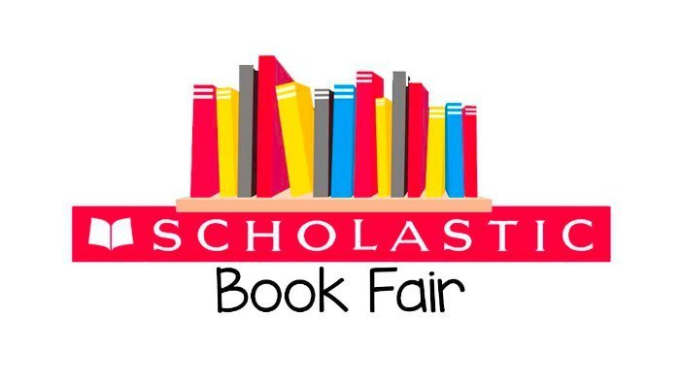
Our class will visit the Scholastic Book Fair this Thursday, October 1st! If you would like to purchase books, you may consider setting up a Scholastic e-Wallet, or you may bring cash to school in a labeled envelope or baggie with your name.
WORD WALL WORDS: stamp, chunk, both, talk, walk
Please practice reading and spelling these words each night!
Homework Schedule
Monday  *Spanish & Gym/Health* | Tuesday  *STEAM& Gym/Health* | Wednesday  *Art* | Thursday  *Gym/Health* | Friday  *Music & Gym/Health*  Library Visit Biweekly
Math: Additional Practice 2.1  Reading: Log | Math: Additional Practice 2.2  Reading: Log | Math: Additional Practice 2.3  Reading: Log | Math: Additional Practice 2.4  Reading: Log | Have a wonderful weekend!
Taking a Closer Look…
- Math: We will begin Topic 2 on even numbers, odd numbers, and arrays.
- Social Studies: We will continue our unit on communities. We will learn about the responsibilities of local government leaders, local services within communities, and jobs of community helpers.
- Reader’s Workshop: We will continue our first reading unit called, Becoming a Big Kid Reader. We will practice reading with fluency “scoops”, reading bigger words part by part, checking for understanding, and reading end punctuation.
- Writer’s Workshop: Students will continue the process of writing small moment stories. We will practice how to tackle challenging words when trying to spell them. We will also practice how to revise our writing.
- Fundations: We will complete Unit 2 in our Fundations program. We will learn the following glued sounds: am, an, ang, ing, ong, ung, ank, ink, onk, unk. Our test is scheduled for Friday!

**Remember to have sneakers for gym class!**

